1. pwd
2. mkdir projects
3. cd projects
4. mkdir data results scripts bin
5. ls ~
6. ls -l ~

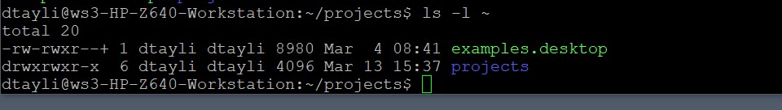

1. ls -a ~



1. ls -tla ~
2. ls -tla --reverse ~
3. ls -shal ~
4. First command only shows the names of the files and folders in my home directory. The second command shows the path of the files and directories and the files under that path.
5. ls -la ~/{P*,D*}
6. ls -la ~/[:upper:]
7. cd data
8. ~~echo “Welcome to Linux” > welcome.txt~~ (given already)
9. cp welcome.txt welcome_2.txt
10. mv welcome_2.txt welcome_copy.txt
11. rm welcome_copy.txt
12. cd ..
13. cp -r data backup