**2.** echo "$two_liner" will write the lines separately in 2 lines.

echo $two_liner will write the lines in only one line.

Since the first command keeps line breaks, while other command makes the variable’s value as a single line.

8. 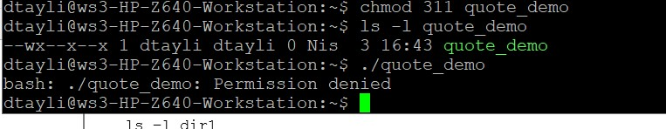

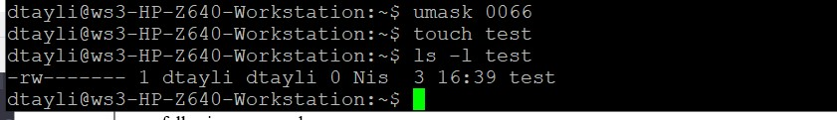

**9.** Since we changed the permissions of the file we are able to read the details of the file.

**10.**

dtayli pts/41 2023-04-03 16:09 (5.27.21.0)

**11.**

ls: cannot open directory dir1: Permission denied

In the permissions, we do not have permission to read. That’s why we cannot see the details of the file.

**12.**

d--x------ 2 dtayli dtayli 4096 Nis 3 17:02 dir1

We are able to see the permissions since we included -d option. With d option, we can see the permission and information of the file unlike the previous (ls -l) command.

**13.**

ls -l dir1 gives output “total 0” & ls -ld dir1 gives output “dr-x------ 2 dtayli dtayli 4096 Nis 3 17:02 dir1”

In the first command we are able to see/ display the content of the file. For the second command we are able to see the permissions and other relevant information about the file.

14.

-rw------- 1 dtayli dtayli 0 Nis 3 17:20 dir1/notes

We are able to see the details of the file since we have permission to read.

15.

chmod 100 dir1

echo "1" > dir1/notes 🡪 worked

cat dir1/notes 🡪 worked

cd dir1 🡪 did not work since we do not have permission to see the details of the directory.

touch notese2 🡪 worked but it is in the home directory

16.

dtayli

18.

The output will be different than question 17. It will repeat last history list item starting with uniq

19.

The output will be different than question 17. It will Repeat last history list item containing uniq

20. press Ctrl – r and type the search value. Then you will be able to see the most recent occurrence with arrows.