**AGU COMPUTER ENGINEERING**

**CAPSTONE PROJECT**

**FINAL REPORT**

**by**

**Dilek Taylı**

**110510228**

**21/01/2024**

**SUMMARY**

This capstone project is accepted within the scope of TÜBİTAK 2209-A University Students Research Projects Support Program (2023 - 1st Term Application). The focus of the project is on the actions that take place after emergencies occur in an autonomous vehicle. Although there are various studies on detecting an emergency (heart attack, seizure, etc.) in the driver, there is not enough research on the actions to be taken after detection. For this reason, in the project, communication modules and emergency decision-making in autonomous cars are developed to protect people's health. In the context of communication modules, Vehicle to Infrastructure (V2I) communication is one of the used forms. Road Side Units (RSU) are main infrastructure for the communication. Dedicated Short Range Communication is used in RSU to provide the communication between vehicles.

1. **INTRODUCTION**

Autonomous vehicles are equipped with sophisticated sensors and intelligent algorithms, can change the way commute by offering increased efficiency, security, safety, and convenience. In recent years, the landscape of transportation has undergone a huge change with accelerated integration of autonomous vehicles into our daily lives. This change holds the promise of not only revolutionizing our commuting experience, but also signaling a future characterized by enhanced safety and efficiency on the roads. The consistent march of innovation in the automotive industry has guided in an era where vehicles are equipped with capability to navigate, make decisions, and adapt to dynamic traffic conditions.

Considering the timeline for autonomous vehicles, the first configuration was carried out in Japan in 1977, when 32.2 km/h was the speed of vehicle which is done by following white stripes on the street. A team at Munich Bundeswehr University managed to accelerate an autonomous vehicle to 97 km/h in a traffic-free environment in the 1980s. Another development that should be taken into consideration is that 1997, more than 20 autonomous cars drove on the California road without an accident [2]. These studies were a starting point for a new transportation era. In recent years, there have been more developments in perception like environment sensing with automotive radar, LIDAR, camera (Image Sensor), Ultrasonic sensors [1].

By 2025, almost 8 million autonomous or semi-autonomous cars are expected to be on the road [5]. For merging onto roads, there is a 6 levels of driving automation advancement to progress. The Society of Automotive Engineers (SAE) proposed automation levels where 0 stands for fully manual and 5 stands for fully autonomous [6].

metin, ekran görüntüsü içeren bir resim

Açıklama otomatik olarak oluşturuldu

Figure – Automation Levels

As it is shown in the picture above, in the Level 0 the control of the vehicle is fully done by driver, where Level 1 & Level 2 have partial automation driving features. Other levels are:

Level 3: Even though it is mandatory to have a drive, there is no need to constantly monitor but still the driver must be prepared for warnings from the vehicle.

Level 4: This level is high automation where all driving functions can be done by the vehicle under specific circumstances.

Level 5: This is a full automation. The vehicle is successful under all circumstances. Additionally, if the driver wants to take control, it is possible at any time [7].

Although autonomous vehicles are developing continuously in terms of making driving experiences easier, action must be taken if the driver experiences health problems. In hybrid driving situations, the autonomous driving mode will need to take control quickly if the driver becomes ineffective due to a sudden health problem. By providing this procedure, by monitoring the driver’s condition and activating autonomous driving when an emergency case is detected, the autonomous vehicle will be able to communicate to other vehicles or vehicle with emergency case will pull to the side of the road and deliver to the nearest healthcare institution. In tis way, the driver’s life can be saved.

1. **RELATED WORK**

In the scope of the project, heart attack is considered as emergency case since heart attack is one of the important medical conditions in drivers’ profile [8].

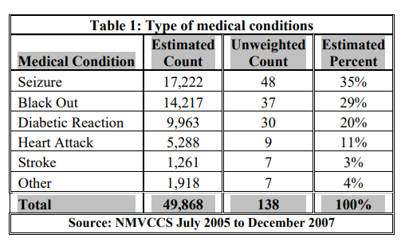

Figure - Drivers' Type of Medical Conditions

For detection of this emergency case, there are several ways that can be used. One of them is using video cameras. Similarly, in 2012 Kalitzin et. al. used 72 different videos of 50 people in their study to detect heart attack [9]. Additionally, a wearable device can be preferred too. Chowdhury et. al. showed that the driver’s heart attack detection reached a successful prediction rate of over 96%, thanks to the watch-style device [10]. Overall, these studies showed that heart attack detection can be done with various ways but still there is need for afterwards.

In case of emergency detection, the vehicle needs to communicate with others to cooperate. There are several ways to inform vehicles by using communication types such as Vehicle to Vehicle (V2V), Vehicle to Network (V2N), Vehicle to Infrastructure (V2I) etc.

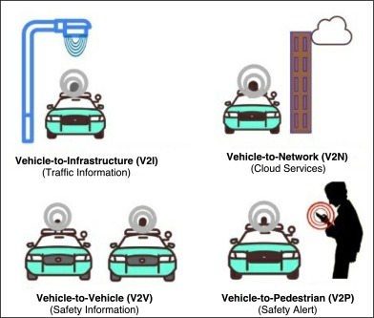

Figure - Communication Types [11]

Vehicle to Infrastructure (V2I): a communication type that involves communication between vehicles and different infrastructure elements (road signs, traffic lights, roadside units, and more) to improve traffic flow, efficiency, and safety.

Vehicle to Network (V2N): involves communication between vehicles and communication network infrastructures. Vehicles exchange information like traffic condition or relevant updates with the network.

Vehicle to Vehicles (V2V): communication between vehicles to cooperate with each other to enhance safety.

Vehicle to Pedestrian (V2P): communication between vehicles and pedestrians involving alerts and information to increase pedestrian safety in traffic.

Intelligent Transportation System (ITS) is one of the directions has Internet of Things has led to. It is for management of traffic and providing safety. Vehicle to Vehicle communication is crucial for achieving a successful Intelligent Transportation System by reducing the frequency of collisions between vehicles and the infrastructure access points on roads. V2V communication would be quite important where not enough Roadside Units are not placed [12].

To decide whether a communication type would be sufficient for the project the drawbacks and advantages were considered. In 2021, Osman et. al. prepared a novel approach to enhance both traffic efficiency and safety. This technique relies on V2V communication to establish a clear route for emergency vehicles. During this process, firstly the closest vehicles are identified for communication, then it was facilitated the swift clearance of the road lane to ensure emergency vehicles reach to destination in minimum time [3].

Another study showed that combining V2V and V2I might be quite powerful in terms of enhancement of Quality-of-Service (QoS) in vehicular networks with high mobility, a collaborative communication strategy [4]. The strategy integrates both V2V and V2I approaches, effectively boosting system reliability and efficiency according to environmental conditions. This is accomplished through the adaptive selection of communication schemes.

1. **SYSTEM MODEL** 
   1. **Simulation Model**

In the simulation, Vehicle to Infrastructure communication is implemented when the vehicle had an accident. This accident indicates that the driver in the autonomous car had a heart attack and chose to inform other vehicles using Roadside Units that were close. In the following figure shows the network design of the project. There are 2 roadside units, connection manager, obstacles, and vehicles aka nodes. The communication will be starting when the heart attack detection happens.

metin, ekran görüntüsü, yazı tipi, yazılım içeren bir resim

Açıklama otomatik olarak oluşturuldu

Figure - System Model

* 1. **Real Life Example**

With help of different tools, real life maps can be turned into a map that can be used in network simulation. Firstly, we need to find the area we want to work on openstreetmap, then download it. Lastly, convert it to an “osm” file by following steps assuming downtown.osm is the file we downloaded:

1. netconvert --osm-files downtown.osm --output-file downtown.net.xml --geometry.remove --roundabouts.guess --junctions.join --tls.guess-signals --tls.discard-simple --tls.join
2. python randomTrips.py -n downtown.net.xml -e 1000 -o downtown.trips.xml

(don’t forget to add the this randomTrips.py file in the maps’ folder. You can find it under C:\Program Files (x86)\Eclipse\Sumo\tools )

1. duarouter -n downtown.net.xml --route-files downtown.trips.xml -o downtown.rou.xml -- ignore-errors
2. downtown.sumo.cfg file must be prepared

<?xml version="1.0" encoding="UTF-8"?>

<configuration xmlns:xsi="http://www.w3.org/2001/XMLSchema-instance" xsi:noNamespaceSchemaLocation="http://sumo.dlr.de/xsd/sumoConfiguration.xsd">

    <input>

        <net-file value="downtown.net.xml"/>

        <route-files value="downtown.rou.xml"/>

    </input>

    <time>

        <begin value="0"/>

        <end value="1000"/>

    </time>

</configuration>

Even though, the map of “Kayseri Cumhuriyet Meydanı” was not suitable to work in the simulation area. Here is the output of this process:

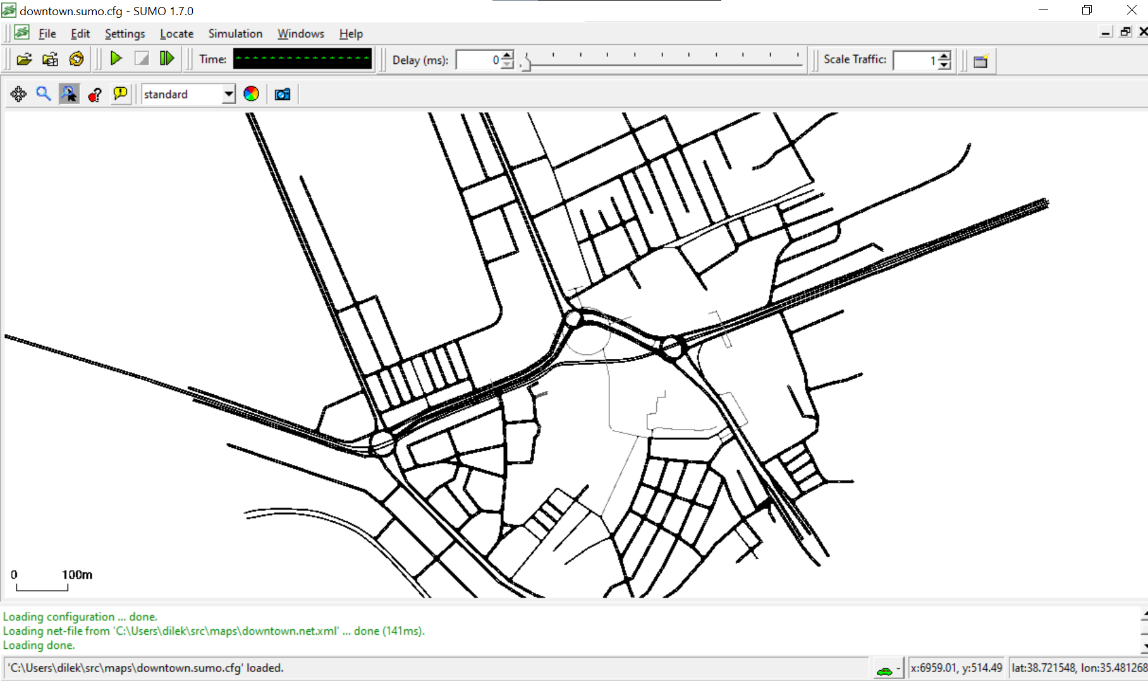

Figure - Kayseri Cumhuriyet Meydanı

1. **PROPOSED SOLUTION APPROACHES**

In this section, the proposed solution will be discussed using the demonstration pictures of the project. Firstly, process will be shown.

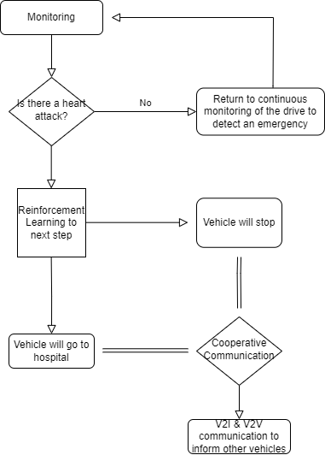



Figure - Work Flow

In the TUBITAK 2209-A project, this is the overall design flow. The autonomous car will have a continuous monitoring to check whether the driver is having a heart attack. After detection of heart attack, reinforcement learning will be used to decide whether vehicle will stop or vehicle will go to a hospital. In both cases cooperative communication will be used to inform other vehicles to provide safety in traffic.

In the scope of this capstone project, only communication part is completed. So, Vehicle to Infrastructure (V2I) communication will be shown how it was implemented. In the demonstration picture, only when the car/node stops, the car will send a message to roadside units. After this message sent, roadside unit will be sending the emergency message to other vehicles that are on the same route as the vehicle with emergency. Additionally, Vehicle to Vehicle communication is added to this demonstration since V2V communication can be preferable in rural areas where roadside unit integration is not enough or expensive. (This demonstration is simulated in city environment.)

metin, harita, diyagram, plan içeren bir resim

Açıklama otomatik olarak oluşturuldu

Figure - Demonstration

In Vehicle to Infrastructure communication, the IEE 802.11p (WAVE – Wireless Access in Vehicular Envirroments) protocol is used. This protocol is designed to meet the challenges of high-mobility environments, providing short-range, low-latency communication suitable for applications such as collision avoidance and cooperative adaptive cruise control. 5.9GHz frequency band operates on this protocol. Dedicated Short Range Communication is one of the schemes this protocol is integrated in. DSRC is a communication standard that enables short to medium range communication between vehicles and infrastructure. It is widely used for applications like collision avoidance, cooperative cruise control, and other safety-critical communication scenarios.

In the demonstration, the first emergency case will be happening in the 70th second, and the second one will be starting at 110th second. These emergency cases were chosen randomly to show the network simulation. All these implementations were declared in the initialization file (omnetpp.ini). The mobility of the vehicles/nodes are from TraCI scenario manager from Veins.

1. **PERFORMANCE EVALUATIONS** 
   1. **Performance Evaluation**

In performance evaluation, the requirements of the capstone project were satisfied since the communication was established between the vehicles and roadside units with the vehicle with an emergency. The car was able to notify the others afterwards. Technical competence might have been better in terms of testing different communication protocols like cellular network. Additionally, real life scenarios were left to be tested due to fit the timeline and complexity of simulation tools.

* 1. **Development Tools**
     1. **Omnet++ (5.6.2):** Objective Modular Network Testbed in C++ an extensible, modular, component-based simulation framework primarily designed for building network simulations. It is widely used for research and development in the field of networks and communication systems.

grafik, ekran görüntüsü, grafik tasarım, renklilik içeren bir resim

Açıklama otomatik olarak oluşturuldu

Figure - Omnet++

* + 1. **Sumo (1.7.0):** Simulation of Urban Mobility is a traffic simulation software that allows users to model and simulate road traffic in urban areas. It provides a platform for evaluating and testing various traffic management strategies and intelligent transportation systems (ITS).

**yazı tipi, logo, grafik, simge, sembol içeren bir resim

Açıklama otomatik olarak oluşturuldu**

Figure - SUMO

* + 1. **Veins (5.0):** Vehicles in Network Simulation is a framework for vehicular network simulations that integrates with OMNeT++. It allows researchers to model and simulate communication protocols for vehicular ad-hoc networks (VANETs) within the OMNET++ simulation environment.

yazı tipi, logo, grafik, tasarım içeren bir resim

Açıklama otomatik olarak oluşturuldu

Figure - Veins

* + 1. **Inet4:** The INET framework is a library for OMNET++ that provides a comprehensive collection of pre-built models for various networking protocols. It simplifies the process of building network simulations within the OMNET++ environment.
    2. **Open Street Map:** OSM is a collaborative mapping platform that provides freely accessible and editable geographic data. It is often used in conjunction with simulation tools like SUMO to create realistic urban environment for traffic simulations.

el aynası, metin içeren bir resim

Açıklama otomatik olarak oluşturuldu

Figure - OSM

* + 1. **Java OpenStreet Map Editor**: JSOM is an editor for OpenStreetMap data. It allows users to view, edit, and create geographic data on OpenStreetMap. It can be used to customize and enhance maps for simulations involving OpenStreetMap data.

ofis malzemesi, yazı aleti, kalıcı, sabit, kırtasiye, çocukların yaptığı resimler içeren bir resim

Açıklama otomatik olarak oluşturuldu

Figure - JSOM

(Following tutorial link can be used for downloading process [13]. Additionally, instead of downloading all the network simulation tools separately, a virtual machine can be used.)

1. **CONCLUSIONS**

The TUBITAK 2209-A University Students Research Project focuses on post-emergency actions in autonomous vehicles while addressing the lack of studies on the afterwards for emergency detection on the driver. The suggested project aimed to implement communication modules and emergency decision-making for autonomous cars to protect drivers that may suffer from a heart attack. Roadside Units (RSUs) were utilized for Vehicle to Infrastructure communication to enhance the safety and efficiency in traffic flow. To simulate this communication, Omnet++, SUMO, Veins, and INET framework were used. This approach might be successful in areas that roadside unit implementation is easy and affordable however for rural areas V2I communication might not be effective. Additionally, there is a need for a study how to decide which communication type would be more effective.

1. **REFERENCES**
2. Z. Liu, H. Jiang, H. Tan, and F. Zhao, “An overview of the latest progress and core challenge of autonomous vehicle technologies,” *MATEC Web of Conferences*, vol. 308, p. 06002, Jan. 2020, doi: 10.1051/matecconf/202030806002.
3. J. Anderson, "Autonomous Vehicle Technology", RAND, vol.3, pp. 8. 2007
4. R. A. Osman, A. I. Zaki, and A. K. Abdelsalam, “Novel Road Traffic Management Strategy for rapid clarification of the emergency vehicle route based on V2V communications,” *Sensors*, vol. 21, no. 15, p. 5120, Jul. 2021, doi: 10.3390/s21155120.
5. R. A. Osman, X. Peng, and M. Omar, “Adaptive cooperative communications for enhancing QoS in vehicular networks,” *Physical Communication*, vol. 34, pp. 285–294, Jun. 2019, doi: 10.1016/j.phycom.2018.08.008.
6. “ABI Research Forecasts 8 Million Vehicles to Ship with SAE Level 3, 4 and 5 Autonomous Technology in 2025.” https://www.abiresearch.com/press/abi-research-forecasts-8-million-vehicles-ship-sae-level-3-4-and-5-autonomous-technology-2025/
7. P. Talwar, “AUTONOMOUS VEHICLE SAFETY OVERVIEW,” *International Research Journal of Modernization in Engineering Technology and Science*, 2021, [Online]. Available: https://www.researchgate.net/publication/351824746_AUTONOMOUS_VEHICLE_SAFETY_OVERVIEW
8. “The 6 levels of vehicle autonomy explained | Synopsys Automotive.” https://www.synopsys.com/automotive/autonomous-driving-levels.html
9. “The Contribution of Medical Conditions to Passenger Vehicle Crashes,” *National Highway Traffic Safety Administration*, Nov. 2009, [Online]. Available: https://crashstats.nhtsa.dot.gov/Api/Public/ViewPublication/811219
10. S. Kalitzin, G. Petkov, D. N. Velis, B. Vledder, and F. L. Da Silva, “Automatic segmentation of episodes containing epileptic clonic seizures in video sequences,” *IEEE Transactions on Biomedical Engineering*, vol. 59, no. 12, pp. 3379–3385, Dec. 2012, doi: 10.1109/tbme.2012.2215609.
11. M. E. H. Chowdhury *et al.*, “Wearable Real-Time heart Attack detection and Warning System to reduce road accidents,” *Sensors*, vol. 19, no. 12, p. 2780, Jun. 2019, doi: 10.3390/s19122780.
12. P. K. Singh, S. Nandi, and S. Nandi, “A tutorial survey on vehicular communication state of the art, and future research directions,” *Vehicular Communications*, vol. 18, p. 100164, Aug. 2019, doi: 10.1016/j.vehcom.2019.100164.
13. M. Zorkany, A. Yasser, and A. I. A. Galal, “Vehicle to vehicle ‘V2V’ communication: scope, importance, challenges, research directions and future,” *The Open Transportation Journal*, vol. 14, no. 1, pp. 86–98, Jun. 2020, doi: 10.2174/1874447802014010086.
14. Dr. Joanne Skiles, “Introduction to VANETs,” *YouTube*. May 20, 2020. [Online]. Available: https://www.youtube.com/watch?v=tCs-K9AkDrQ
15. **APPENDIX**

Turnitin report should stand here.