PAKETLEME ASAGIDAKI GIBI OLALACAKTIR. ANCAK LIFTING HOOKS KOYULMAYACAK
( ARALARA SIKISIYOR VE MALA ZARAR VERIYOR) MALLAR KESINLIKLE EKTEKI SEKILDE 150X150MM DUNNAGE KULLANILARAK ISTIF EDILMELIDIR. AKSI TAKDIRDE MUSTERI MALLARI BOSALTMAYI REFUSE EDECEKTİR.

++++
In secure bundles of MAX 2.5 mt. Packing to be suitable for export.Bundles for 12 meters to be tied at 7 points and to have 3 lifting hooks that are made by 8mm wire rods wrapped around the bundle twice.
Bundles for 14,15,16,18meters tobe tied at 8 points and to have 3 lifting hooks that are made by 8mm wire rods wrapped around the bundle twice.
+++++


Total Ship Services
How rebar should be loaded into a vessel

Gaps
Bundles are to be gapped very 4 bundles all of the same size. If 4 bundles of the same size cannot be loaded then they should be gapped only in the same size and not made up to 4.
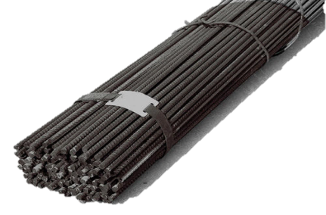




Timbers to be used
Timbers should be 2.25 M long and 12 cm wide x 12 cm deep when placed underneath rebar.
2.25 M
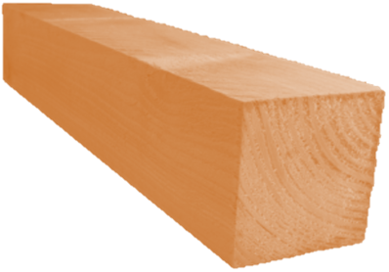
12 cm
12 cm

Timbers should be 0.5 m long and 12 cm wide x 12 cm deep when placed inbetween rebar.
12 cm
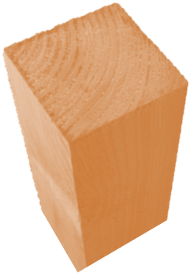
12 cm

0.50 M

Positioning of Timbers
Timbers must be placed in the same position down the whole stack when the lengths are the same. (Side view)

Timbers should over lap slightly to ensure there are no gaps. (Top view)

A minimum of 4 timbers should be used on 6 meter rebar, 6 on 12–15 meter rebar and 7 on 15–18 meter rebar. Timbers should be evenly spaced across the length of the bundle. Two timbers are required closer together towards the lifting points of the bundle to allow a strop to pass under easily. (Side view)


The smaller timbers should be placed inbetween the bundles facing up to ensure the gaps are maintained during voyage. Three small timbers should be used per gap and spread evenly along the gap. (Top view) & (End view)

Loading
Bundles must be laid straight and not be over lapping (Top view)

Rebar must be loaded by size; first by length (longest first) then by thickness (thickest first). (Side view)

Sufficient gaps must be left between stacks (Side view)

Ties
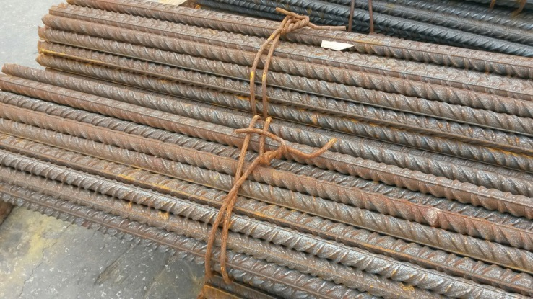
Bundles must have steel wire ties that have been wrapped around the bundle at least twice. Ties must be tight to the bundle and well spaced to ensure the bundle is not loose in any areas. No additional lifting ties should be on the bundle.

