SETTING UP MOBILE
PREREQUISITES:
- Expo Go (Available in Playstore and Appstore)

NOTE: For the mobile project to work, both computer and the mobile device should be connected over the same network.

PROJECT SETUP:
- Open xampp, start Apache and MySQL
  - If applicable, perform php artisan migrate
- Run the command php artisan serve --host=0.0.0.0 --port=8000.
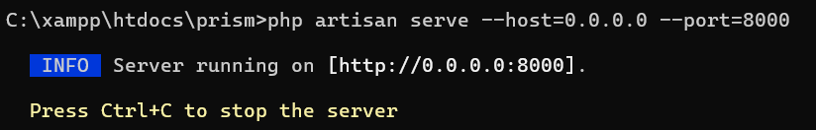
Note: You may continue using http://127.0.0.1:8000/login for the web application. This command is only required to allow the mobile application to access the shared API.

- In another terminal, run npm run dev
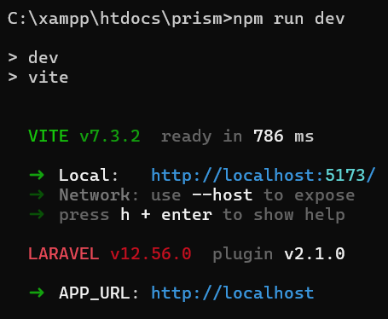

- In another terminal, change the directory to the `mobile` folder. Then run the command “npx expo start”
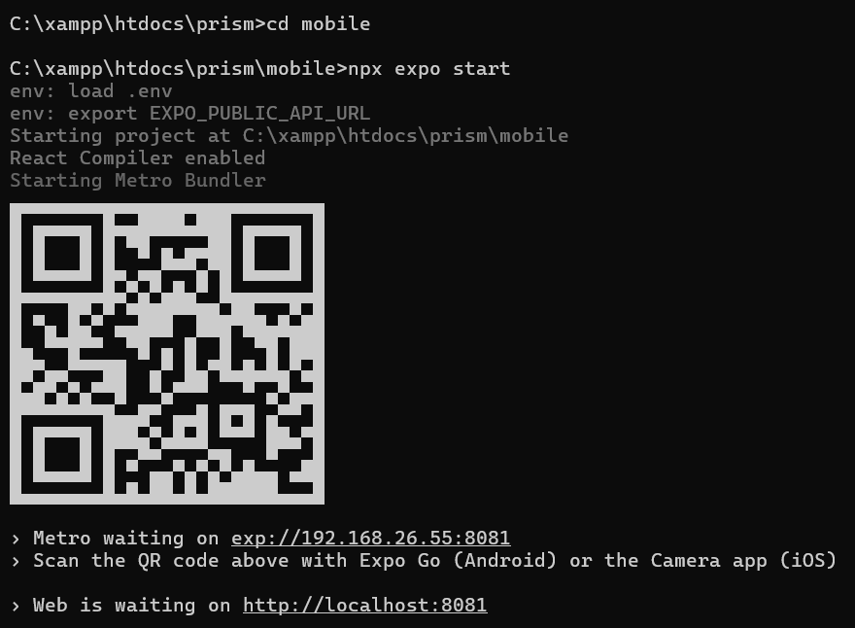

- Open the Expo Go app, scan the QR code within the terminal.

