**Organizer - Team “Grapefruit”**

**JavaScript Applications Teamwork**

**Team Members:**

[Velidar Petrov](http://telerikacademy.com/Users/Velidar)

[Iliq Nikushev](http://telerikacademy.com/Users/VaderTheOne)

[Borislav Borisov](http://telerikacademy.com/Users/borislav.borisov.tues)

[Dimitar Dimitrov](http://telerikacademy.com/Users/d_iliev_d)

[Kiril Tanushev](http://telerikacademy.com/Users/kiril.tanushev)

**Project Purpose:**

Single user organizer with possibilities to add tasks, events, anniversaries (and store them in different lists) and view location in Google maps.

**Diagram:**

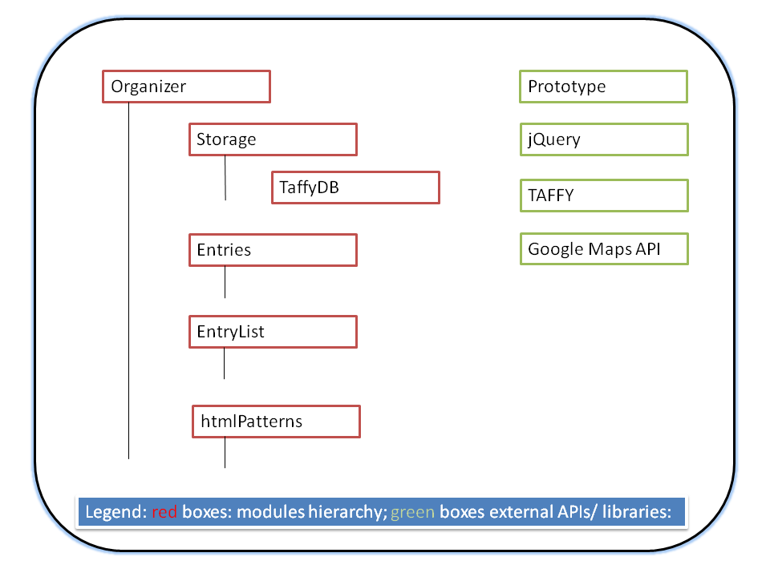

**Repository:**

<https://code.google.com/p/js-apps-project-team-grapefruit/>

[Commit logs](https://code.google.com/p/js-apps-project-team-grapefruit/source/list)