

Sri Lanka Institute of Information Technology

[**Enterprise Standards and Best Practices for IT Infrastructure**](http://courseweb.sliit.lk/course/view.php?id=137)

**LAB 02**

**Creating Amazon RDS Database**

**IT 130 699 64**

**Subhani K.G.D.**

**Weekday IT**

**28th July 2016**

**Amazon RDS Database Instance.**

In this capture it is going to describe how to create Amazon Relational Database Services (RDS) using amazon web services.

**Step 1: Launch a DB instance**

* First of all to create the DB instance go to database section in home page and select RDS.

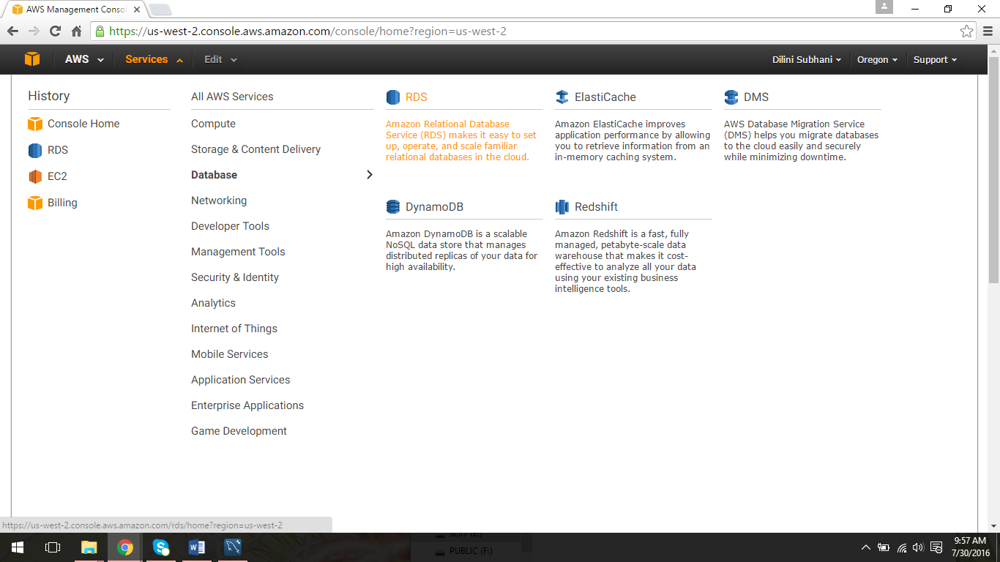

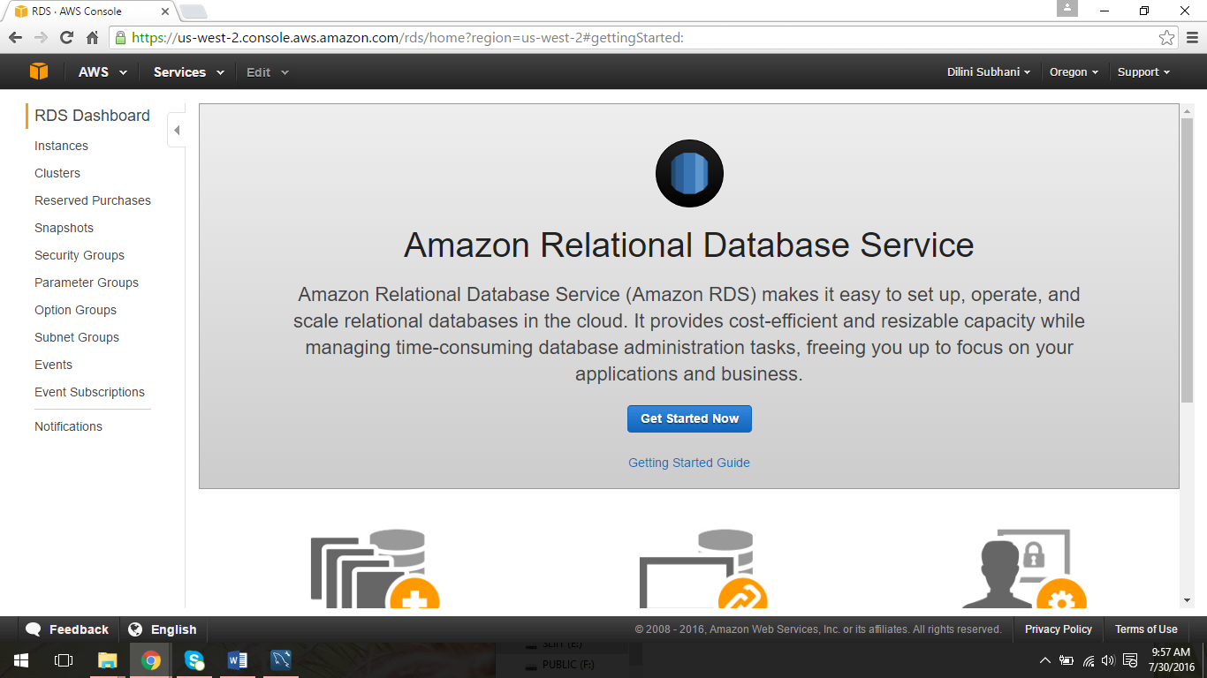

* Select any database type whatever you like. Here MySql is going to use as an example.

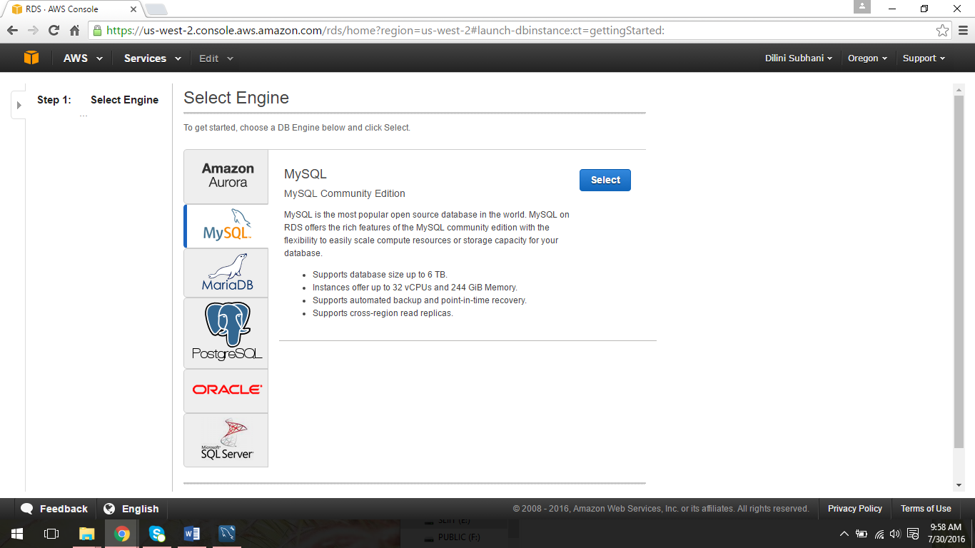

* After selecting the engine have select a database aording to the production purpose.

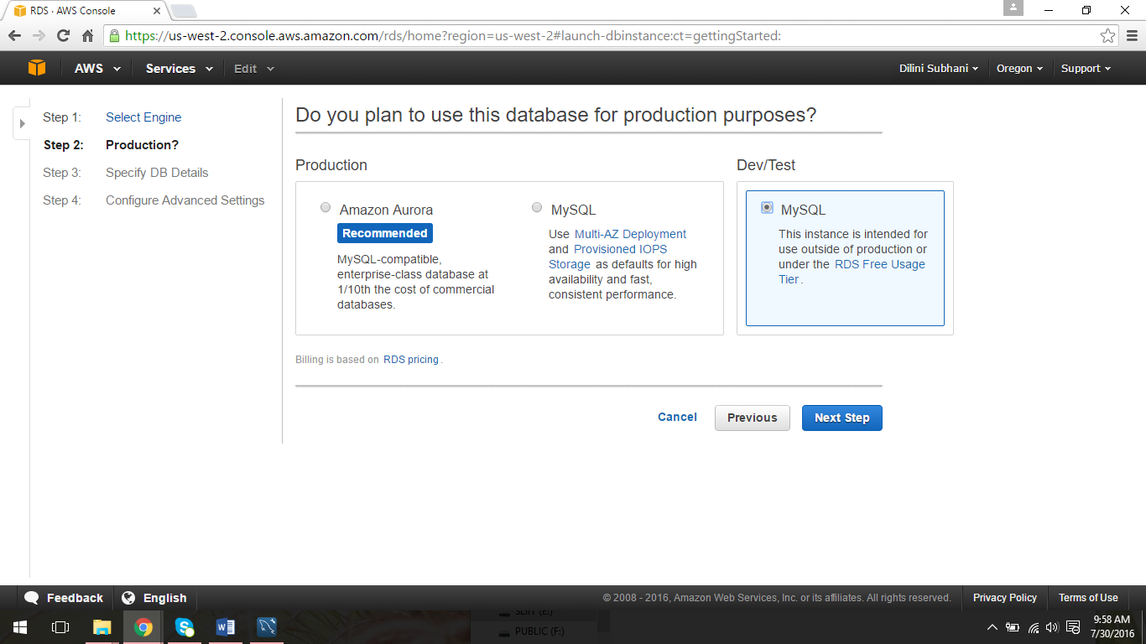

* Here I’m going to select MySql RDS Free Usage Tier. Then click “Next Step” button.



* Specify the DB details. According to the purpose can select any DB instance class , can allocate any storage type and storage size. The important part here is to create name for “DB instance identifer” , give a username for “Master Username” and generate passwrod for “Master Password” options. And also it is very vital to remember this password and the DB instance name to connect your workbench with instance.

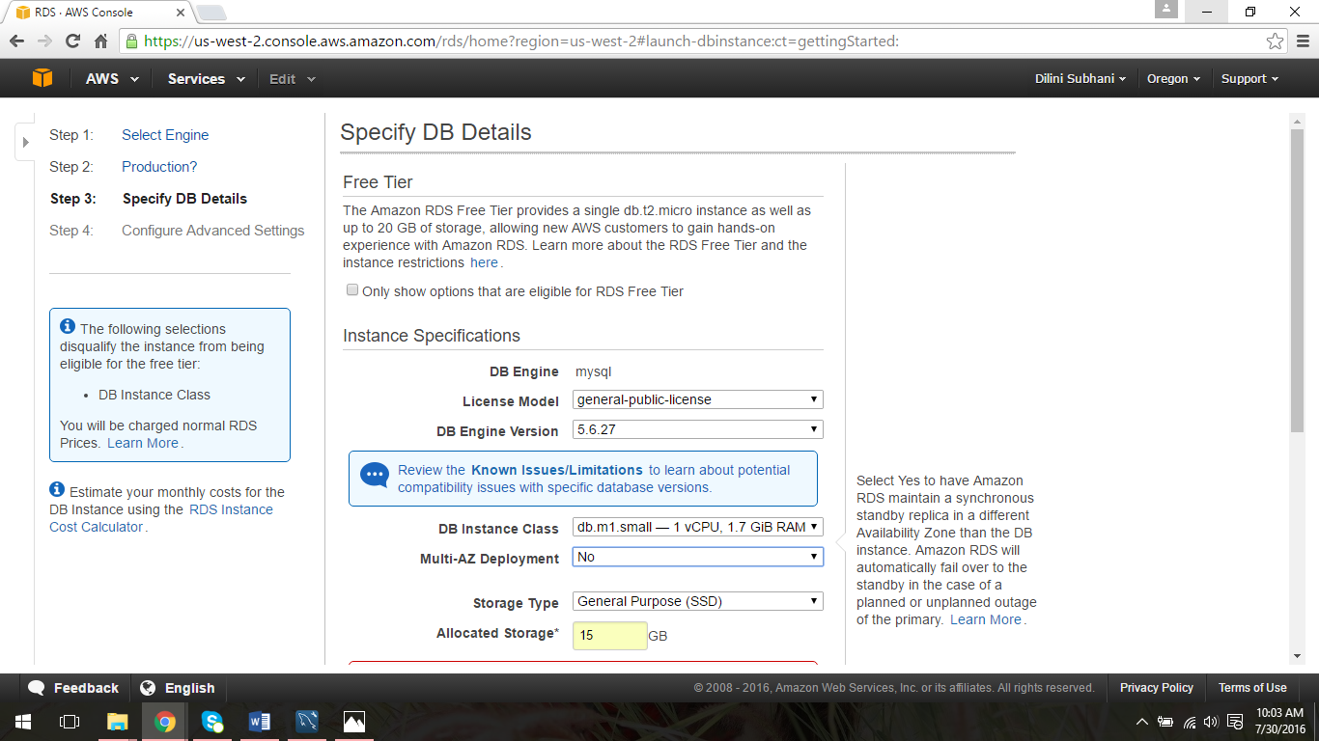

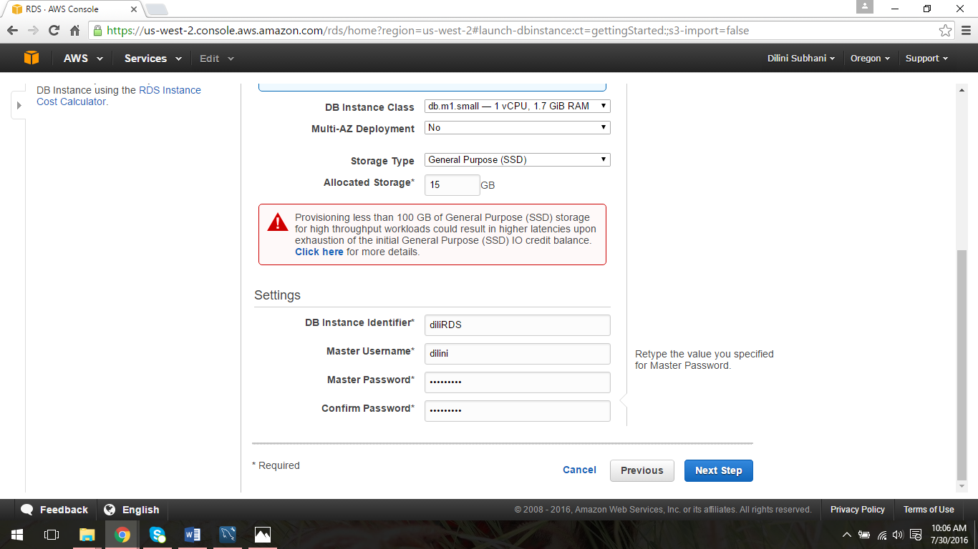

* Configure the advanced Settings. Give any name to the database and keep other information as default.

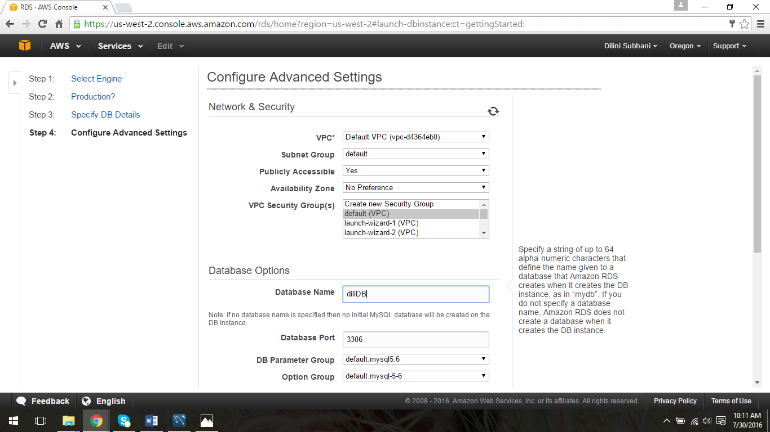

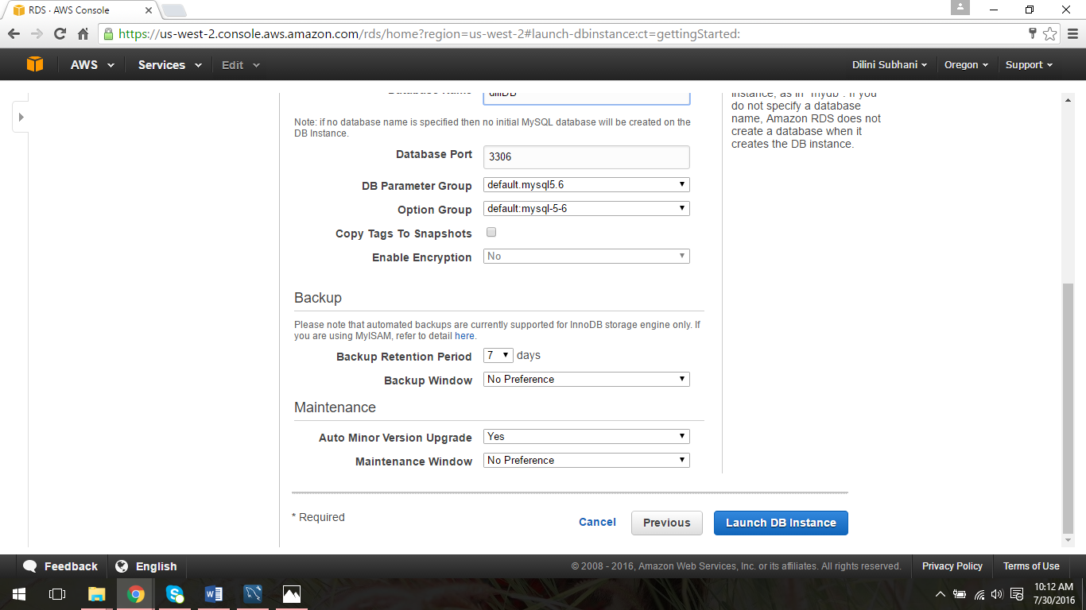

* Launch DB instance.

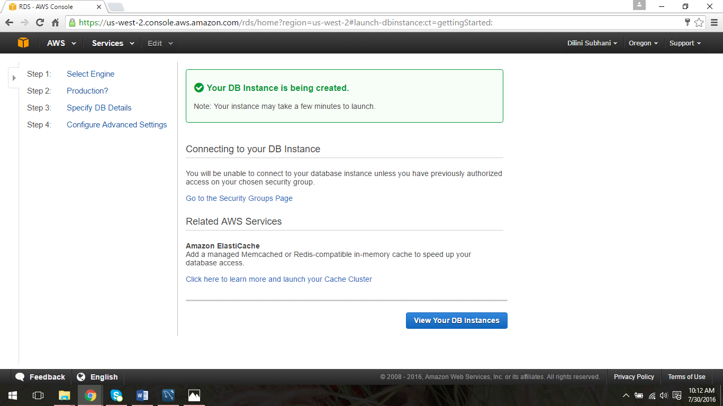

* View the details of the instance.

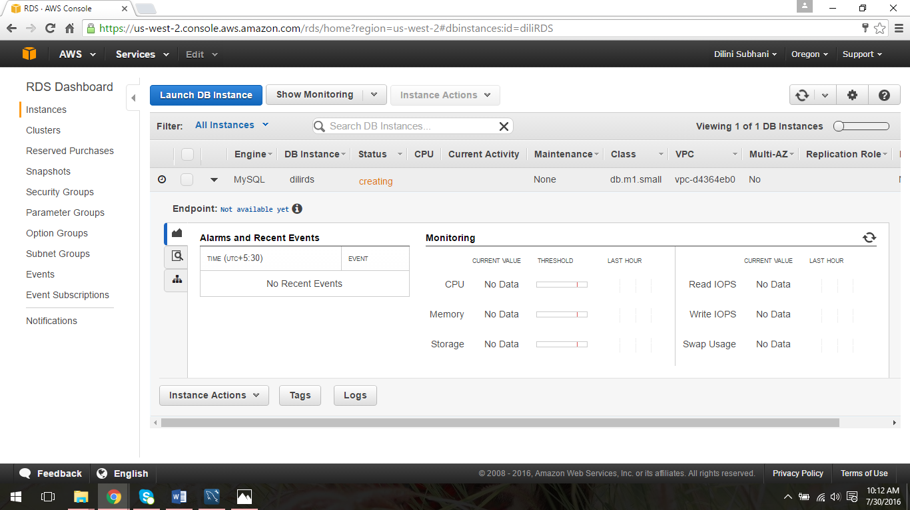

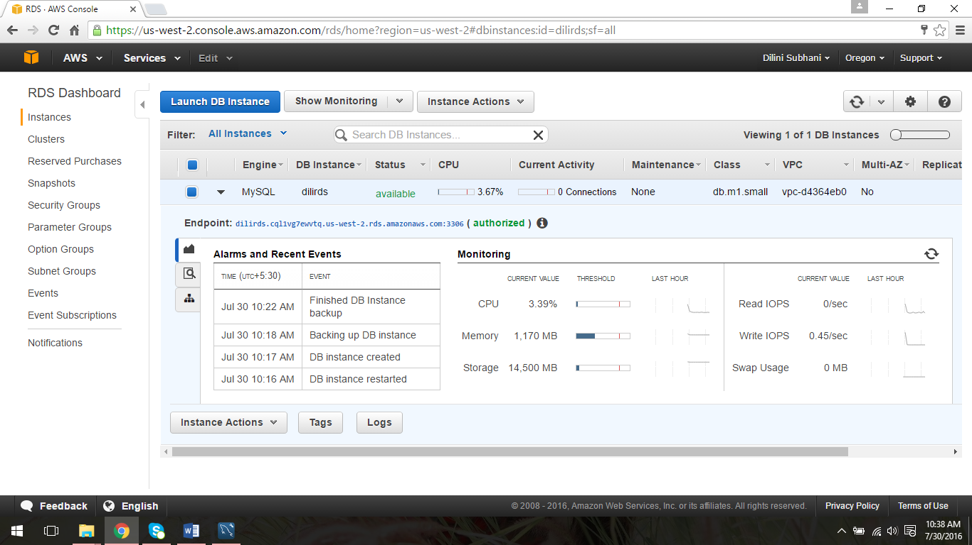

**Step 2: Connect to the DB Instance.**

* Open up MySQL Workbench.

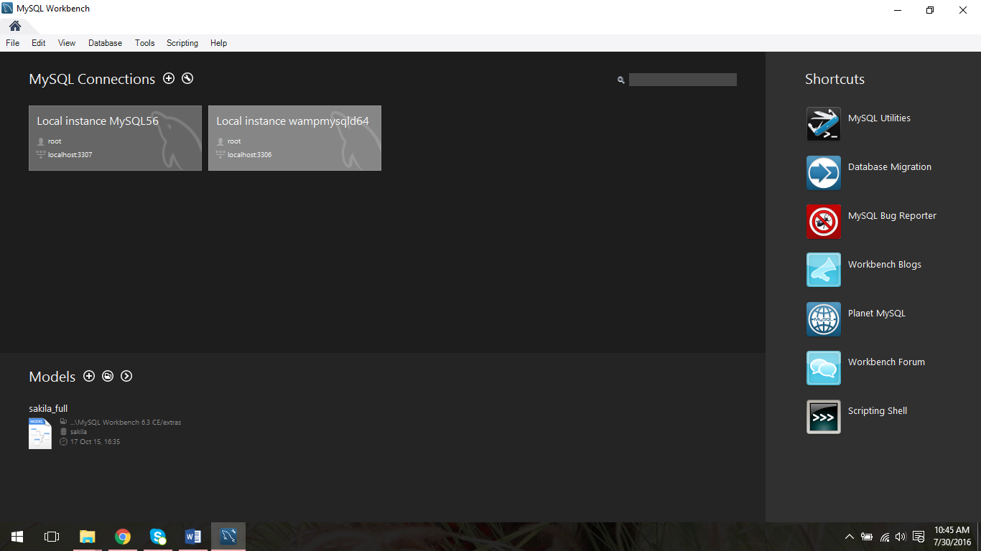

* Go to Database option and setup an new connection. Give DB name as the connection name and give Master Username as the username here. Then select Store in Vault option.

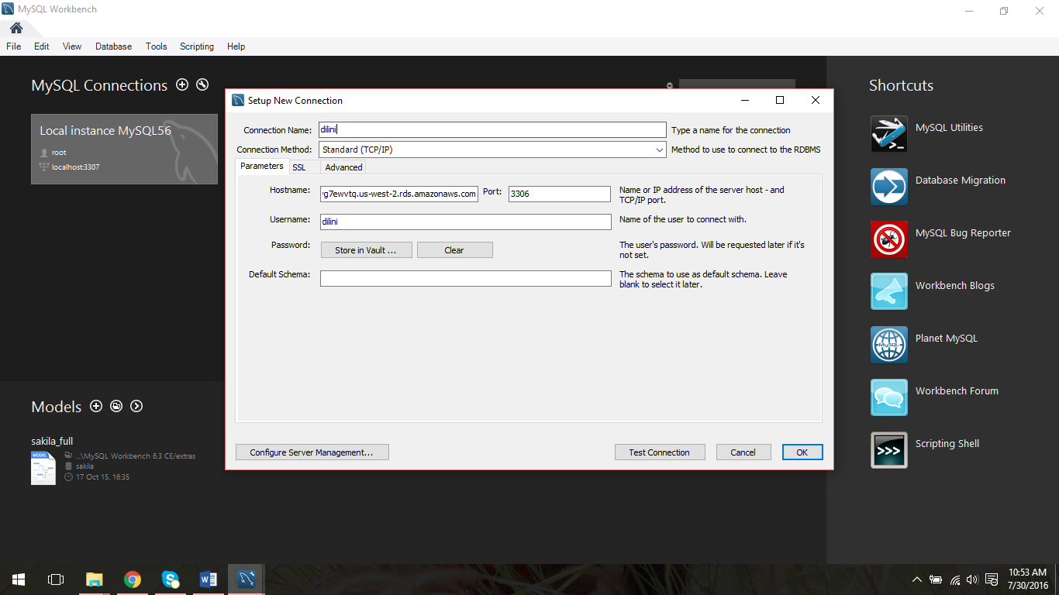

* Type the password which you gave when specifying the DB details. Press OK to continue.

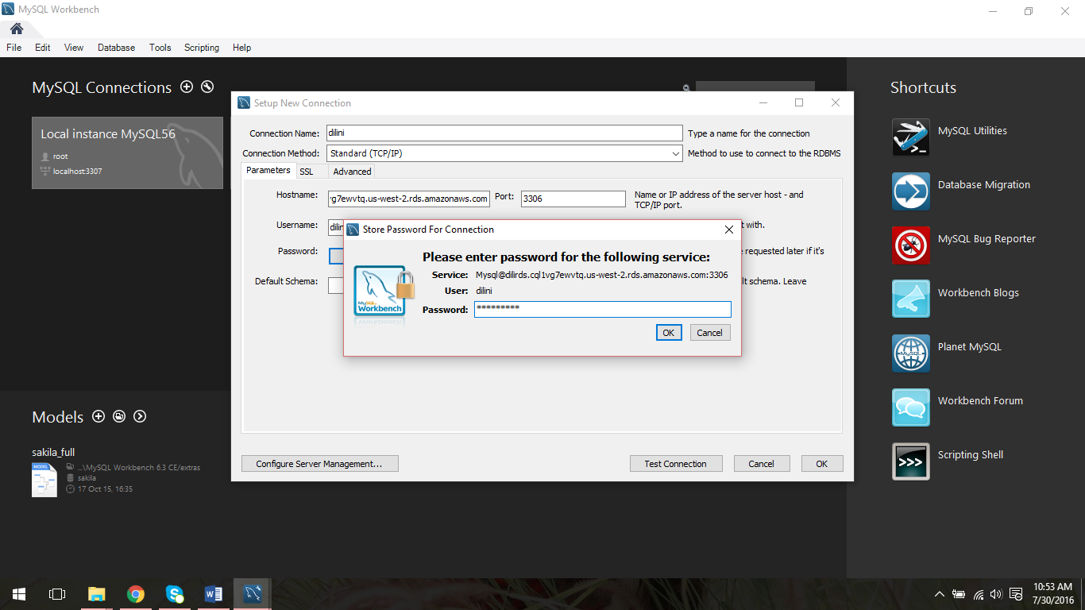

* Finally connection is appear in the console.

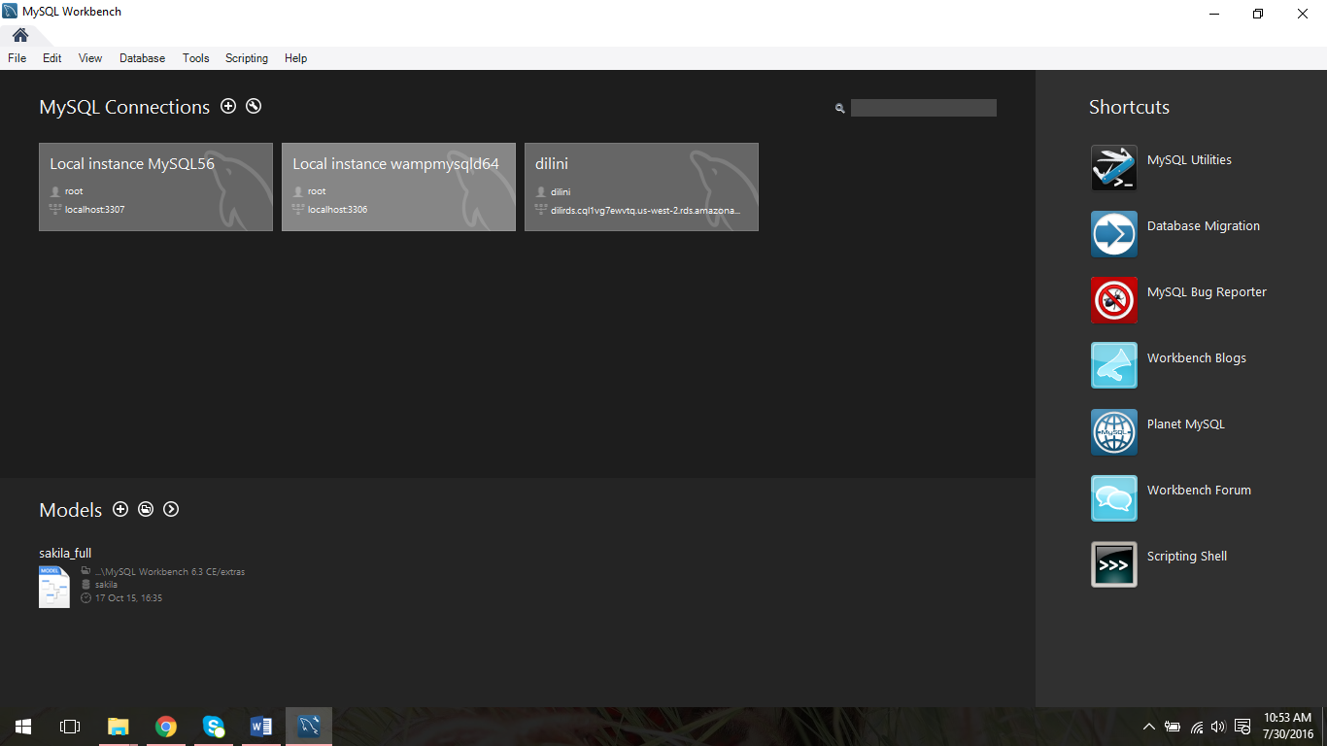

**Step 3: Deleting a DB instance**

* In the Instances list, choose the DB instance you wish to delete. Then choose Instance Actions, and then choose Delete from the dropdown menu.

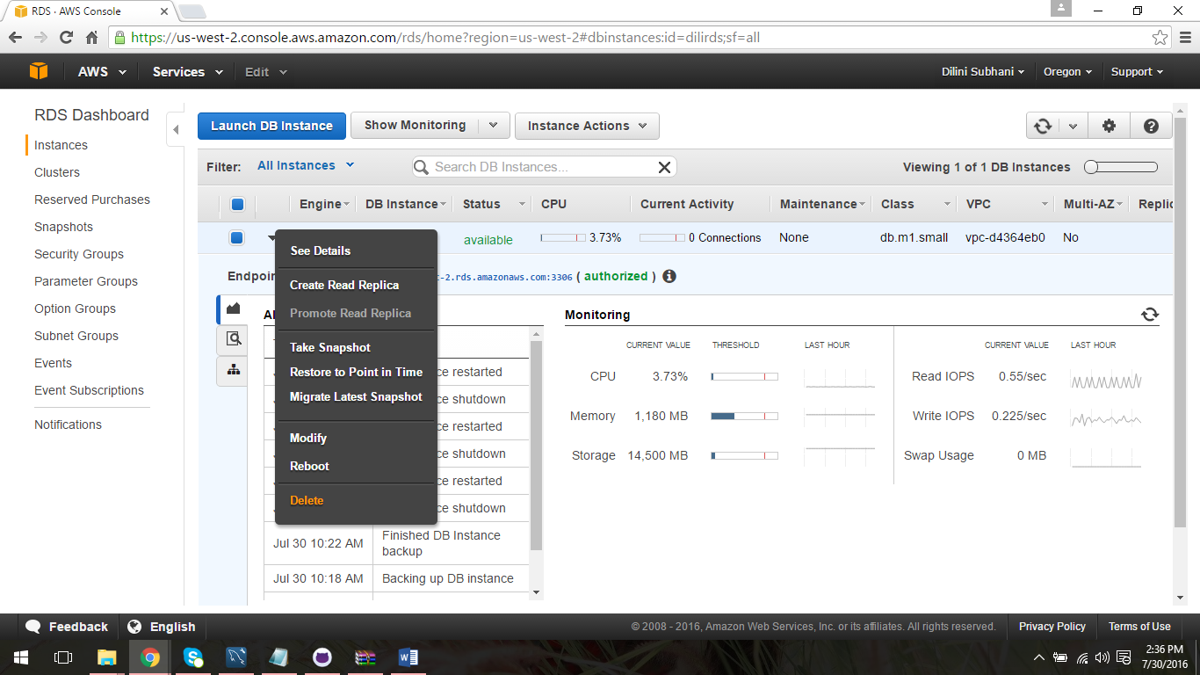

* Choose **No** in the Create final Snapshot drop-down list box and Yes to delete.

