Average Annualized Loss (AAL) calculation
Assuming, we have 96 different events for a model. Each of these 96 events are assigned with their respective probability weights.

Summary of AAL calculation procedure:
- Prepare building footprints data having all the necessary attributes data (e.g.: Occupancy type, No. of stories, Foundation type, etc.). Use National Structure Inventory (NSI) dataset along with Johnson County’s AIMS building footprints dataset.
- Based on different attributes of buildings, assign each building to a Depth Damage Function (DDF) developed by FEMA-HAZUS (Flood Assessment Structure Tool). DDF has damage percentage values for different values of water surface elevation (WSE) as shown in figure.
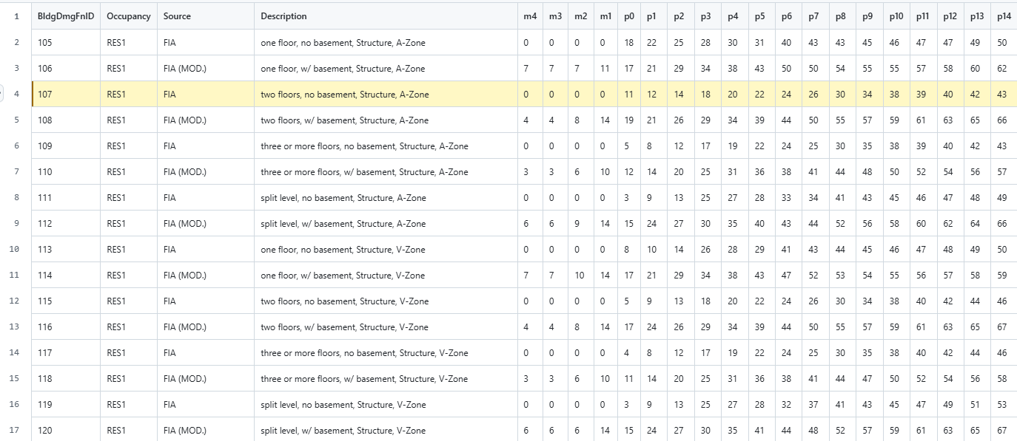
Figure 1: Depth Damage Functions from FEMA

- At each building points, extract the water surface elevation (WSE) values from the WSE raster (exported from HECRAS model).
- The depth of water is then calculated by subtracting ground elevation and first floor height from the WSE.
Depth = WSE – Ground Elevation – First Floor Height
- Using DDF, extract the corresponding damage percentage value for all the depth values by interpolating linearly.
- Step 3 and Step 4 is performed for all events in the HECRAS model.
- Multiply the damage percentage values by probability weights of each event to come up with the overall weighted damage percentage value for each building.
- Use the weighted damage percentage value calculated in Step 5 and building cost to determine loss in US Dollars, which will be our AAL.
- Eventually, AAL values are obtained for all the building points.

