PFRA – Turkey and Brush Creek

Summary of methodology to calculate input data
Precipitation Inputs:
- The precipitation data were derived from NOAA Atlas 14 dataset for 12-hour storm duration for 10 published recurrence intervals (50-, 20-, 10-, 4-, 2-, 1-, 0.5-, 0.2-, 0.1-, 0.05-percent annual-chance events) – The precipitation is basin-averaged and extracted for 3 confidence intervals (10%, median and 90%).
- The mean precipitation is calculated from these data for 10 events
- The calculated mean precipitation is then fitted to a Generalized Extreme Value (GEV) distribution.
- The 11th event is the (0.033-percent-annual-chance event) which is calculated from the fitted GEV distribution.
- The 12th event is determined by integrating the fitted GEV distribution from the 0.033-percent-annual-chance event to the Probable Maximum Precipitation (PMP). This produces mean precipitation data for 12 different events.
- Such obtained precipitation is then combined with NOAA Atlas 14 four quartiles to obtain the hyetographs. Eventually we have a total of (12*4 = 48) differ
- From NOAA Atlas 14, the Quartile and Decile temporal distribution information for the storm duration is obtained. The decile distribution producing the most intense rainfall for each quartile is selected. (10% decile for 1st quartile and 2nd quartile, and 90% decile for 3rd quartile and 4th quartile was utilized).
- The calculated mean precipitation for 12 events is then combined with 4 different NOAA temporal distributions to create rainfall hyetographs. Eventually, a total of (12*4=48) different events are produced.

Infiltration Inputs:
- For each unique Curve Number (CN) present within the watershed, the CN values for wet and dry soil moisture conditions (AMC I and AMC III) are extracted from NRCS.
- These CNs are then fitted into a beta-type distribution and the maximum potential retention (S) values are extracted
- The runoff (Q) is also fitted into a GEV distribution assuming that the maximum runoff is equal to PMP. From the fitted distribution of Q, the values of Q for 12 recurrence intervals are extracted.
- The distribution of “S” conditional on “Q” is calculated using the conditional probability theorems below.
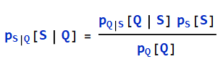
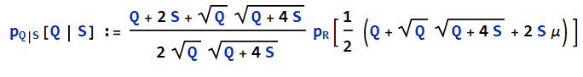
- The values of S for a given value of Q are obtained by portioning the distribution of S into 2 equal partitions of probability (Lower 50% and Upper 50% probabilities). The average value of S is calculated for these two partitions: Average lower 50% S and Average upper 50% S.
- Eventually, we come up with a set of “Average Lower 50% S values” and “Average Upper 50% S values” for each Return Interval. These S values are then converted to CN values using SCS Curve Number equation.
So, we now have 2 sets of infiltration conditions for each event. The 2 sets of infiltration conditions are combined with 48 rainfall hyetographs making a total of (48*2 = 96) different events.

