DATA CLEANING AND PRESENTAION REPORT
Company/Organization: Decode Labs
Course: Data Analytics Industrial Training (Batch 2026)
SUBMITTED By: Dilip
Date Of Submission: 01/06/2026
1. Objective: The main goal of this task was to clean a messy raw dataset to make sure all the information is accurate and reliable. Cleaning the data first ensures that any charts, dashboards, or reports created later are correct and not based on misleading or broken information.
2. Scope: This project focused entirely on cleaning 1,200 records in the Dataset for Data Analytics.xlsx file. The work was limited to three main steps:
- Handling Empty Values: Finding missing data points and filling them in appropriately instead of just deleting rows, keeping the dataset complete.

- Fixing Date Formats: Standardizing all inconsistent dates into one clear format (YYYY-MM-DD) so they sort and filter properly.

- Removing Duplicates: Deleting repeating or double-entered Order IDs so that every transaction is counted exactly once.

- Tools used: Excel

3. Methodology / Step-by-Step Implementation

- Phase 1: Planning & Setup

- Loaded and audited the raw data file (Dataset for Data Analytics.xlsx).

- Inspected the dataset layout to flag missing values, irregular date formats, and suspected duplicate transactions.

- Phase 2: Core Processing

- Strategic Imputation: Scanned all columns for empty or null cells. Instead of performing listwise deletion—which aggressively reduces statistical power and deletes valuable valid data points—missing entries were contextually replaced with appropriate fillers or default indicators to preserve structural integrity.

- Date Formatting: Fixed inconsistent and conflicting date notation styles found within the Date column. All values were standardized into a single, clean uniform format (YYYY-MM-DD) to avoid downstream syntax or sorting errors.

- The Integrity Audit: Evaluated the OrderID column for duplicate records. Enforced the "One Truth, One Record" principle by isolating and eliminating redundant rows, ensuring every line represents a unique transaction.

- Phase 3: Testing & Refinement

- Validated the final row counts against the original metrics to confirm successful deduplication.

- Performed a final quality-gate check to guarantee zero missing values or corrupt data fields remained in the output sheet.

4. Key Features / Outputs Delivered
- Feature 1: Successfully imputed missing data fields, eliminating null gaps without shrinking the data pool.

- Feature 2: Completely standardized timelines and dates across the entire transactional registry.

- Feature 3: Produced a verified, deduplicated "Gold Standard" output dataset ready for analytical modelling and dashboard integration.

5. Visual Evidence / Proof of Work

- Step-1: Task Assignment & Initial Setup
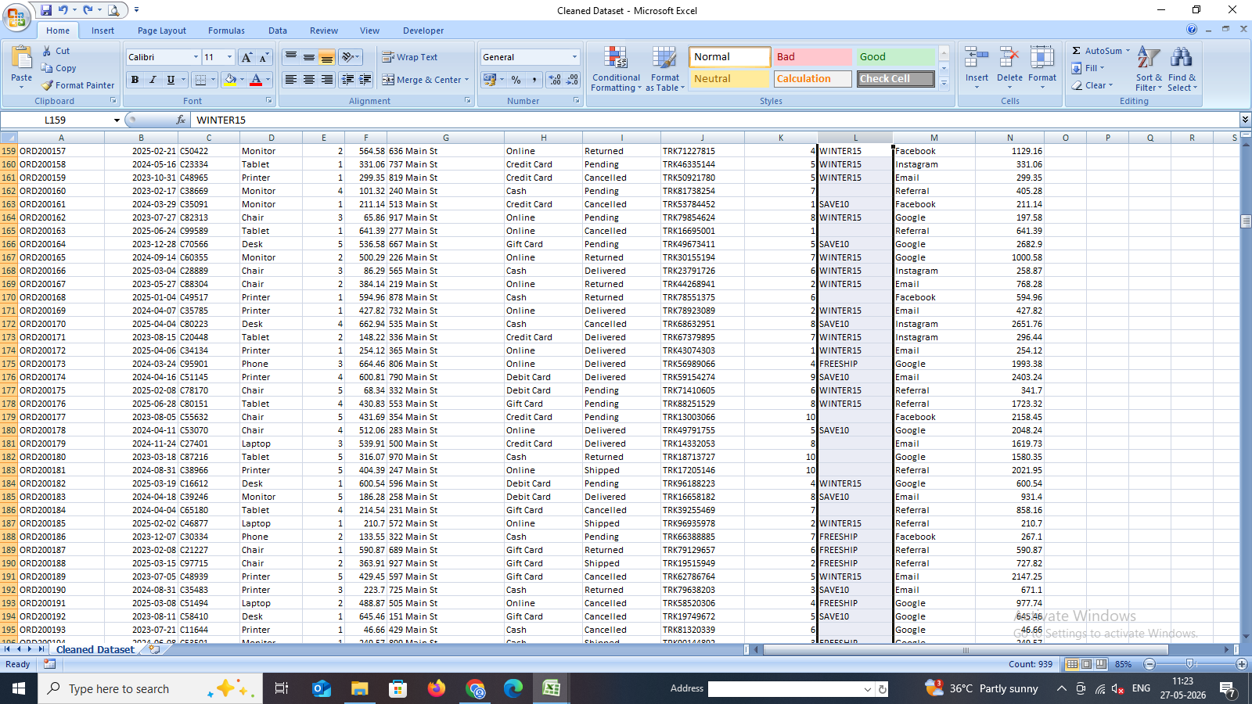

- Step-2: In-Progress Cleaning (Handling Empty Values & Formatting)
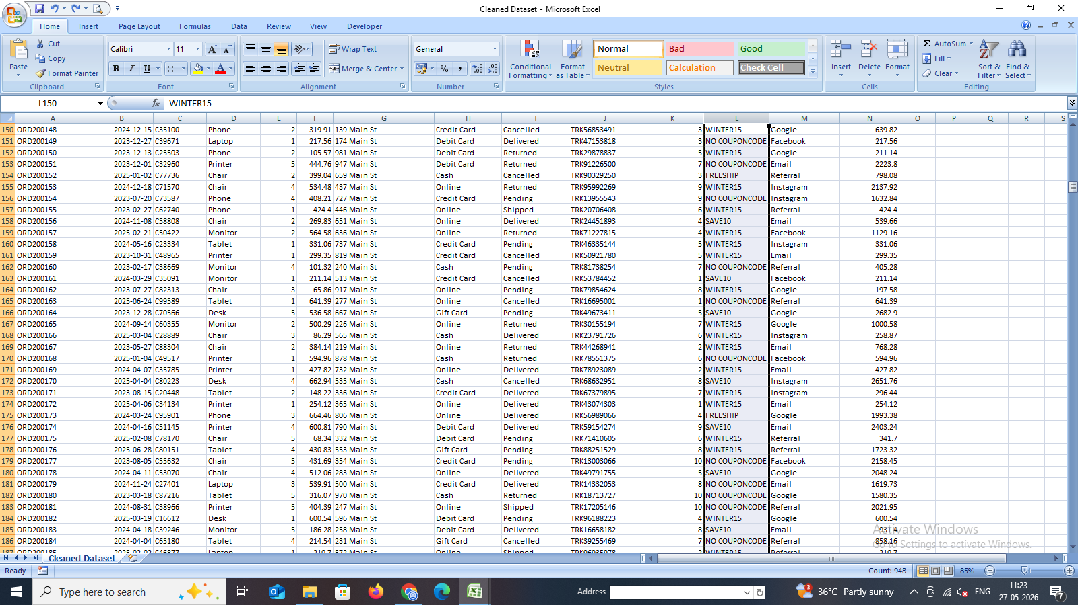

- Step-3: Formatted Date (DD-MM-YYYY)

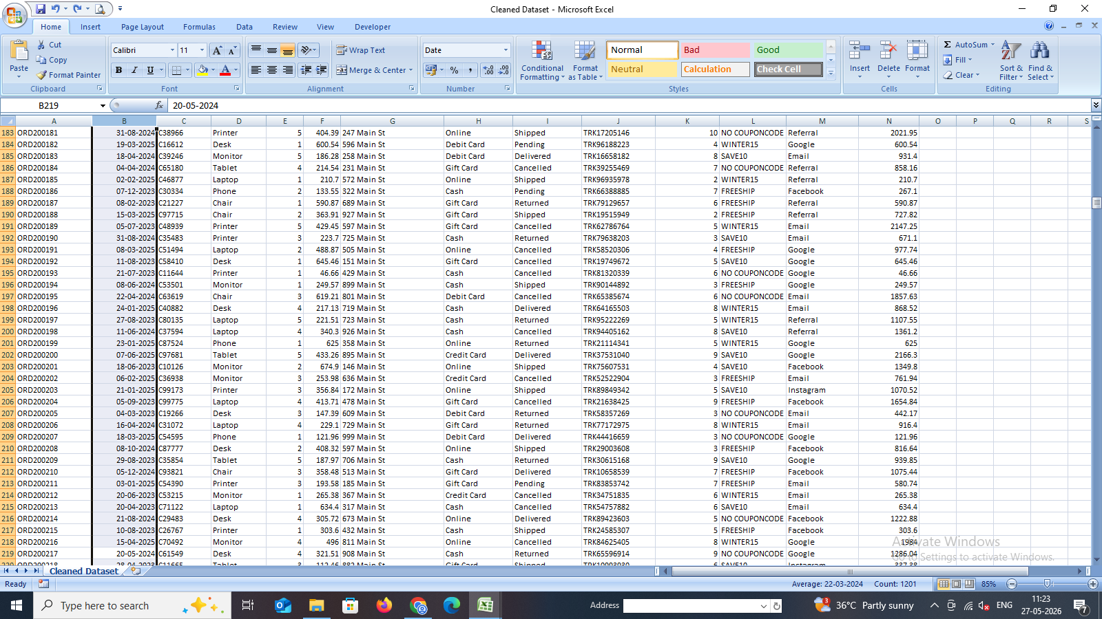

- Step-4: Final Cleaned & Deduplicated Output Dataset
6. Challenges Faced & Solutions

- Challenge: Dealing with missing or null rows where simply discarding data would compromise the overall analytical dataset volume and mask real trends.

- Solution: Applied strategic context-based replacement for empty fields instead of listwise row deletions, safely retaining records while preserving data consistency.

7. Conclusion & Learning Outcomes

- Summary: The dataset successfully cleared all wrangling and scrubbing phases required by DecodeLabs. It has been transformed from a messy raw state into an ironclad digital foundation.

- Key Takeaways: This task reinforced the practical reality that data cleaning makes up the fundamental 80% of an analyst's workflow. It provided vital practical experience in maintaining true data integrity, format rules, and structural validation.

