**Melbourne Institute of Technology**

**Sydney**

**MN521 Network Automation**

**Lab 04**

**Automation using Netconf**

**Student Name: Dilip Sapkota**

**Student ID: MIT242409**

Network Topology configured for automation

Installed Netmiko

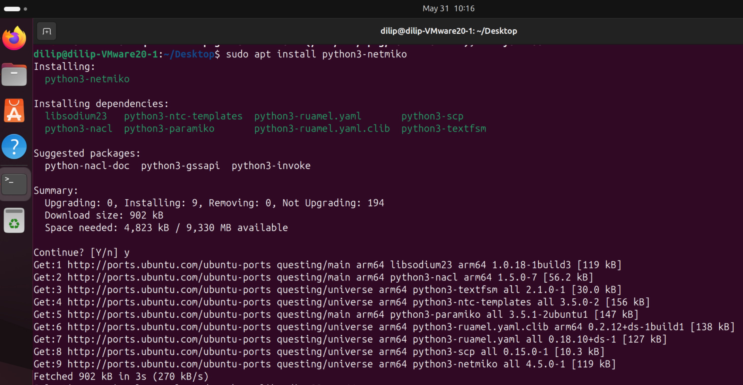

Automation Configuration File

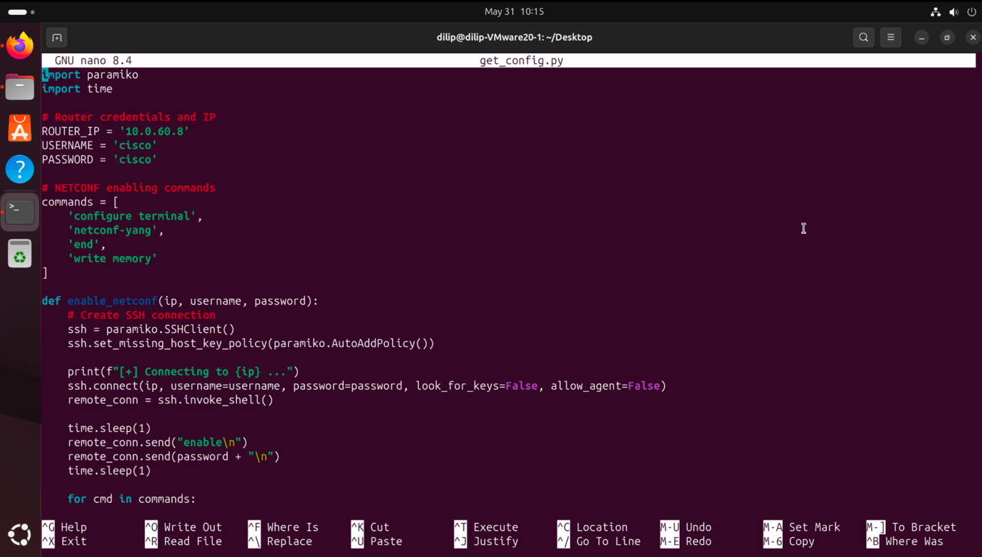

Executed the configuration file and automated the configuration

