Administrator’s User Manual for SunHRM Version

3.0



**Contents**

1. [Audience](http://localhost/installer/guide/index.html#overview)…………………………………………………..3
2. [Support](http://localhost/installer/guide/index.html#pre-requisites) Environment …………………………………......3
   1. [Minimum](http://localhost/installer/guide/index.html#windows) Hardware Requirements………………....3
   2. [Software](http://localhost/installer/guide/index.html#linux) Requirement……………………………....3
3. Backup Strategy.…………………………………………..3
4. Installing SunHRM………………………………………..3

Step 1: Install the environment for OrangeHRM……………………..........3

Step 2: Download HRM…………………………………………………...4

Step 3: Execute the SQL Queries and Take Backup………………………9

Step 4: Restoring Database Backup……………………………………….9

Step 5: Login to the SunHRM……………………………………………..9

1. FAQ……………………………………………………..10
2. **Audience**

This document is intended as a complete guide for using SunHRM 3.0. This document is specially designed for non-specialists; specialists may find the document a useful point of reference. By reading this guide, you will learn how to use OrangeHRM through the elements of the graphical user interface and what's behind some of the advanced features that are not always obvious at first sight. It will hopefully guide you around some common problems that frequently appear for users of OrangeHRM.

1. **Support Environment**

**2.1 Minimum Hardware Requirements**

* Processor - Intel x86 Architecture 3GHz processor or equivalent
* RAM - 2 GB RAM
* Hard Disk - 40GB

*Note: This configuration will support up to 100 users. If you have more users, this configuration may not be sufficient. Please contact support@orangehrm.com to get the optimized hardware requirements.

**2.2 Software Requirements**

* Operating System - Windows XP, Windows 7, Windows Server 2003, Windows Server 2008, Linux distributions such as Ubuntu, Fedora, Redhat.
* Apache Version - Apache 2.2
* MySQL Version - 5.1.36
* PHP Version - 5.3.5, 5.2.10-2Ubuntu6.4
* Browser - Internet Explorer 8, Firefox, Google Chrome, Safari

*Note: JavaScript should be enabled in all the browsers

* Web Server Packages - XAMPP, WAMPP , LAMPP

*Note: If PHP, MySQL & Apache are manually configured, web server packages are not required.

1. **Backup Strategy**

Stop the MySQL server, copy the “data” folder from below mentioned location:

E:\wamp\bin\mysql\mysql5.6.17

Save the folder on the server and stop restart the MySQL server. This should be done on daily basis.

* Developers will commit stable working code into github at the below location:

<https://github.com/Sun-Technologies/SunHRM>

1. **Installing OrangeHRM**

Step 1: Install the environment for OrangeHRM

Install the environment for OrangeHRM (Apache, MySQL and PHP) using XAMPP/WAMPP.

Download XAMPP for Windows at, <http://www.apachefriends.org/en/xampp-windows.html>



OR



Download WAMPP (recommended version - 2.0 and above) for Windows at

<http://www.wampserver.com/en/download.php>

*Note: Alternatively you may download SunHRM one self-extracting installer for windows. This package automatically installs Apache, MySQL and PHP utilities which are required to run OrangeHRM.

Step 2: Download HRM

Please visit GitHub link: <https://github.com/Sun-Technologies/SunHRM> to download SunHRM.

Provided that both Apache and MySQL are running, you can access OrangeHRM via your web browser.

Clone or the content of “SunHRM” directory to:

* 1. My Computer >Local Disk >xampp >htdocs
  2. My Computer >Local Disk >wamp >WWW

*Note: If you are a Linux user, first change the file permission of OrangeHRM.

Open the terminal (console) and navigate to your SunHRM directory (which is in the www folder or htdocs folder) and run the below command:

Ww$ sudo chmod -R 777 Sunhrm

Copy and paste the name of the OrangeHRM version that you have downloaded in the following URL:

<http://localhost>

OR

Type the IP address of your PC instead of the localhost.

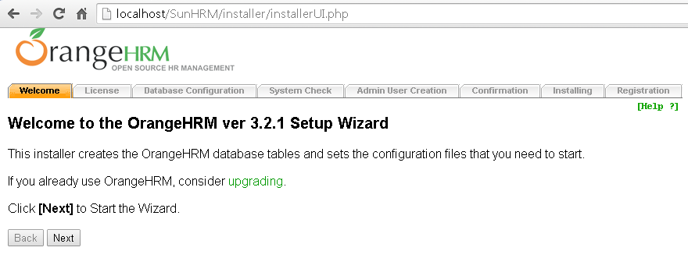**Step 1**: Click “**Next**” to begin the SunHRM installation.

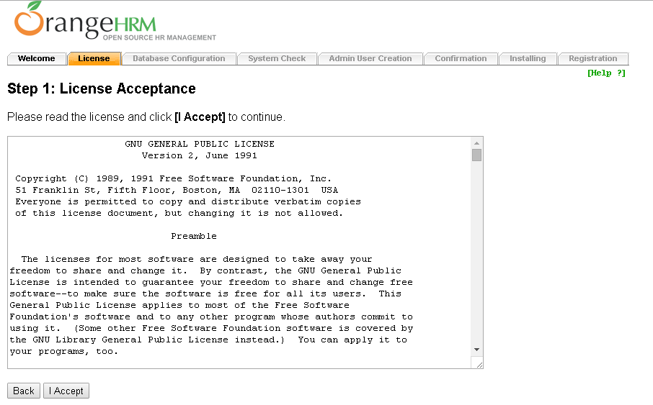**Step 2**: Click “**I accept**” to agree and proceed with the installation

**Step 3**: Enter the relevant information about your MySQL database server and database users. (All the data that is populated into the system later will be stored under this Database Host Name). Check two boxes based on your system requirements.

Database Name: sunhrm

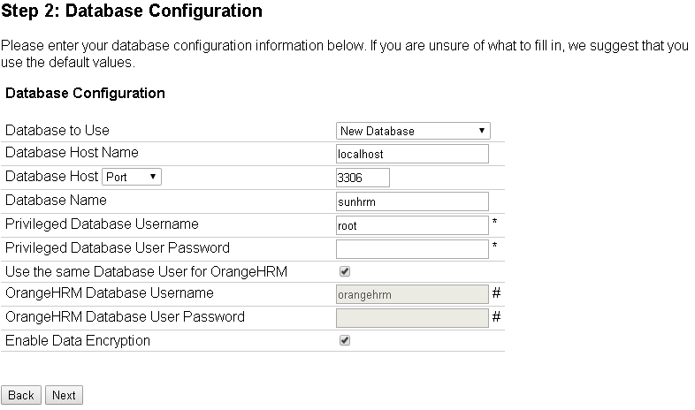

The System will check for minimum system requirements to install OrangeHRM in your PC.

Once the system check is complete, click “**Next**”.

**Step 4:** If on clicking “**Next**” you see following page, then create folders which are not writable in their respective directory.

Create folders named “cache” and “log” under C:\wamp\www\SunHRM\symfony

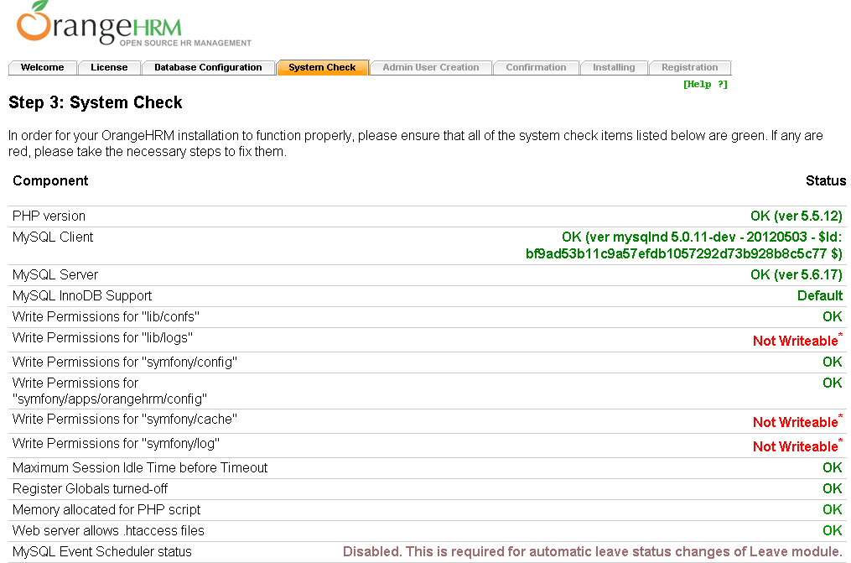Create “logs” folder in C:\wamp\www\SunHRM\lib.

Click “**Re-check**” and if everything is green, click “**Next**”.

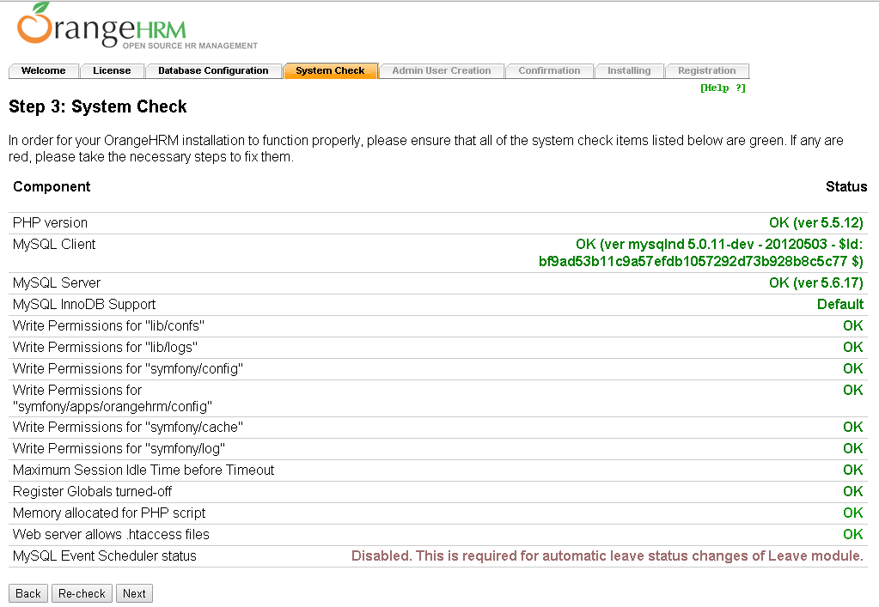

**Step 5**: Enter Administrative credentials mentioned as below and click “**Next**”.

Admin Username: hrmadmin

Admin User Password: hrmadmin

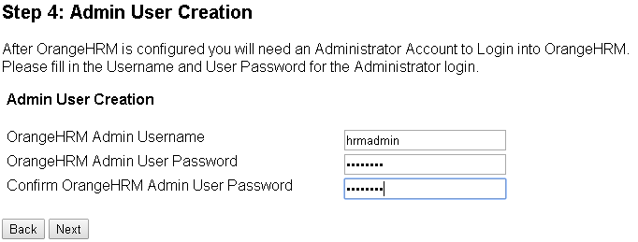

**Step 6**: Confirmation page will appear. Check if all details are correct and click “**Install**”.

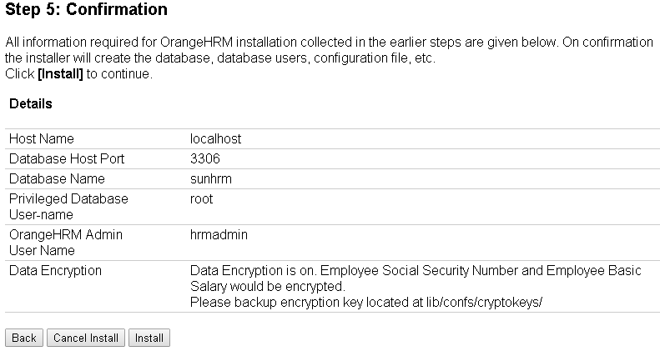

You will see following installing screen. Wait for the installation to complete. Click “**Next**”.

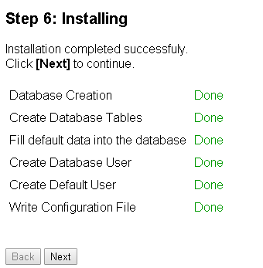

**Step 7**: Once you have successfully installed OrangeHRM, register yourself to receive additional support and services from OrangeHRM.

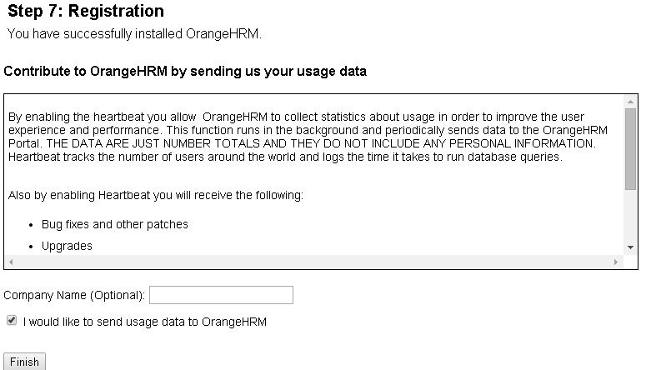

Step 3: Execute the SQL Queries

Execute all the queries mentioned in the below file.



Step 4: Restoring Database Backup

Stop the MySQL server and paste the copied “data” folder in the below location to restore the pervious backup:

E:\wamp\bin\mysql\mysql5.6.17

After restoring the backup, restart the server.

Step 5: Login to the SunHRM

Login using username “hrmadmin” and password “hrmadmin”.



1. **FAQ**
2. In case you see error similar to below screen during installation process, then click on “**Clean up Install**” and follow steps from step 1.

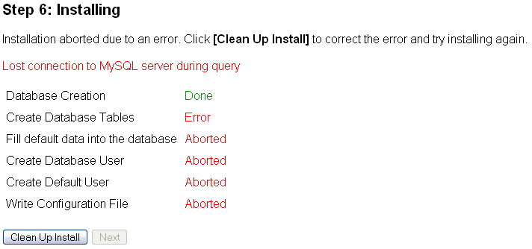

1. For assistance contact [support.hrm@suntechnologies.com](mailto:support.hrm@suntechnologies.com).