# AWX Errors:

## While saving project:

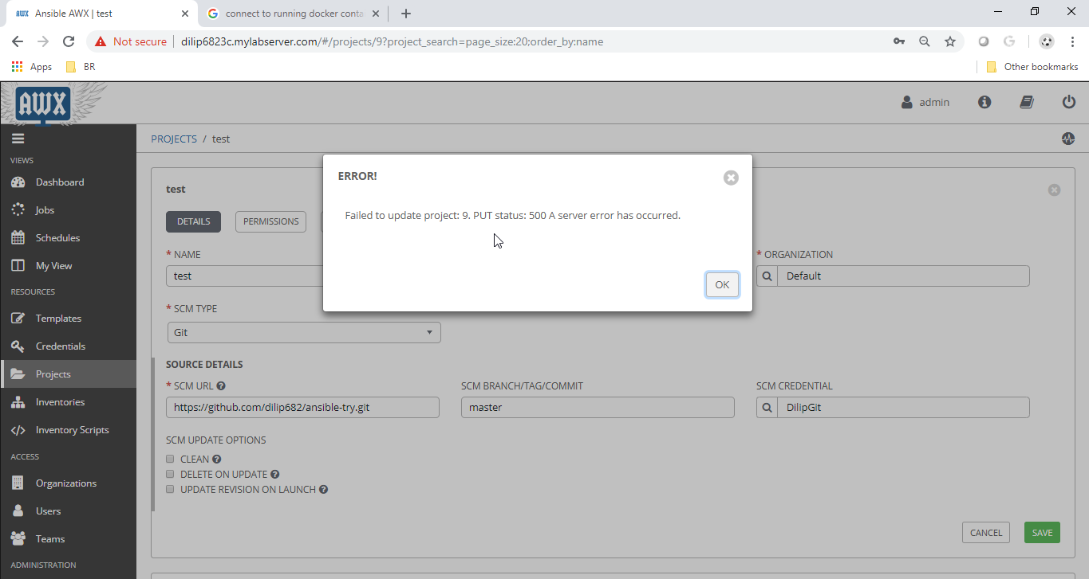

## Call to /api/v2/hosts/. GET returned: undefined A server error has occurred.

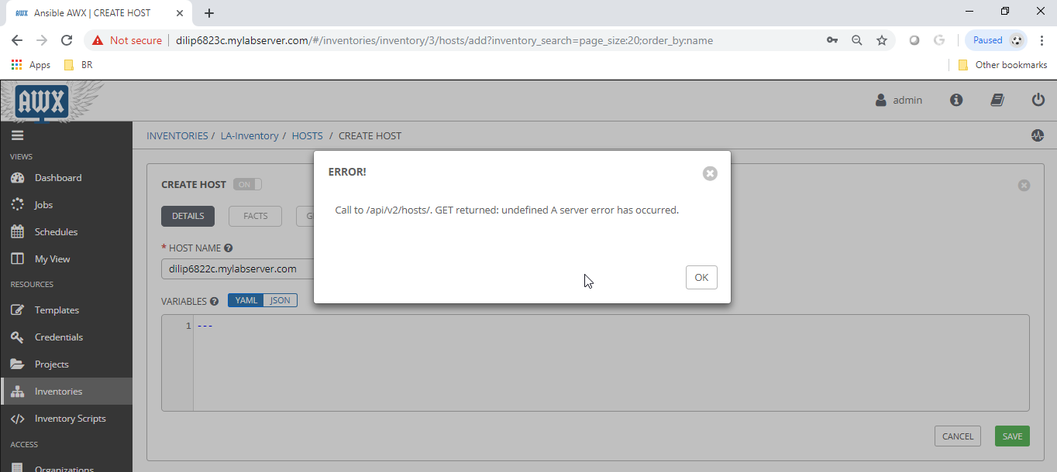

RabbitMQ Container Error:

=ERROR REPORT==== 29-Jan-2019::16:21:23 ===Error on AMQP connection <0.28691.1> (172.17.0.6:40518 -> 172.17.0.4:5672, state: starting):AMQPLAIN login refused: user 'guest' can only connect via localhost

**Solution:**

vi ./ansible.awx/awx/installer/roles/local_docker/defaults/ main.yml

rabbitmq_default_username: "awxuser"

rabbitmq_default_password: "awxpass"

vi ../../../inventory

rabbitmq_user=awxuser

rabbitmq_password=awxpass

$ vi ./ansible.awx/awx/installer/roles/local_docker/templates/docker-compose.yml.j2

From:

rabbitmq_user=awxuser

rabbitmq_password=awxpass

To:

rabbitmq_user=awxuser

rabbitmq_password=awxpass