# Setup Work Station

1. Install Terraform & Ansible. Disable host-key-checking in ansible.cfg
2. IAM and DNS Setup

Create AWS Access Key in IAM

Create AWS Profile

$ aws configure --profile **awsprofile-dilipbr**

AWS Access Key ID [None]: XXXXXXXXXXXXXXXXXX

AWS Secret Access Key [None]: XXXXXXXXXXXXXXXXXXXXXXXXXXXx

Default region name [None]: us-east-2

Default output format [None]:

Profile details are stored in ~/.aws/credentials

Ex:

c:\Users\dilip\.aws>type credentials

[default]

aws_access_key_id = XXXXXXXXXXXXXXXX

aws_secret_access_key = XXXXXXXXXXXX

[**awsprofile-dilipbr**]

aws_access_key_id = XXXXXXXXXXXXX

aws_secret_access_key = XXXXXXXXXXXXX

Test profile:

c:\Users\dilip\.aws>aws s3 ls

c:\Users\dilip\.aws>aws ec2 describe-instances --profile awsprofile-dilipbr

c:\Users\dilip\.aws>set AWS_PROFILE=awsprofile-dilipbr

c:\Users\dilip\.aws>aws ec2 describe-instances

# Provider, Credentials, Variables

Providers understand API interactions and expose resources.

Providers are generally IaaS (e.g. AWS, GCP, Microsoft Azure, OpenStack), Paas (e.g. Heruku) or SaaS Services (e.g. Terraform Enterprise, DNSimple, CloudFlare).

## Simple VPC :

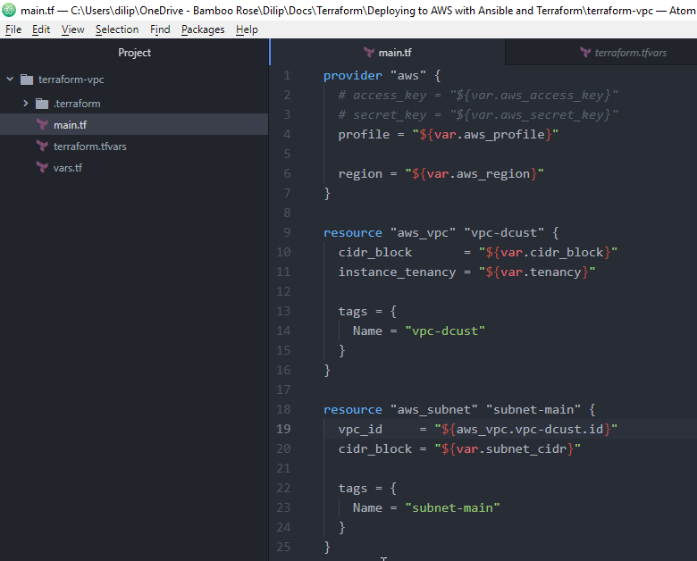



### main.tf

provider "aws" {

# access_key = "${var.aws_access_key}"

# secret_key = "${var.aws_secret_key}"

profile = "${var.aws_profile}"

region = "${var.aws_region}"

}

resource "aws_vpc" "vpc-dcust" {

cidr_block = "${var.cidr_block}"

instance_tenancy = "${var.tenancy}"

tags = {

Name = "vpc-dcust"

}

}

resource "aws_subnet" "subnet-main" {

vpc_id = "${aws_vpc.vpc-dcust.id}"

cidr_block = "${var.subnet_cidr}"

tags = {

Name = "subnet-main"

}

}

### Vars.tf

variable "aws_profile" {

default = ""

}

variable "aws_region" {

default = ""

}

variable "cidr_block" {

default = "10.0.0.0/16"

}

variable "tenancy" {

default = "default"

}

variable "subnet_cidr" {

default = "10.0.1.0/24"

}

### Terraform.tfvars

aws_profile = "awsprofile-dilipbr"

aws_region = "us-east-2"

## VPC with using modules:

