DevOps
DevOps Introduction

7 DevOps Practices
1. Configuration Management
2.Release Management
3.Continuous Integration
4. Continuous Deployment
5.Infrastructure as Code
6.Application Performance Monitoring
7. Test Automation

7 DevOps Habits
1. Team autonomy and Enterprise Alignment
2. Rigorous Management of Technical Debt
3.Focus on Flow of Customer Value
4. Hypothesis Driven Development
5. Evidence Gathered in Production
6. Live Site Culture
7. Manage Infrastructure as a Flexible Resource

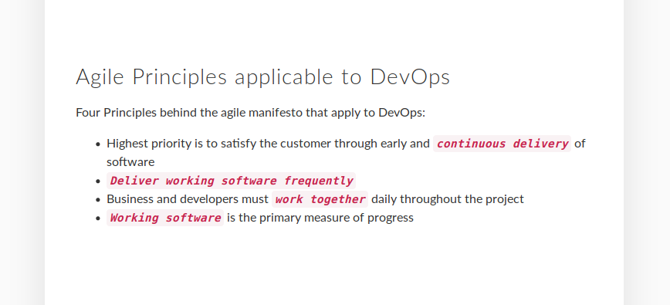

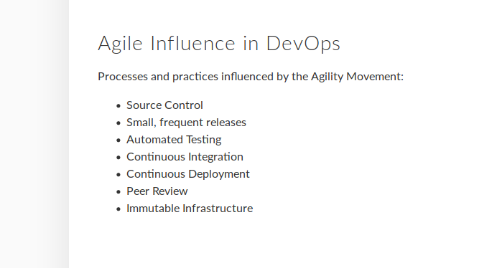
KPIs and Metrics

1. Deployment Frequency
- How quickly are we deploying

2. Change lead time
-how quickly can we change

3. Change fail rate
-How often we fail when deployed
-Faile rate is suppose to go down

4.Mean time to detect and repair
- how quickly are we catching on what’s happening in the server and solving the defects

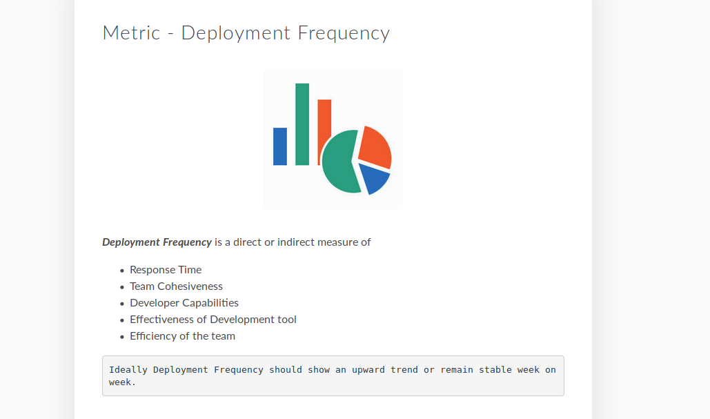
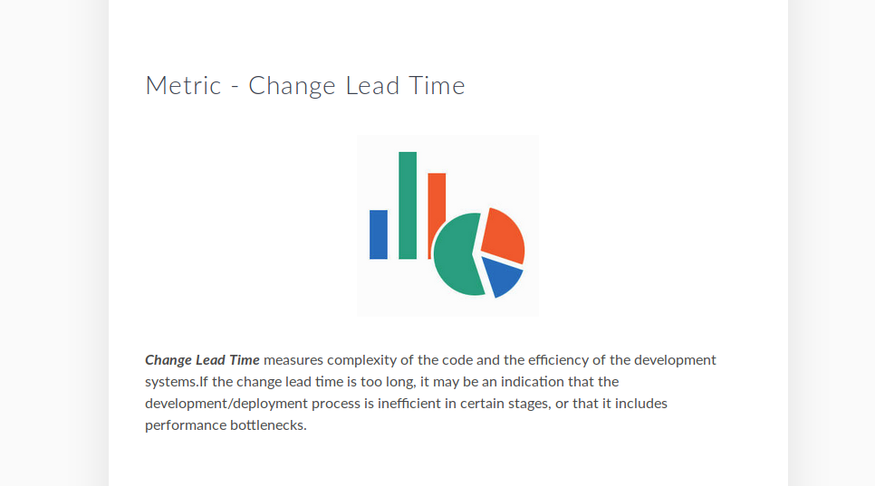
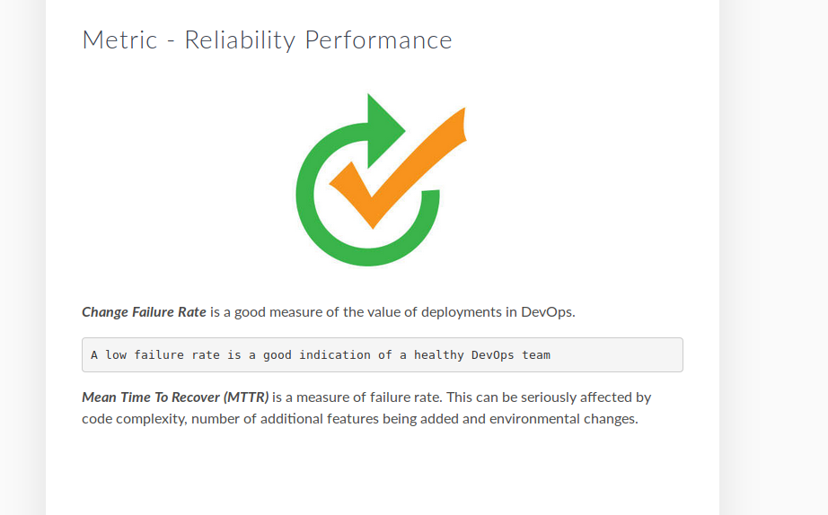

Source Control and Automation in DevOps

