
Functional Specification
Groupomania Campaign Management Module


Contents
Current Problem 3
Solution 3
High level requirements 3
Glossary of terms for this module 4
Use cases 4
Glossary of terms 4
Sign Up as a new customer 5
Sign In as an existing customer 6
Edit Company and Customer details 7
Manage a campaign 8
Domain Model 9
Glossary of terms 9
List of entities 9
Class Diagram 10
Wireframes 11
Landing page 11
Sign In page 11
Sign up page 12
Reset password page 12
Forgot password Page 13
Create a campaign 14
Preview a campaign 15
Campaign successful message 16
Home page 17
Home Page – List of campaigns 17
Home Page – Campaign detail 18
Edit Company Info 18
Edit User Info 19
Appendix A – Use cases in a table format with more detail 19
Use case # 1 19
Use case # 2 20
Use case # 3 21
Use case # 4 22
Use case # 5 22
Use case # 6 23
Use case # 7 23
Use case # 8 24
Use case # 9 24
Use case # 9 25

Current Problem
Groupomania is an e-commerce company that sells offers and coupons to its users at a discounted price. The company currently has a website which allows users to sign up and buy these items.
An offer is usually about goods that user can buy for a price. For example, an offer to buy a 10 kg dumbbell pair for $50. A coupon on the other hand is usually a service that offers a discount on the original price. For example, a coupon to have a lunch at 50% off for a given restaurant every Monday.
Groupomania receives these offers and coupons from different businesses such as gyms, restaurants and manufacturing companies to name a few. Now, company staff must enter these offers and coupons manually into their backend system. Their current process includes entering these details manually in a spreadsheet and manually uploading it into the database.
Such a manual process if inefficient and company is spending lot of money hiring data entry staff. As the company is getting more popular, they are finding it hard to keep up with the volume.

Solution
Groupomania wants to improve and bring efficiency to this manual process of entering coupons and offers by allowing businesses to create their own login accounts and enter it themselves. As part of this journey, the company wants to enhance their current website by building this functionality. They want to build a module for companies who wants to provide offers and coupons. Representatives from these companies will create the login account and then create a campaign which could be either offer or coupon. Each company will be able to create up to 10 campaigns. These campaigns will run from their given start and end date and thus automating the whole flow of receiving offers and coupons from companies and then allowing users to buy it during the active period.

High level requirements
I have identified below requirements from the product owner at Groupomania as an MVP (minimal viable product) for their company module.
- A representative from any company (a.k.a. company user) should be able to create the login account. There could be multiple representatives but they each will have Admin role in the first iteration.
- A company user that has an admin role can also delete other user accounts from the same company.
- Once login is created, Groupomania Admin will manually verify the company by calling their primary contact number and checking the street address and then should be able to either approve or reject the login account.
- Once approved, a company user can create a campaign. A campaign can be of type offer or coupon. User can select how the value of a campaign needs to be entered. It can be entered either as a price, discount percentage or a discount text.
- Groupomania Admin reviews each new campaign and can either approve it or reject it. This is to prevent companies from entering fraudulent deals.
- Once approved, a company user then can activate a campaign. Activated campaign will go live on its start date. Once the end date is reached, the campaign is considered complete. A completed campaign has an option to stay live up to 4 days. After 4 days period, a campaign is taken offline.
- A company user can also deactivate a campaign at any time. Deactivated campaign is taken offline immediately.
- A campaign can be edited fully before it goes live. Once it is live then only a very minor edits are allowed such as correcting typos. These edits need to go through the approval process by site admins.

Glossary of terms for this module
This module uses certain terms which are described as below.
Term | Meaning
Customer | A customer represents a company user. This person is typically an employee of a company who will create a login account in this application and will create campaigns.
Groupomania Admin | A groupomania admin is a person who has admin role and has authority to approve or reject customer logins and approve or reject new campaigns.
Company | A company is a business which wants to offer deals in the form of offers and coupons to its users via this application.  e.g., a restaurant that wants to offer 50% off to patrons every Monday.

Use cases
- I have identified below use cases from the above high-level requirements. I have used UML diagrams to depict it visually. Having a visual diagram greatly facilitates the conversations and it can act as a tool to communicate across team members.
- I have also written use cases using a table-based format in a plain text. They are available as a reference in Appendix A. Writing use case in a table-based format allows for more detailed information in a methodical way which complements the diagrams.

Glossary of terms
Use cases use several terminologies. This project mainly uses Level-1 use cases and following terms.
Term | Meaning
Actor | An Actor is an entity that triggers, or initiates a given use case. An actor can be either a person, another system, or a time. E.g., a person can initiate a login process, a system can initiate a database stored procedure on another system, or a specific time can trigger a run of a scheduled job.
Includes | When a use case A requires use case B as part of its execution then it is said that use case A includes use case B.  e.g., a login requires an actor to enter username and password. So, a login use case includes entering username and password.
Extends | When a use case B is related to use case A but is optional then It is said that use case B extends use case A.  e.g., Deactivating a campaign is related to Activating a campaign but it may or may not happen. Therefore, deactivation use case extends activation use case. `
System | A system encompasses a boundary within which use cases execute. If something is outside of a boundary, it means that it is not part of the system and so will not be implemented.

Sign Up as a new customer
This use case describes the process of signing up a new customer. In this use case, a customer and groupomania admin are actors.
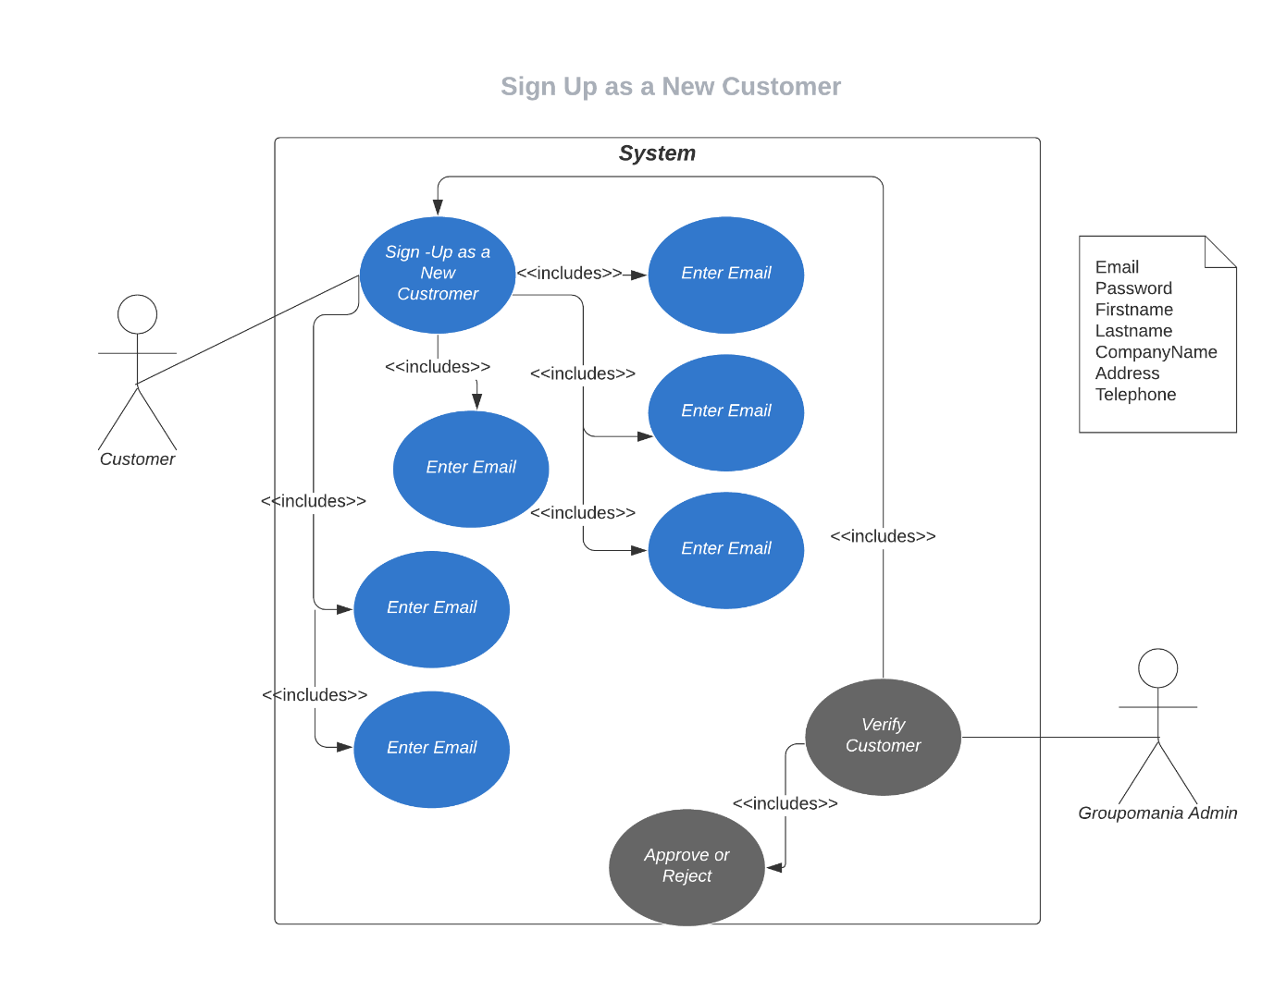

Sign In as an existing customer
This use case describes signing in as an existing customer. In this use case, actor is a customer.
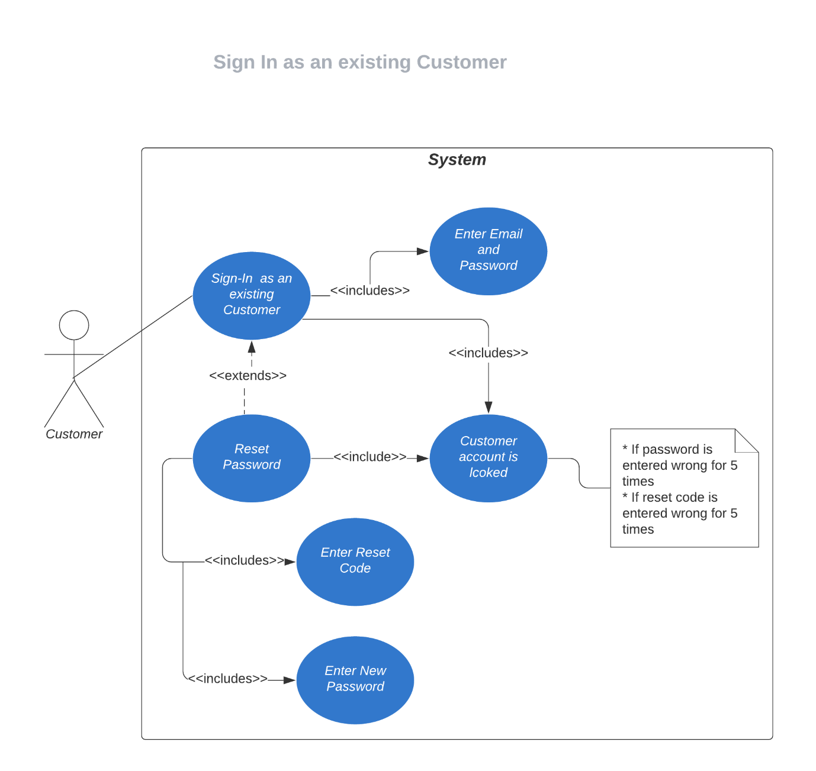

Edit Company and Customer details
This use case describes editing a company and customer details. In this use case, actors are a customer and groupomania admins.
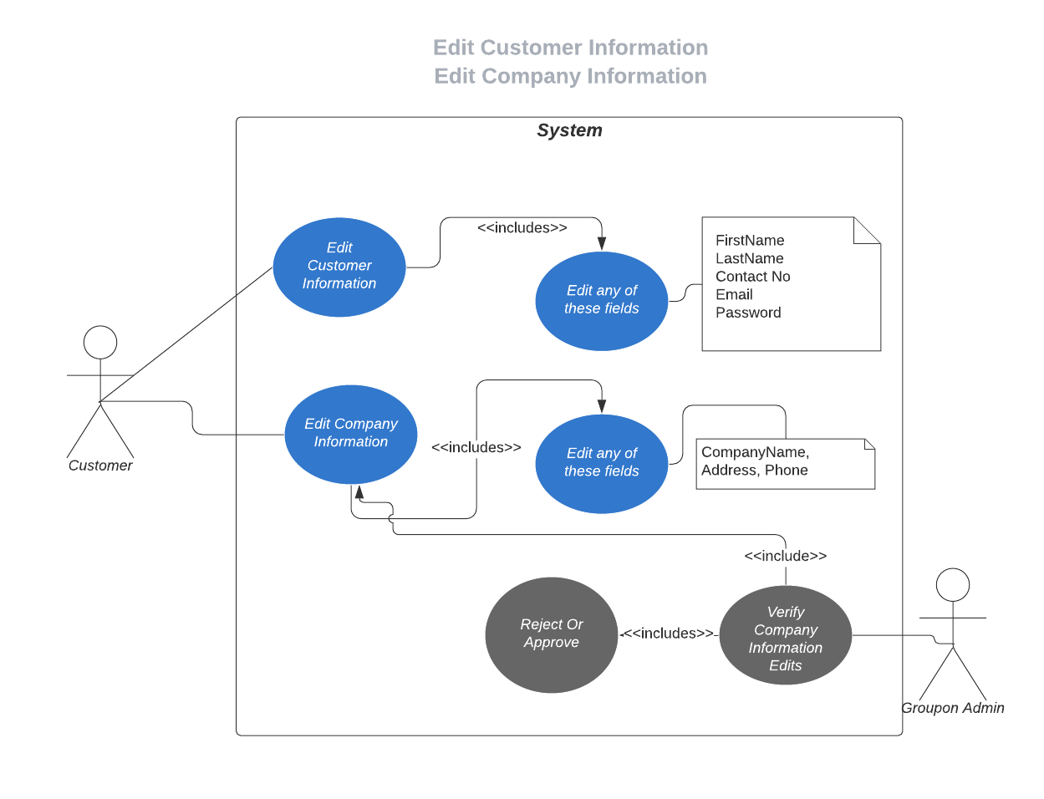

Manage a campaign
This use case is about creating a campaign, verifying a campaign, activating a campaign, deactivating a campaign, and completing a campaign. In these use cases, actors are customer and groupomania admin.
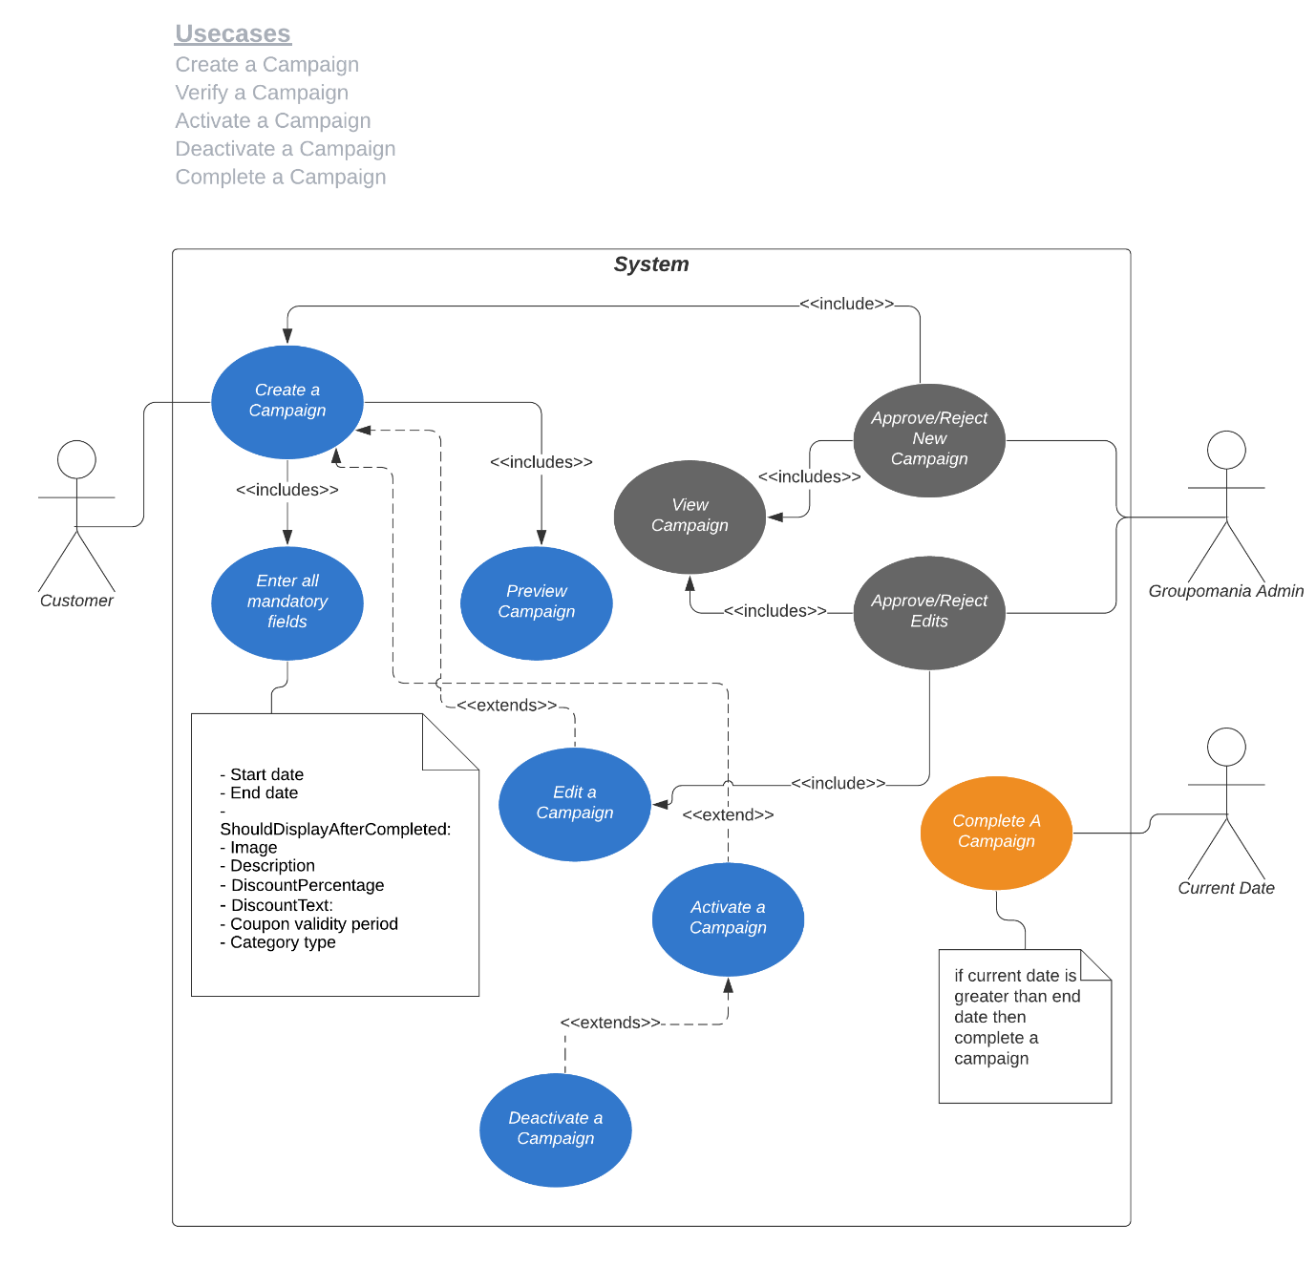

Domain Model
Domain model represents the business entities and how they relate to each other. Domain model is depicted using a class diagram as below.

Glossary of terms
Term | Meaning
Entity | An entity represents a business object that gets stored in the database. An entity has a unique identity.
Domain | A sphere of knowledge influence, or activity. The subject area to which the user applies a program is the domain of the software.
Value Object | An object that has attributes but no identity.
Model | A system of abstractions that describes selected aspects of a domain and can be used to solve problems related to that domain.
Aggregate | A collection of objects that are bound together by an aggregate root.
Context | The setting in which a word or statement appears that determines its meaning.

List of entities

Entity name | Purpose
ClientUser | It represents the people who work in each company and will create login accounts in this web application to create campaigns.
ClientCompany | It represents company or a business that wants to offer deals to its patrons.
Campaign | A campaign is a deal that could be either a coupon or offer.
CampaignStatus | It represents the status of a campaign
Category | It represents the category of a campaign
CampaignType | It represents the type of a campaign
CampaignCategory | It is used for keeping relationship between a campaign and categories.

Class Diagram
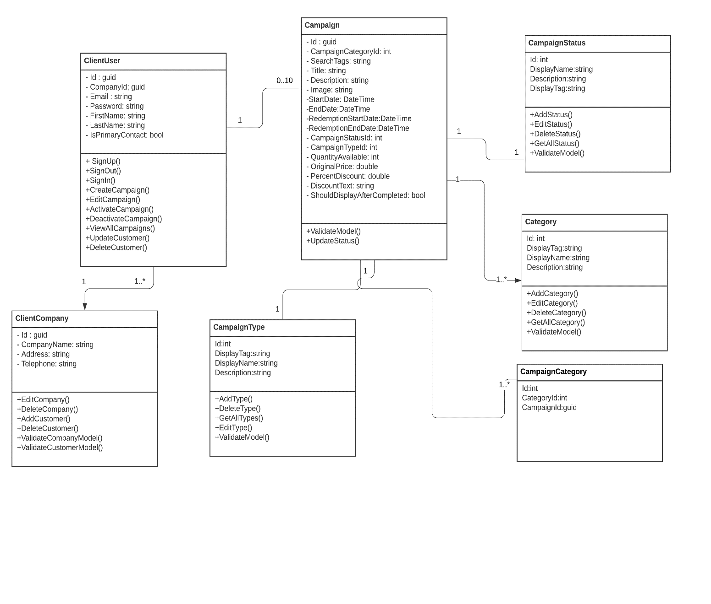

Wireframes

Landing page
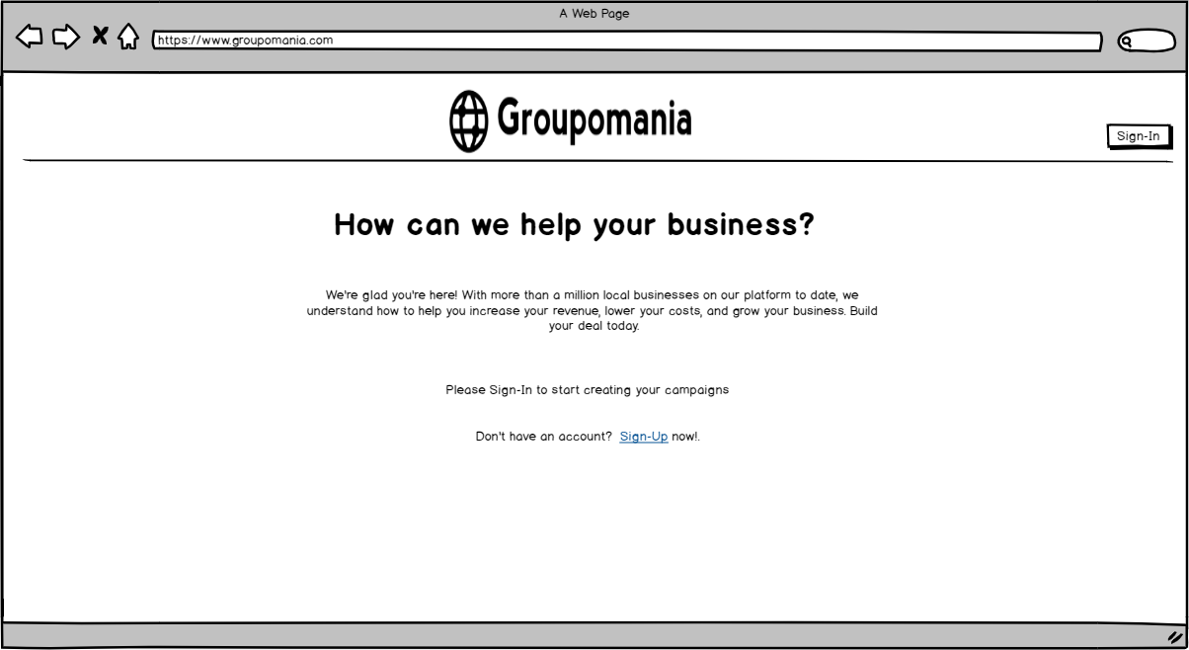

Sign In page
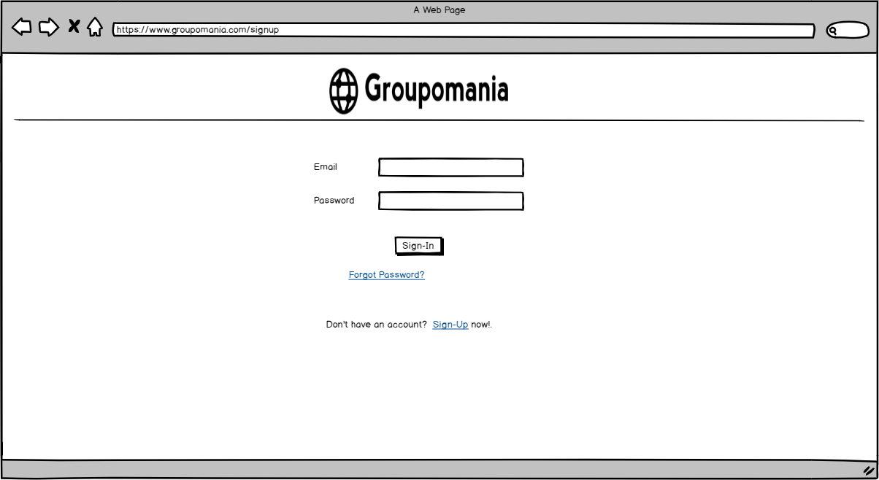

Sign up page
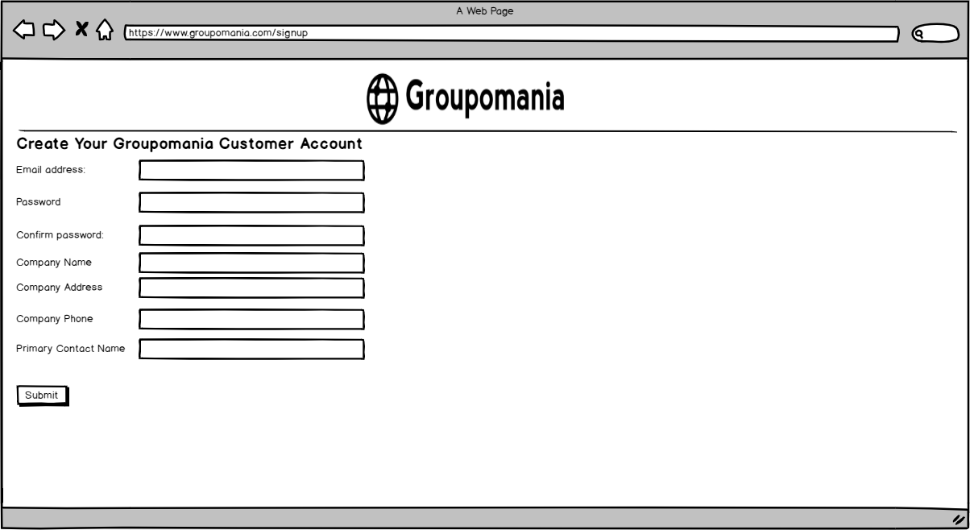

Reset password page
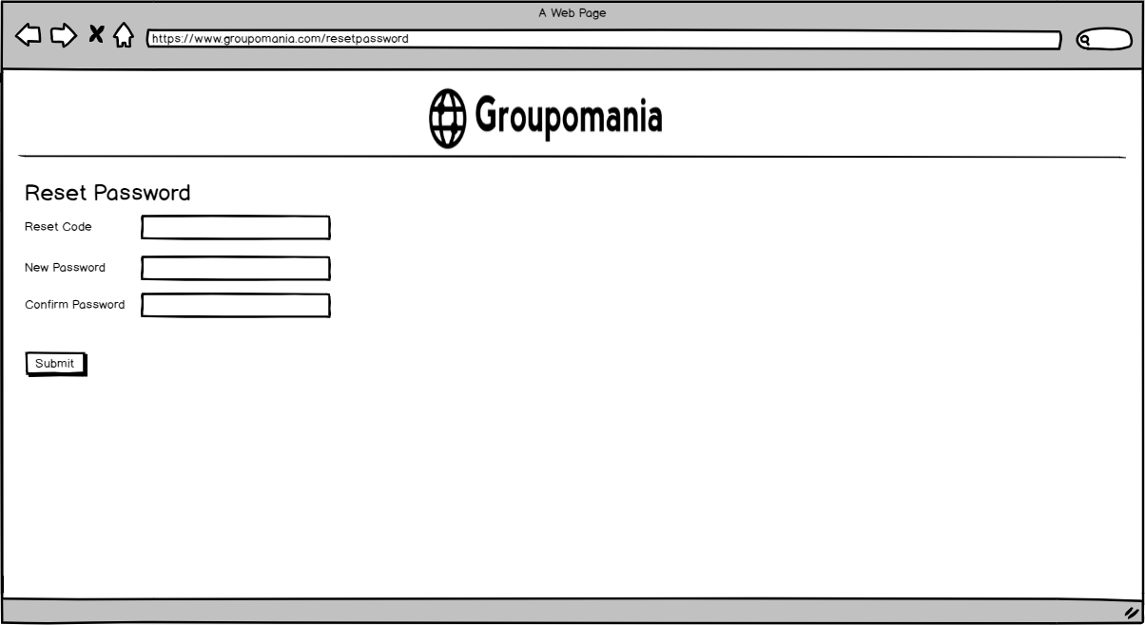

Forgot password Page
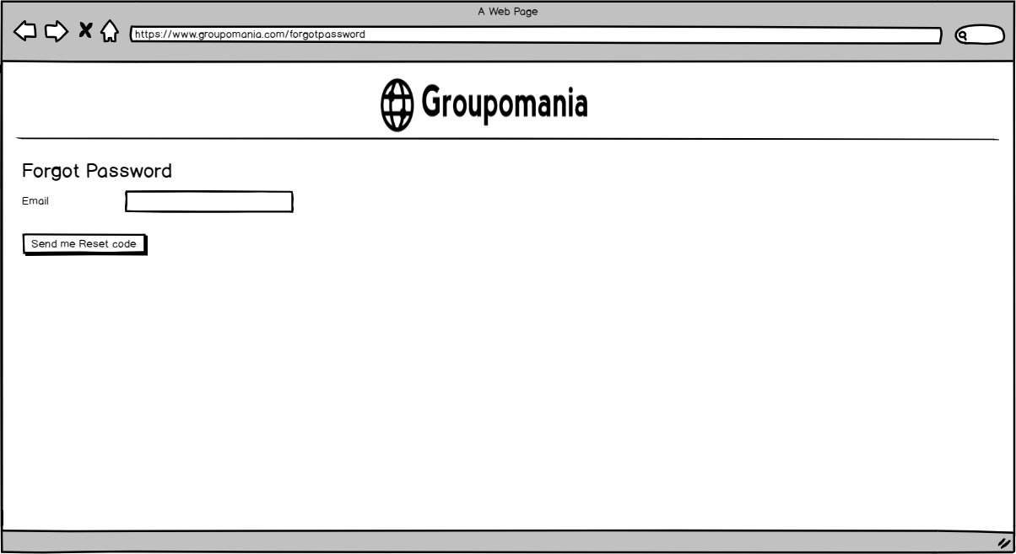

Create a campaign
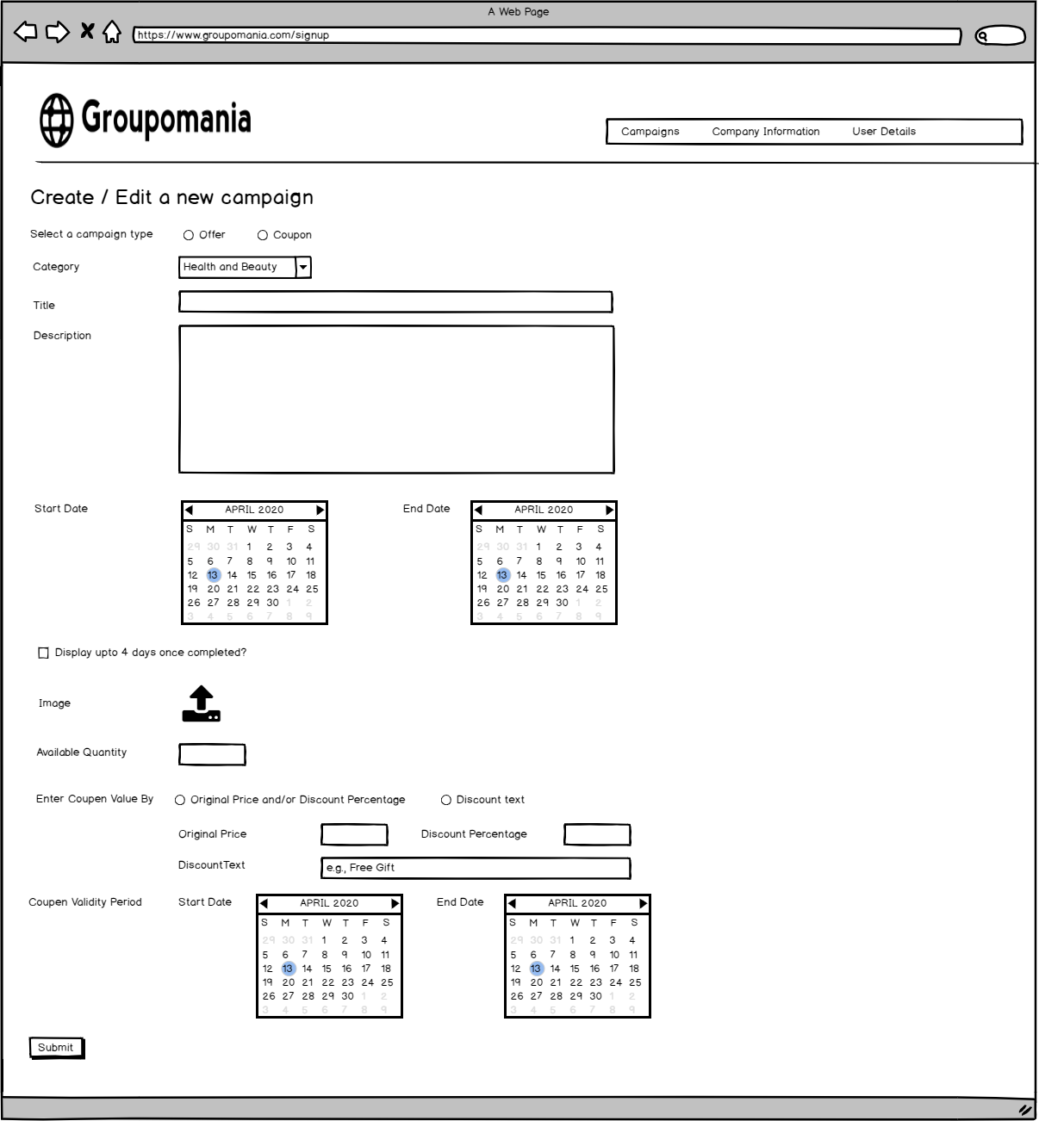

Preview a campaign
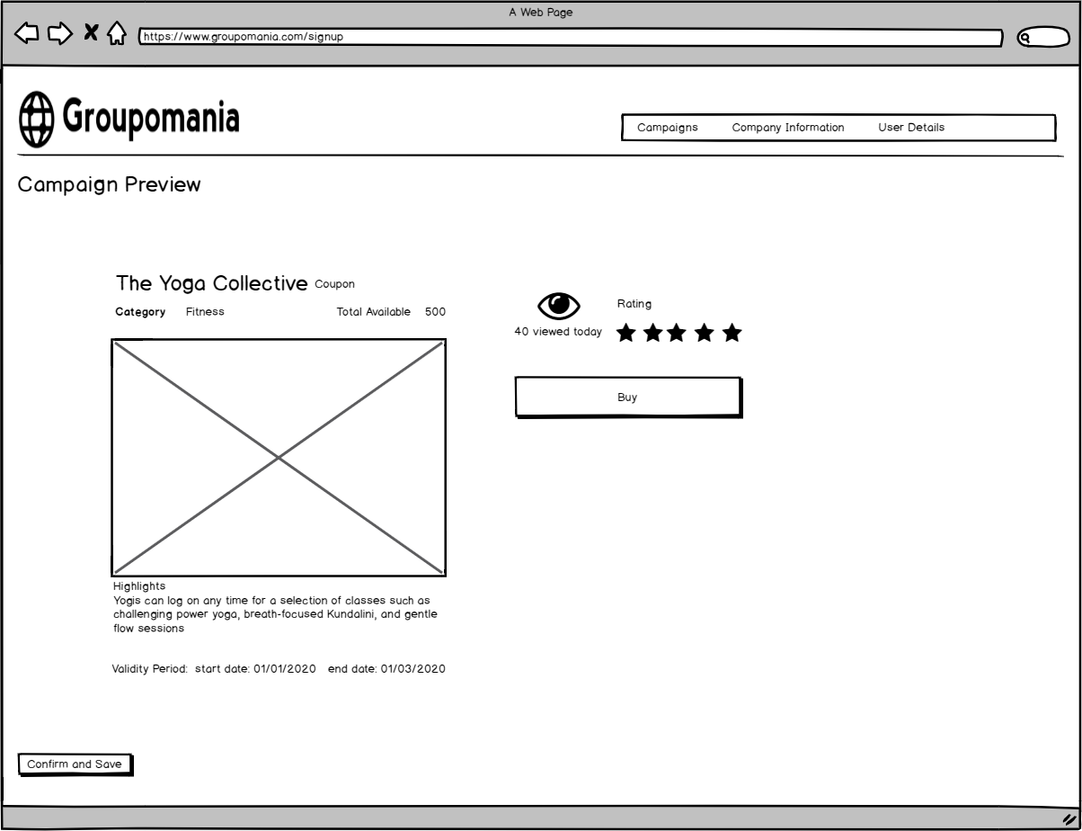

Campaign successful message
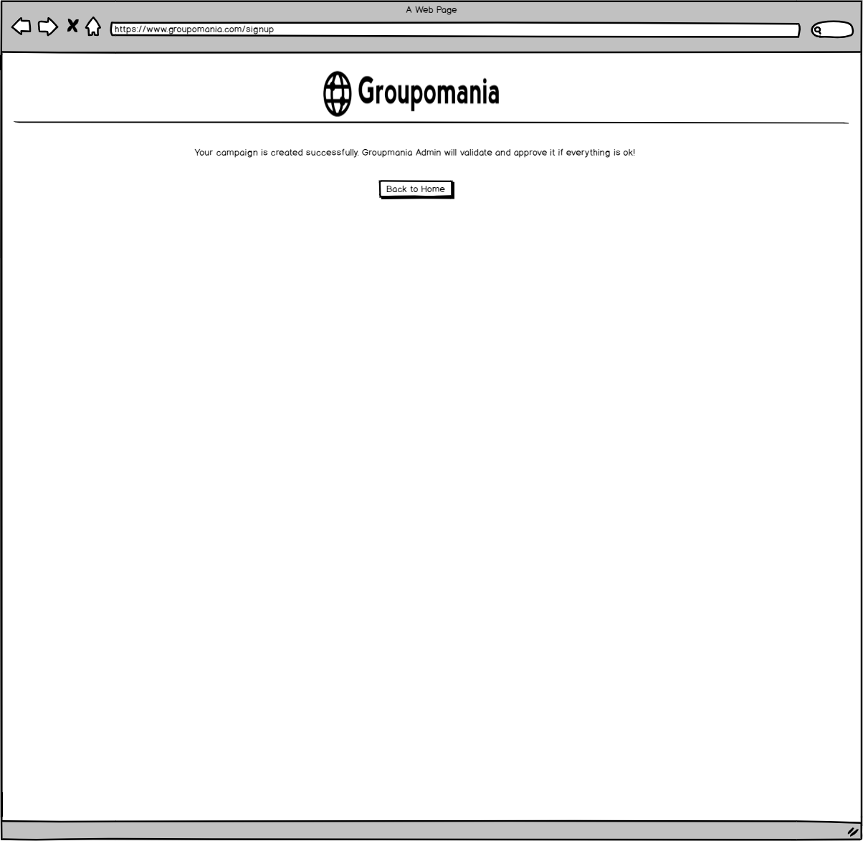

Home page
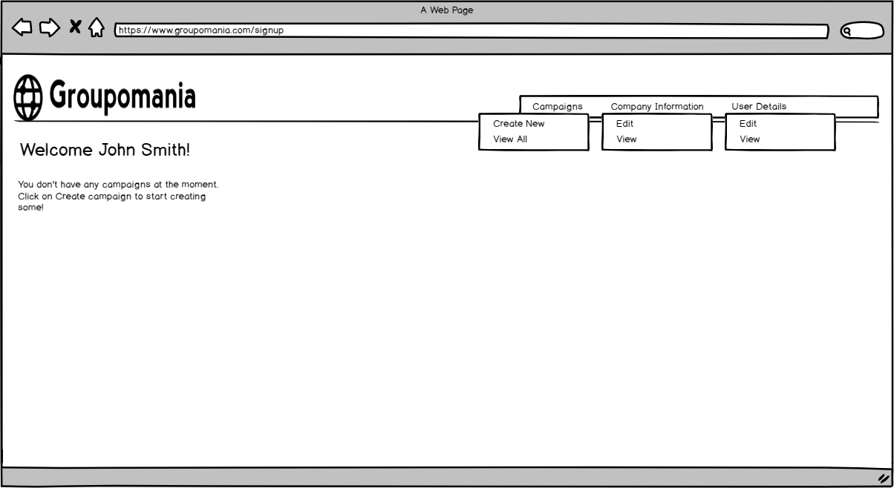

Home Page – List of campaigns
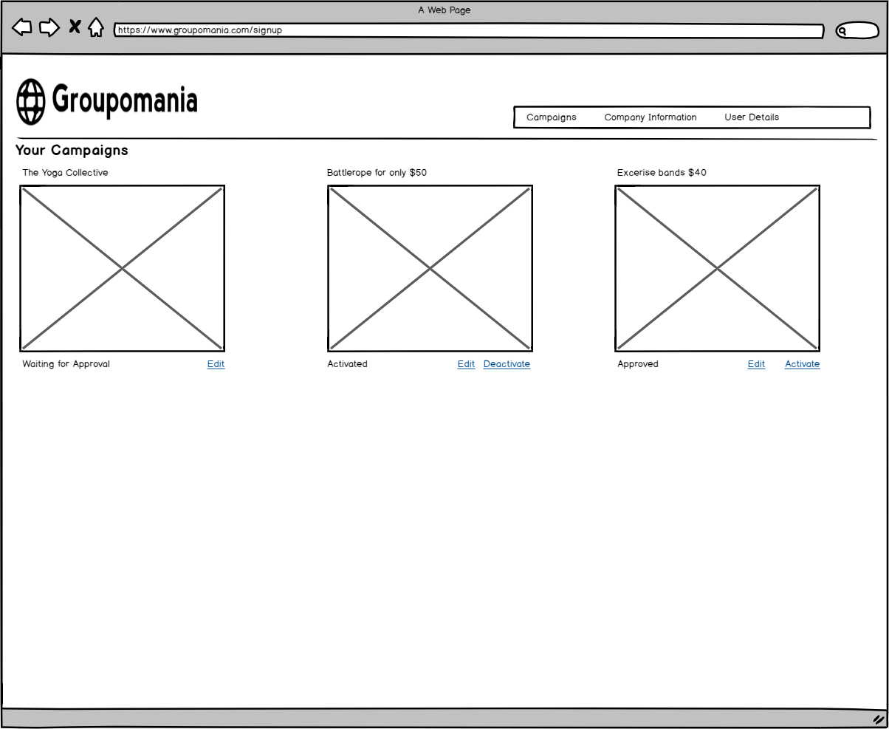

Home Page – Campaign detail
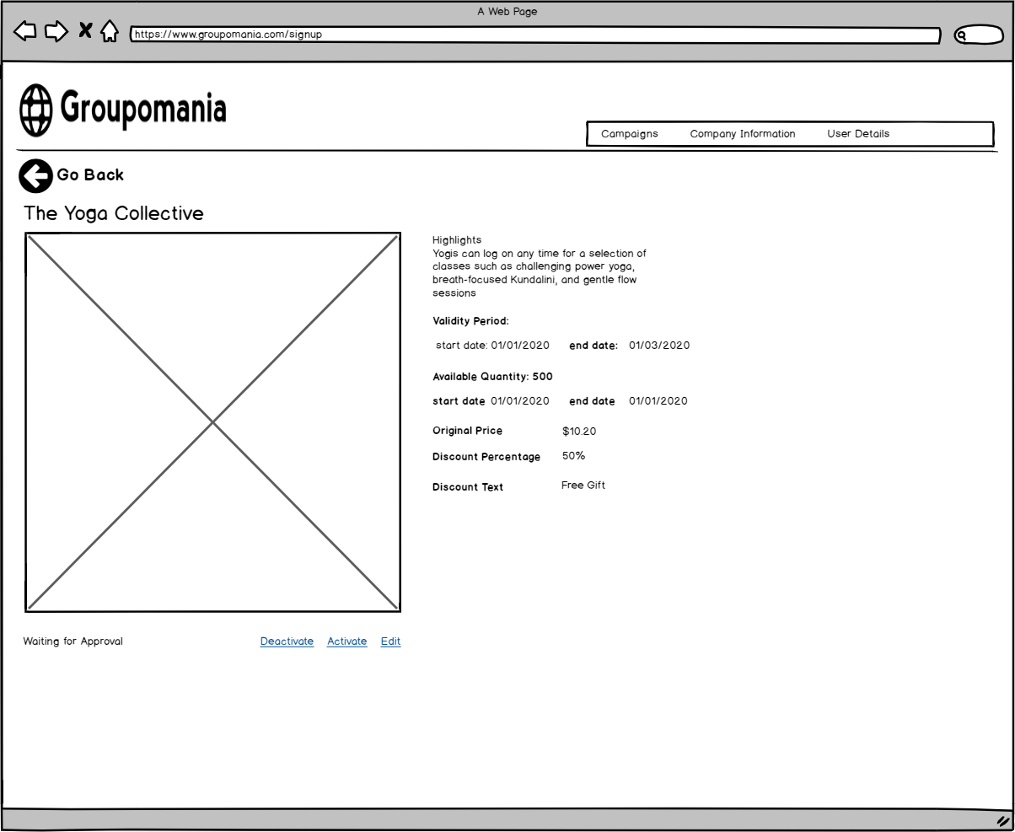

Edit Company Info
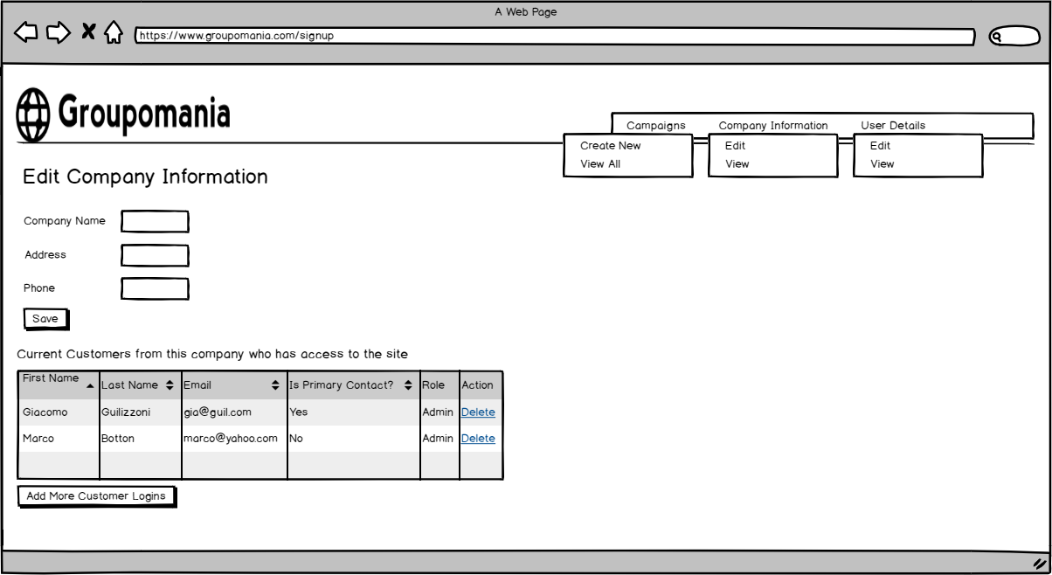

Edit User Info
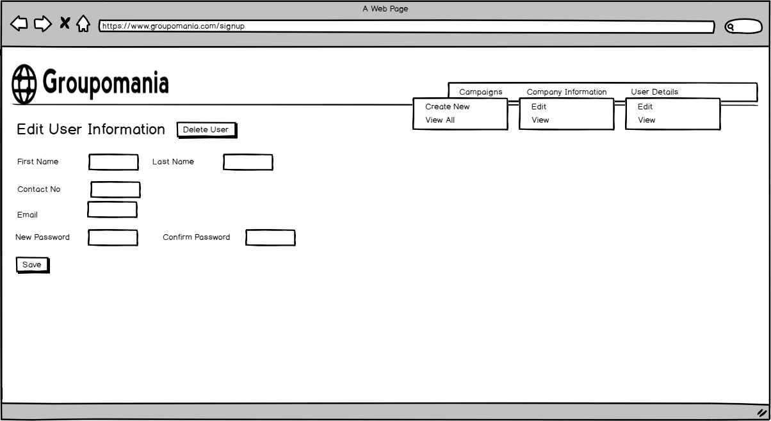

Appendix A – Use cases in a table format with more detail

Use case # 1
Goal | New customer sign-up
Summary | This use case represents the customer signing-up so that the same customer can login and thus interact with the system and use the features provided by it.
Actor | Customer
Preconditions | Customer has not signed up before and does not exist in the system
Descriptions (Steps) | - Customer requests for the sign-up page  - System shows the sign-up page that contains a form  - Customer fills out all the mandatory fields of the form  - Customer clicks on “Sign-Up” button  - System shows the message “Thank you for signing-up. Our team will verify your business and enable your account soon”.  - Groupomania Admin reviews the customer and marks the account as either ‘Verified’ or ‘Rejected’.
Exception 1 | Validation errors as a result of below conditions:  User did not fill all mandatory fields  Show error message on each required field as ‘<fieldname> is required’  Customer account already exists  If the customer account already exists, then customer gets the error message “Account already exists”. System checks this based on the email address. Email address of each onboarded customer must be unique.  Password and confirm password did not match  Show error message that ‘password and confirmed password didn’t match’.  Invalid Format for Email Address  Show error message that ‘Invalid email address’.
Exception 2 | Groupon Admin verifies the customer as non-genuine  Customer verification is a manual process where Groupon Admin calls the contact person of the customer business and verifies the business address and its registered business number. If Groupon Admin finds the customer as non-genuine then the account does not get enabled. When the customer logs in, customer gets the message “Sorry! Your account did not get verify. Please call Groupon to discuss”
Postconditions | Customer account gets created and its status is either ‘Verified’ or ‘Rejected’

Use case # 2
Goal | Existing customer Signs in
Summary | This use case represents the existing customer signs in so that the same customer can interact with the system and use the features provided by it.
Actor | Customer
Preconditions | Customer has signed up before and exists in the system
Descriptions (Steps) | - Customer requests for the sign in page  - System shows the sign in page that contains a form with two fields. (1) Email (2) Password  - Customer fills out these mandatory fields of the form  - Customer clicks on “Sign In” button  - System shows the landing page if login details are correct
Exception 1 | Validation errors as a result of below conditions:  User did not fill all mandatory fields  Show error message on each required field as ‘<fieldname> is required’  Customer enters invalid email and/or password  System shows error message “Login was not successful. Please try again”  Customer enters invalid password for 5 times in a row  System locks the customer’s account and now customer must go through the forgot password use case.
Exception 2 | Customer’s status is Rejected as Groupomania Admin’s Verification was not successful.  Customer will see the message “Sorry! Your current status is not verified. Please contact us to discuss further”. Customer cannot do any other operation.
Postconditions | Customer logs in successfully and can see the landing page or only sees the error message depending upon customer’s verification status.

Use case # 3
Goal | Customer Resets Password
Summary | This use case represents the existing customer has forgotten password and want to reset it.
Actor | Customer
Preconditions | Customer has signed up before and exists in the system
Descriptions (Steps) | - Customer requests for the sign in page  - System shows the sign in page that contains a form with two fields. (1) Email (2) Password.  - System also shows a link for ‘Forgot password’  - Customer clicks on ‘Forgot password’ link  - System asks for Email address  - Customer enters the email address  - Customer clicks submit button  - System sends an email with a link that has a reset code  - Customer clicks on that link  - System shows a form for ‘Reset password’  - Customer enters reset code and new password  - Customer clicks submit button  - System saves the new password
Exception 1 | Validation errors as a result of below conditions:  User did not fill all mandatory fields  Show error message on each required field as ‘<fieldname> is required’  Customer enters invalid reset code  System shows error message “Invalid reset code. Please try again.”  Customer enters invalid reset code for 5 times  System locks the account which requires the customer to go through forgot password flow again and obtain a new reset code.
Postconditions | Customer can reset the password and system saves the new password.

Use case # 4

Goal | Customer Signs Out
Summary | This use case represents the existing customer has signed out
Actor | Customer
Preconditions | Customer has signed up before and exists in the system
Descriptions (Steps) | - Customer clicks on Sign out button  - System signs out and shows the landing page
Postconditions | Customer can sign out

Use case # 5
Goal | Create a campaign
Summary | A customer can create a campaign.  - A campaign can be of type ‘Offer’ or ‘Coupon’.  - If a campaign type is ‘Offer’ then it must have a ‘Price’. Otherwise price is not mandatory  - Both offer and coupon needs to have ‘Quantity Available’. This field can either be a number greater than zero or -1, where -1 represents the ‘Unlimited quantity available’  - A campaign also has following fields  - Start date: mandatory  - End date: mandatory  - Status: tracked by the system and updated according to a use case. could be Waiting for Approval, Approved, Activated, Deactivated, Completed  - ShouldDisplayAfterCompleted: optional, default is false  - Image: mandatory  - IsApproved: Not visible by the customer. Only Groupon Admin can update it.  - Detail: mandatory  - DiscountPercentage: mandatory if offer type is coupon  - DiscountText: user can choose whether to enter price/discount percentage or free text but not both  - Coupon validity period: capture start and end date  - Category type: capture category of a campaign
Actor | Customer
Preconditions | - Customer is signed-up and verified.  - Customer has not created up to 10 campaigns  - Customer is signed in
Descriptions (Steps) | - Customer requests for the ‘Create campaign’ page from the landing page menu  - System shows ‘Create campaign’ page  - Customer selects the campaign type and fills out all mandatory fields  - Customer clicks ‘Submit’ button  - System shows Preview screen  - Customer clicks Confirm button  - System creates the campaign
Exception 1 | Customer has already created 10 campaigns and attempts to create more  System shows error message “cannot create more than 10 campaigns”
Exception 2 | Customer selects the campaign type as ‘Offer’, chooses to enter price/discount percentage but does not enter ‘price’  System shows error ‘price is mandatory for offers’  Customer selects the campaign type as ‘Offer’, chooses discountText but does not enter ‘discountText  System shows error ‘discount text is mandatory’
Exception 3 | Customer selects ‘Unlimited quantity available’ instead of entering value for the available quantity  System shows warning ‘You have selected unlimited quantity’ before a campaign is created
Exception 4 | Campaign start date is not less than end date  System shows error ‘start date is not less than the end date’.
Exception 5 | Customer did not enter a mandatory field  System shows error ‘A field is required underneath the given field’.
Postconditions | A campaign gets created under the logged in customer’s account

Use case # 6
Goal | Approve a campaign
Summary | A Groupon Admin can approve a campaign.
Actor | Groupon Admin
Preconditions | A campaign is created earlier but not approved yet
Descriptions (Steps) | - Groupon Admin logs in and requests for list of unapproved campaigns.  - System shows the list of all unapproved campaigns by the customer  - Groupon admin decides which campaign to approve and then clicks on ‘Approve’ button  - System marks the campaign as ‘Approved’.
Exception 1 | Groupon Admin decides to reject a campaign  If the offer is not genuine or fraudulent then it can be rejected. Rejected campaigns cannot be activated.
Postconditions | A campaign now carries a status ‘Approved’ and is available for activation.

Use case # 7
Goal | Activate a campaign
Summary | A customer can activate a campaign.
Actor | Customer
Preconditions | A campaign is created and approved earlier but not activated yet
Descriptions (Steps) | - Customer logs in and requests for the list of campaigns  - System shows list of campaigns with its status  - Customer finds the campaign that is not activated yet and is the one that needs to get activated  - Customer clicks ‘Activate’ Button next to it  - System activates that campaign
Exception 1 | A campaign is already activated  System does not show ‘Activate’ button next to it.  A campaign is not approved  System does not show ‘Activate button next to it.
Postconditions | A campaign gets activated and will go live on its start date. Going live means that users of the system will start seeing this campaign in their search results.

Use case # 8
Goal | Deactivate a campaign
Summary | A customer can deactivate a campaign
Actor | Customer
Preconditions | A campaign is created and activated.
Descriptions (Steps) | - Customer logs in and requests for list of campaigns.  - System shows list of campaigns with its status.  - Customer finds the campaign that is already activated and is the one that needs to get deactivated  - Customer clicks ‘Deactivate’ Button next to it  - System deactivates that campaign
Exception 1 | A campaign is already deactivated  System does not show this campaign, takes it offline.
Postconditions | A campaign gets deactivated and will be taken offline. Users will not be able to see it in their search results. Once deactivated, a campaign cannot be activated again ever.  Deactivated campaigns remain available on customer’s account so that customer can use it as a guide for creating new campaigns later on.

Use case # 9
Goal | Edit a campaign
Summary | Customer can edit a campaign as follows  If campaign is not activated yet, then it can be edited  If campaign is activated but today is less than the start date, then also it can be edited.  If today is greater than or equal to start date, then following applies.  - Price cannot be edited.  - A detail of the campaign can be edited but only to address minor typos and editing goes through approval from Groupon Admin.
Actor | Customer
Preconditions | A campaign is created, approved and not activated yet Or  A campaign is activated but today is less than the start date
Descriptions (Steps) | - Customer logs in and requests for list of campaigns  - System shows list of campaigns that the same customer created  - Customer selects the campaign for editing  - Customer can update the fields and click ‘Save’ button  - System saves the new detail
Exception 1 | A campaign is activated and today is greater than or equal to start date  - Price cannot be edited.  - A detail of the campaign can be edited but only to address minor typos and editing goes through approval from Groupon Admin.
Postconditions | A campaign gets edited

Use case # 9
Goal | Complete a campaign
Summary | A campaign gets completed once its end date is reached.
Actor | Current Date is greater than or equal to End Date
Preconditions | A campaign is created, approved, and activated. It has gone live and users are getting it in their search results.
Descriptions (Steps) | - Today is greater than or equal to the start date of a campaign  - System marks that campaign as ‘Complete’
Postconditions | A campaign gets completed and will still be available in user’s search results for up to 4 days. After 4 days, it will be taken offline.

