[](http://www.ardentcollaborations.com/index.php)

* [Home](http://www.ardentcollaborations.com/index.php)
* [Profile](http://www.ardentcollaborations.com/profile.php)
* [Workshops](http://www.ardentcollaborations.com/workshops.php)
* [Why Ardent](http://www.ardentcollaborations.com/why_ardent.php)
* [VT 2013](http://www.ardentcollaborations.com/vt2013.php)
* [Summer Training 2013](http://www.ardentcollaborations.com/ArdentIT2013.PDF)
* [http://www.ardentcollaborations.com/images/rss.gif](http://www.ardentcollaborations.com/vt2013.php)

[http://www.ardentcollaborations.com/banner.gif](http://www.ardentcollaborations.com/liveprojects.php)

* [Home](http://www.ardentcollaborations.com/index.php)
* [About Us](http://www.ardentcollaborations.com/vt2013.php)
* [Workshop](http://www.ardentcollaborations.com/workshops.php)
* [Our Technical Team](http://www.ardentcollaborations.com/facilitators.php)
* [Trainings](http://www.ardentcollaborations.com/trainings.php)
* [Quick Links](http://www.ardentcollaborations.com/vt2013.php)
* [Contact Us](http://www.ardentcollaborations.com/contact.php)

News Updates[Registration for Summer Industrial Training 2013 is onhttp://www.ardentcollaborations.com/images/newsarrow.jpg](http://www.ardentcollaborations.com/vt2013.php)

* [VT 2013](http://www.ardentcollaborations.com/vt_2013.php)
* [Summer Training](http://www.ardentcollaborations.com/vt_2013.php)
* [Training Calendar](http://www.ardentcollaborations.com/course.php)

[Share with friends](http://www.ardentcollaborations.com/vt2013.php)

We at Ardent are committed to continually achieving higher quality standard in providing – Training & Consulting in Information Technology, Project Management and offering Staffing & Software Solutions ensuring customers’ delight every time.

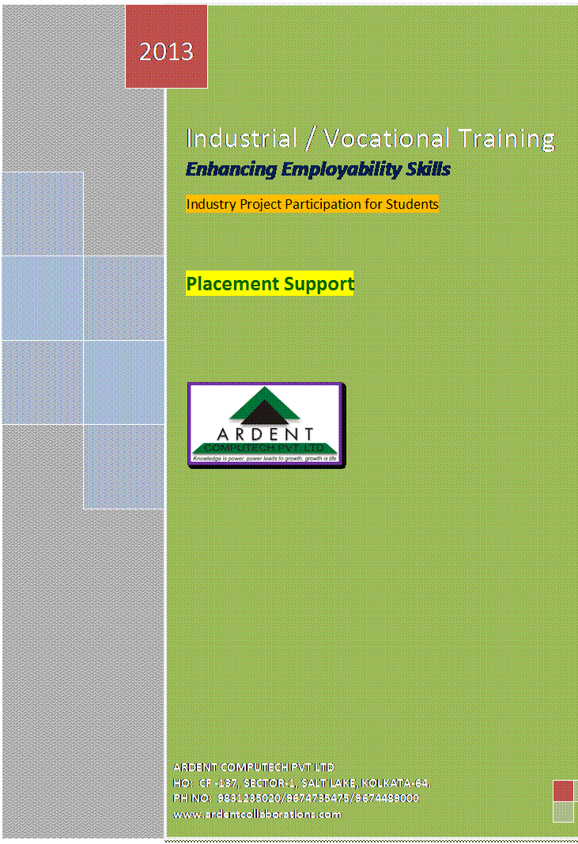

**ARDENT**offerslive**Project**based **Industrial Training** in different technologies for **MCA/BCA/BE/B.Tech/MSc (CS/IT/ECE ) s**tudents & professionals. If you are an engineering student or pursuing graduate/post-graduate level IT degree then you may have already heard the term **Industrial Training**.**Industrial Training** for **B.Tech** /**MCA/BCA/Engineering** students is important because it is the best way to acquire as much knows how about their field. As a **B.Tech**/**MCA/BCA/Engineering** student, training could help you to learn how to implement the concepts you learned at your classes. The meaning of Training is to learn a skill. Training is the act of increasing the knowledge and skill of a person for doing a particular job. Actual challenges appear when we have to develop real-world software. Training develops confidence in whatever we have learned. After completing training you will feel much confident about your field. So as much as possible, clear your confusions and get new ideas of your fields with the help of summer training, project training and become confident and sincere about your future. If someone is looking for quality training then he/she must visit Tech Mentor & to feel the difference between Rote and Conceptual Training.   
As Ardent has also a development wings and Ardent has successfully executed many software project & achieved a good name at outsourced market as well as the local market so we can provide a customized training program as per the requirement of your company.

**Training Modules**

|  |  |
| --- | --- |
| **Software and Networking Modules** | |
| **1** | **[Linux System Programming – Process, IPC, Sockets, Threads, MySQL connectivity, Debugging with GDB.](http://www.ardentcollaborations.com/contents/linux.docx)** |
| **2** | **[Android – Write Android apps, test in the emulator, download in device, and publish in the apps market.](http://www.ardentcollaborations.com/contents/android.docx)** |
| **3** | **[Java 7 with Oracle 11g – SPRING Framework, Aspect  Oriented Programming, Modelling with UML, Persistence with Oracle 11g.](http://www.ardentcollaborations.com/contents/java7.docx)** |
| **4** | **[JEE 6 specs with Servlet 3.0 and JSP 2.1 with POJO as MODEL Tier and JPA as DATA Tier.](http://www.ardentcollaborations.com/contents/jee.docx)** |
| **5** | [**Cloud Computing – Set up and Manage your own cloud.**](http://www.ardentcollaborations.com/contents/cloudcomputing.docx) |
| **6** | **[Oracle SQL- PL/SQL with front-end in C/Java.](http://www.ardentcollaborations.com/contents/oracle.docx)** |
| **7** | **[ASP.NET 4.5 with C# 2012 and Visual Studio 2012.](http://www.ardentcollaborations.com/contents/aspdotnet.docx)** |
| **8** | **[PHP 5 with OOP, Persistence with MySQL, AJAX, Wordpress.](http://www.ardentcollaborations.com/contents/php5.docx)** |
| **9** | **[Professional C.](http://www.ardentcollaborations.com/contents/professionalc.docx)** |
| **10** | **[Oracle Database Administration – DBA.](http://www.ardentcollaborations.com/contents/dba.docx)** |
| **11** | **[Exploring the IBM DB2 with front end in C / Java.](http://www.ardentcollaborations.com/contents/ibmdb2.docx)** |
| **12** | **[Oracle Form and Reports.](http://www.ardentcollaborations.com/contents/oracleformsandreports.docx)** |
| **13** | **[Networking with CISCO Tools.](http://www.ardentcollaborations.com/contents/Networking%20with%20CISCO%20Tools.docx)** |
| **Modules for - ECE, EE, AEIE, CSE, IT** | |
| **1** | [**Microcontroller based Embedded System Design and Practice.**](http://www.ardentcollaborations.com/contents/Microcontroller%20based%20Embedded%20System%20Design%20and%20Practice.docx) |
| **2** | [**FPGA Based VLSI and Embedded System Design & Simulation-USING XILINX Tool.**](http://www.ardentcollaborations.com/contents/FPGA%20Based%20VLSI%20and%20Embedded%20System%20Design%20&%20Simulation-USING%20XILINX%20TOOL.docx) |
| **3** | [**Programmable Logic Controller- PLC design and Practice.**](http://www.ardentcollaborations.com/contents/Programmable%20Logic%20Controller-%20PLC%20design%20and%20Practice.docx) |
| **4** | [**Advanced Electronic Circuit Design and Hardware Implementation.**](http://www.ardentcollaborations.com/contents/Advanced%20Electronic%20Circuit%20Design%20and%20Hardware%20Implementation.docx) |
| **5** | [**Telecommunication Network Management.**](http://www.ardentcollaborations.com/contents/tnm.docx) |
| **6** | [**Microprocessor.**](http://www.ardentcollaborations.com/MICROPROCESSOR.pdf) |

* We have around 4000 Sq ft area office in Kolkata, 2000 sq ft office in Durgapur & 2000 sq ft office at Bandel.
* Multiple labs with 20 computers in each.
* Library for students.
* 35 full time faculties. (M.Tech,B.Tech,MCA) and 10 Administrative and support staff.
* Branches: We have four branches in West Bengal (Salt Lake Kolkata Jadavpur (South Kolkata), Durgapur & Bandel) and one branch in Durgapur.
* **Training modules designed as  per Industry requirement.**
* **Industry approved infrastructure.**
* **Industry Evaluated Trainers.**
* **Project Guide & Evaluation by Industry Experts.**
* **Auto registration with Ardent Placement Cell.**
* **Project will be uploaded in Ardent Cloud.**
* **Special Advisor Team from  Tier 1  Corporate .**
* **Participate in Real Time Projects.**

**The Process**

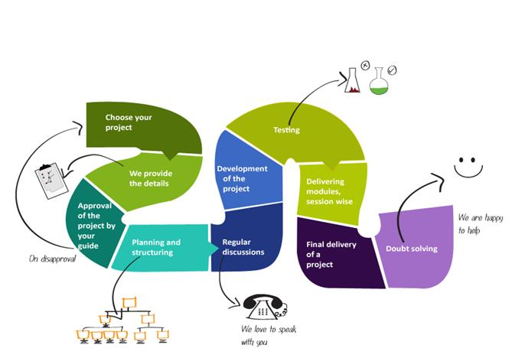

**Work on the cloud/get access to real time servers/host your projects on our cloud and access them from everywhere/live projects/get certified by Ardent and the clients/get placed/get mileage in the company you join.**

**Project Domains**

**Manufacturing**

Inventory Monitoring with Tracker

Supply Chain Management System

E-Procurement with Mobile Interface

Stock Monitoring and Administration

**Networking**

Peer-to-Peer Communication

Cache Proxy Server

Sniffer Firewall

Web Server for HTML hosting

Network Monitoring and Administrating

**Web Services**

XML web service connecting heterogeneous application

XML Web Service implementing middle tier of a 3-tier application

WCF connecting heterogeneous application (Windows Communication Foundation)

**Artificial Intelligence**

Expert Systems

Virtual Medical Diagnosis with learning

Security Analysis

Neural Network

Character Recognition

Security Analysis

**Mobile Computing**

Projects on MANET

AODV Simulation

Projects on Wireless Sensor Networks

**Mobile Applications**

Bluetooth Applications

Utilities

Games

**Web Applications**

Portal Development

E-Commerce Implementation

Interaction with Payment Gateways

CMS

Web Applications with WPF (Windows Presentation Foundation)

Exploring XAML with WPF

Service Oriented Architecture (SOA)

Applications on Spring Framework / Hibernate

**Information Management System**

Intelligence Management System

CMS (Customer Management System)

SCMS (Supply Chan Management System

Extended SCMS for JIT model (Just In Time)

HRM Recruitment module

HRM Payroll module

HRM

**Healthcare**

Data Repository and Data Mining

Information systems for Vaccination Programs

Any time information service

**Microcontroller (Interfacing with C Programming Language)**

Temperature Sensor

Automatic Factory Crane

Infrared based Remote Controlled Device

Design of Traffic Light System

**Fee Structure**

|  |  |
| --- | --- |
| **Per Student/Per Module** | Rs. 4500/- |
| **Duration** | As per university guideline. |

Payments to be made by Cash/Cheque/DD drawn in favor of “**ARDENT COMPUTECH PVT LTD”**, payable at Kolkata.  
**Registration Process:**   
  
[Register Online](http://www.ardent.info/onlineadmission.jsp)   
  
Industrial / Summer Training is a paid training program. Company will charge for the cost of seat, time and training from the students.

* Admission has started for for May / June/July 2013 batches .
* Download Registration Form at

<http://www.ardentcollaborations.com/admission_form.pdf>

* Deposit the registration amount of **Rs. 1000** in the below Bank:

**Bank Details**   
**Bank Name:-State Bank Of India**  
**Account Name:-Ardent Computech Pvt Ltd**  
**Account Number:- 31631857366**  
**Branch: - CF-351, Salt Lake, Kolkata-700064**  
**IFS Code:-SBIN001236**

* Send duly filled Registration Forms with original Bank Deposit Slip or Cheque or DD payable at par in favor of **Ardent Computech Pvt Ltd**, Payable at ,Kolkata in the following address:-

**ARDENT COMPUTECH PVT LTD**  
**CF-137, Second Floor,**  
**Sector – 1,**  
**Salt Lake, Kolkata-700064**

[http://www.ardentcollaborations.com/images/left_arrow.gif](http://www.ardentcollaborations.com/vt2013.php)

* [](http://www.ardentcollaborations.com/vt2013.php)
* [](http://www.ardentcollaborations.com/vt2013.php)
* [](http://www.ardentcollaborations.com/vt2013.php)
* [](http://www.ardentcollaborations.com/vt2013.php)
* [](http://www.ardentcollaborations.com/vt2013.php)
* [](http://www.ardentcollaborations.com/vt2013.php)
* [](http://www.ardentcollaborations.com/vt2013.php)
* [](http://www.ardentcollaborations.com/vt2013.php)
* [](http://www.ardentcollaborations.com/vt2013.php)
* [](http://www.ardentcollaborations.com/vt2013.php)
* [](http://www.ardentcollaborations.com/vt2013.php)
* [](http://www.ardentcollaborations.com/vt2013.php)
* [](http://www.ardentcollaborations.com/vt2013.php)
* [](http://www.ardentcollaborations.com/vt2013.php)

[http://www.ardentcollaborations.com/images/right_arrow.gif](http://www.ardentcollaborations.com/vt2013.php)

* [**Home**](http://www.ardentcollaborations.com/index.html)
* [**Profile**](http://www.ardentcollaborations.com/profile.php)
* [**Why ARDENT**](http://www.ardentcollaborations.com/why_ardent.php)
* [**Vision & Mission**](http://www.ardentcollaborations.com/vision_mission.php)
* [**Board of Directors**](http://www.ardentcollaborations.com/board_of_directors.php)
* [**History**](http://www.ardentcollaborations.com/history.php)
* [**Training Calendar**](http://www.ardentcollaborations.com/trainings.php)
* [**VT 2012**](http://www.ardentcollaborations.com/vtv_2012.php)
* [**Winter training 2012**](http://www.ardentcollaborations.com/wt_2012.php)
* [**Pre Placement Training**](http://www.ardentcollaborations.com/aiop.php)
* [**Admission Form**](http://www.ardentcollaborations.com/admission_form.pdf)
* [**Training Contents**](http://www.ardentcollaborations.com/training_contents.php)
* [**Our Strengths**](http://www.ardentcollaborations.com/our_strength.php)
* [**Terms and Conditions**](http://www.ardentcollaborations.com/termsandconditions.php)
* [**Privacy Policy**](http://www.ardentcollaborations.com/privacypolicy.php)
* [**Refund Policy**](http://www.ardentcollaborations.com/refundpolicy.php)
* 9674735475, 9674735471
* Ardent Computech Pvt. Ltd
* [**st@ardentcollaborations.com**](http://www.ardentcollaborations.com/vt2013.php)
* [**Google Maps**](http://www.ardentcollaborations.com/vt2013.php)

© 2013 [Ardent Computech Pvt. Ltd.](http://www.ardentcollaborations.com/vt2013.php) All Rights Reserved

[Top](http://www.ardentcollaborations.com/vt2013.php)

© 2013 [Ardent Computech Pvt. Ltd.](http://www.ardentcollaborations.com/vt2013.php) All Rights Reserved

[Top](http://www.ardentcollaborations.com/vt2013.php)

* **Follows us our servcies**
* [http://www.ardentcollaborations.com/images/facebook_icon.gif](http://www.ardentcollaborations.com/vt2013.php)
* [http://www.ardentcollaborations.com/images/linkedin_icon.gif](http://www.ardentcollaborations.com/vt2013.php)
* [http://www.ardentcollaborations.com/images/twitter_icon.gif](http://www.ardentcollaborations.com/vt2013.php)
* [http://www.ardentcollaborations.com/images/rssfeed_icon.gif](http://www.ardentcollaborations.com/vt2013.php)
* [http://www.ardentcollaborations.com/images/social_icon.gif](http://www.ardentcollaborations.com/vt2013.php)