1. Creating and Renaming Files/Directories
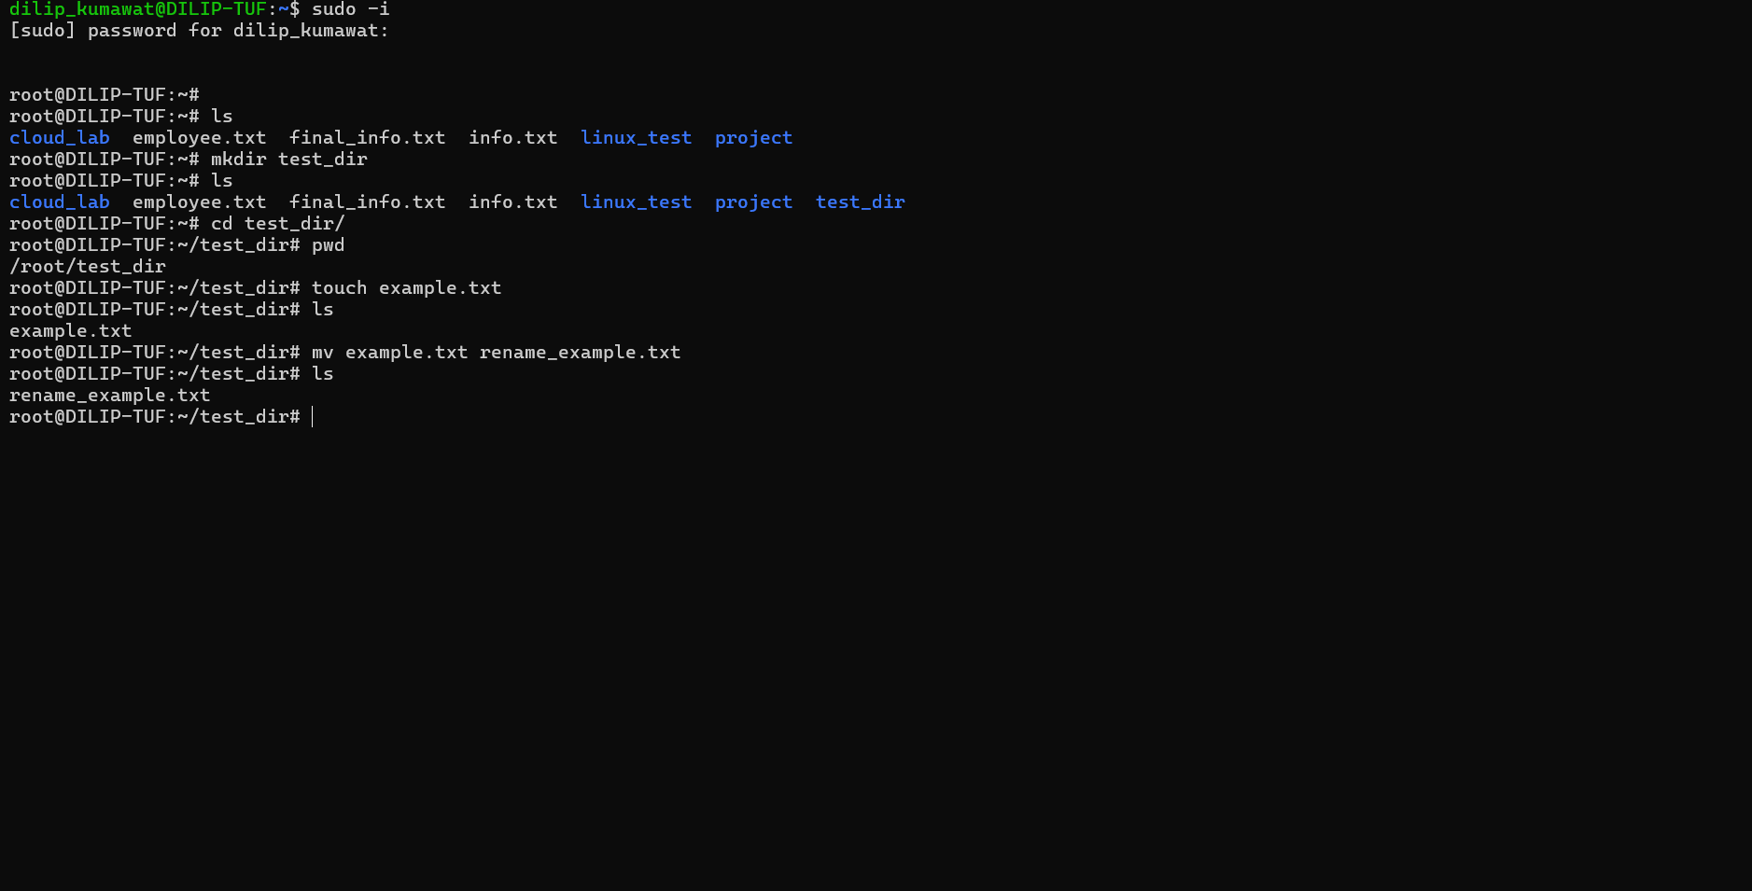
mkdir: Creates a directory.
cd: Changes the current directory.
touch: Creates an empty file.
mv: Renames or moves a file.
2. Viewing File Contents
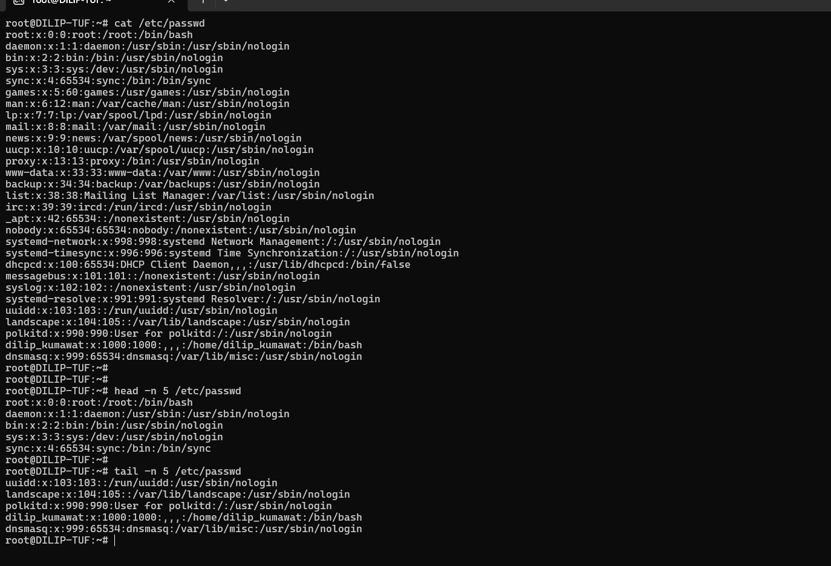
cat – Used to display the contents of a file.
head – Used to display the beginning lines of a file.
tail – Used to display the ending lines of a file.
3.Searching for Patterns
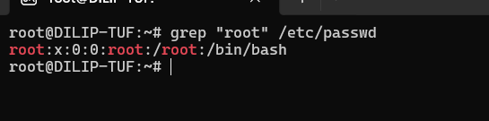
This command searches for all lines containing the word "root" in the /etc/passwd file and displays the matching lines.
grep – Used to search for specific words or patterns in a file.
4. Zipping and Unzipping
zip
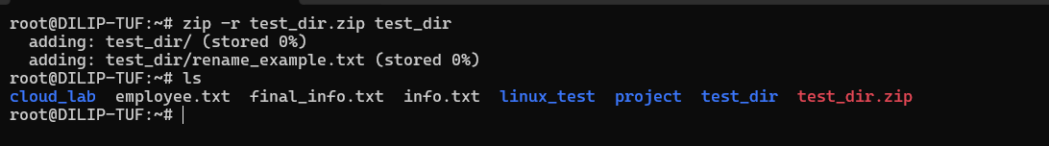
unzip
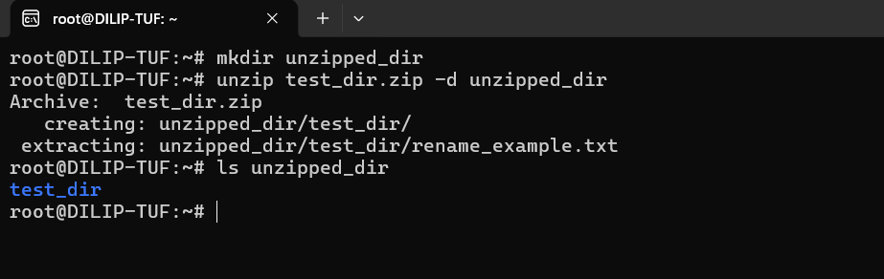
zip – Used to compress files and directories into a zip archive.
unzip – Used to extract files from a zip archive.
5. Downloading Files
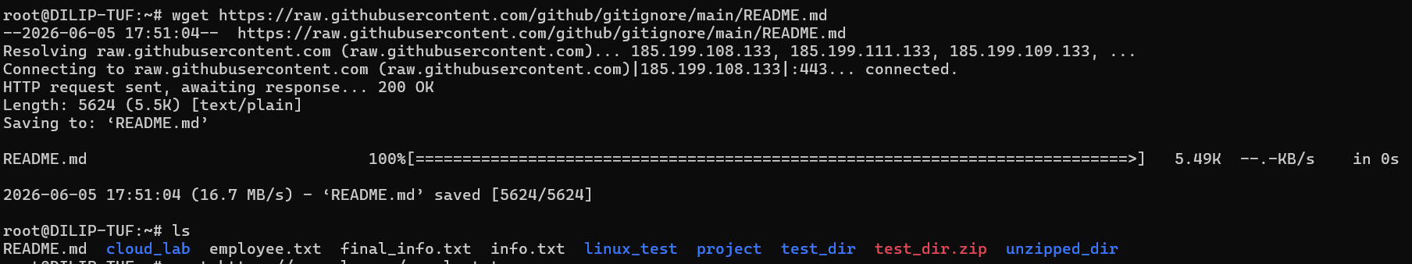
This command downloads a file from the specified URL and saves it in the current directory.
6. Changing Permissions
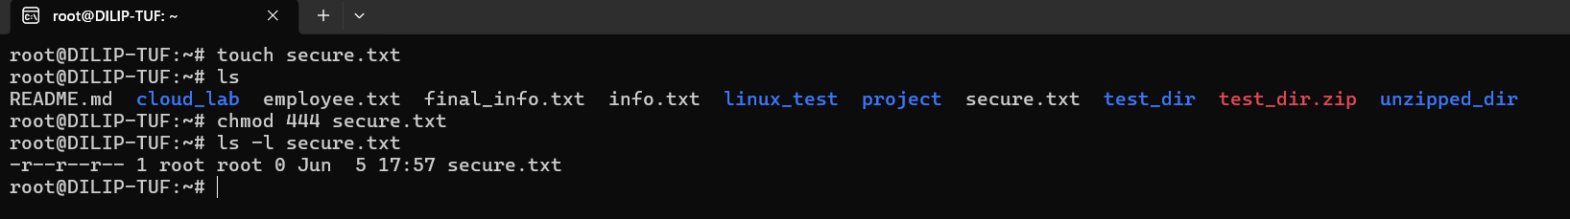
chmod – Used to change file and directory permissions.
7. Working with Environment Variables
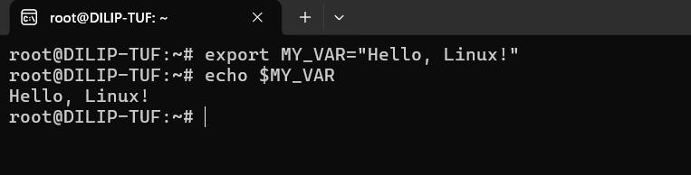
export – Used to create and set environment variables.
echo – Used to display the value of a variable.

