Contents

How to Install Git? 3

How to configure GIT ? 5

How to create Files ? 6

How to unset the configurations ? 6

How to create a local Repository ? 6

How to Track the file changes? 6

How to add a file to the Git Repository ? 6

How to add the updated files ? 6

How to commit the file to the repository ? 7

How to check the history of changes ? 7

To determine how many commits are made to the repository ? 9

What is HEAD ? 9

How to check the differences between the different commited version ? 9

How to remove files using Git ? 9

How to Rename File names? 9

How to undo the changes made ? 9

How to remove the current version and add the previous version as the latest ? 9

How to Clean the working Copy ? 10

Ignoring Files with .gitignore ? 10

How to clone the repository to local ? 11

How to View Commits ? 11

How to view list of changes made in a commit ? 11

Git Remote: 12

Git protocols: 12

How to view Branches ? 13

How to View Tags? 13

What is Origin ? 13

How to add the local repository to Remote? 13

Pull - How to get the updates made to the repository? 13

Push – How to push the changes to the remote repository ? 14

How to remove the origin ? 14

How to pull a remote ? 14

How to clear the console ? 14

To check? 14

Commands: 14

# How to Install Git?

Step 1 :

<https://git-scm.com/download/win>

Go to the above link and download the latest version as per the OS.

Step 2:

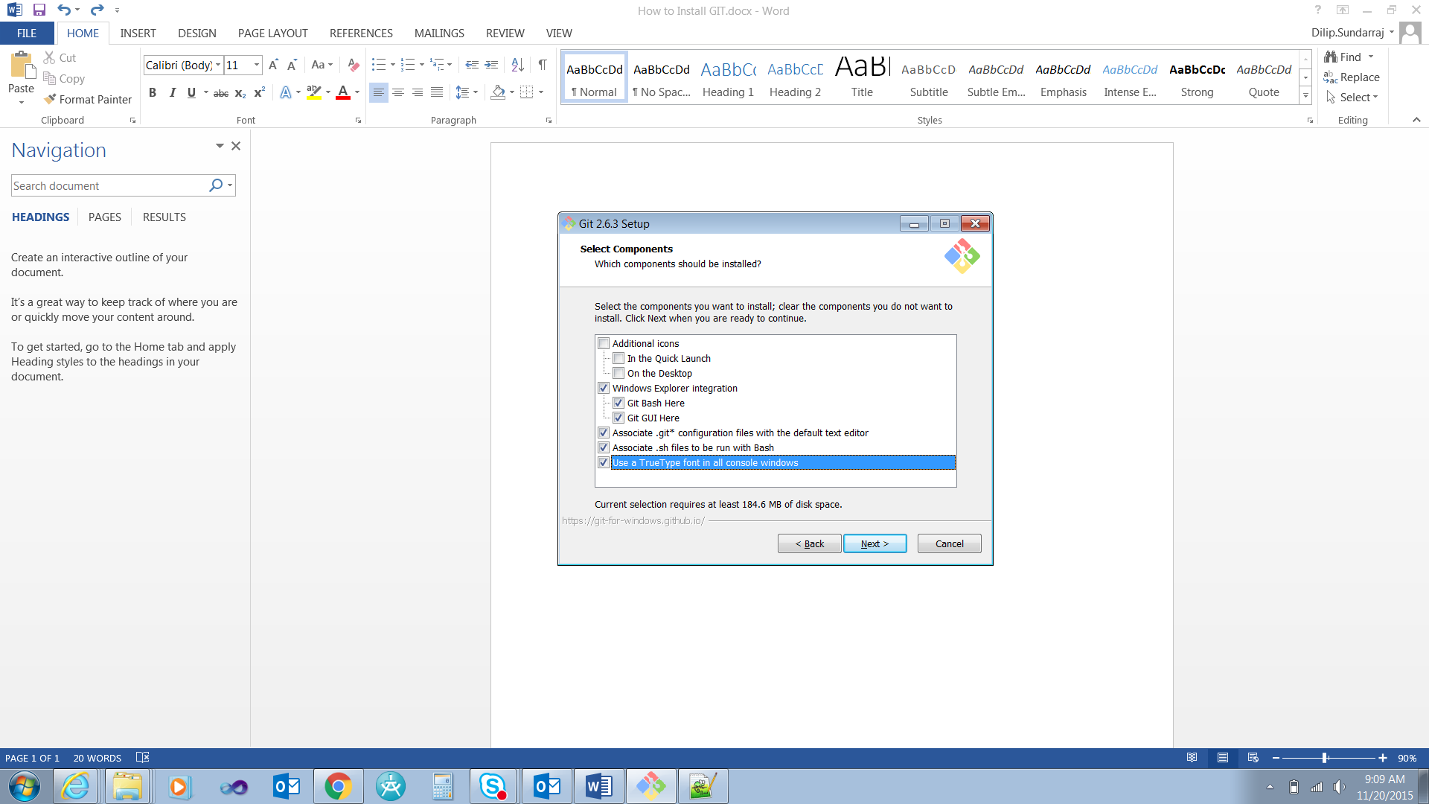

Step 3:



Step 4:



# How to configure GIT ?

**To set the user name for the GIT globally:**

DHC+Z001QGD@2QBZP12 MINGW64 /c/Dilip/Study/GIT (master)

$ git config --global user.name "Dilip Sundarraj"

$ git config --global –list:

This is used to list global variables for GIT in the system.

DHC+Z001QGD@2QBZP12 MINGW64 /c/Dilip/Study/GIT (master)

$ git config --global --list

user.name=Dilip Sundarraj

**To set the email:**

DHC+Z001QGD@2QBZP12 MINGW64 /c/Dilip/Study/GIT (master)

$ git config --global user.email [dilip.thelip@gmail.com](mailto:dilip.thelip@gmail.com)

**Auto** **Correct**:

The below command actually auto corrects if you mistype something.

It waits for one tenth of a second and auto corrects it. As per the below command it waits for 0.1 seconds and auto corrects it.

DHC+Z001QGD@2QBZP12 MINGW64 /c/Dilip/Study/GIT (master)

$ git config --global help.autocorrect 1

Eg.,

We mistyped statsu but it waited for 0.1 seconds and auto corrects it.

$ git statsu

WARNING: You called a Git command named 'statsu', which does not exist.

Continuing under the assumption that you meant 'status'

in 0.1 seconds automatically...

On branch master

Initial commit

Untracked files:

(use "git add <file>..." to include in what will be committed)

How to Install GIT.docx

~$w to Install GIT.docx

nothing added to commit but untracked files present (use "git add" to track)

**Color.ui:**

DHC+Z001QGD@2QBZP12 MINGW64 /c/Dilip/Study/GIT (master)

$ git config --global color.ui auto

**Crlf : (Carriage return line feed)**

**Read this is in GIt document.**

**For windows it is preferred to set it as true.**

**For Mac and Unix it is preferred to set it as false.**

DHC+Z001QGD@2QBZP12 MINGW64 /c/Dilip/Study/GIT (master)

$ git config --global core.autocrlf true

**To display the config:**

cat .git/config

vim .git/config

# Shortcuts : How to create Files ?

echo “Hello Again”> Readme.txt -> This will create the Readme.txt file with the Hello Again

touch file1.txt file2.txt -> This command creates two files.

## How to unset the configurations ?

Git config –unset user.name -> This command unsets the configuration variable from the configuration list.

# How to create a local Repository ?

DHC+Z001QGD@2QBZP12 MINGW64 /c/Dilip/Study/GIT (master)

$ git init

# How to Track the file changes?

Git status -> this command will tell you what are the untracked files in the repository.

Untracked files:

This tells the files mentioned are not in the repository and the files are not tracked by Git.

$ git status

On branch master

Initial commit

Untracked files:

(use "git add <file>..." to include in what will be committed)

How to Install GIT.docx

README.txt

~$w to Install GIT.docx

~WRL1961.tmp

nothing added to commit but untracked files present (use "git add" to track)

# How to add a file to the Git Repository ?

$ git add README.txt

# How to add the updated files ?

git add -u

# How to commit the file to the repository ?

$ git commit -m 'added readme'

# How to commit and add the file in one command?

DHC+Z001QGD@2QBZP12 MINGW64 /c/Dilip/Study/GIT (master)

$ git commit -am 'addinf and commiting together'

[master 4a02c31] addinf and commiting together

4 files changed, 1 insertion(+), 1 deletion(-)

delete mode 100644 ~WRL1961.tmp

# How to check the history of changes ?

Approach 1:

$ git log

commit 405ea2a3d6e2202194c15a910539876af48be7e9

Author: Dilip.Sundarraj <dilip.thelip@gmail.com>

Date: Fri Nov 20 13:33:32 2015 -0600

added readme

Approach 2:

DHC+Z001QGD@2QBZP12 MINGW64 /c/Dilip/Study/Git_PluralSight/Remote_Repository/gitTutorial (master)

$ git log --oneline

ec3d3a3 Merge pull request #2 from dilipthelip/news

c3cd16f added the news module

b64a57e Merge pull request #1 from dilipthelip/feature1

79d674c added new module

4370fcf added the file inside the folder

ef46c74 added this change

89d4a6b made changes

2da6825 added index.html

24dba1f Initial commit

Approach 3:

This will give you the graph option.

DHC+Z001QGD@2QBZP12 MINGW64 /c/Dilip/Study/Git_PluralSight/Remote_Repository/gitTutorial (master)

$ git log --graph

* commit ec3d3a37c064c4b9d3a54e38b59638340c9b147b

|\ Merge: b64a57e c3cd16f

| | Author: dilipthelip <dilip.thelip@gmail.com>

| | Date: Wed Aug 12 07:13:55 2015 -0500

| |

| | Merge pull request #2 from dilipthelip/news

| |

| | added the news module

| |

| * commit c3cd16f9d48a23133124d56b15224c84d7c72d8b

|/ Author: dilipthelip <dilip.thelip@gmail.com>

| Date: Wed Aug 12 06:46:45 2015 -0500

|

| added the news module

|

* commit b64a57e4400d727e12a1d354a180903978bf3b2f

|\ Merge: 4370fcf 79d674c

| | Author: dilipthelip <dilip.thelip@gmail.com>

| | Date: Wed Aug 12 06:42:29 2015 -0500

| |

| | Merge pull request #1 from dilipthelip/feature1

| |

| | sasadadsadadded new module

| |

| * commit 79d674c4ab5ecbea9418c6aec05599fef61ea140

|/ Author: dilipthelip <dilip.thelip@gmail.com>

| Date: Wed Aug 12 06:31:13 2015 -0500

|

| added new module

|

* commit 4370fcfaf2a5091ac62414d9780fb390a49c424d

| Author: dilipthelip <dilip.thelip@gmail.com>

| Date: Tue Aug 11 17:35:08 2015 -0500

|

| added the file inside the folder

|

* commit ef46c7448391b00f6a0b804377218ada0c04f279

| Author: dilipthelip <dilip.thelip@gmail.com>

| Date: Tue Aug 11 16:37:01 2015 -0500

|

| added this change

|

* commit 89d4a6b25f34d98096aeb8f00f6c52f9c2c7472d

| Author: dilipthelip <dilip.thelip@gmail.com>

| Date: Tue Aug 11 16:13:38 2015 -0500

|

| made changes

|

* commit 2da682525ce742870bd943616a742bb4e28e2a91

| Author: dilipthelip <dilip.thelip@gmail.com>

| Date: Tue Aug 11 15:49:16 2015 -0500

|

| added index.html

|

* commit 24dba1f387d594f9ac46df9c21d86f012c34e3f3

Author: dilipthelip <dilip.thelip@gmail.com>

Date: Tue Aug 11 15:19:24 2015 -0500

Initial commit

Approach 4:

This is another view of the log. If there are multiple people involved in checking in the files then it will be listed down below.

DHC+Z001QGD@2QBZP12 MINGW64 /c/Dilip/Study/Git_PluralSight/Remote_Repository/gitTutorial (master)

$ git shortlog

dilipthelip (9):

Initial commit

added index.html

made changes

added this change

added the file inside the folder

added new module

Merge pull request #1 from dilipthelip/feature1

added the news module

Merge pull request #2 from dilipthelip/news

Approach 5:

git shortlog -sne

S -> summary

N ->order them by Numerically decreasing

E ->include email in the result

DHC+Z001QGD@2QBZP12 MINGW64 /c/Dilip/Study/Git_PluralSight/Remote_Repository/gitTutorial (master)

$ git shortlog -sne

WARNING: You called a Git command named 'shorlog', which does not exist.

Continuing under the assumption that you meant 'shortlog'

in 0.1 seconds automatically...

9 dilipthelip <dilip.thelip@gmail.com>

## To determine how many commits are made to the repository ?

The below command will tell you how many commits are made to the repository ?

DHC+Z001QGD@2QBZP12 MINGW64 /c/Dilip/Study/Git_PluralSight/Remote_Repository/gitTutorial (master)

$ git log --oneline | wc -l

9

# What is HEAD ?

The latest commit is known as HEAD.

Head~1 -> This is the version is the prior to the latest commit.

# How to check the differences between the different commited version ?

HEAD -> This is the latest committed version

DHC+Z001QGD@2QBZP12 MINGW64 /c/Dilip/Study/GIT (master)

$ git diff HEAD~1..HEAD

# How to remove files using Git ?

DHC+Z001QGD@2QBZP12 MINGW64 /c/Dilip/Study/GIT (master)

$ rm file2.txt

# How to Rename File names?

DHC+Z001QGD@2QBZP12 MINGW64 /c/Dilip/Study/GIT (master)

$ mv file file_updated.txt

# How to undo the changes made ?

Approach 1:

To undo the changes of one particular file

DHC+Z001QGD@2QBZP12 MINGW64 /c/Dilip/Study/GIT (master)

$ git checkout file_updated.txt

# How to remove the current version and add the previous version as the latest ?

**Approach 1:**

DHC+Z001QGD@2QBZP12 MINGW64 /c/Dilip/Study/GIT (master)

$ git reset --soft HEAD~1

This command removes the current HEAD version from the repository and updates it with the previous version.

**Approach 2:**

If you want to undo changes of multiple files then

Git reset –hard

# How to Clean the working Copy ?

DHC+Z001QGD@2QBZP12 MINGW64 /c/Dilip/Study/GIT (master)

$ git clean

fatal: clean.requireForce defaults to true and neither -i, -n, nor -f given; refusing to clean

git clean –n:

This will give you the message would remove the stray files

git clean –f:

This will remove the unstaged files from the working directory

# Ignoring Files with .gitignore ?

Add the .gitignore file in to the root path of the repository.

.gitignore file is a txt file.

Eg.,

I have added a logs folder to the root path.

$ git status

On branch master

Changes not staged for commit:

(use "git add <file>..." to update what will be committed)

(use "git checkout -- <file>..." to discard changes in working directory)

modified: How to Install GIT.docx

Untracked files:

(use "git add <file>..." to include in what will be committed)

logs/

~WRL1250.tmp

~WRL4044.tmp

no changes added to commit (use "git add" and/or "git commit -a")

I do not want to be considered as a tracked file. Add the below line in the .gitignore file.



After adding the /logs in the ignore file the log folder is not displayed in the untracked files section after you run the git status command.

DHC+Z001QGD@2QBZP12 MINGW64 /c/Dilip/Study/GIT (master)

$ git status

On branch master

Changes not staged for commit:

(use "git add <file>..." to update what will be committed)

(use "git checkout -- <file>..." to discard changes in working directory)

modified: How to Install GIT.docx

Untracked files:

(use "git add <file>..." to include in what will be committed)

.gitignore

~WRL1250.tmp

~WRL4044.tmp

no changes added to commit (use "git add" and/or "git commit -a")

Working Remotely with GIT:

# Clone : How to clone the repository to local ?

git clone <URL>

# How to View Commits ?

This will tell you what is the latest commit that has been made to the repository.

DHC+Z001QGD@2QBZP12 MINGW64 /c/Dilip/Study/Git_PluralSight/Remote_Repository/gitTutorial (master)

$ git show HEAD

commit ec3d3a37c064c4b9d3a54e38b59638340c9b147b

Merge: b64a57e c3cd16f

Author: dilipthelip <dilip.thelip@gmail.com>

Date: Wed Aug 12 07:13:55 2015 -0500

Merge pull request #2 from dilipthelip/news

added the news module

# How to view list of changes made in a commit ?

Follow the below steps:

DHC+Z001QGD@2QBZP12 MINGW64 /c/Dilip/Study/Git_PluralSight/Remote_Repository/gitTutorial (master)

$ git log --oneline

ec3d3a3 Merge pull request #2 from dilipthelip/news

c3cd16f added the news module

b64a57e Merge pull request #1 from dilipthelip/feature1

79d674c added new module

4370fcf added the file inside the folder

ef46c74 added this change

89d4a6b made changes

2da6825 added index.html

24dba1f Initial commit

DHC+Z001QGD@2QBZP12 MINGW64 /c/Dilip/Study/Git_PluralSight/Remote_Repository/gitTutorial (master)

$ git show 24dba1f

commit 24dba1f387d594f9ac46df9c21d86f012c34e3f3

Author: dilipthelip <dilip.thelip@gmail.com>

Date: Tue Aug 11 15:19:24 2015 -0500

Initial commit

**diff --git a/README.md b/README.md**

**new file mode 100644**

**index 0000000..27e4350**

**--- /dev/null**

**+++ b/README.md**

@@ -0,0 +1 @@

+# gitTutorial

# Git Remote:

This tells “Git” from where the code is fetched and pushed to.

DHC+Z001QGD@2QBZP12 MINGW64 /c/Dilip/Study/Git_PluralSight/Remote_Repository/gitTutorial (master)

$ git remote

origin

DHC+Z001QGD@2QBZP12 MINGW64 /c/Dilip/Study/Git_PluralSight/Remote_Repository/gitTutorial (master)

$ git remote -v

origin https://github.com/dilipthelip/gitTutorial.git (fetch)

origin https://github.com/dilipthelip/gitTutorial.git (push)

# Git protocols:

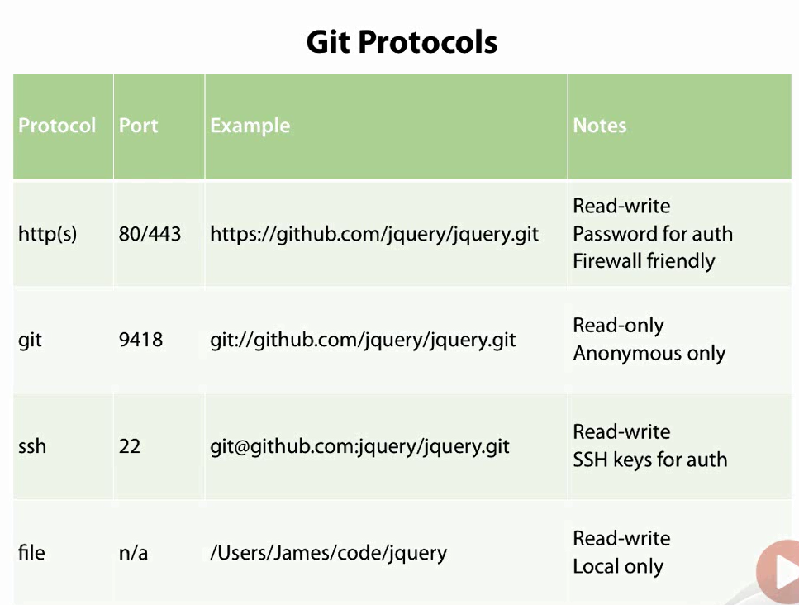

# Branches - How to view Branches ?

git branch -> This command will list of branches created for the repository.

DHC+Z001QGD@2QBZP12 MINGW64 /c/Dilip/Study/Git_PluralSight/Remote_Repository/gitTutorial (master)

$ git branch

* master

# Tags - How to View Tags?

Tags -> Tags are known points in your code base where we can often tag versions.

The below tag will list down the number of tags available for the repository

DHC+Z001QGD@2QBZP12 MINGW64 /c/Dilip/Study/Git_PluralSight/Remote_Repository/gitTutorial (master)

$ git tag

# What is Origin ?

**origin** is not the remote repository name. It is an alias given to the URL pointing to the default remote repository.

# Unstage – how to unstage a staged file ?

DHC+z001qgd@2QBZP12 MINGW64 /c/Dilip/Study/GIT (master)

$ git rm --cached How_to_Install_GIT_And_Commands.docx

# How to add the local repository to Remote?

Create the repository in github and get the clone url

<https://github.com/dilipthelip/git_pluralsight>

Approach 1:

DHC+Z001QGD@2QBZP12 MINGW64 /c/Dilip/Study/GIT (master)

$ git remote add origin <https://github.com/dilipthelip/git_pluralsight.git>

DHC+Z001QGD@2QBZP12 MINGW64 /c/Dilip/Study/GIT (master)

$ git push -u origin master

Approach 2: (SSh version)

# Pull - How to get the updates made to the repository?

Approach 1:

This will pull down any changes made to the remote repository.

DHC+Z001QGD@2QBZP12 MINGW64 /c/Dilip/Study/GIT (master)

$ git fetch

The below command will tell you the changes that has been made to the branch remotely by someone.

DHC+Z001QGD@2QBZP12 MINGW64 /c/Dilip/Study/GIT (master)

$ git log origin/master

How to get that in to our local working copy?

DHC+Z001QGD@2QBZP12 MINGW64 /c/Dilip/Study/GIT (master)

$ git merge origin/master

Updating 04698df..0480afd

Fast-forward

README.txt | 4 +++-

1 file changed, 3 insertions(+), 1 deletion(-)

Approach 2:

The below command gets the updates from the remote branch and updates the local repository.

DHC+Z001QGD@2QBZP12 MINGW64 /c/Dilip/Study/GIT (master)

$ git pull

remote: Counting objects: 3, done.

remote: Compressing objects: 100% (3/3), done.

remote: Total 3 (delta 1), reused 0 (delta 0), pack-reused 0

Unpacking objects: 100% (3/3), done.

From https://github.com/dilipthelip/git_pluralsight

0480afd..3ab3e2c master -> origin/master

Updating 0480afd..3ab3e2c

Fast-forward

README.txt | 1 +

1 file changed, 1 insertion(+)

**Scenario 1: (changes not committed)**

Changes not committed in local.

Git pull will always fail

**Scenario 2:**

Changes committed to the repository but not pushed to remote.

Git pull will automerge the changed lines in the file like below.

<<<<<<< HEAD

Changing it in local.

=======

Changing it in remote.

>>>>>>> 91903b3cf7072c0e816a441e5ddf7e128aa999d2

# Push – How to push the changes to the remote repository ?

warning: push.default is unset; its implicit value has changed in

Git 2.0 from 'matching' to 'simple'. To squelch this message

and maintain the traditional behavior, use:

git config --global push.default matching

To squelch this message and adopt the new behavior now, use:

git config --global push.default simple

Simple -> Pushes only the current branch.This is the preferable option.

Matching -> It will push all the branches to the remote branch and would merge them.

<http://stackoverflow.com/questions/21839651/git-what-is-the-difference-between-push-default-matching-and-simple>

DHC+Z001QGD@2QBZP12 MINGW64 /c/Dilip/Study/GIT (master)

$ git commit -am 'addinf and commiting together'

[master 4a02c31] addinf and commiting together

4 files changed, 1 insertion(+), 1 deletion(-)

delete mode 100644 ~WRL1961.tmp

DHC+Z001QGD@2QBZP12 MINGW64 /c/Dilip/Study/GIT (master)

$ git push

If changes are not pushed then we need to set the working directory to point to the correct branch.

DHC+Z001QGD@2QBZP12 MINGW64 /c/Dilip/Study/GIT (master)

$ git branch --set-upstream-to=origin/master master

Provide the credentials it will automatically push it to the branch

# How to remove the origin ?

DHC+Z001QGD@2QBZP12 MINGW64 /c/Dilip/Study/GIT (master)

$ git remote rm origin

# Tags – Creating and verifying Tags?

This is basically used to tag a commit point.

Regardless of whatever happens the tag version v1.0 always points to the commit point when the tag was created.

Approach 1:

DHC+z001qgd@2QBZP12 MINGW64 /c/Dilip/Study/GIT (master)

$ git tag v1.0

Approach 2:

In the below version it provides a tag with a message.

DHC+z001qgd@2QBZP12 MINGW64 /c/Dilip/Study/GIT (master)

$ git tag v1.0_message -m 'tag with version'

Approach 3:

Signing the tag – meaning some person signed and confirmed this is the official 1.0 release.

Follow the below link and set up few stuff

<http://stackoverflow.com/questions/12061645/generating-a-gpg-key-for-git-tagging>

Please re read it again. It did not work.

# Tags – Verifying tag :

-v is used to verify tag.

DHC+z001qgd@2QBZP12 MINGW64 /c/Dilip/Study/GIT (master)

$ git tag -v v1.0_message

object b2fd4bbea33c34818ab88a08298ae8129271f311

type commit

tag v1.0_message

tagger dilipthelip <dilip.thelip@gmail.com> 1448551517 -0600

tag with version

error: no signature found

error: could not verify the tag 'v1.0_message'

# Tag – Pushing tags to Remote :

DHC+z001qgd@2QBZP12 MINGW64 /c/Dilip/Study/GIT (master)

$ git push –tags

This will push the tag to the remote.

# Branch : Visualizing Branches:

DHC+Z001QGD@2QBZP12 MINGW64 /c/Dilip/Study/GIT (master|MERGING)

$ git log --graph --oneline --all --decorate

# Alias: setting in GIT:

This get alias lga a defined value like below.

DHC+Z001QGD@2QBZP12 MINGW64 /c/Dilip/Study/GIT (master|MERGING)

$ git config --global alias.lga "log --graph --oneline --all --decorate"

Alias : TO view it in git config.

DHC+Z001QGD@2QBZP12 MINGW64 /c/Dilip/Study/GIT (master|MERGING)

$ cat ~/.gitconfig

# Branch: Creating Local Branch:

The below command creates a local branch

DHC+Z001QGD@2QBZP12 MINGW64 /c/Dilip/Study/GIT (master)

$ git branch feature1

# Branch : How to switch between branches?

“git checkout” will make you switch between branches.

DHC+Z001QGD@2QBZP12 MINGW64 /c/Dilip/Study/GIT (master)

$ git checkout feature1

# BRANCHES VS TAGS :

|  |  |
| --- | --- |
| Branches | Tags |
| This will create branch and follow the commits made to the branch. | This is like a reference which points to one commit. |
|  |  |

# How to pull a remote ?

# How to clear the console ?

Clear

# To check?

How to remove the initialized repository ?

How to handle conflicts?

Scenario 1:

1. Modify the file in Git hub
2. Modify the same file in local and do not commit or stage the file.
3. Git pull request

This will not let you update the file in the local. Git will notify you to push the change or stage the change to the GIT repository.

Scenario 2:

1. Add a new file in local.
2. Modify a different file in git hub
3. Pull request.

# Commands:

Cat:

Cat command is used to read one or more files and display it in the standard output.