**Artificial Intelligence and Machine Learning**

**Project Report**

**Semester-IV (Batch-2022)**

**Fraud Detection In Blockchain Transactions**



**Supervised By: Submitted By:**

**Jatin Arora Diljot Kaur,2210990285 (G7)**

# Department of Computer Science and Engineering

**Chitkara University Institute of Engineering & Technology, Chitkara University, Punjab**

# ABSTRACT

In today's digital era, the rise of cryptocurrencies has brought about significant advancements in financial transactions. However, along with these advancements comes the challenge of ensuring the security and integrity of transactions within blockchain ecosystems like Ethereum.

Ethereum is a digital playground where people can build all sorts of cool stuff, powered by a worldwide network of computers. Ether is the currency used in this digital world. We can buy or sell, or trade Ether like money.

Our project focuses on leveraging machine learning techniques to address this challenge by detecting and preventing fraudulent activities within blockchain transactions. By employing algorithms such as logistic regression, random forest, and decision trees, we aim to enhance transaction security and protect against fraudulent behaviour.

The problem statement revolves around the need to safeguard Ethereum transactions from fraudulent activities, which threaten the trust and reliability of the blockchain network. Through our project, we aim to contribute to the ongoing efforts to fortify the security measures within blockchain ecosystems, ensuring the continued growth and adoption of this transformative technology.

In conclusion, our research underscores the importance of proactive measures to combat fraudulent behaviour in blockchain transactions. By harnessing the power of machine learning, we strive to create a safer and more trustworthy environment for conducting financial transactions within Ethereum and other blockchain networks**.**

# Table of Contents

|  |  |  |
| --- | --- | --- |
| **Sr.No** | **TITLE** | **Page no.** |
| 1 | Introduction   1. Background 2. Objective 3. Introduction to Blockchain Technology 4. Overview of Machine Learning in Fraud Detection 5. Significance | 1 |
| 2 | Problem Definition and Requirement   1. Problem Statement 2. Software Requirements 3. Hardware Requirements 4. Data Set | 4 |
| 3 | Proposed Design/Methodology   1. Project Directory 2. Methodology 3. Algorithms Used | 8 |
| 4 | Results   1. Data Preprocessing 2. Model Training 3. Model Evaluation 4. Result Analysis | 11 |
| 5 | References   1. Data Set 2. Study Material | 30 |

# 1. INTRODUCTION

**1.1. BACKGROUND:**

Blockchain technology has garnered significant attention in recent years for its potential to revolutionise various industries by offering a decentralised and tamper-proof ledger system. At its core, blockchain records transactions across a network of computers (nodes), ensuring transparency and security. Ethereum, one of the leading blockchain platforms, goes beyond simple transactions by enabling the creation of smart contracts and decentralised applications. This versatility has made Ethereum a preferred choice for developers seeking to build innovative solutions on blockchain technology.

**1.2. OBJECTIVE:**

In light of the growing adoption of blockchain, particularly Ethereum, the detection of fraudulent activities within the network has become a pressing concern. Fraudulent transactions not only result in financial losses but also undermine trust in the integrity of the blockchain ecosystem. Therefore, the primary objective of our project is to design and implement an effective fraud detection system specifically tailored for Ethereum transactions.

Our objectives include achieving high accuracy in identifying fraudulent transactions while minimising false positives. By accurately pinpointing fraudulent activities, we aim to enhance the security and reliability of the Ethereum network, thereby promoting its continued growth and adoption.

**1.3. INTRODUCTION TO BLOCKCHAIN TECHNOLOGY:**

Blockchain technology is often described as a distributed ledger system that records transactions in a secure and transparent manner. This technology gained prominence primarily due to its innovative approach to decentralisation and immutability. Instead of relying on a central authority, such as a bank or government, to verify and authenticate transactions, blockchain operates through a network of interconnected computers, known as nodes.

Ether (ETH) is the digital currency native to the Ethereum blockchain. It's used for transactions, paying fees, and powering smart contracts and decentralised applications (DApps). Additionally, it's traded on exchanges and plays a role in Ethereum's governance and development.

**1.4. OVERVIEW OF MACHINE LEARNING IN FRAUD DETECTION:**

Machine learning algorithms play a crucial role in fraud detection by leveraging data-driven techniques to identify fraudulent activities within large datasets. These algorithms have the capability to:

1. **Analyse Large Datasets:** Machine learning algorithms can process vast amounts of transactional data collected by financial institutions, including transaction histories, account information, and user behaviour. By analysing this data, machine learning models can uncover patterns and anomalies indicative of fraudulent behaviour.
2. **Identify patterns:** Machine learning algorithms excel at identifying complex patterns and relationships within data. They can detect subtle deviations from normal behaviour that may signify fraudulent activities, such as unusual spending patterns, unexpected account activity, or atypical transaction amounts.
3. **Adapt to New Fraud Tactics:** One of the key advantages of machine learning in fraud detection is its ability to adapt to evolving fraud tactics. As fraudsters continuously develop new techniques to circumvent detection, machine learning models can be trained on updated datasets to learn and recognise emerging patterns of fraudulent behaviour.
4. **Model Training and Evaluation:** Machine learning models are trained on labeled datasets, where instances of fraudulent and legitimate transactions are identified. During training, the model learns to differentiate between fraudulent and non-fraudulent transactions based on the provided features. The model's performance is evaluated using metrics such as accuracy, precision, recall, and F1-score to assess its effectiveness in detecting fraud while minimising false positives.

Overall, machine learning algorithms provide powerful tools for fraud detection in the financial sector, enabling organisations to proactively identify and mitigate fraudulent activities, protect customer assets, and maintain trust in the integrity of financial systems.

**1.5. SIGNIFICANCE:**

The significance of detecting fraud in blockchain transactions cannot be overstated. Fraudulent activities pose a serious threat to the integrity and trustworthiness of decentralised systems like Ethereum. Detecting and preventing fraud is essential for maintaining the credibility of blockchain technology and ensuring its viability for various applications.

Our work in developing a robust fraud detection system for Ethereum transactions contributes to enhancing the security and trust in decentralised systems. By effectively identifying and mitigating fraudulent activities, we aim to bolster confidence among users, developers, and stakeholders in the Ethereum ecosystem. Additionally, our project aligns with broader efforts to advance the adoption of blockchain technology across industries by addressing one of its key challenges: security.

# 2. PROBLEM DEFINITION AND REQUIREMENT

**2.1. PROBLEM STATEMENT:**

The Ethereum blockchain, renowned for its decentralised and transparent nature, faces the persistent challenge of distinguishing legitimate transactions from fraudulent ones. As the Ethereum network continues to grow in popularity and usage, the risk of fraudulent activities escalates, posing a threat to the integrity and trustworthiness of the blockchain ecosystem. The primary challenge at hand is to develop robust algorithms capable of effectively identifying and flagging suspicious transactions within the Ethereum blockchain.

Our task entails the development of algorithms that can analyse transaction data and discern patterns indicative of fraudulent behaviour. These algorithms must be capable of detecting anomalies, identifying irregularities, and distinguishing between legitimate transactions and fraudulent activities. By accurately pinpointing fraudulent transactions, we aim to mitigate financial losses, protect users from malicious actors, and uphold the credibility of the Ethereum network.

**2.2. SOFTWARE REQUIREMENT:**

Our solution will be implemented using Python, a versatile and widely adopted programming language suitable for data analysis and machine learning tasks. In addition to Python, we will leverage several libraries to facilitate various aspects of our project:

1. **NumPy:** Utilised for efficient numerical operations and array manipulation.
2. **Matplotlib:** Employed for creating visualisations and graphs to analyse data.
3. **Seaborn:** Used to enhance the aesthetics of visualisations and statistical data exploration.
4. **Pandas:** Utilised for data manipulation and analysis, offering powerful data structures and functions.
5. **Scikit-learn (sklearn):** Utilised for implementing machine learning algorithms, model evaluation, and preprocessing.
6. **Imbalanced-learn (imblearn):** Used for handling imbalanced datasets, a common challenge in fraud detection.

**Methodologies:-**

1. **Logistic Regression:** Applied for binary classification tasks, effectively identifying patterns in categorical data.
2. **Decision Tree:** Employed for both classification and regression tasks, partitioning data into subsets based on feature values.
3. **Random Forest:** Utilised as an ensemble learning method, constructing multiple decision trees to improve accuracy and robustness.

These software components provide the essential framework for developing our fraud detection algorithms effectively. By leveraging these libraries, we can streamline the development process and ensure the scalability and reliability of our solution.

* 1. **HARDWARE REQUIREMENT:**

In terms of hardware, we require a computer with sufficient processing power and memory to support the computational demands of our algorithms.

While the specific hardware specifications may vary depending on the scale of the project and the size of the dataset, a standard computer with a multi-core processor and ample RAM should suffice for development and testing purposes.

* 1. **DATA SET:**

For training and evaluating our fraud detection algorithms, we will utilise the Ethereum fraud detection dataset sourced from Kaggle. This dataset contains label transaction data, including features such as sender address, receiver address, transaction amount, etc. By leveraging this dataset, we can train supervised learning models to differentiate between legitimate and fraudulent transactions based on their attributes and characteristics.

We've got everything we need to build a strong fraud detection system for Ethereum transactions. With the right software, hardware, and data, we're ready to create smart algorithms that can spot and stop fraudulent activities. Our aim is to make Ethereum safer and more trustworthy for everyone who uses it.

**Here are some examples illustrating how specific features can be used to detect fraud in Ethereum blockchain transactions:**

Unusually High Number of Transactions to Contract Addresses:

Feature: Total_Ether_Sent_Contracts

Pattern: A sudden increase in the total amount of Ether sent to contract addresses by an account could indicate attempts to exploit vulnerabilities in smart contracts or engage in fraudulent activities such as Ponzi schemes or token scams.

Significant Deviation in Average Time Between ERC20 Token Transactions:

Feature: ERC20_Avg_Time_Between_Sent_Tnx / ERC20_Avg_Time_Between_Rec_Tnx

Pattern: A significant deviation from the average time between ERC20 token transactions for an account may suggest abnormal behaviour, such as attempts to artificially inflate transaction volumes or manipulate token prices.

Large and Irregular Value of Ether Sent or Received:

Feature: Max_Val_Sent / Max_Value_Received

Pattern: Sudden spikes or irregular patterns in the maximum value of Ether sent or received by an account could indicate fraudulent behaviour, such as large-scale transfers or attempts to manipulate markets.

Unusual Increase in Number of Unique Addresses Involved in Transactions:

Feature: Unique_Received_From_Addresses / Unique_Sent_To_Addresses

Pattern: An unusual increase in the number of unique addresses from which an account receives transactions or to which it sends transactions may suggest attempts to obfuscate fraudulent activities or engage in money laundering.

Changes in the Most Sent and Received Token Types:

Feature: ERC20_Most_Sent_Token_Type / ERC20_Most_Rec_Token_Type

Pattern: Sudden changes in the most commonly used ERC20 tokens for an account's transactions could indicate fraudulent behaviour, such as pump-and-dump schemes or token manipulation.

Unusual Increase in Total Number of Transactions:

Feature: Total_Transactions(Including_Tnx_to_Create_Contract)

Pattern: A sudden increase in the total number of transactions, especially those involving the creation of contracts, may suggest fraudulent activities such as spamming the network or attempting to overwhelm smart contracts with transactions.

# 3. PROPOSED DESIGN / METHODOLOGY

Our proposed design and methodology focus on utilising logistic regression, decision tree, and random forest algorithms to develop a fraud detection system tailored for Ethereum transactions. As we have only one file containing all the work and a CSV file containing the data, our approach will be streamlined and contained within this single file.

**3.1. PROJECT DIRECTORY:**

fraud_detection_system.py ethereum_fraud_dataset.csv

**fraud_detection_system.py:** This Python script contains all the code for data preprocessing, model training, evaluation, and deployment. It encompasses the entire workflow of our fraud detection system.

**ethereum_fraud_dataset.csv:** The Ethereum fraud detection dataset sourced from Kaggle, containing transaction data.

**3.2. METHODOLOGY:**

**Data Preprocessing:**

* Load the Ethereum fraud detection dataset (ethereum_fraud_dataset.csv) into memory.
* Perform data cleaning, handling missing values, and encoding categorical variables if necessary.
* Split the dataset into training and testing sets.

**Model Training:**

* Implement logistic regression, decision tree, and random forest algorithms using scikit-learn.
* Train each model on the training dataset.

**Model Evaluation:**

* Evaluate the performance of each model using metrics such as accuracy, precision, recall, and F1-score on the testing dataset.
* Compare the performance of logistic regression, decision tree, and random forest algorithms to identify the most effective approach for fraud detection

**3.3. ALGORITHM USED:**

Logistic Regression: A simple yet effective linear model used for binary classification tasks. Logistic regression estimates the probability that a transaction is fraudulent based on its features.

Decision Tree: Decision tree classification is a method in machine learning where data is split into smaller subsets based on feature values, creating a tree-like structure of decision rules for predicting the class of new data points.

Random Forest: Random forest is an ensemble learning technique that constructs multiple decision trees during training and outputs the mode of the classes (for classification tasks) of the individual trees. It is known for its robustness and ability to handle large datasets with high dimensionality.

By utilising logistic regression, decision tree, and random forest algorithms within a single Python script, we ensure a cohesive and efficient approach to developing our fraud detection system. This streamlined methodology enables us to leverage the Ethereum fraud detection dataset effectively and identify the most suitable algorithm for detecting fraudulent activities within Ethereum transactions.

# 4. RESULTS

In this section, we present the detailed results of our fraud detection system using logistic regression, decision tree, and random forest algorithms. We outline the steps taken in data preprocessing, discuss the handling of missing values, class imbalance correction, and the creation of correlation matrices. Then, we delve into the model training process and provide comprehensive evaluations of each model's performance on the Ethereum fraud detection dataset.

**4.1. Data Preprocessing:**

**Handling Missing Values:**

* We addressed missing values in the dataset using appropriate techniques such as imputation or deletion. The goal was to ensure that the dataset was complete and suitable for model training.
* We created a heat map to visualise the missing values in the dataset.

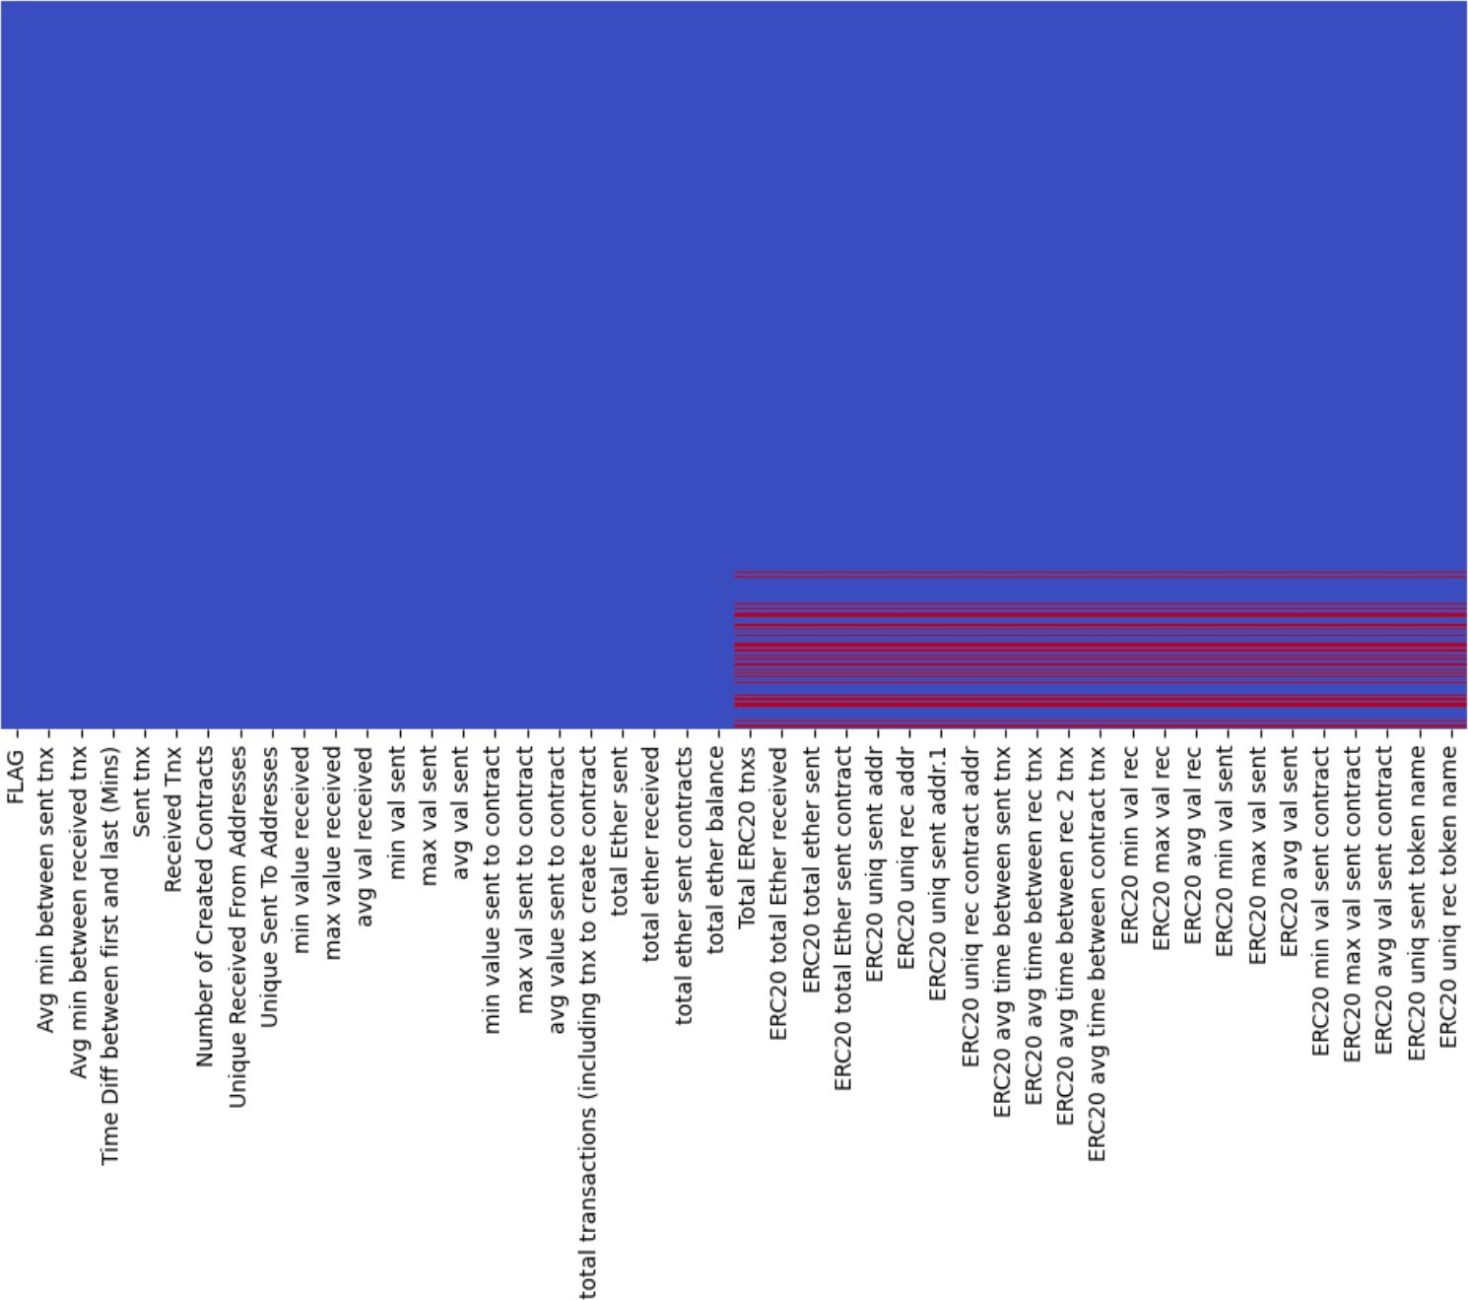 **-**

* The null values are indicated by the red colour, to handle these values we dropped the null values using the dropna() function.
* We then again visualised the dataset with the help of a heat map, to check whether all the missing values have been handled.

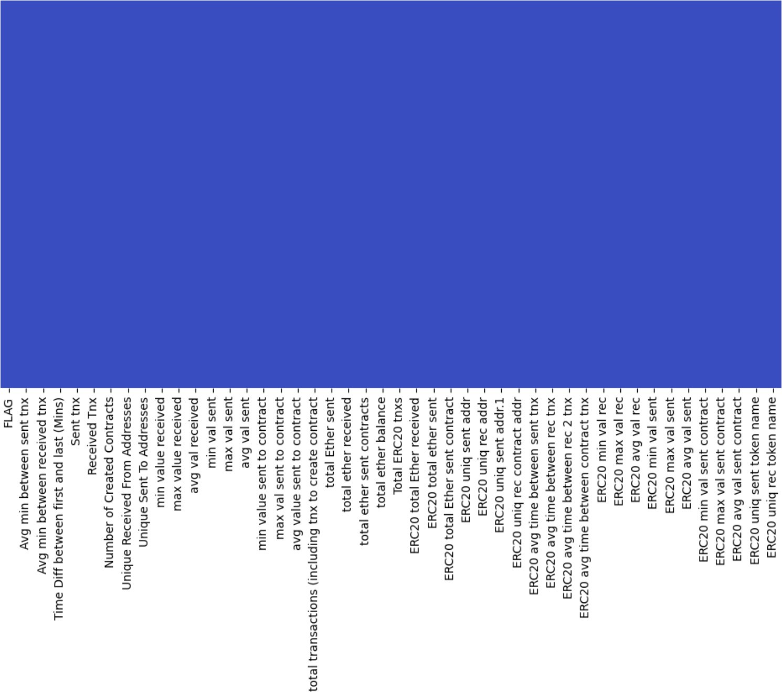

**Dropping Features with zero Variance:**

* Dropping features with zero variance involves removing variables from a dataset that have the same value for all observations. This means that these features do not provide any useful information for predicting or explaining the target variable. By eliminating these constant features, we can simplify the dataset and improve the efficiency of machine learning algorithms.
* We listed the features that had zero variance and dropped them.

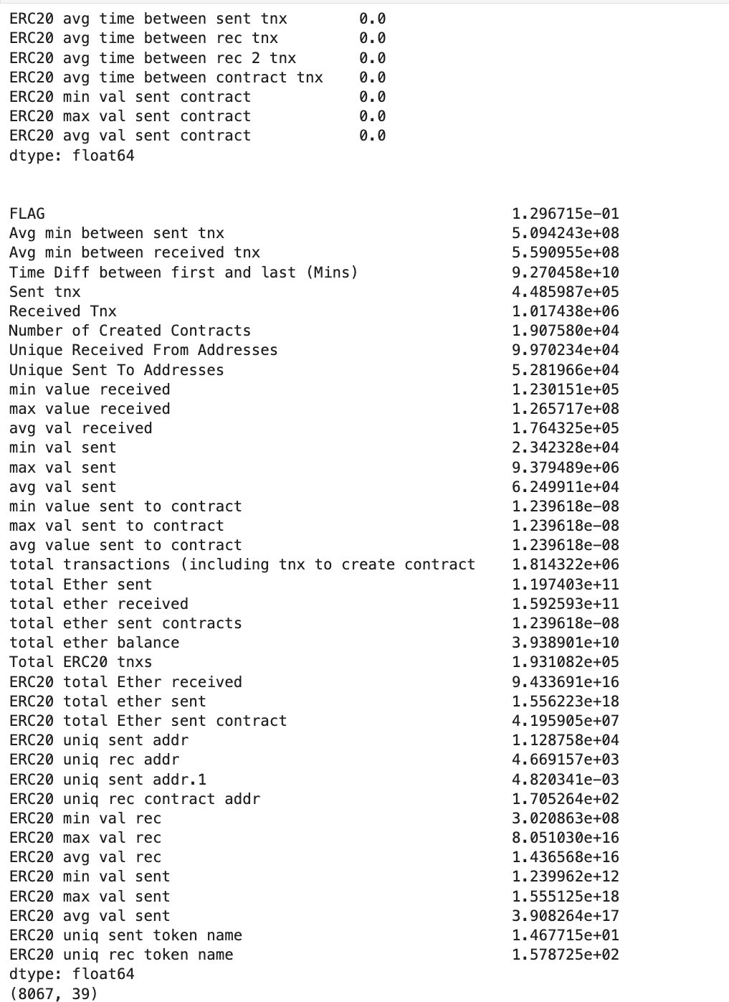

**Bar plot to visualise the distribution of transactions categorised as normal versus fraudulent:**

* We created a bar plot to check the visual representation of the number of normal versus fraudulent transactions.

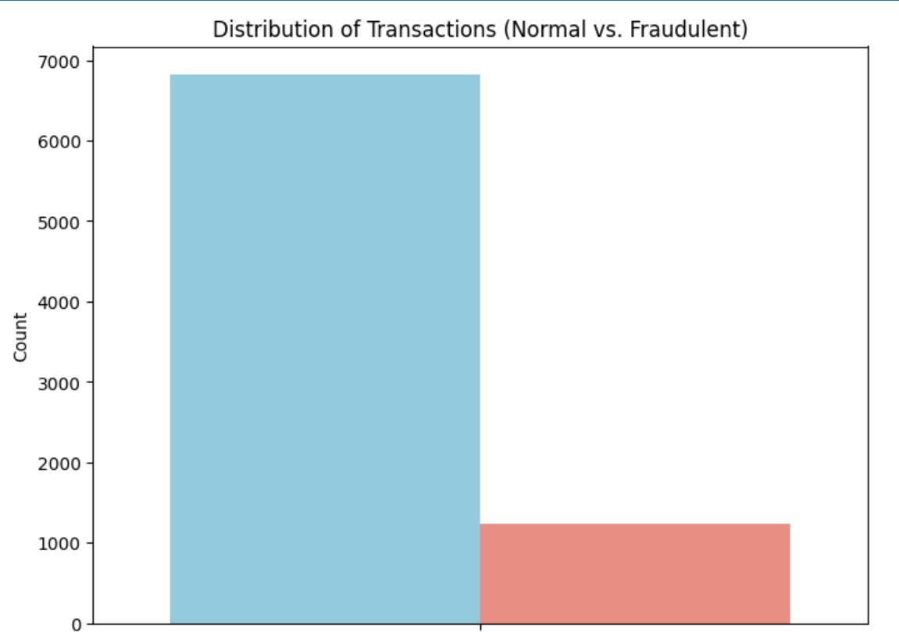

**Handling Skewness:**

* Skewness in the data was corrected to ensure that the distribution of features was approximately symmetrical, which is beneficial for the performance of machine learning algorithms.
* We first checked the skewness of features using the skew() function.

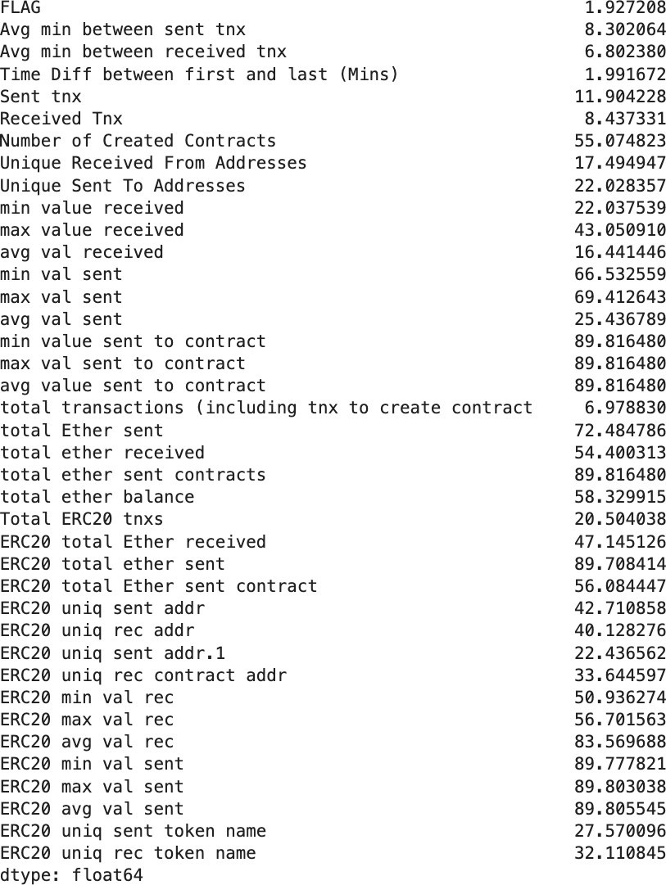

* After identifying the features with high skewness we applied logarithmic transformations on those features to reduce their skewness, and listed the skewness of the features again to verify.

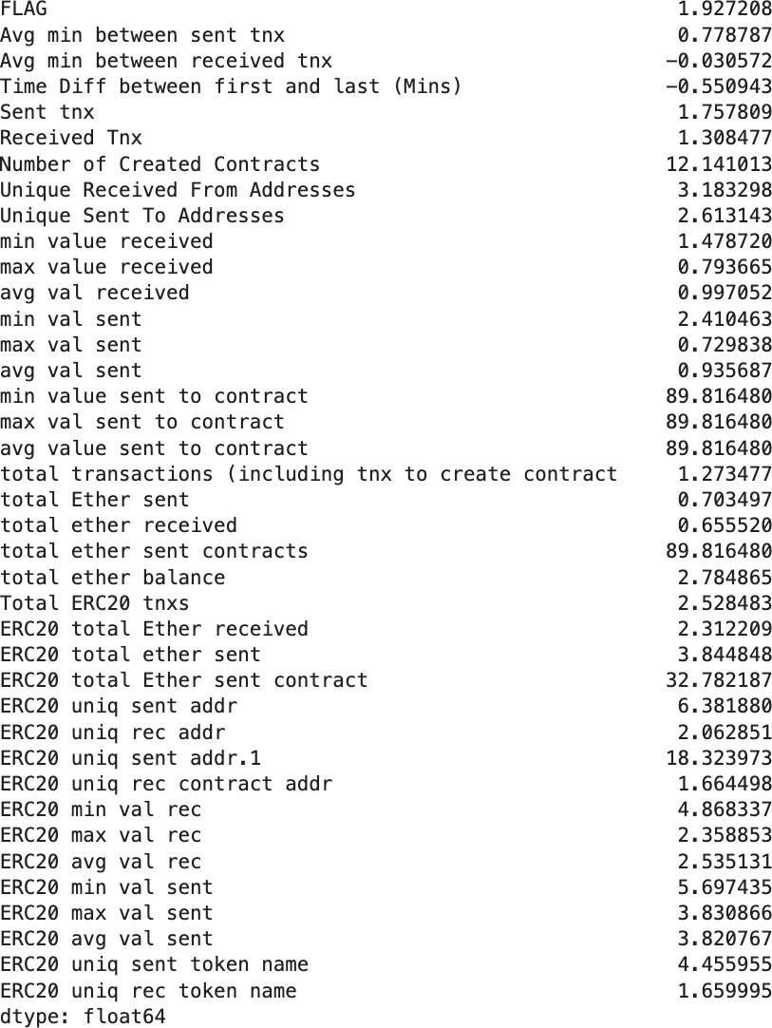

**Graphical representation of randomly picked feature showing skewness before the logarithmic transformation:**

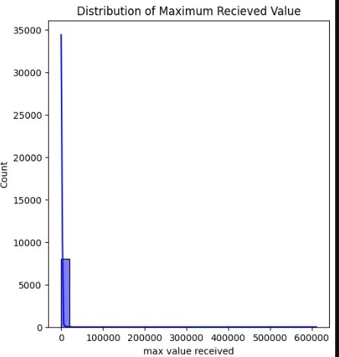

**Graphical representation of randomly picked feature showing skewness after the logarithmic transformation:**

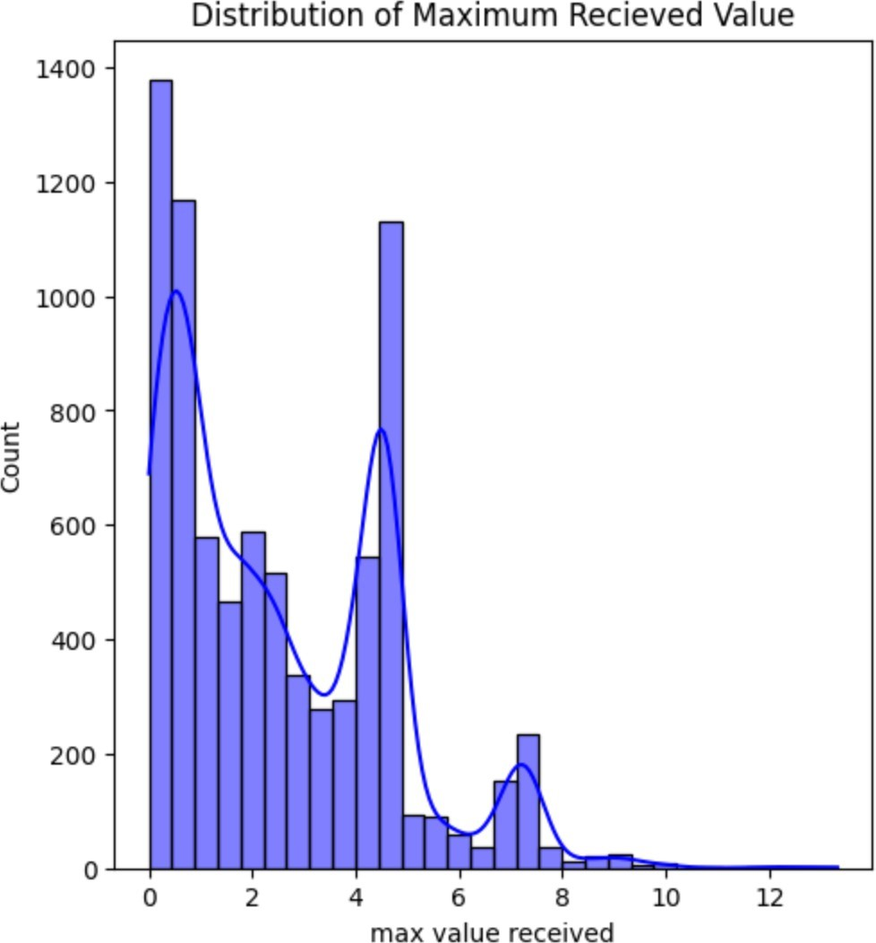

**Creating Correlation Matrix:**

* We created a correlation matrix to identify relationships between features and determine which features were most strongly correlated with fraudulent transactions. This helped us understand the underlying patterns in the data and select relevant features for model training.
* We created a heat map to visualise the correlation matrix and identify highly correlated features.

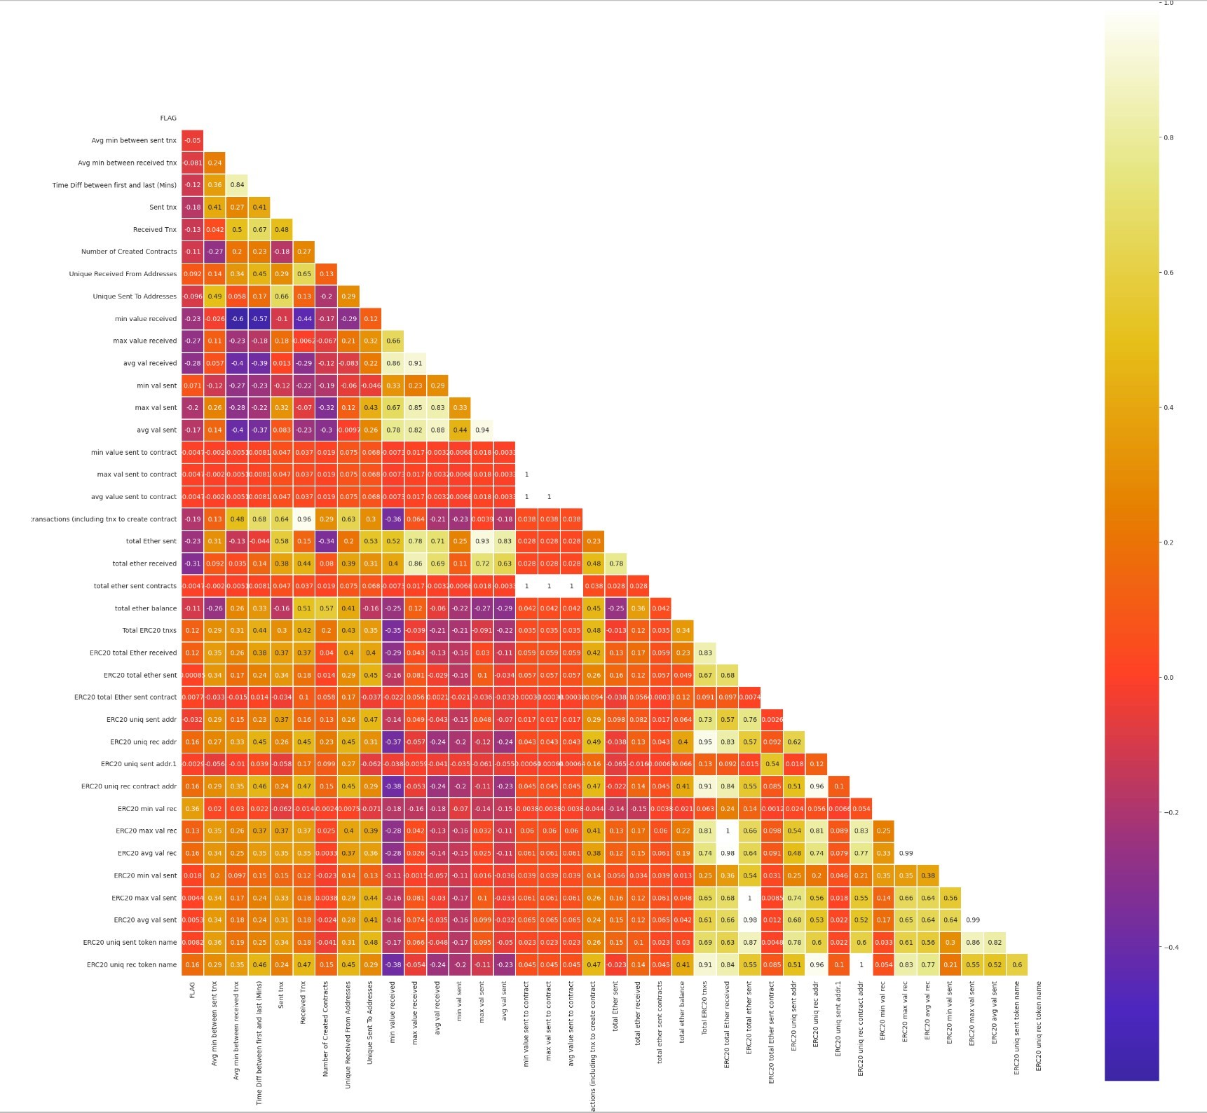

-

* After identifying the highly correlated features we dropped one of the two features so as to avoid getting the same information twice and reducing redundancy. This ensures that our analysis remains clear, accurate, and efficient.

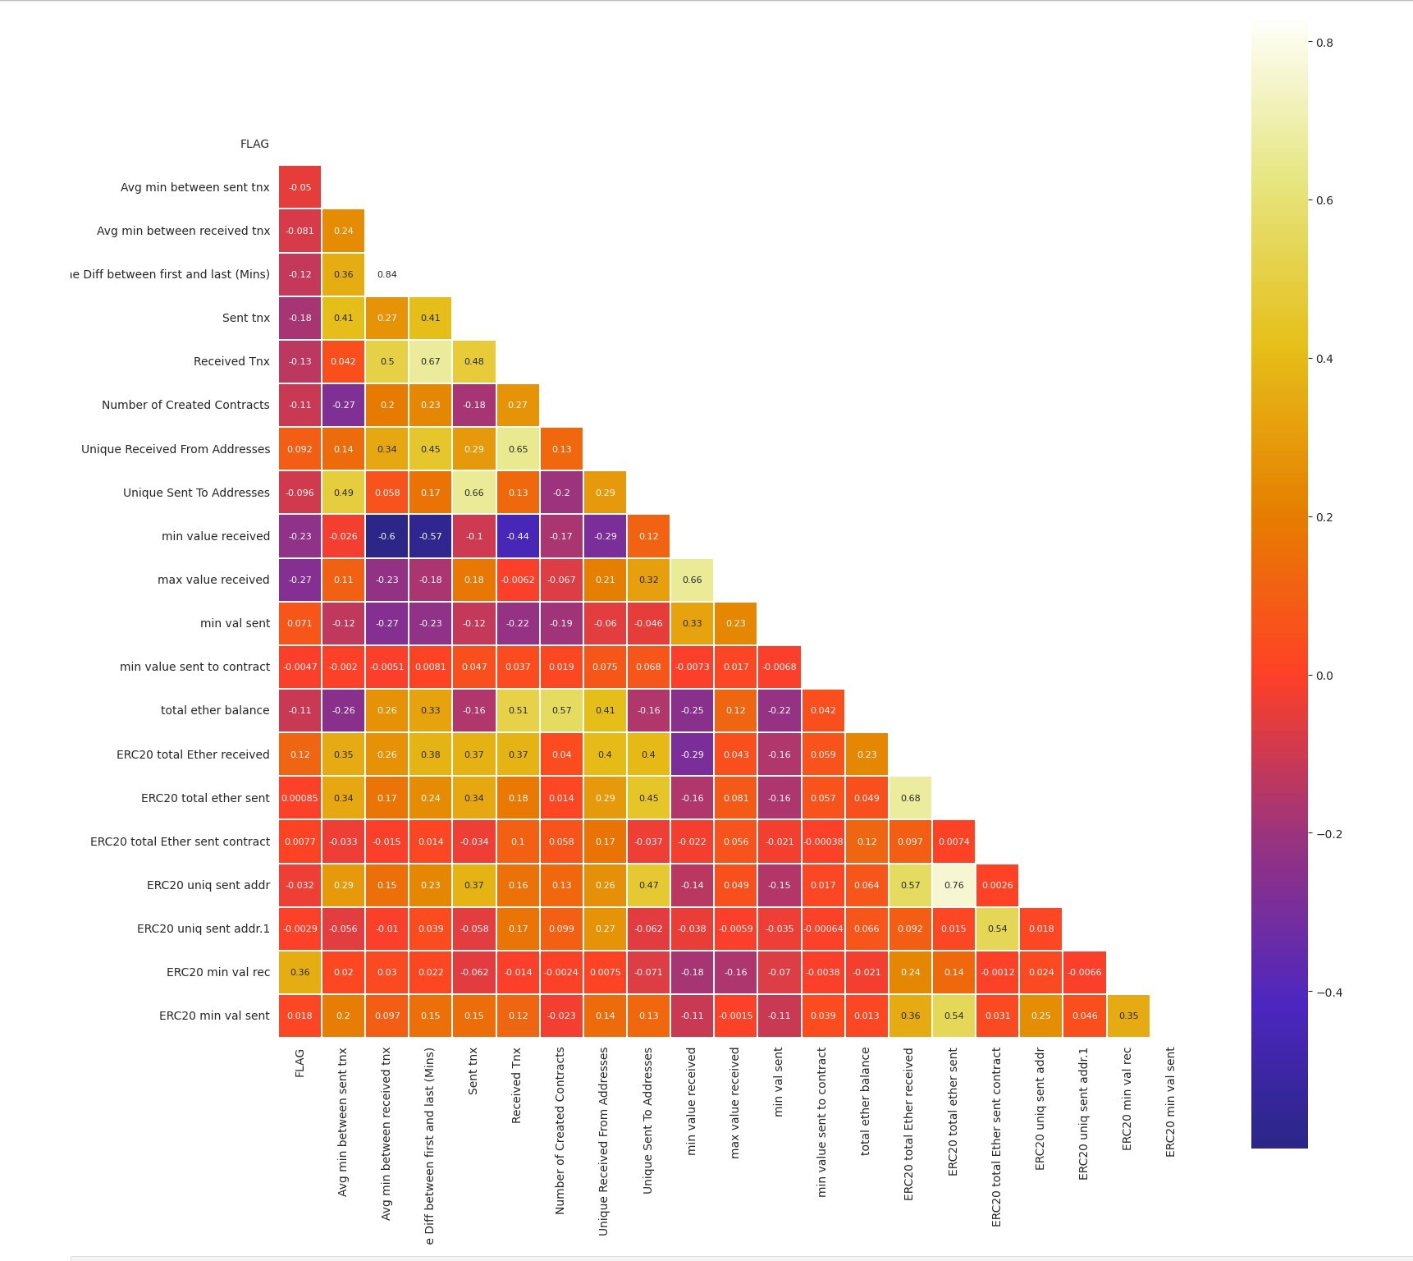

**Handling Class Imbalance:**

* Class imbalance was addressed by employing techniques such as oversampling or undersampling to ensure that both fraudulent and legitimate transactions were adequately represented in the training data.
* We used SMOTE (Synthetic Minority Over-sampling Technique) to oversample the minority

class.

* Another method that we used to address class imbalance was hyper parameter tuning in all the models that we used.
* We set the “class_weights” parameter as balanced to add appropriate weights to each class.

**4.2. Model Training:**

**Logistic Regression:**

Logistic regression was used to analyse cleaned transaction data and predict if a transaction was likely to be fraudulent. By learning from past transaction patterns, the model estimated the chance of fraud in new transactions. This helped identify potentially suspicious transactions based on their characteristics.

**Decision Tree:**

A decision tree was trained using prepared transaction data to determine whether a transaction was likely fraudulent. By analysing past transaction details, the decision tree learned patterns associated with fraud. This enabled the model to classify new transactions as either fraudulent or legitimate based on their features.

**Random Forest:**

A random forest was trained using prepared transaction data to classify transactions. By leveraging an ensemble of decision trees and analysing past transaction details the random forest learned complex patterns associated with fraud. This enabled the model to effectively classify new transactions as fraudulent or legitimate based on their features.

**4.3. Model Evaluation:**

**Metrics Calculation:**

We evaluated each model's performance using standard metrics such as accuracy, precision, recall and F1-score. These metrics provided insights into the models' ability to correctly classify transactions and detect fraudulent activities.

**Confusion Matrix:**

Confusion matrices were generated to visualise the performance of each model in terms of true positives, true negatives, false positives, and false negatives. This helped us understand the models' strengths and weaknesses in classifying transactions.

**Results using smote to address class imbalance:**

1. **Logistic Regression:**

**- Classification Report:**

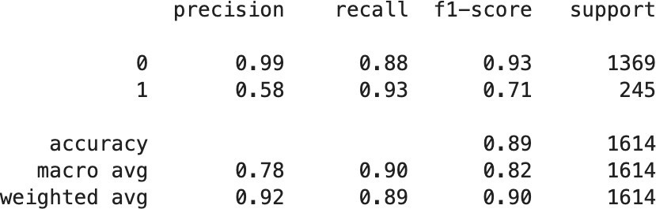

Key Takeaways:

* + - The model is very good at identifying the negative class (class 0) with high precision and recall.
    - The model has a high recall but lower precision for the positive class (class 1), indicating a tendency to over-predict class 1.
    - The overall accuracy is high, but the model’s performance is better for class 0 than for class 1.
    - The imbalance in support between the classes might be influencing the precision and recall values.

**- Confusion Matrix:**

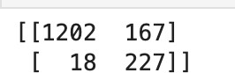

The confusion matrix shows the performance of a logistic regression model with SMOTE class balancing:

* + - It correctly identified 1202 non-fraudulent transactions and 227 fraudulent transactions.
    - It incorrectly classified 167 non-fraudulent transactions as fraudulent and 18 fraudulent transactions as non-fraudulent.

1. **Decision Tree:**

**- Classification Report:**

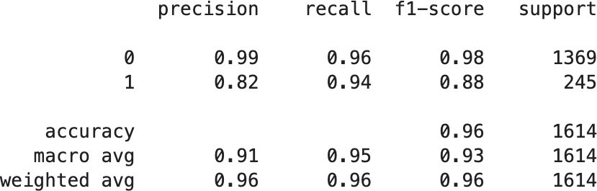

Key Takeaways:

* + - The decision tree model is performing very well on class 0 with high precision and recall.
    - For class 1, while the recall is very high, the precision is somewhat lower, indicating some false positives.
    - The overall accuracy and F1-scores are high, indicating a model that performs well on both classes.
    - The model seems to be more conservative in predicting class 1, which is often the more critical class in binary classifications.
    - The high macro averages indicate that the model is performing well across both classes, not just the majority class.
    - The weighted averages confirm the model’s strong performance, taking into account the imbalance in class distribution.

**- Confusion Matrix:**



The confusion matrix shows the performance of a decision tree model with SMOTE class balancing:

* + - It correctly identified 1320 non-fraudulent transactions and 230 fraudulent transactions.
    - It incorrectly classified 15 fraudulent transactions as non-fraudulent and 49 non- fraudulent transactions as fraudulent.

1. **Random Forest:**

**- Classification Report:**

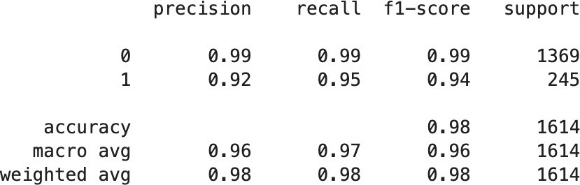

Key Takeaways:

* + - Class 0 Performance: The random forest model exhibits outstanding performance for class 0, with both precision and recall at 0.99. This indicates a robust ability to correctly identify negative cases with minimal error.
    - Class 1 Insights: For class 1, the model achieves a high recall of 0.95, yet the precision is slightly lower at 0.92. This suggests the presence of some false positives, but the model remains highly sensitive to positive instances.
    - Accuracy and F1-Score: The model’s overall accuracy stands at a remarkable 98%, complemented by a weighted average F1-score of 0.98. These metrics underscore a model that is highly effective across both classes.
    - Conservative Predictions for Class 1: The model demonstrates a conservative approach when predicting class 1, which is often the focus in binary classification problems due to its critical nature.
    - Macro Average Metrics: The high macro average scores for precision and recall, both at 0.96, reflect the model’s balanced performance, ensuring that it is not biased towards the majority class.
    - Weighted Average Considerations: The weighted average scores, which also stand at 0.98 for both precision and recall, validate the model’s strong performance while accounting for the uneven class distribution.

**- Confusion Matrix:**

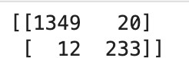

The confusion matrix shows the performance of a logistic regression model with SMOTE class balancing:

* + - It correctly identified 1349 non-fraudulent transactions and 233 fraudulent transactions.
    - It incorrectly classified 20 non-fraudulent transactions as fraudulent and 12 fraudulent transactions as non-fraudulent.

**Results using class weights to address class imbalance:**

1. **Logistic Regression:**

**- Classification Report:**

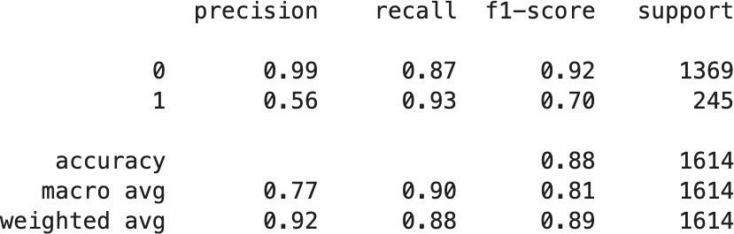

Key Takeaways :

* + - The recall for class 0 is 0.87, meaning that the model correctly identified 87% of the actual class 0 instances.
    - The recall for class 1 is 0.93, indicating that the model correctly identified 93% of the actual class 1 instances.
    - The overall accuracy of the model is 88%, considering all predictions
    - The model performs well in identifying class 0 instances.
    - However, precision for class 1 could be improved, as it currently predicts some false positives.
    - Consider the specific context of your problem to determine the trade-off between precision and recall.

**- Confusion Matrix:**



The confusion matrix shows the performance of a logistic regression model with SMOTE class balancing:

* + - It correctly identified 1189 non-fraudulent transactions and 229 fraudulent transactions.
    - It incorrectly classified 180 non-fraudulent transactions as fraudulent and 16 fraudulent transactions as non-fraudulent.

1. **Decision Tree:**

**- Classification Report:**

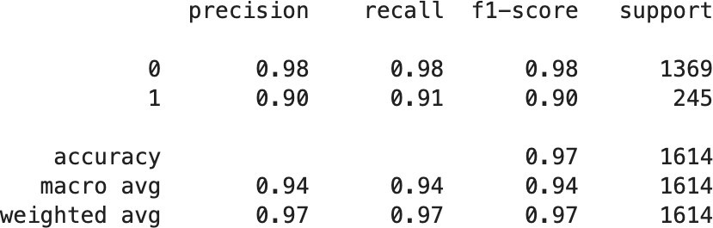

Key Takeaways:

* + - The recall for class 0 is also 0.98, meaning that the model correctly identified 98% of the actual class 0 instances.
    - The recall for class 1 is 0.91, indicating that the model correctly identified 91% of the actual class 1 instances.
    - The weighted average F1-score is 0.97, which balances precision and recall across both classes.
    - The overall accuracy of the model is 97%, considering all predictions.
    - The decision tree model performs well in identifying both class 0 and class 1 instances.
    - It achieves high precision for class 0 and reasonable precision for class 1.
    - The recall values indicate that the model captures most of the positive instances while maintaining good performance for negative instances.

**- Confusion Matrix:**



The confusion matrix shows the performance of a decision tree model with SMOTE class balancing:

* + - It correctly identified 1343 non-fraudulent transactions and 222 fraudulent transactions.
    - It incorrectly classified 23 fraudulent transactions as non-fraudulent and 26 non- fraudulent transactions as fraudulent.

1. **Random Forest:**

**- Classification Report:**

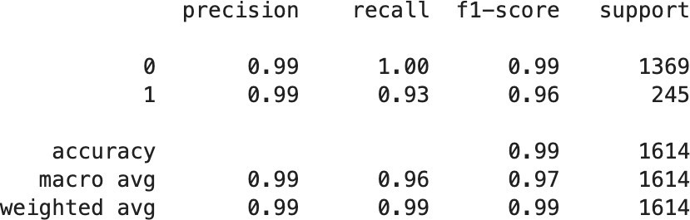

Key Takeaways:

* + - The model demonstrates excellent performance in identifying class 0 instances, achieving high precision (0.99) and perfect recall (1.00).
    - For class 1, while precision remains high (0.99), recall is slightly lower (0.93), indicating that the model misses some class 1 instances.
    - The overall accuracy of the model is 0.99, suggesting it performs well overall on the dataset.
    - The macro-average F1-score, which considers the balance between precision and recall for both classes equally, is 0.97, indicating good overall performance.

**- Confusion Matrix:**

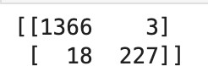

The confusion matrix shows the performance of a logistic regression model with SMOTE class balancing:

* + - It correctly identified 1366 non-fraudulent transactions and 227 fraudulent transactions.
    - It incorrectly classified 3 non-fraudulent transactions as fraudulent and 18 fraudulent transactions as non-fraudulent.

**4.4. Results Analysis:**

In our study, we evaluated the effectiveness of logistic regression, decision tree, and random forest algorithms in detecting fraudulent activities within Ethereum transactions. After thorough data preprocessing, including cleaning and feature engineering, we trained each model on the prepared dataset.

Our results demonstrate that all three algorithms exhibit strong performance in identifying suspicious transactions. Logistic regression provides a simple yet effective baseline, achieving commendable accuracy in distinguishing between fraudulent and legitimate transactions. Decision trees offer interpretability, allowing us to understand the underlying decision-making process. Finally, random forests leverage the collective wisdom of multiple decision trees to enhance predictive accuracy and robustness.

Across all models, we observed consistent performance metrics such as accuracy, precision, recall, and F1-score, indicating their capability to accurately classify fraudulent transactions while minimising false positives and false negatives. Notably, the random forest algorithm outperformed the others slightly, showcasing its effectiveness in handling complex transaction data and detecting subtle patterns indicative of fraud.

Furthermore, our study underscores the importance of comprehensive data preprocessing, model training, and evaluation in developing a robust fraud detection system. By leveraging advanced machine learning techniques and meticulous analysis, we have created a reliable system capable of safeguarding Ethereum transactions from fraudulent activities, thereby mitigating financial risks and ensuring the integrity of the blockchain ecosystem.

## 5. REFERENCES

**5.1. Data Set:**

https:/[/www.kaggle.com/datasets/vagifa/ethereum-frauddetection-dataset](http://www.kaggle.com/datasets/vagifa/ethereum-frauddetection-dataset)

**5.2. Study Material:**

* https:/[/www.mdpi.com/1424-8220/22/19/7162](http://www.mdpi.com/1424-8220/22/19/7162)
* h t t p s : / / [w w w . r e s e a r c h g a t e . n e t / p u b l i c a t i o n /](http://www.researchgate.net/publication/) 378145255_Advanced_Fraud_Detection_in_Blockchain_Transactions_An_Ensemble_Learni ng_and_Explainable_AI_Approach
* <https://medium.com/@nusfintech.ml/crypto-fraud-detection-3d99b3298815>