

Kwantlen Polytechnic University

School of Business

Assignment # 3

System Analysis and Design
INFO 1113 S11

Prepared by
Your Name: Diljot Singh Narula
Your Student ID: 100361707

Submitted to: Dr. Abhijit Sen
Submitted on: Nov 15,2018

Github links:
www.github.com/diljotnarula/testProject
www.github.com/usernameisarsh/testProject

© 2018

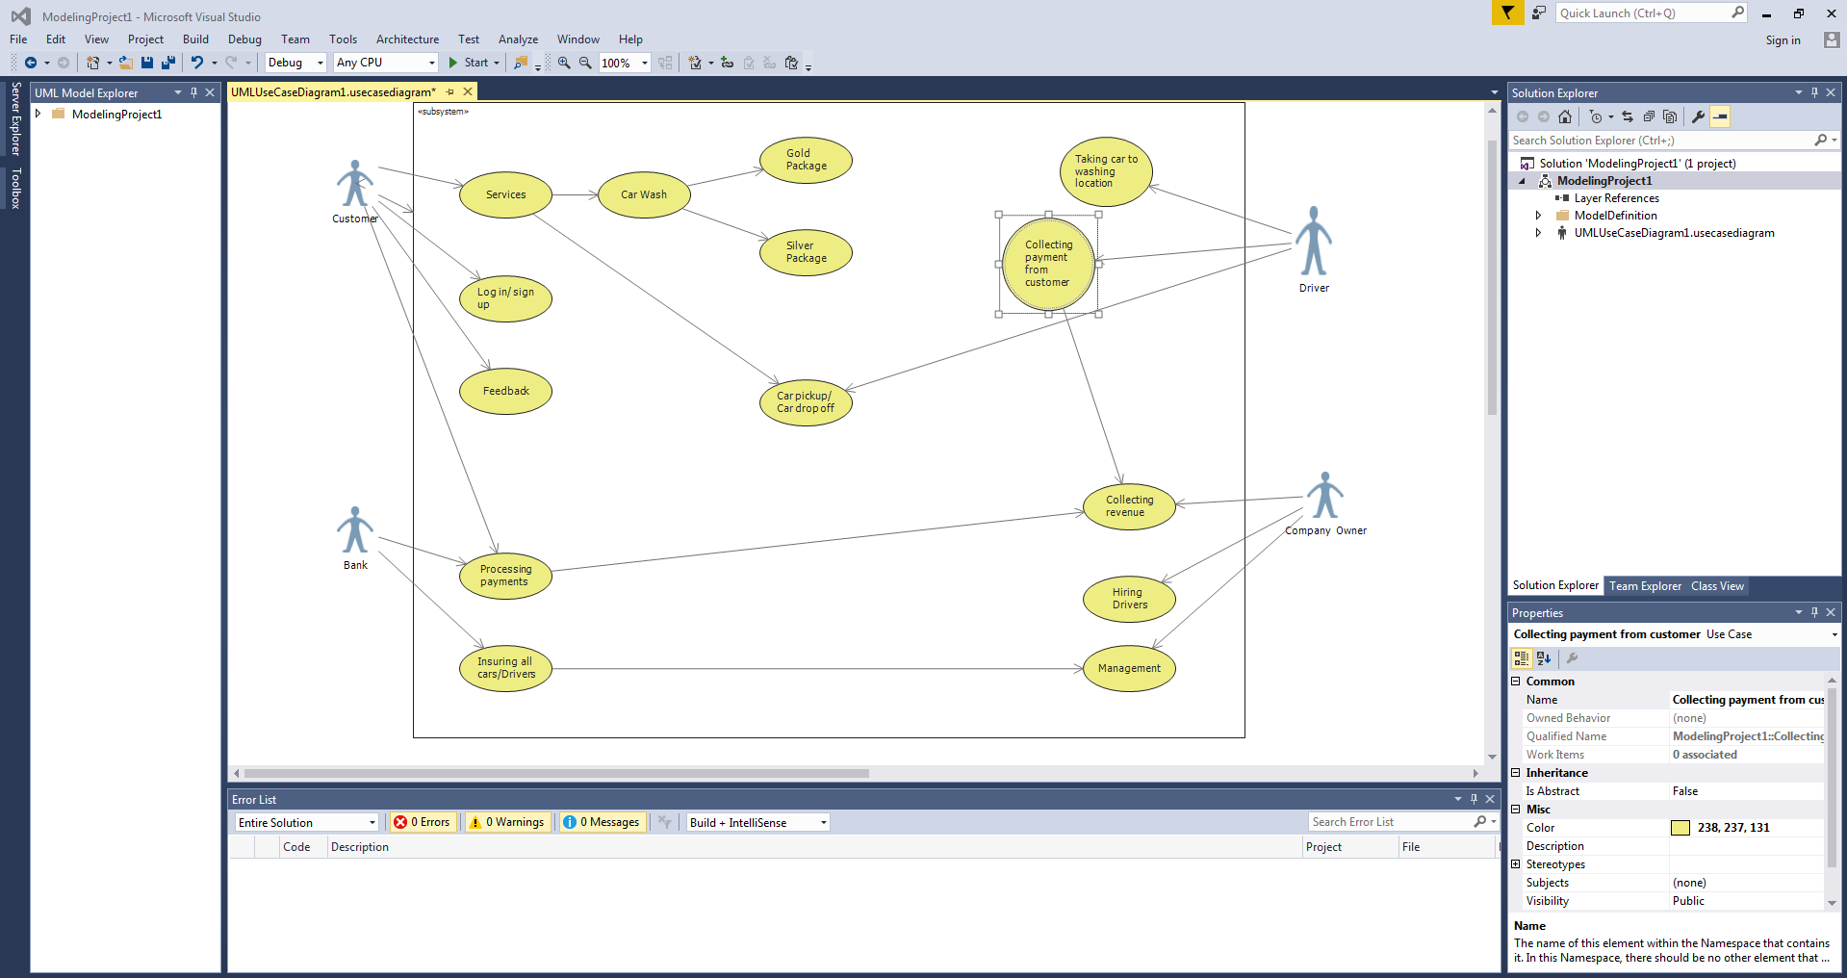

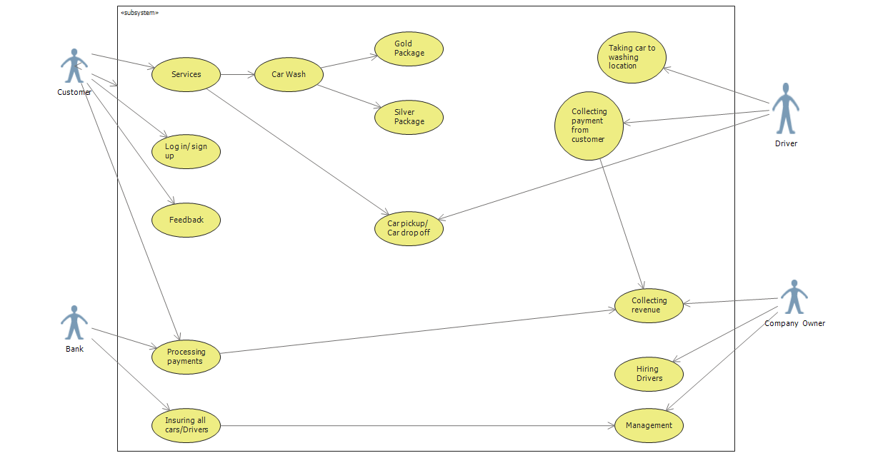
USE CASE Services

Primary actor Customer

Level Start level

Stakeholder Customer, Driver

Precondition Customer opens App

Minimal Guarantee App doesn’t have internet connectivity

Success Guarantee Everything is done in correct order

USE CASE Log in/ Sign up

Primary actor Customer

Level Homepage level

Stakeholder Customer

Precondition Customer has access

Minimal Guarantee User will have the access to his account

Success Guarantee Privacy will be provided

USE CASE Processing payments

Primary actor Bank

Level Homepage Level

Stakeholder Bank, Customer, Company Owner

Precondition Have a local bank account

Minimal Guarantee Safe payment gateway

Success Guarantee It will reach the correct accounts

USE CASE Insuring All Drivers

Primary actor Bank

Level Homepage Level

Stakeholder Bank, Company Owner

Precondition Proper health conditions for insurance

Minimal Guarantee Help if something bad happens

Success Guarantee Insurance will be provided when needed

