**Assignment 1**

Dilkhush Yadav (n01723579)

Humber College

Back-End Web Development 1 : HTTP-5125

Christine Bittle

09/30/2024

Question 1-

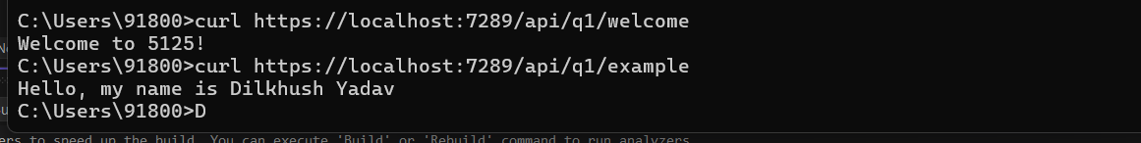

Question 2-

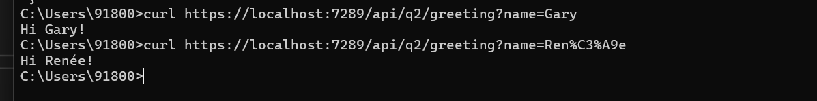

Question 3-

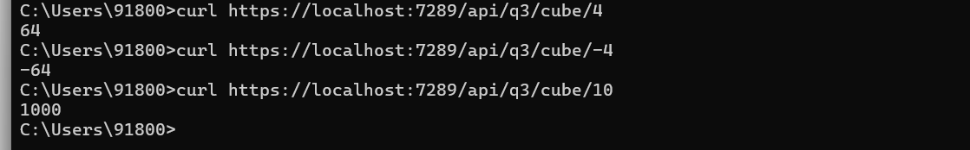

Question 4-

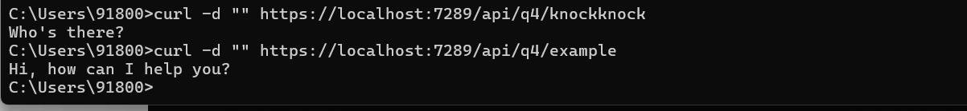

Question 5-

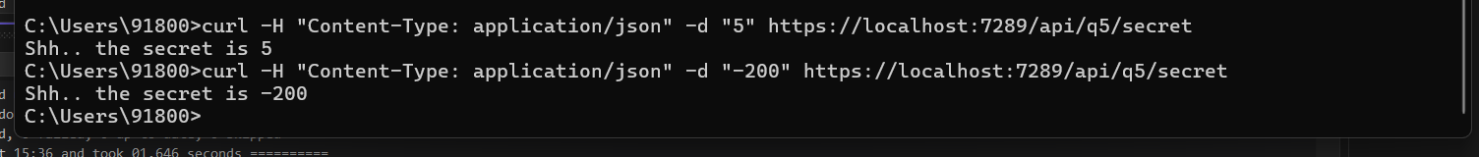

Question 6-

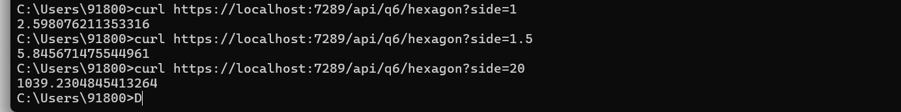

Question 7-



Question 8-

