**Cumulative 1**

Dilkhush Yadav (n01723579)

Humber College

Back-End Web Development 1 : HTTP-5125

Christine Bittle

_____________________________________

**A web page that displays information on all teachers:**

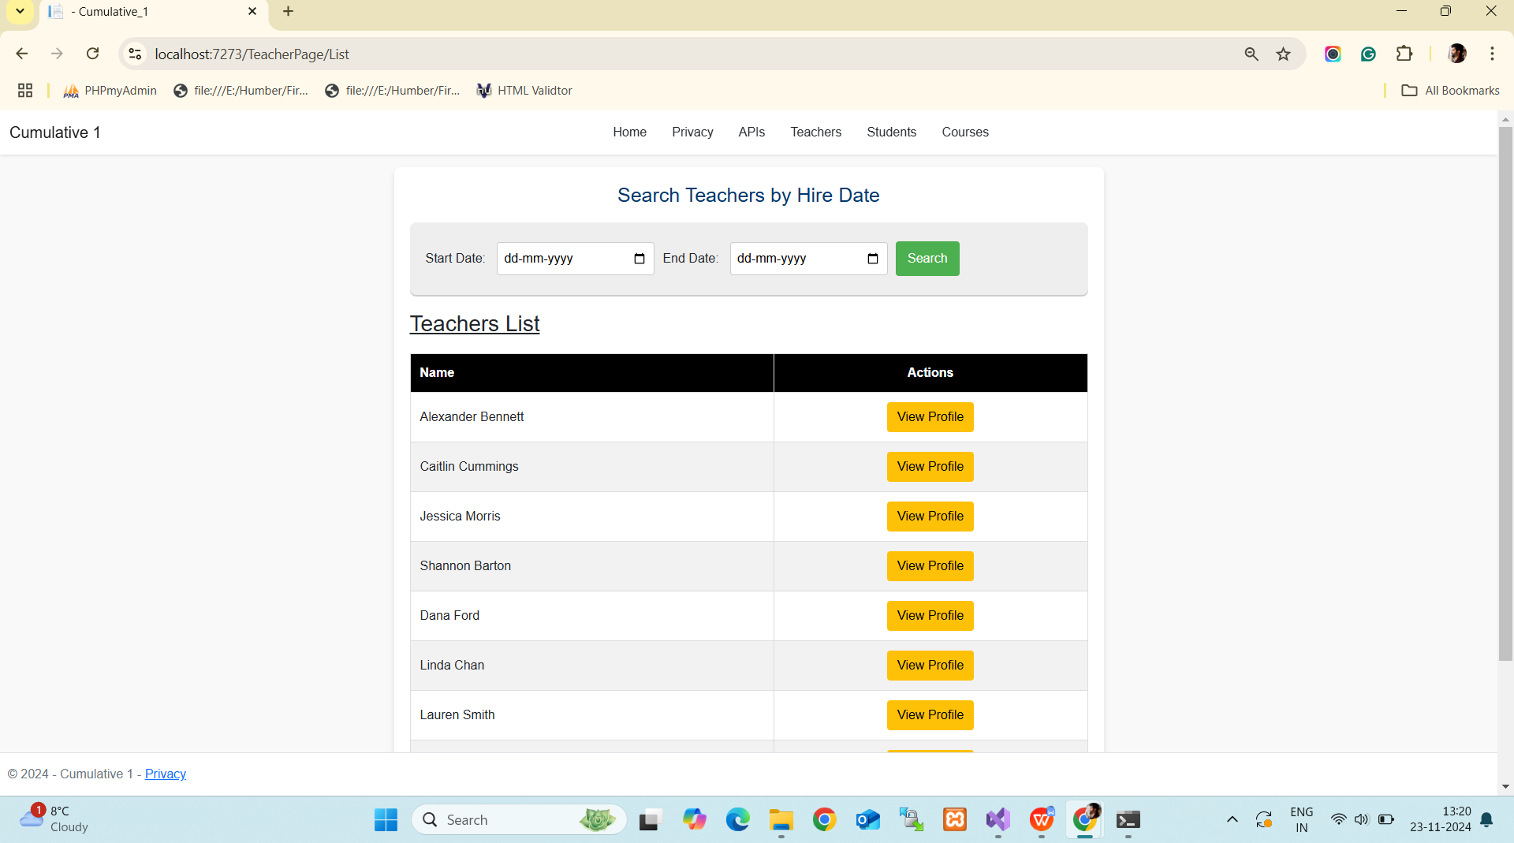

**A web page that displays all information on a teacher:**

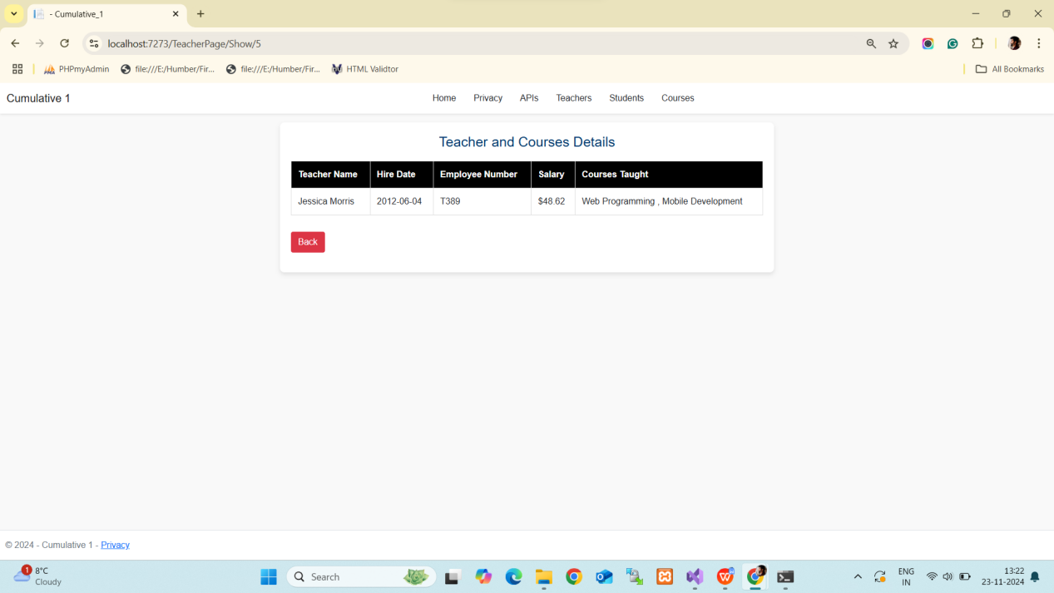

**API to show all teachers:**

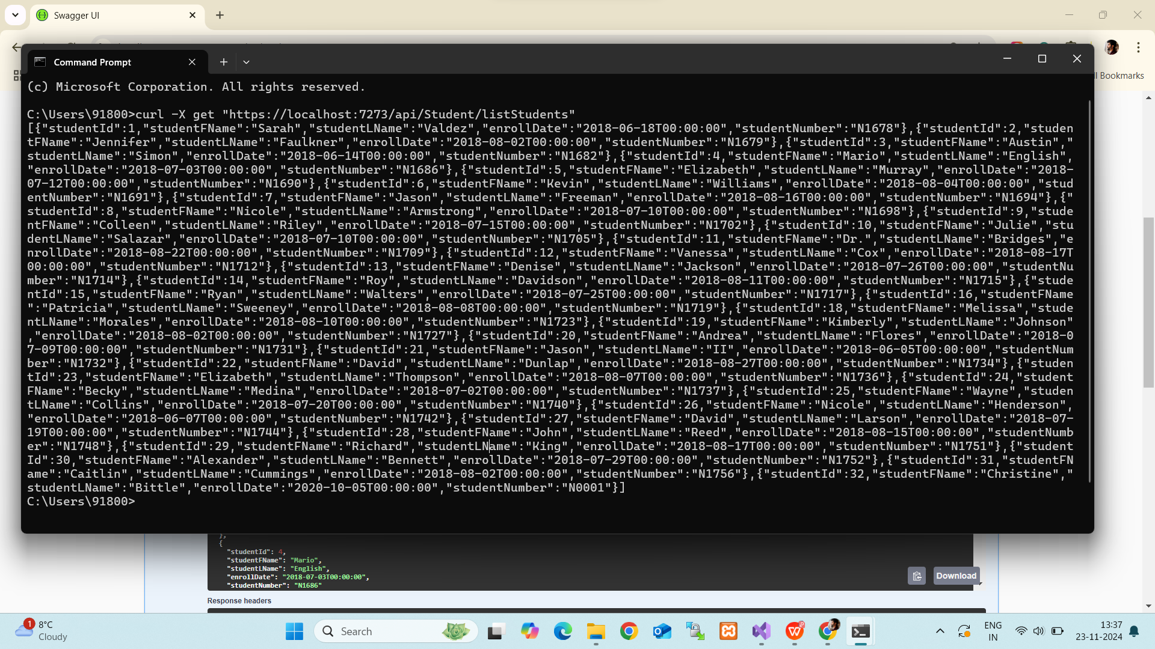

**API to show teacher details by teacher ID:**

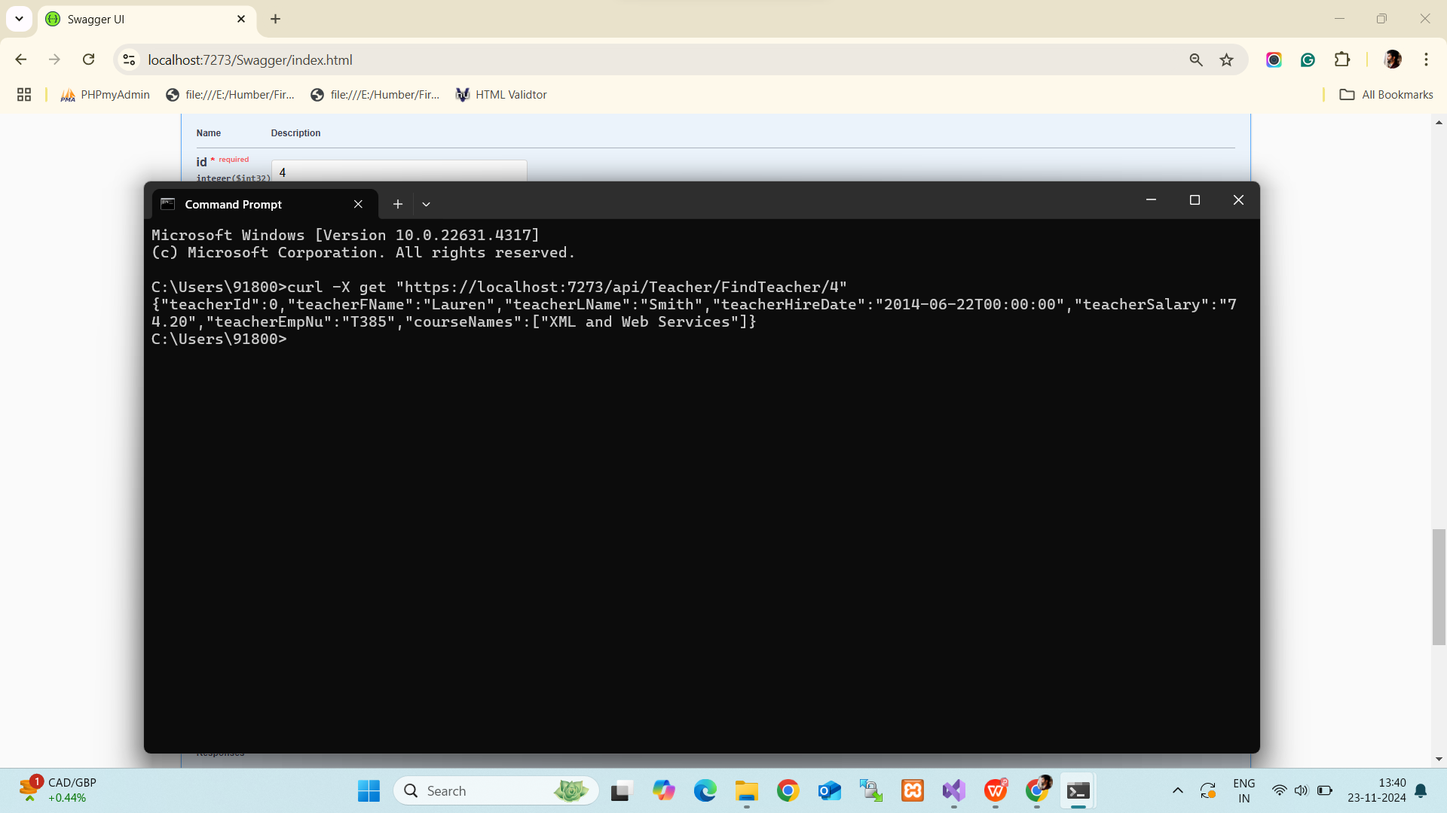

**Error Handling- Teacher with ID 345 doesn’t exists:**

