Game Design Document

Fill up the following document

1. Write the title of your project.

Tarbo the Tarbosaurus

1. What is the goal of the game?

For Tarbo to out run and win a battle against Spino and will win his territory

1. Write a brief story of your game.

Once Tarbo lost his fame and territory, Spino gave him a second chance. And that his how the epic batles begun!

1. Which are the playing characters of this game?

* Playing characters are the ones who respond to the user based on the input from the user.
* Cars, monkeys, dinos, wizards, etc., are the playing characters in the game.

|  |  |  |
| --- | --- | --- |
| Number | Character Name | What can this character do? |
| 1 | Tarbo | Tarbo ball |
| 2 |  |  |
| 3 |  |  |
| 4 |  |  |
| 5 |  |  |
| 6 |  |  |
| 7 |  |  |
| 8 |  |  |

1. Which are the Non-Playing Characters of this game?

* Non-Playing characters are the ones that don't have an action or behavior when the user interacts with the game.
* Hurdles, stones, bananas, coins, etc., are non-playing characters in the game.

|  |  |  |
| --- | --- | --- |
| Number | Character Name | What can this character do? |
| 1 | Spino | Spino Ball |
| 2 | Pteradon | Beak swipe |
| 3 |  |  |
| 4 |  |  |
| 5 |  |  |
| 6 |  |  |
| 7 |  |  |
| 8 |  |  |

Draw your imagination of this game. What does this game look like?

* Draw the game either on your computer or on paper.
* Add images of the game scenes to show each of the playing and non-playing characters at least once.

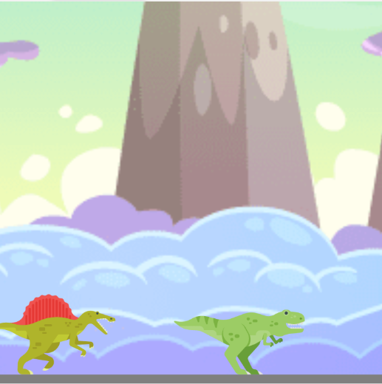

How do you plan to make your game engaging?

In the race, there will be a pteradon trying to kill Tarbo with it’s beak and in the battle, Spino and Tarbo can shoot fire balls at each other.