Unemployment in India
An Exploratory Data Analysis of Trends, COVID-19 Impact, and Policy Insights
Data Period: May 2019 - June 2020 | 28 States & Union Territories | Rural & Urban Areas
Prepared using Python (pandas, matplotlib, seaborn)
11.8%  Overall Avg. Unemployment | 9.5%  Pre-COVID Avg. | 24.3%  Lockdown Peak Avg.  (Apr-May 2020) | 76.7%  Puducherry, Apr'20  Highest Single Record

Executive Summary
This report analyzes monthly unemployment rate data across 28 Indian states and union territories from May 2019 through June 2020, covering both rural and urban areas. The dataset captures a critical period in India's labour market history: the months immediately before the COVID-19 pandemic, and the sharp shock caused by the nationwide lockdown that began in late March 2020.
The analysis finds that the national average unemployment rate held in a relatively stable range of 8-10% before the pandemic, then more than doubled to an average of 17.8% during March-June 2020, peaking above 24% during the strictest lockdown months of April-May 2020. Urban areas and a handful of states - notably Puducherry, Jharkhand, Haryana, Bihar and Tripura - were hit hardest. By June 2020, as restrictions eased, the national rate had already fallen back toward pre-pandemic levels, pointing to a fast but uneven initial recovery.

1. Data Cleaning & Methodology
The raw dataset contained 768 rows with 7 columns (Region, Date, Frequency, Estimated Unemployment Rate, Estimated Employed, Estimated Labour Participation Rate, and Area). The following cleaning steps were applied using Python (pandas):
- Removed 28 fully blank rows and trimmed leading/trailing whitespace from text columns and headers (the raw file had inconsistent spacing, e.g. ' Date' and ' Region').
- Parsed the Date column into proper datetime format (DD-MM-YYYY) and derived Year, Month, and Year-Month fields for time-series aggregation.
- Verified no duplicate records and confirmed data types for numeric columns (unemployment rate, employed count, labour participation rate).
- Final clean dataset: 740 monthly observations across 28 regions and 2 area types (Rural, Urban), spanning May 2019 to June 2020.
All charts and statistics below were generated directly from this cleaned dataset using pandas, matplotlib, and seaborn.

2. National Unemployment Trend
The chart below shows the national average unemployment rate by month. The rate stayed within a fairly narrow 8-10% band through early 2020, then spiked dramatically starting in April 2020 as the COVID-19 lockdown took effect, reaching a nationwide peak of 23.97% in April 2020 before beginning to ease by June.
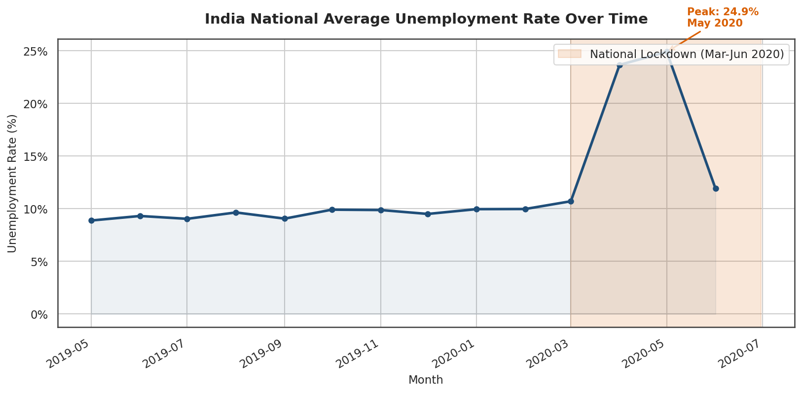
Figure 1: National average monthly unemployment rate, with the lockdown period highlighted.

3. The Impact of COVID-19
COVID-19's effect on India's labour market was sudden and severe. Comparing average unemployment across three phases makes the shock clear:
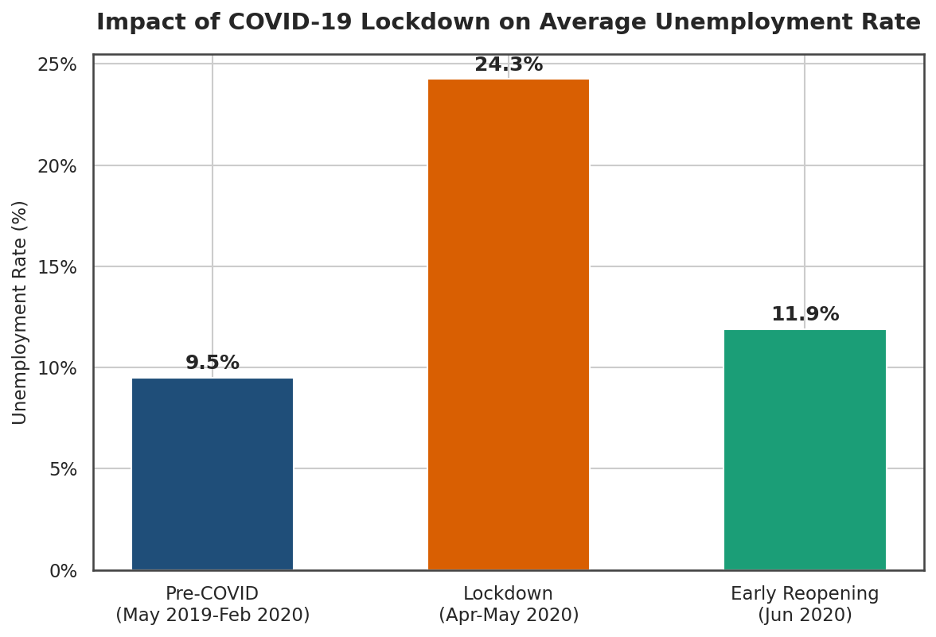
Figure 2: Average unemployment rate before, during, and immediately after the strictest lockdown period.
The average unemployment rate rose from 9.5% pre-COVID to 24.3% during the strict lockdown of April-May 2020 - a two-and-a-half-fold increase - before easing to 11.9% in June 2020 as the economy began reopening. The states hit hardest during the March-June 2020 peak period were:
Rank | State/UT | Avg. Unemployment Rate (Mar-Jun 2020)
1 | Puducherry | 38.96%
2 | Jharkhand | 36.35%
3 | Haryana | 34.65%
4 | Bihar | 31.63%
5 | Tripura | 26.70%

These states likely faced compounding factors: dependence on informal/migrant labour, manufacturing and construction sectors that halted entirely during lockdown, and, in Puducherry's case, a small labour market where shocks show up as larger percentage swings.

4. Rural vs. Urban Divide
Urban unemployment (13.2% average) ran consistently higher than rural unemployment (10.3% average) across the full period. This gap widened sharply during the lockdown, as urban formal-sector and service jobs (retail, hospitality, transport) were more directly affected by mobility restrictions, while agriculture - India's largest rural employer - was classified as an essential activity and continued operating through most of the lockdown.
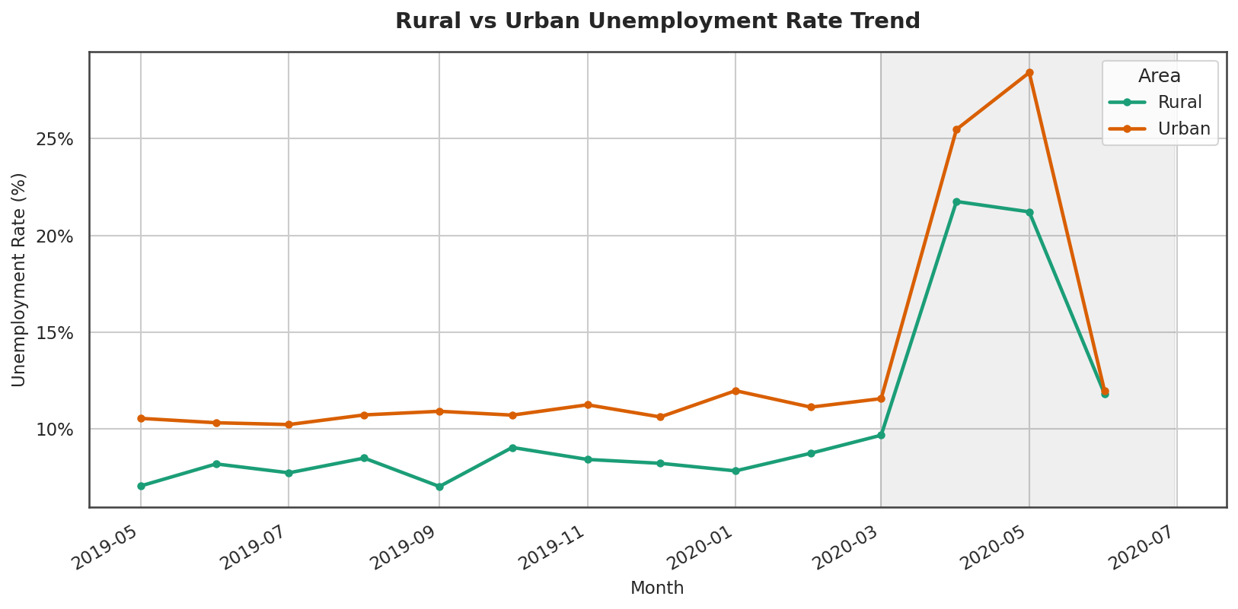
Figure 3: Rural vs. urban unemployment rate trend, showing urban areas absorbing a larger initial shock.

5. State-wise Variation
Unemployment levels varied widely by state even before the pandemic, reflecting differences in industrial structure, urbanization, and labour force participation. The chart below ranks states by their average unemployment rate across the full study period.
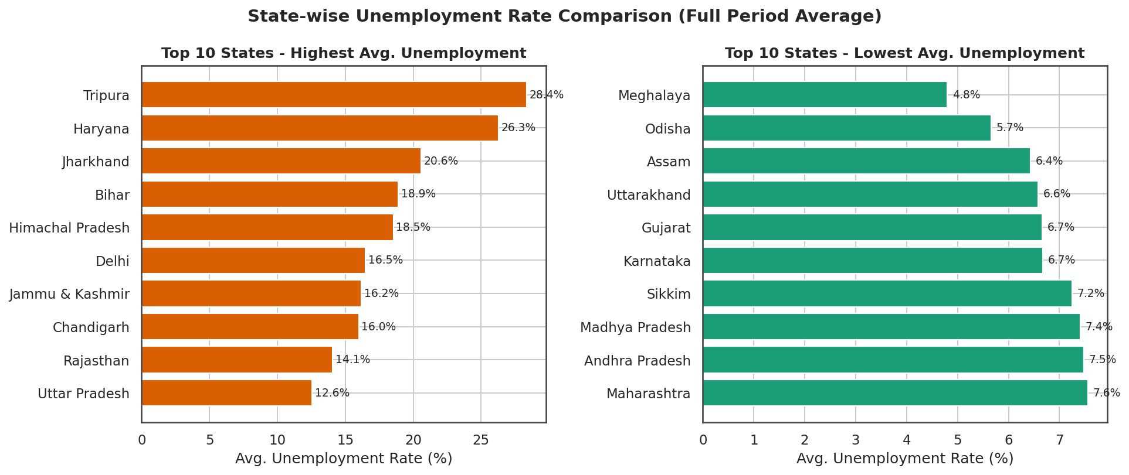
Figure 4: States with the highest and lowest average unemployment rates over the full period.
The heatmap below visualizes every state's unemployment rate month-by-month, making the April-May 2020 shock visible as a band of red across almost every row.
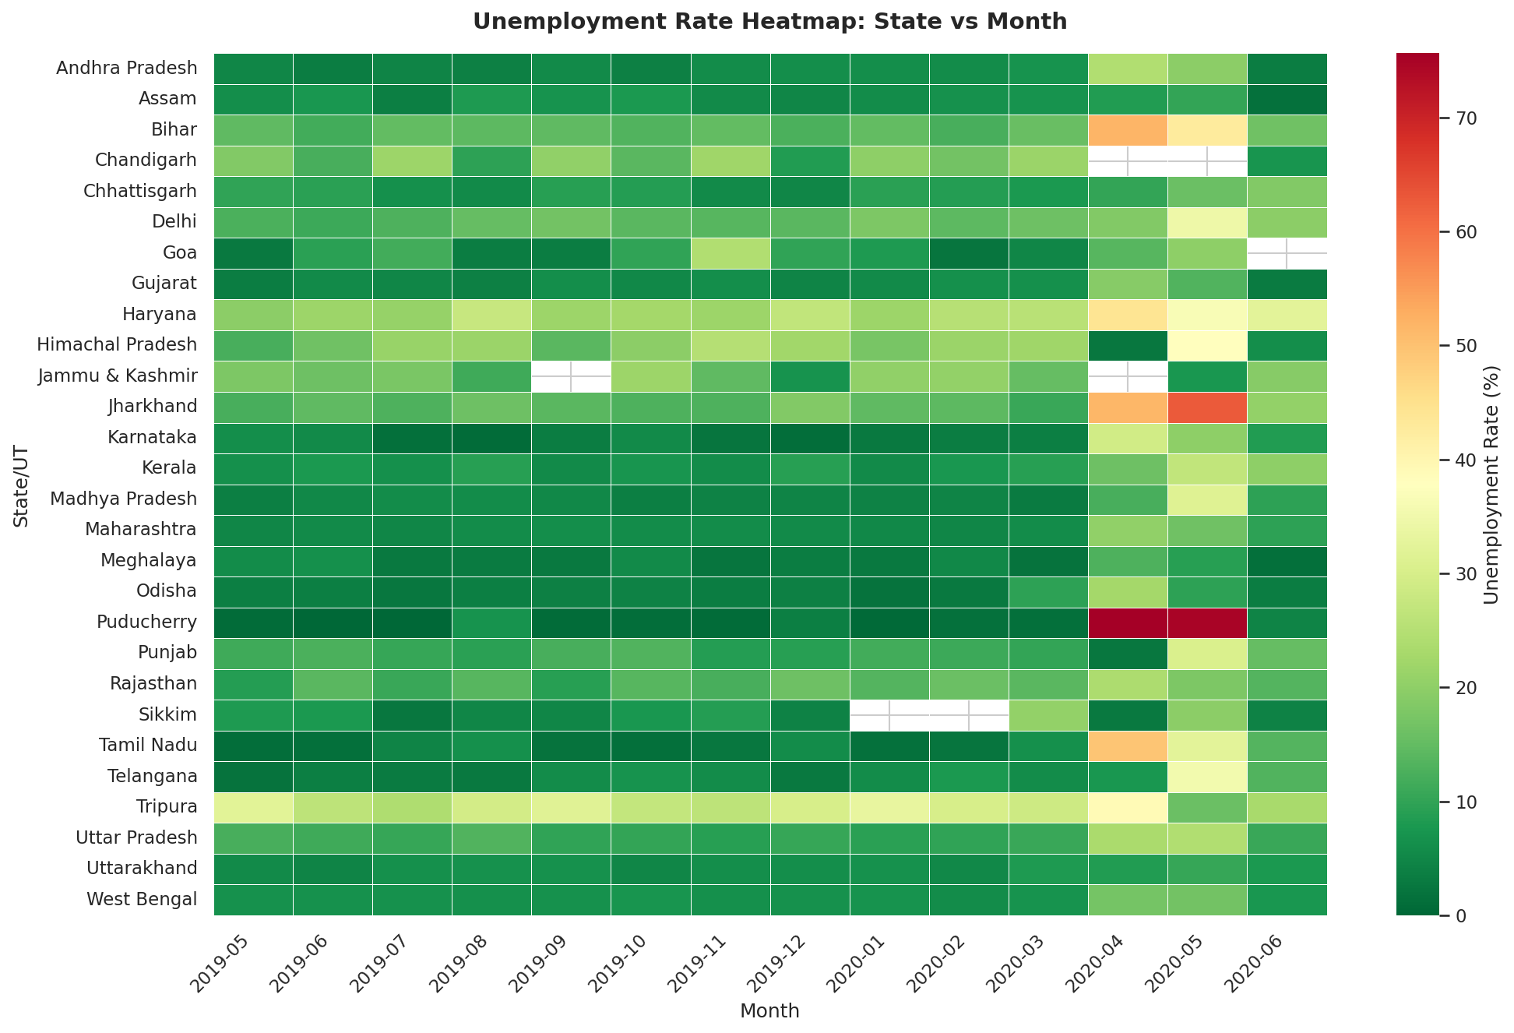
Figure 5: State-by-month unemployment rate heatmap (darker red = higher unemployment).

6. Seasonal Patterns
Looking only at the pre-COVID months (May 2019-February 2020) to isolate normal seasonal behavior, unemployment tends to be slightly lower in the summer months (May) and higher toward the end of the calendar year and in February, which may reflect agricultural harvest cycles and post-monsoon labour demand patterns in rural areas.
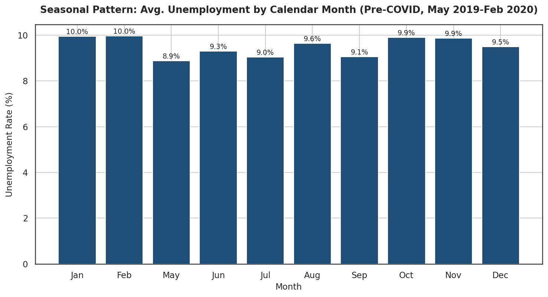
Figure 6: Average unemployment rate by calendar month, pre-COVID period only.

7. Labour Force Participation vs. Unemployment
The scatter plot below plots labour participation rate against unemployment rate for every state-month observation, colored by year. The 2020 points (yellow) visibly cluster toward higher unemployment rates, and in several cases toward lower participation rates too - consistent with 'discouraged worker' effects, where people stopped actively seeking work during the lockdown and were classified as outside the labour force rather than unemployed.
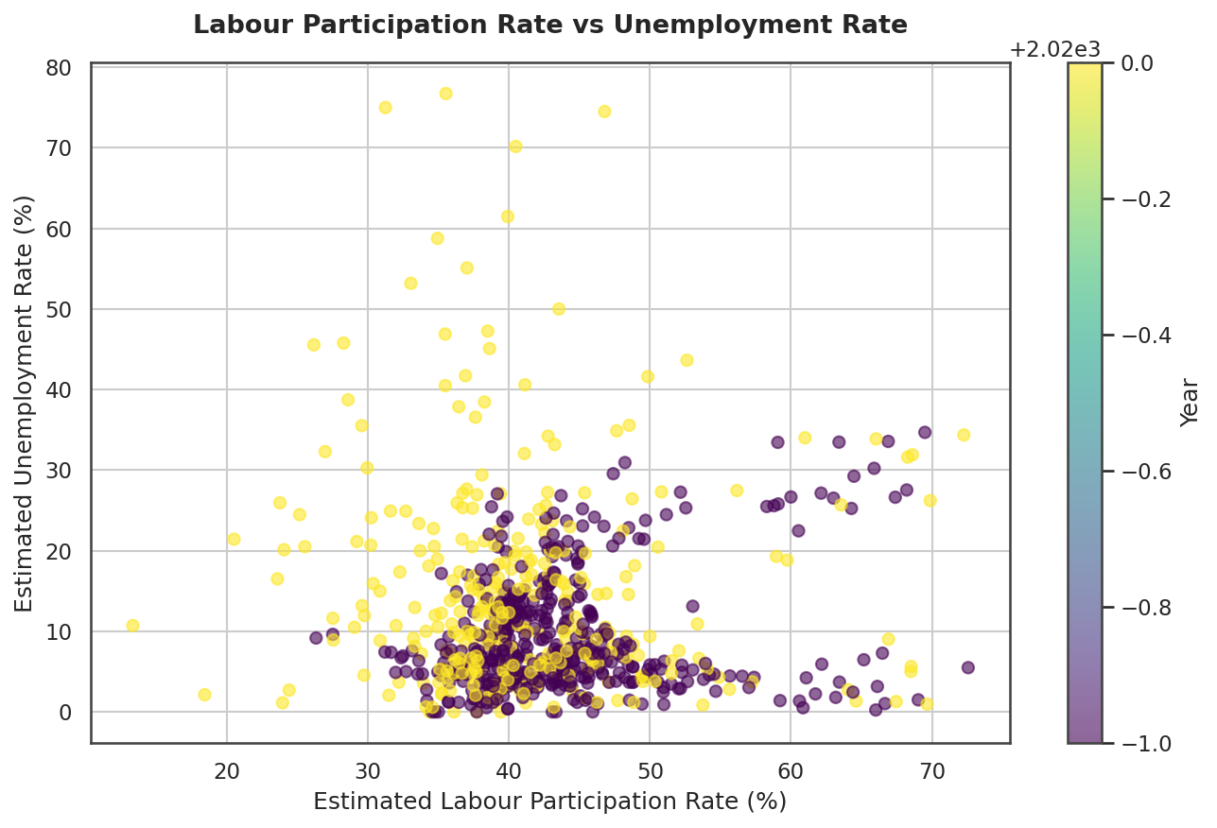
Figure 7: Labour participation rate vs. unemployment rate, colored by year.

8. Key Insights for Policy
- Targeted state support: Puducherry, Jharkhand, Haryana, Bihar and Tripura experienced the steepest unemployment spikes and should be prioritized for emergency employment schemes (e.g. expanded MGNREGA allocations, wage subsidies) during any future economic shock.
- Urban safety nets: Because urban unemployment rose faster and higher than rural during lockdown, urban India lacks an equivalent safety net to MGNREGA's rural employment guarantee. An urban employment guarantee scheme or portable social security for informal urban/migrant workers could reduce the severity of future shocks.
- Migrant and informal worker protection: The sharp rural-urban divergence during lockdown is consistent with large-scale reverse migration of urban informal workers to rural areas. Portable benefits, emergency cash transfers, and better labour data on informal/migrant workers would improve crisis response.
- Faster, higher-frequency data: This dataset stops in June 2020, right as recovery was beginning. Policymakers benefit from higher-frequency (weekly) and more current unemployment data to detect emerging shocks and track recovery in real time, rather than relying on monthly or quarterly releases.
- Monitor labour force participation, not just unemployment rate: A falling unemployment rate can mask people leaving the labour force entirely ('discouraged workers'). Tracking labour participation rate alongside unemployment rate gives a fuller picture of true economic distress.
- Sectoral diversification: States with economies concentrated in a few lockdown-sensitive sectors (construction, hospitality, informal manufacturing) saw the largest swings. Diversifying state-level industrial bases can reduce vulnerability to sector-specific shocks.

9. Limitations
- The dataset covers only May 2019-June 2020, so it captures the onset of the pandemic but not the medium- or long-term recovery trajectory.
- Some states (e.g. Puducherry) have small labour markets, so their unemployment rate can swing more dramatically on a percentage basis than larger states for the same absolute change in jobs.
- The data does not break down unemployment by sector, age, or gender, which would sharpen the policy recommendations above.
Report generated with Python (pandas, matplotlib, seaborn) from the provided Unemployment_in_India.csv dataset.

