URL Shortener

MOHAMMED DILKUSH MP

# Project Idea :

*URL Shortener*

To build an application that will shorten the url .

# Project Github Link:

<https://github.com/dilkushmp/urlshortener>

# Brief Description :

The application is expected to accept a link as input and print the output as shorter.

# Expected Interfaces:

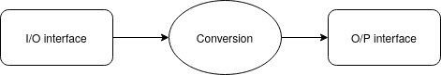*The UI’s*

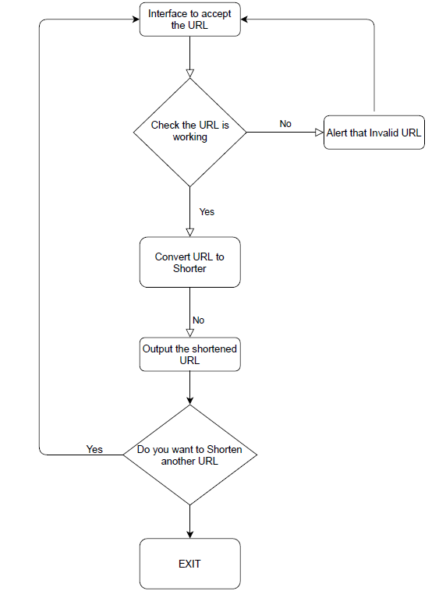

# Project Plan:

## Day One:

Accept a URL through a form and print it on the next screen on clicking submit.

## Day Two:

Read about how URL translation is done. Find a library or API to convert and practice implementing it.

## Day Three.

Accept Input from the first screen and print the shortened one.

## Day Four

Work on UI of the input screen

## Day Five

Work on UI of Output Screen

## Day 6-8 (3 days ideally)

Buffer, in case things don’t go as planned.

# My Experience:

## Tuesday - 9th April

Done the document outline