MAJOR PROJECT STAGE-I FIRST INTERNAL EVALUATION REPORT ON
NGO Management System Using Blockchain
in the partial fulfillment of the requirement for the award of a degree of
BACHELOR OF TECHNOLOGY
IN
COMPUTER SCIENCE AND ENGINEERING (CYBER SECURITY)
Submitted by
Adpula Maruthi Pratap 23B81A6225
SK Shahezeen Sultana 23B81A6244
Dilli Sindhu 23B81A6251
Under the guidance of
Dr. C. Raghavendra
Associate Professor

DEPARTMENT OF COMPUTER SCIENCE AND ENGINEERING
(CYBER SECURITY)
CVR COLLEGE OF ENGINEERING
(An Autonomous Institution, NAAC Accredited and Affiliated to JNTUH, Hyderabad)
Vastunagar, Mangalpalli (V), Ibrahimpatnam (M), Rangareddy (D), Telangana-501 510
AUGUST 2026

1. Abstract:
Non-governmental organizations (NGOs) depend on public donations to conduct social-welfare activities, but donors often have limited visibility into how funds are collected, allocated, and spent. Conventional donation-management platforms typically rely on centralized databases and administrative reporting, which can create information asymmetry and make independent verification of transaction history difficult. This project proposes an NGO Management System Using Blockchain that combines a web application, role-based access control, conventional data storage, decentralized document storage, payment services, and blockchain-based transaction recording. The proposed architecture provides separate interfaces for administrators, NGOs, and donors, while managing users, campaigns, donations, expenditures, documents, transactions, and reports. MongoDB is used for core application records, IPFS is used for documents and receipts, and Solidity-based smart contracts on an Ethereum-compatible blockchain maintain immutable transaction records. Payment gateways such as Razorpay and Stripe, notification services, and an AI-powered financial assistant are integrated as external services. The platform further includes an audit and verification layer that cross-checks information across the application, storage, and blockchain layers. The proposed system is designed to improve transparency, traceability, accountability, and donor confidence while reducing dependence on a single centralized record.

2. Introduction:
Non-governmental organizations play an important role in mobilizing financial and material resources for social welfare. A donation lifecycle generally involves identifying a campaign, receiving donations, recording transactions, allocating resources, and reporting expenditures. When these activities are managed through conventional centralized systems, donors may have to depend on organizational reports to understand how their contributions were used, which creates information asymmetry between donors, NGOs, administrators, and other stakeholders. Existing systems also suffer from a lack of transparency, the risk of data tampering, poor donation and expenditure traceability, manual financial-document management, and limited financial analysis capability.
NGO Management System Using Blockchain is proposed to address these challenges by combining blockchain technology with a conventional web application. Blockchain provides a distributed ledger in which transactions can be recorded in an ordered and tamper-resistant manner, offering traceability, transparency, cryptographic integrity, and programmable smart contracts. The proposed architecture assigns different responsibilities to appropriate layers: MongoDB stores core application records, IPFS stores documents and receipts, and Solidity smart contracts on an Ethereum-compatible blockchain record immutable transaction information. The platform supports three principal user categories, namely Admin, NGO, and Donor, and manages users, campaigns, donations, expenditures, documents, transactions, and reports, while an AI-powered financial assistant allows users to query financial information in natural language.
By maintaining an immutable and independently verifiable record of donations and expenditures, the system improves transparency, traceability, accountability, and donor trust, while reducing dependence on a single centralized record. The proposed system therefore provides a reliable and auditable approach for managing NGO donations from collection to expenditure.

3. Literature survey:
S.No. | Existing Methodology | How it Works | Advantages | Disadvantages / Drawbacks | Citation (Year)
1 | Traditional Centralized NGO Management | Stores NGO, donor, donation, and expenditure information in a centralized database controlled by the organization. | Simple implementation; easy database management; low initial cost. | Single point of control; records can be modified; limited independent verification and transparency. | Mariyam et al., 2025
2 | Centralized Online Donation Platforms | Donors contribute through a centralized website, while the platform maintains donation and campaign records. | Easy for donors to use; convenient online donations; centralized reporting. | Donors have limited visibility after donation; depends heavily on platform/NGO records. | Sung et al., 2023
3 | Manual Donation & Expenditure Tracking | NGOs maintain donation, expenditure, bills, and beneficiary records using spreadsheets or manual documentation. | Easy to implement; familiar to NGO staff; no blockchain infrastructure required. | Time-consuming; prone to human error; difficult to audit; records can be altered or lost. | Palma, 2024
4 | Centralized Cloud-Based Record Management | NGO financial records and documents are stored on centralized cloud/database servers and accessed through web applications. | Remote access; scalable storage; convenient document management. | Centralized trust; unauthorized modification remains possible; integrity depends on server controls. | Palma, 2024
5 | Blockchain Donation Traceability | Each donation is recorded as a blockchain transaction, allowing stakeholders to trace funds from donor to recipient. | Immutable records; improved traceability; transparent transaction history. | Blockchain transaction costs; scalability issues; mainly focuses on donation tracking. | Almaghrabi & Alhogail, 2022
6 | Smart Contract-Based Charity Management | Smart contracts automatically record and manage donations according to predefined rules on a blockchain. | Automation; reduces intermediaries; improves accountability and transparency. | Smart-contract bugs can cause security problems; requires blockchain knowledge. | Nairi et al., 2024
7 | Blockchain-Based Donation System with Trust Verification | Blockchain provides transparent and immutable donation information that donors can use to evaluate an NGO's activities. | Improves donor trust; provides transparency and immutability; enables donation tracking. | Does not necessarily provide complete NGO administration or expenditure-document management. | Sung et al., 2023
8 | Blockchain-Based Philanthropic System with Authentication | Uses blockchain, cryptographic hashing, smart contracts, and authentication mechanisms to secure charity transactions. | Better authentication; tamper-resistant records; improved privacy and traceability. | More complex implementation; authentication and blockchain integration increase system complexity. | Ahmed et al., 2024
9 | Blockchain-Based Charity Platform with Hash Verification | Donation records are assigned unique hashes and stored on blockchain so that modifications can be detected. | Tamper detection; verifiable transactions; improved donor confidence. | Primarily focuses on donation transactions; limited expenditure and document management. | Narasimhulu et al., 2025
10 | Ethereum-Based Transparent Charity Framework | Uses Ethereum smart contracts and distributed ledger technology to track donations from contribution to final allocation. | Immutable records; real-time tracking; fraud reduction; improved accountability. | Public blockchain dependency; scalability and transaction-cost concerns; limited complete NGO management. | Mariyam et al., 2025

4. Requirement Analysis:
The NGO Management System Using Blockchain requires a secure and transparent platform for recording and tracking donations and expenditures across the NGO donation lifecycle. The system should allow authorized participants to perform their respective activities while maintaining an immutable and auditable record on the blockchain.
4.1. Functional Requirements
- User and Role Management - The system should provide Admin, NGO, and Donor roles, with JWT-based authentication and role-based access control (RBAC) restricting operations according to the user's role.
- NGO and Campaign Management - Authorized NGO users should be able to create and manage donation campaigns, with campaign details stored as core application data.
- Donation Management - Donors should be able to select a campaign and make a donation through a supported payment gateway; the backend should record the donation metadata and invoke the corresponding smart-contract operation.
- Expenditure and Document Management - NGOs should be able to record expenditures against a campaign and upload supporting documents and receipts, which are stored through IPFS with references maintained in the application.
- Blockchain and Smart Contract Recording - Donation and expenditure transactions should be recorded on an Ethereum-compatible blockchain through Solidity smart contracts, and the blockchain should return a transaction reference that can be associated with the application record.
- AI-Powered Financial Assistant - The system should allow users to ask financial questions in natural language, such as total donations, expenditures for a period, or category-wise spending, and receive meaningful responses.
- Reporting and Audit & Verification - The system should generate reports that combine application records, blockchain references, and supporting documents, and should cross-check these sources to detect inconsistencies.
- Notifications - The system should deliver email and SMS notifications related to campaigns and transactions.
4.2. Non-Functional Requirements
- Security - Only authorized participants should be able to perform specific operations, enforced through JWT authentication and RBAC.
- Transparency - Donation and expenditure transactions should be independently verifiable through the blockchain.
- Data Integrity - Recorded blockchain transactions should not be easily modified or deleted.
- Reliability - The system should correctly maintain campaign, donation, and expenditure information across all layers.
- Usability - The interface should be simple and easy for administrators, NGOs, and donors to operate.
- Scalability - The system should be designed so that additional NGOs, campaigns, and donors can be added in the future.
4.3. Hardware Specifications
- Processor: Intel Core i5/i7, 11th Gen or above
- RAM: 16 GB
- Storage: 512 GB SSD
4.4. Software Specifications
- Operating System: Windows 10/11
- Programming Languages: JavaScript, Solidity, Python
- Frontend: React.js, HTML, CSS
- Backend: Node.js, Express.js
- Blockchain: Ethereum, Hardhat, Solidity
- Blockchain Interaction: Ethers.js
- Database Management: MongoDB
- AI/NLP: Python, NLP/LLM APIs
- Development Environment: VS Code

5. System Architecture Design
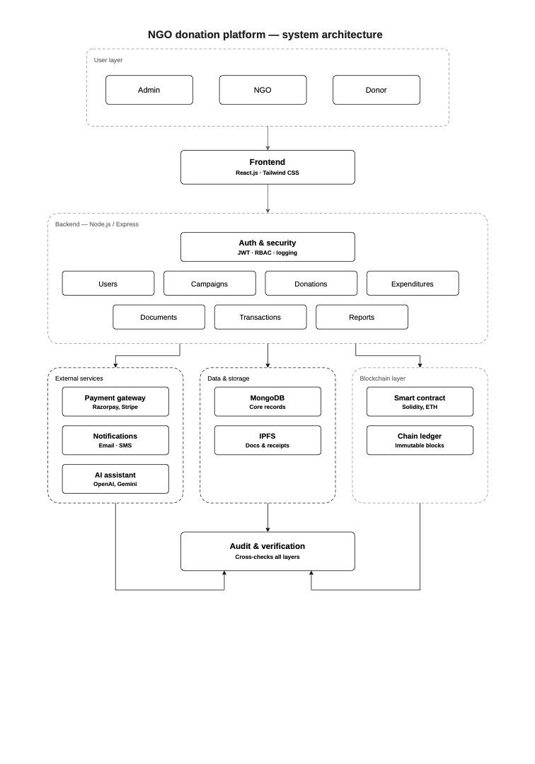
The proposed methodology follows a layered web-and-blockchain architecture. The workflow begins when an Admin, NGO representative, or Donor accesses the React.js and Tailwind CSS frontend, and requests are sent to the Node.js/Express backend, where JWT-based authentication and role-based access control (RBAC) are applied. The backend manages Users, Campaigns, Donations, Expenditures, Documents, Transactions, and Reports, and connects to three supporting layers. The data-and-storage layer uses MongoDB for core application records and IPFS for documents and receipts. The blockchain layer uses Solidity smart contracts on an Ethereum-compatible chain ledger to maintain an immutable record of donation and expenditure transactions. The external-services layer integrates payment gateways such as Razorpay and Stripe, email/SMS notifications, and an AI assistant using OpenAI or Gemini. Finally, the audit-and-verification layer cross-checks information across the application, storage, and blockchain components, making inconsistencies easier to detect and providing a traceable basis for reporting.

