**AIM:**

|  |
| --- |
| Write the python program to implement A* algorithm |

**PROGRAM:**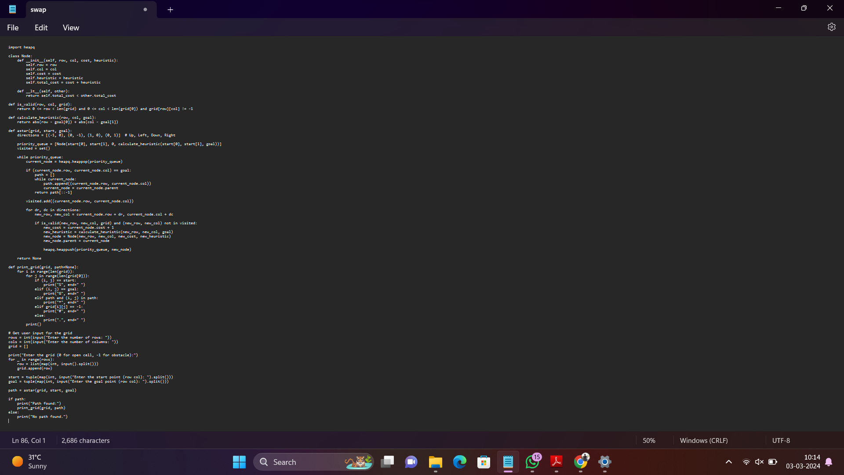

**INPUT:** Enter the number of rows: 5

Enter the number of columns: 5

Enter the grid (0 for open cell, -1 for obstacle):

0 0 0 0 0

0 0 -1 0 0

0 -1 0 -1 0

0 0 0 0 0

0 0 0 0 0

Enter the start point (row col): 0 0

Enter the goal point (row col): 4 4

**OUTPUT**: Path found:

S * * * *

. . # . .

. # . # .

. . . . .

. . . . G

**RESULT:** Program to implement A* algorithm is successfully executed and verified.