**AIM:**

|  |
| --- |
| Write the python program for Map Coloring to implement CSP. |

**PROGRAM:**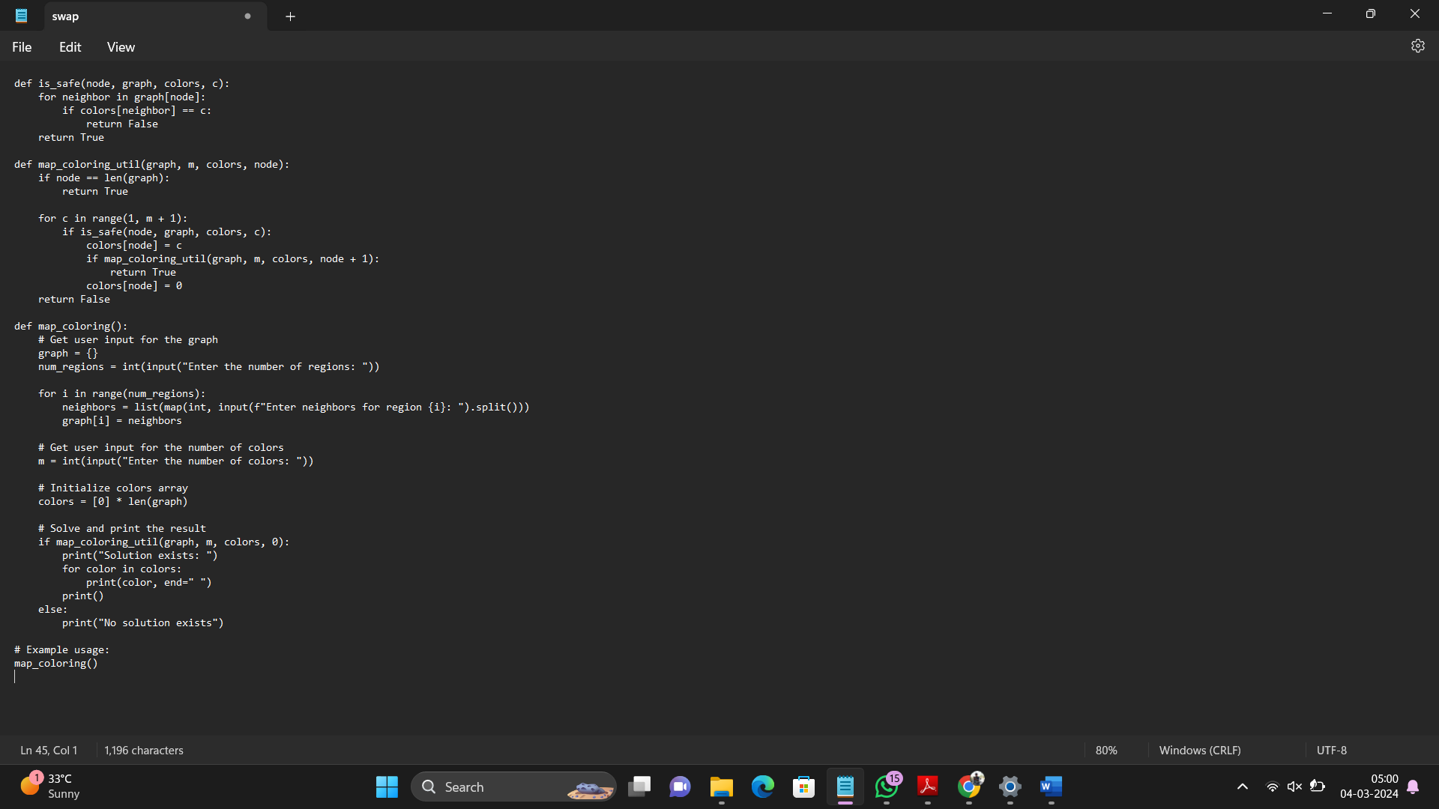

**INPUT:** **Enter the number of regions: 4**

**Enter neighbors for region 0: 1 3**

**Enter neighbors for region 1: 0 2 3**

**Enter neighbors for region 2: 1 3**

**Enter neighbors for region 3: 0 1 2**

**Enter the number of colors: 3**

**OUTPUT: Solution exists:**

**1 2 1 3**

**RESULT:**

|  |
| --- |
| python program for Map Coloring to implement CSP is successfully executed and verified. |