**AIM:**

|  |
| --- |
| **Write the python program for Tic Tac Toe game** |

**PROGRAM:**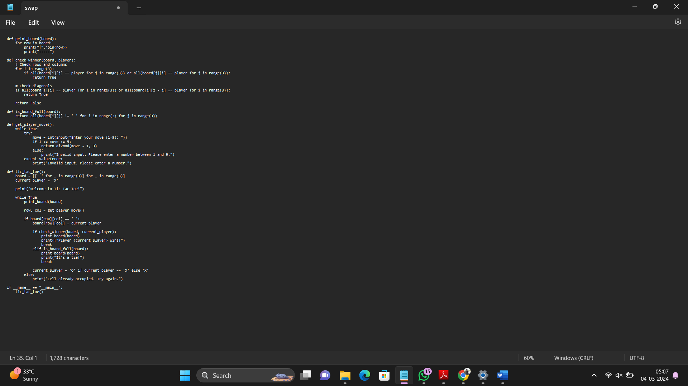

**INPUT/OUTPUT:**

**Welcome to Tic Tac Toe!**

**| | | |**

**-----**

**| | | |**

**-----**

**| | | |**

**-----**

**Enter your move (1-9): 5**

**| | | |**

**-----**

**| |X| |**

**-----**

**| | | |**

**-----**

**Enter your move (1-9): 1**

**| | | |**

**-----**

**| |X| |**

**-----**

**|O| | |**

**-----**

**Enter your move (1-9): 9**

**| | | |**

**-----**

**| |X| |**

**-----**

**|O| |X|**

**-----**

**Enter your move (1-9): 2**

**| | | |**

**-----**

**| |X| |**

**-----**

**|O|O|X|**

**-----**

**Enter your move (1-9): 7**

**| | | |**

**-----**

**| |X| |**

**-----**

**|X|O|X|**

**-----**

**Enter your move (1-9): 4**

**| | | |**

**-----**

**|O|X| |**

**-----**

**|X|O|X|**

**-----**

**Enter your move (1-9): 3**

**| | |X|**

**-----**

**|O|X| |**

**-----**

**|X|O|X|**

**-----**

**Player X wins!**

**RESULT: python program for Tic Tac Toe game is successfully executed and veified.**