**AIM:**

|  |
| --- |
| Write the python program to implement Apha & Beta pruning algorithm for gaming |

**PROGRAM:**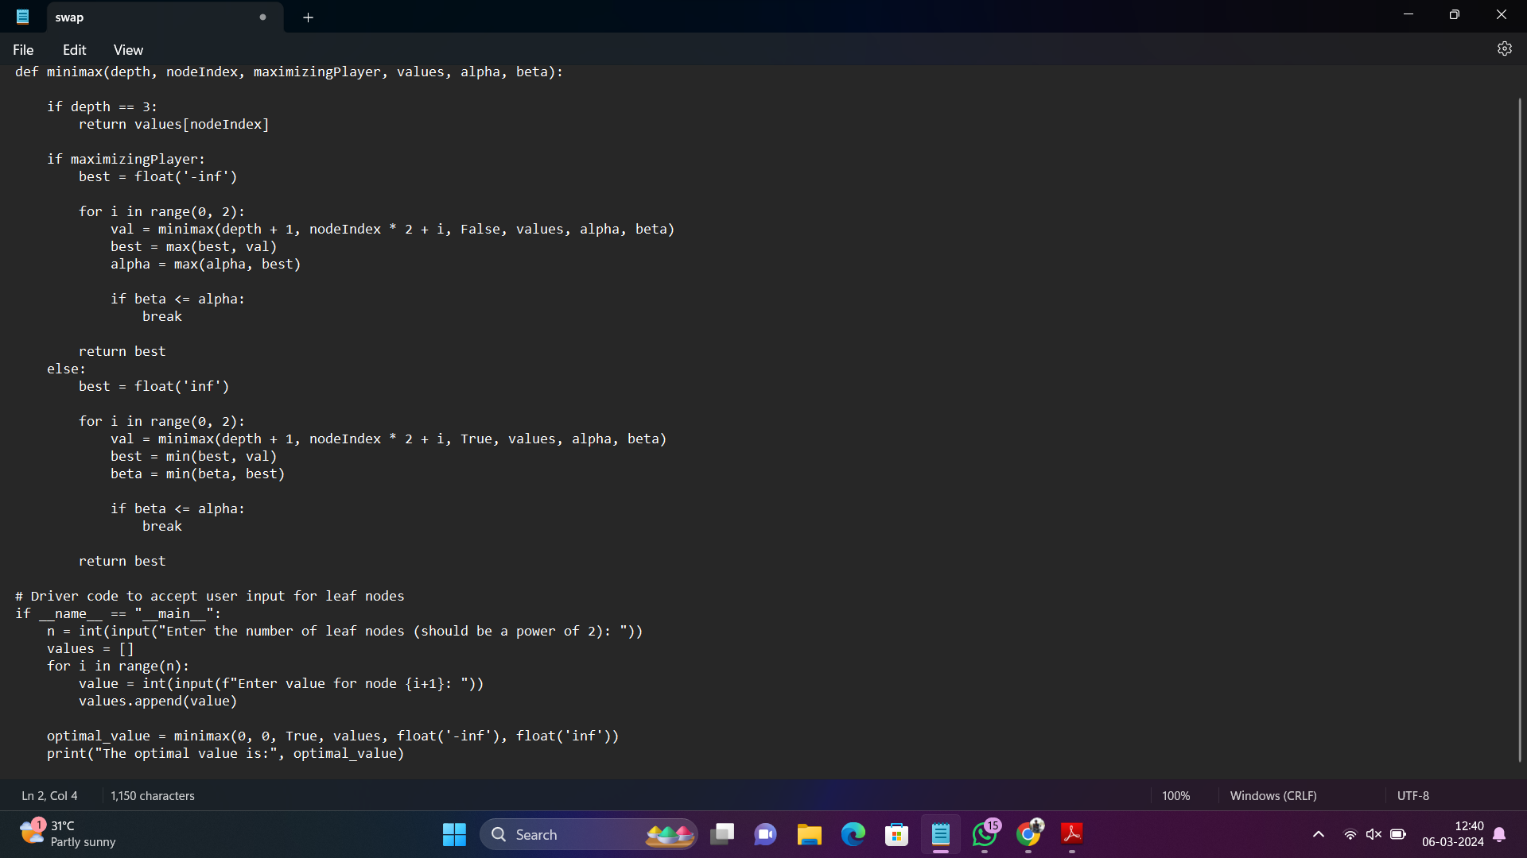

**INPUT:** **Enter the number of leaf nodes (should be a power of 2): 8**

**Enter value for node 1: 3**

**Enter value for node 2: 5**

**Enter value for node 3: 6**

**Enter value for node 4: 9**

**Enter value for node 5: 1**

**Enter value for node 6: 2**

**Enter value for node 7: 0**

**Enter value for node 8: -1**

**OUTPUT:** **The optimal value is: 5**

**RESULT:**

|  |
| --- |
| **python program to implement Apha & Beta pruning algorithm for gaming is succesfuly executed and verified.** |