**AIM:**

|  |
| --- |
| Write the python program to implement Decision Tree |

**PROGRAM:**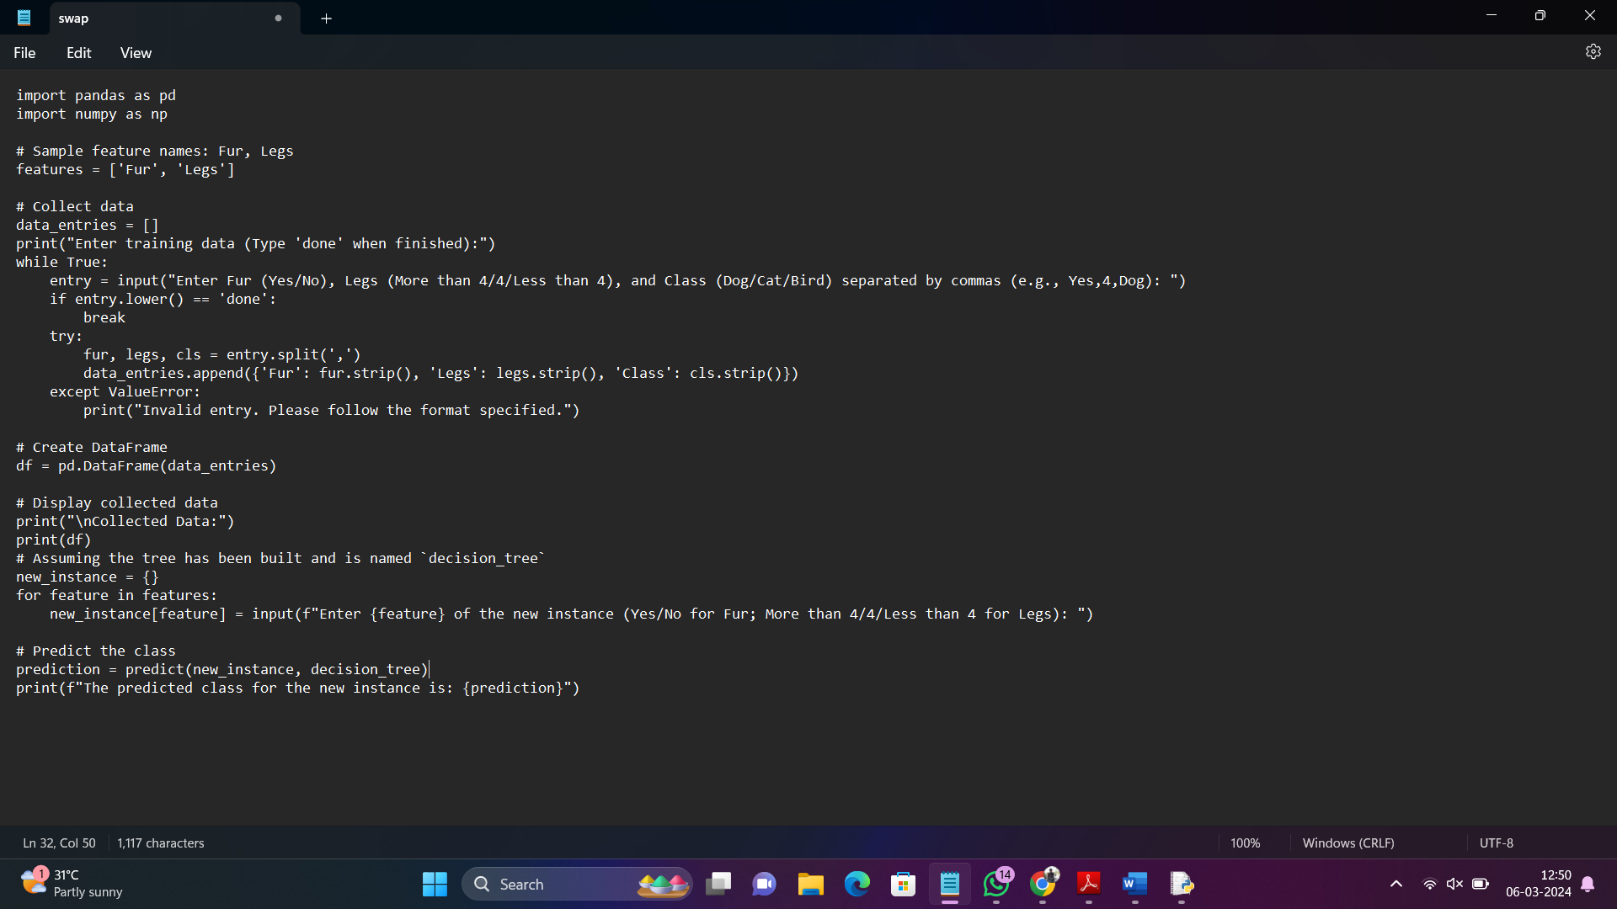

**RESULT: Implementing decision tree is executed and verified succesfuly.**