**AIM:**

|  |
| --- |
| Write the python program to solve 8-Queen problem |

**PROGRAM:**

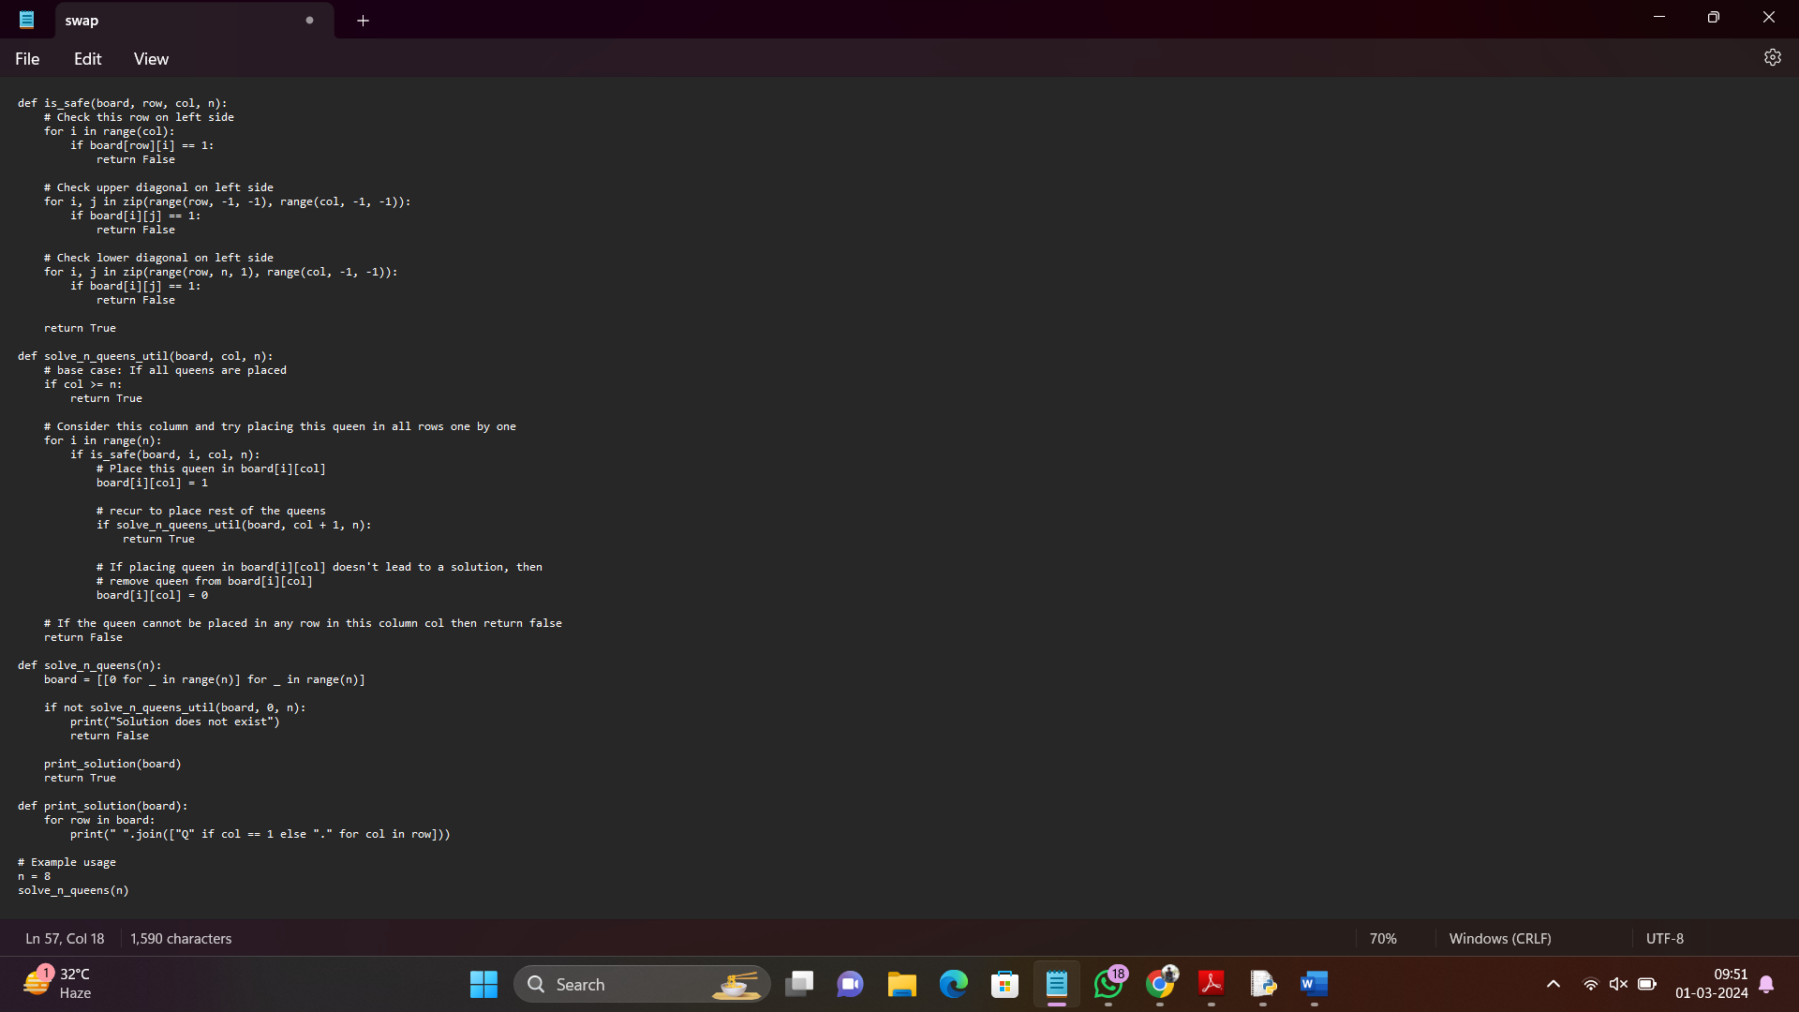

**INPUT:** Enter the size of the board (e.g., 8 for the 8-Queens problem): 8

**OUTPUT:** Total solutions found: 92

Q.......

.....Q..

....Q...

.......Q

.Q......

...Q....

......Q.

..Q.....

s(continues to print all 92 solutions for the 8-Queens problem)

**RESULT:** 8-Queen problem successfully executed and verified.