**AIM:**

|  |
| --- |
| Write the python program for Water Jug Problem |

**PROGRAM: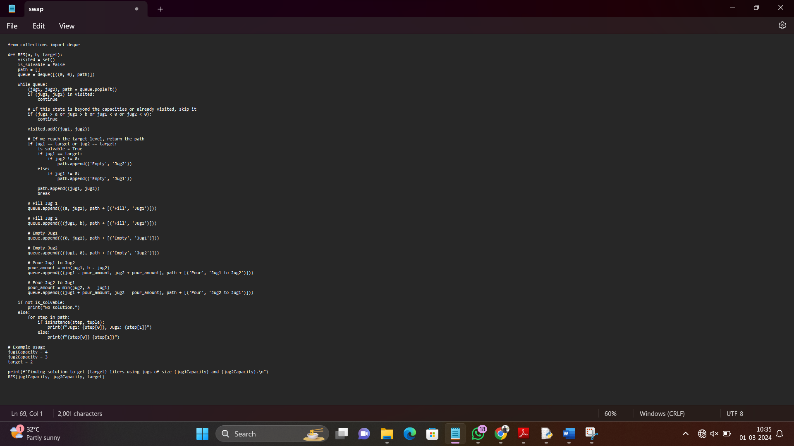  
INPUT:** jug1Capacity = 4

jug2Capacity = 3

target = 2

**OUTPUT**: Finding solution to get 2 liters using jugs of size 4 and 3.

Jug1: Fill, Jug2: Jug2

Jug1: Pour, Jug2: Jug2 to Jug1

Jug1: Fill, Jug2: Jug2

Jug1: Pour, Jug2: Jug2 to Jug1

Jug1: Empty, Jug2: Jug1

Jug1: 4, Jug2: 2

**RESULT:** Water jug problem successfully executed and verified.