**AIM:**

|  |
| --- |
| Write the python program for Cript-Arithmetic problem |

**PROGRAM:**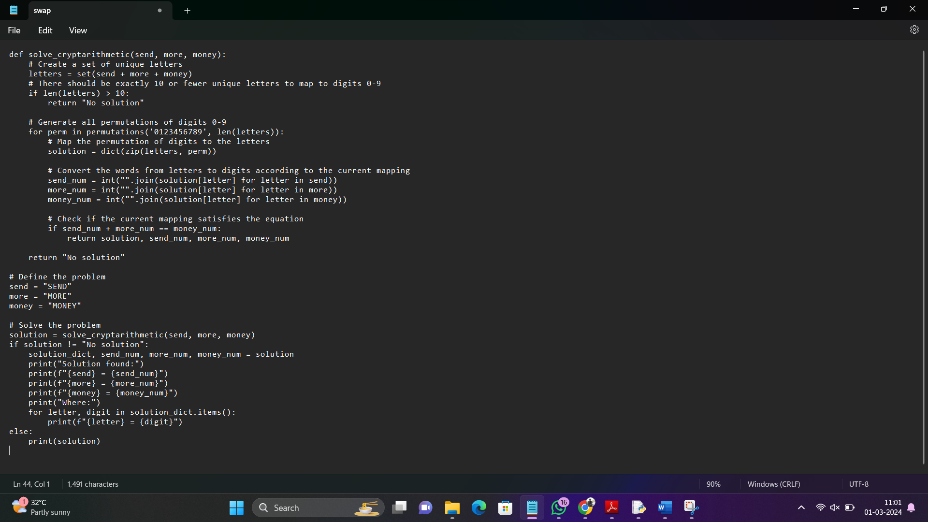

**INPUT**: send = "SEND"

more = "MORE"

money = "MONEY**"**

**OUTPUT**: Solution found:

SEND = 9567

MORE = 1085

MONEY = 10652

Where:

O = 0

M = 1

R = 8

E = 5

Y = 2

S = 9

D = 7

N = 6

**RESULT:** Cript-Arithmetic problem is successfully executed and verified.