**AIM:**

|  |
| --- |
| Write the python program for Missionaries Cannibal problem |

**PROGRAM:**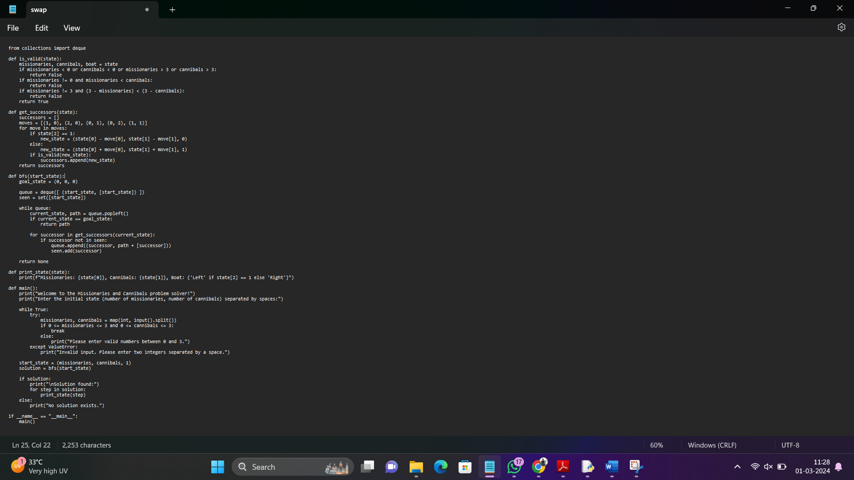

**INPUT:** Welcome to the Missionaries and Cannibals problem solver!

Enter the initial state (number of missionaries, number of cannibals) separated by spaces:

3 3.

**OUTPUT:** Solution found:

Missionaries: 3, Cannibals: 3, Boat: Left

Missionaries: 2, Cannibals: 2, Boat: Right

Missionaries: 3, Cannibals: 2, Boat: Left

Missionaries: 1, Cannibals: 1, Boat: Right

Missionaries: 3, Cannibals: 1, Boat: Left

Missionaries: 3, Cannibals: 0, Boat: Right

Missionaries: 3, Cannibals: 1, Boat: Left

Missionaries: 0, Cannibals: 0, Boat: Right

**RESULT:** Missionaries Cannibal problem is successfully executed and verified.