**AIM:**

|  |
| --- |
| Write the python program for Vacuum Cleaner problem |

**PROGRAM:**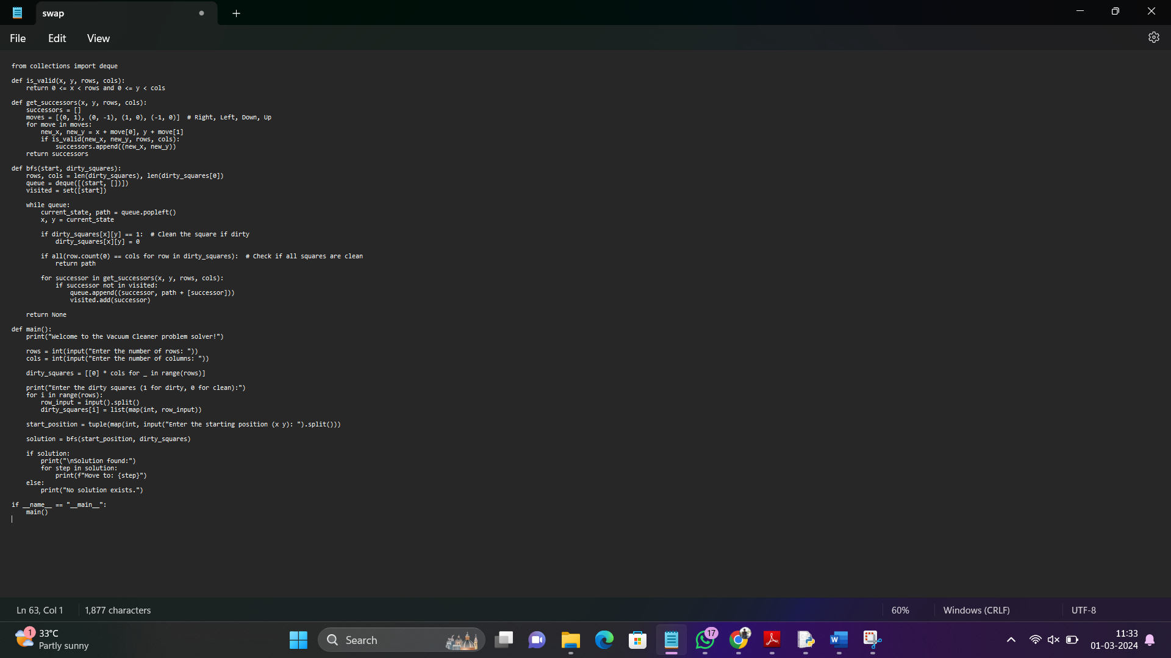

**INPUT:**

**3**

**3**

**101**

**010**

**101**

**11**

**OUTPUT:** Solution found:

Move to: (2, 1)

Move to: (2, 2)

Move to: (1, 2)

Move to: (0, 2)

Move to: (0, 1)

Move to: (1, 1)

**RESULT:** Vacuum Cleaner problem is successfully executed and verified.