**AIM:**

|  |
| --- |
| Write the python program to implement BFS. |

**PROGRAM:**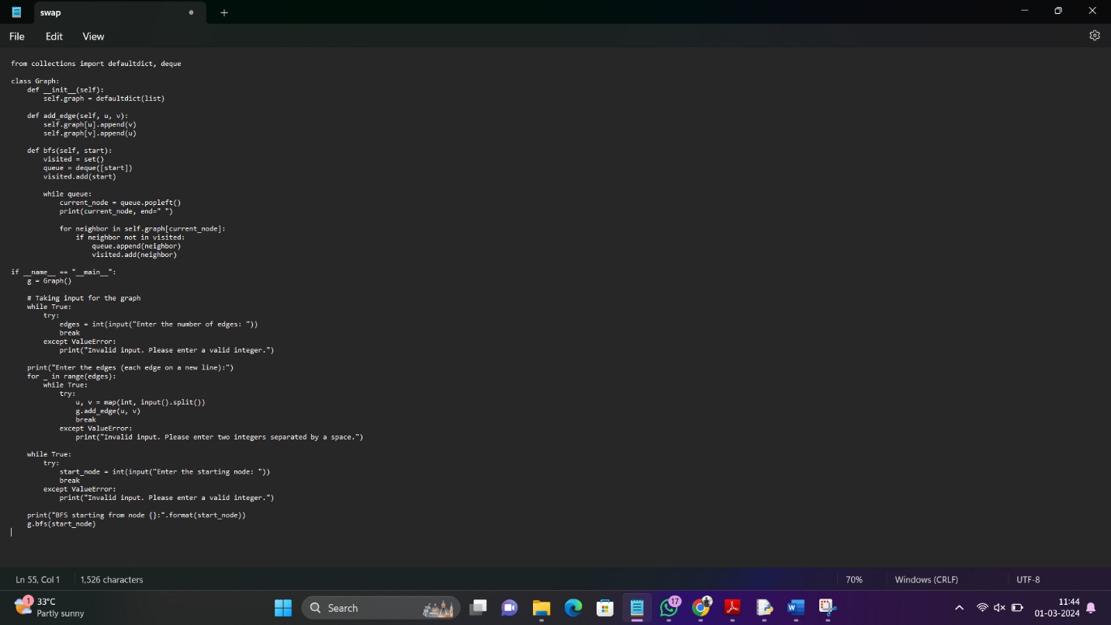

**INPUT:** Enter the number of edges: 6

Enter the starting node: 1

**OUTPUT:**

Enter the edges (each edge on a new line):

1 2

1 3

2 4

2 5

3 6

3 7

BFS starting from node 1: [1, 2, 3, 4, 5, 6, 7]

**RESULT:** Program to implement BFS is successfully executed and verified.