CHAPTER -1
INTRODUCTION

CHAPTER 1
INTRODUCTION

  - OVERVIEW OF THE PROJECT:
Diagnosing leukemia is primarily based on the reality that white cell count is accelerated with immature blast cells (lymphoid or myeloid), and neutrophils and platelets are reduced. Consequently, hematologists mechanically study blood smear below microscope for proper identification and type of blast cells. Acute Lymphoblastic Leukemia (ALL) is a heterogeneous clonal disorder of haemopoietic progenitor cells (“blasts”), which lose the capacity to differentiate typically and to reply to ordinary regulators of proliferation. In this paper, most effective ALL is considered. In this paper, only acute lymphocytic leukemia is considered. This method greatly relies upon on the operator’s capability and fatigue stages. Diagnostic confusion additionally takes place because of imitation of comparable signs by way of different problems. Furthermore, the identification task is generally difficult due to the form of capabilities and the often doubtful pictures purpose missing out on important indicators as to which shape of leukemia is being determined. The project presents the classifications and detection of acute lymphoblastic leukemia in blood microscopic images using supervised classifiers.ALL is a fast-growing cancer of the blood. Input blood microscopic image is converted into gray scale for better features extraction. Then the segmentation process is done by Fuzzy C-means clustering method. The system will be used to classify the queried images automatically to decide the abnormality.

  - SCOPE OF THE PROJECT:
Acute Lymphoblastic Leukemia (ALL) is a subtype of acute leukemia, which is prevalent among adults. The average age of a person with ALL is 65 years. The need for automation of leukemia detection arises since current methods involve manual examination of the blood smear as the first step toward diagnosis. DRLBP has better discriminatory power. When compared with FNN, PNN is fast and better compatible in classification. The performance of the system is evaluated through sensitivity, specificity and accuracy.

  - OBJECTIVE OF PROJECT:
The aim of our project is review detection of acute lymphoblastic leukemia in blood microscopic images and also providing effective classification of blood cells. Finally, detecting whether it is normal or abnormal cell.

1.4 EXISTING SYSTEM:
i) OTSU THRESHOLD:
Paper: Remote Computer-Aided Breast Cancer Detection and Diagnosis System Based on Cytological.
In computer vision and image processing, Otsu's method, is used to automatically perform clustering-based image thresholding or the reduction of a graylevel image to a binary image. The algorithm assumes that the image contains two classes of pixels following bi-modal histogram (foreground pixels and background pixels), it then calculates the optimum threshold separating the two classes so that their combined spread (intra-class variance) is minimal, or equivalently (because the sum of pairwise squared distances is constant), so that their inter-class variance is maximal. Consequently, Otsu's method is roughly a one-dimensional, discrete analog of Fisher's Discriminant Analysis. Otsu's method is also directly related to the Jenks optimization method. Thresholding approach doesn’t provide optimal results.

ii) PRINCIPAL COMPONENT ANALYSIS:
Paper: Biometric system from heart sound using wavelet based feature set.
Principal Component Analysis (PCA) is a statistical procedure that uses an orthogonal transformation to convert a set of observations of possibly correlated variables into a set of values of linearly uncorrelated variables called principal components. The number of distinct principal components is equal to the smaller of the number of original variables or the number of observations minus one. This transformation is defined in such a way that the first principal component has the largest possible variance (that is, accounts for as much of the variability in the data as possible), and each succeeding component in turn has the highest variance possible under the constraint that it is orthogonal to the preceding components. The resulting vectors are an uncorrelated orthogonal basis set. PCA is sensitive to the relative scaling of the original variables. Principal Component Analysis has low discriminatory power.

iii) LBP AND GLCM FEATURES:
Paper: Automatic recognition of five types of white International Conference Image Analysis and Recognition.
An LBP code for a neighborhood was produced by multiplying the threshold values with weights given to the corresponding pixels, and summing up the result. LBP codes are weighed using gradient vector to generate the histogram of robust LBP and discriminative features are determined from the robust local binary pattern codes. LBP doesn’t differentiate the local texture region.
The Gray Level Co-occurrence Matrix (GLCM) method is a way of extracting second order statistical texture features. A GLCM is a matrix where the number of rows and columns is equal to the number of gray levels, G, in the image. A statistical method of examining texture that considers the spatial relationship of pixels is the gray-level co-occurrence matrix (GLCM), also known as the gray-level spatial dependence matrix. The GLCM functions characterize the texture of an image by calculating how often pairs of pixel with specific values and in a specified spatial relationship occur in an image, creating a GLCM, and then extracting statistical measures from this matrix. (The texture filter functions, described in texture analysis cannot provide information about shape, that is, the spatial relationships of pixels in an image.)
iv) K MEANS CLUSTERING:
Paper: K-means clustering-based multilayer perceptron neural network for liver CT images automatic segmentation.
k-means clustering is a method of vector quantization, originally from signal processing, that is popular for cluster analysis in data mining. k-means clustering aims to partition n observations into k clusters in which each observation belongs to the cluster with the nearest mean, serving as a prototype of the cluster. The problem is computationally difficult (NP-hard); however, there are efficient heuristic algorithms that are commonly employed and converge quickly to a local optimum. The algorithm has a loose relationship to the k-nearest neighbor classifier, a popular machine learning technique for classification that is often confused with c-means because of the k in the name. One can apply the 1-nearest neighbor classifier on the cluster centers obtained by k-means to classify new data into the existing clusters. This is known as nearest centroid classifier or Rocchio algorithm.

1.5 PROPOSED SYSTEM:
Acute Lymphoblastic Leukemia detection from blood microscopic images using,
- Clustering.
- Hybrid (color, texture and shape) features.
- Supervised Classifier (PNN).
The pre-processing includes the image resizing, Gray color space conversion and de-noising. Before the segmentation process, we are going to resize the input image into fixed Row and Column size [256 256] using imresize command. Then the input image is converted into gray scale conversion for accurate segmentation. The conversion is done by RGB2GRAY Matlab commands. To reduce the effect of noise we apply the median filter for de-noising. Clustering of numerical data forms the basis of many classification and system modeling algorithms. Fuzzy C-means clustering is a data clustering technique in which a dataset is grouped into n clusters with every data point in the dataset belonging to every cluster to a certain degree. It is rather easy to implement and apply even on large data sets, particularly when using heuristics such as Lloyd’s algorithm. The DescriptoR Local Binary Pattern (DRLBP) is used to compare all the pixels including the center pixel with the neighboring pixels in the kernel to improve the robustness against the illumination variation. An LBP code for a neighborhood was produced by multiplying the threshold values with weights given to the corresponding pixels, and summing up the result. DRLBP is a gray-scale texture pattern which characterizes the spatial structure of a local image texture. A DRLBP operator computes the edge response values in all eight directions at each pixel position and generates a code from the relative strength magnitude. DRLBP feature describes the local primitives including different types of curves, corners, and junctions, more stably and retains more information. Feature Extraction is used to identify various features of the system like energy, entropy, contrast, correlation and homogeneity.
Advantages:
- Lloyd’s has high robustness and low complexity.
- DRLBP has better discriminatory power.
- PNN is fast and better compatible in classification

CHAPTER -2
LITERATURE SURVEY

CHAPTER 2
LITERATURE SURVEY
The purpose of the literature survey is to give the brief overview and also to establish complete information about the reference papers. The goal of literature survey is to completely specify the technical details related to the main project in a concise and unambiguous manner.

2.1 Nuclei segmentation of leukocytes in blood smear digital images
Author Name: Abbas N, Mohamad D, Abdullah AH,
College of Computer and Information Sciences (CCIS),
Prince Sultan University Riyadh, KSA.
Description:
The Leukocytes are differentiated from each other on the basis of their nuclei, demanded in many Medical studies, especially in all types of Leukemia by the Hematologists to note the disorder caused by specific type of Leukocyte. Leukemia is a life threatening disease. The work for diagnosing is manually carried out by the Hematologists involving much labor, time and human errors. The problems mentioned are easily addressed through computer vision techniques, but still accuracy and efficiency are demanded in terms of the basic and challenging step segmentation of Leukocyte's nuclei. The underlying study proposed better method in terms of accuracy and efficiency by designing a dynamic convolution filter for boosting low intensity values in the separated green channel of an RGB image and suppressing the high values in the same channel. The high values in the green channel become 255 (background) while the nuclei always have low values in the green channel and thus clearly appear as foreground. The proposed technique is tested on 365 images achieving an overall accuracy of 95.89%, while improving the efficiency by 10%. The proposed technique achieved its targets in a realistic way by improving the accuracy as well as the efficiency and both are highly required in the area.
2.2 Computer Aided System for Leukocytes Classification and Segmentation in Blood Smear Images, in Frontiers of Information Technology
Author Name: Muhammad Sajjad, S.K., Muhammad Shoaib,
Hazrat Ali, Zahoor Jan,
Frontiers of Information Technology (FIT).
Description:
In the last two decades, a number of automatic and semiautomatic methods are proposed for the segmentation and classification of medical diagnostic modalities. Medical image processing techniques allow us to segment and classify different types of blood cells, soft tissues, and bones from medical images. It has been observed in medical field that majority of the diseases in the body can be identified by analyzing blood samples. There are numerous categories of blood cells such as red blood cells (erythrocytes), white blood cells (leukocytes), and platelets (thrombocytes). Furthermore, each of these blood categories are further divided into various classes. The total count of blood cells and fractional count of WBCs provide important information to doctors for identification and diagnosing of different kinds of diseases. To accomplish this task, there are two possible methods: Manual segmentation of nucleus from WBCs and their classification based on a set of parameters, which is inherently difficult, prone to errors, and time consuming due to involvement of humans. Furthermore, the instruments used by experts for manual segmentation and classification of WBCs are not affordable by all hospital and clinics.

2.3 Automatic recognition of five types of white International Conference Image Analysis and Recognition.
Author Name: Seyed Hamid Rezatofighi,Kosar Khaksari,Hamid Soltanian-
Zadeh
Control and Intelligent Processing Center of Excellence,
Department of Electrical and Computer Engineering,
Faculty of Engineering University of Tehran Iran.
Description:
An automatic system which is capable of recognizing white blood cells can assist hematologists in the diagnosis of many diseases. In this paper, a new system is proposed based on image processing techniques in order to recognize five types of white blood cells in the peripheral blood. To segment nucleus and cytoplasm, a Gram-Schmidt orthogonalization method and a snake algorithm are applied, respectively. Moreover, three kinds of features are extracted from the segmented areas and two groups of textural features extracted by Local Binary Pattern (LBP) and co-occurrence matrix are evaluated. Best features are selected using a Sequential Forward Selection (SFS) algorithm and performances of two classifiers, ANN and SVM, are compared. In this application, the best result is obtained using LBP as the textural feature and SVM as the classifier. In sum, the results demonstrate that the methods are accurate and fast enough to execute in hematological laboratories.

2.4 Remote Computer-Aided Breast Cancer Detection and Diagnosis System Based on Cytological
Author Name: Yasmeen Mourice George,Hala Helmy Zayed,
Mohamed Ismail Roushdy,
Comput. Sci. Dept., Ain Shams Univ., Cairo, Egypt.
Description:
The purpose of this study is to develop an intelligent remote detection and diagnosis system for breast cancer based on cytological images. First, this paper presents a fully automated method for cell nuclei detection and segmentation in breast cytological images. The locations of the cell nuclei in the image were detected with circular Hough transform. The elimination of false-positive (FP) findings (noisy circles and blood cells) was achieved using Otsu's thresholding method and fuzzy c-means clustering technique. The segmentation of the nuclei boundaries was accomplished with the application of the marker-controlled watershed transform. Four classification models were used, namely, multilayer perceptron using back-propagation algorithm, probabilistic neural network (PNN), learning vector quantization, and support vector machine (SVM). The classification results were obtained using tenfold cross validation. The performance of the networks was compared based on resulted error rate, correct rate, sensitivity, and specificity. Finally, we have merged the proposed computer-aided detection and diagnosis system with the telemedicine platform. This is to provide an intelligent, remote detection, and diagnosis system for breast cancer patients based on the Web service. The proposed system was evaluated using 92 breast cytological images containing 11502 cell nuclei. In addition, two benchmark data sets were evaluated for comparison. The results showed that the predictive ability of PNN and SVM is stronger than the others in all evaluated data sets.

2.5 Biometric system from heart sound using wavelet based feature set
Author Name: Girish Gautam , Deepesh Kumar
Electronics and Communication Department,
National Institute Of Technology, Rourkela, India.

Description:
Heart sound is generally used to determine the human heart condition. Recent reported research proved that cardiac auscultation technique which uses the characteristics of phonocardiogram (PCG) signal, can be used as biometric authentication system. An automatic method for person identification and verification from PCG using wavelet based feature set and Back Propagation Multilayer Perceptron Artificial Neural Network (BP-MLP-ANN) classifier is presented in this paper. Database is collected from 10 volunteers (between 20-40 age groups) during one month period using a digital stethoscope manufactured by HDfono Doc. The proposed algorithm is tested on 4000 PCG samples and yields 90.52% of identification accuracy and Equal Error Rate (EER) of 9.48%. The preprocessing before feature extraction involves selection of heart cycle, filtering for noise reduction, aligning and segmentation of S1 and S2. Performance of the classifier is determined from the Receiver Operating Curve (ROC). The experimental result shows that the performance of the proposed algorithm is better than the other reported technique which uses Linear Band Frequency Cepstral Coefficient (LBFCC) feature set.

2.6 Melanoma Classification on Dermoscopy Images Using a Neural Network Ensemble Model
Author Name: Fengying Xie,Haidi Fan,Yang Li
Image Processing Center,
School of Astronautics, Beihang University, Beijing, China.
Description:
We develop a novel method for classifying melanocytic tumors as benign or malignant by the analysis of digital dermoscopy images. The algorithm follows three steps: 1. Lesions are extracted using a Self-Generating Neural Network (SGNN); 2. Features descriptive of tumor color, texture and border are extracted; and 3. Lesion objects are classified using a classifier based on a neural network ensemble model. In clinical situations, lesions occur that are too large to be entirely contained within the dermoscopy image. To deal with this difficult presentation, new border features are proposed, which are able to effectively characterize border irregularities on both complete lesions and incomplete lesions. In our model, a network ensemble classifier is designed that combines Back Propagation (BP) neural networks with fuzzy neural networks to achieve improved performance. Experiments are carried out on two diverse dermoscopy databases that include images of both the xanthous and caucasian races. The results show that classification accuracy is greatly enhanced by the use of the new border features and the proposed classifier model.

2.7 Fuzzy C-means clustering-based multilayer perceptron neural network for liver CT images automatic segmentation
Author Name: Yuqian Zhao, Yunlong Zan,Xiaofang Wang,
School of Info-Physics & Geomatics Engineering,
Central South University, Changsha 410083, China.
Description:
A new liver segmentation algorithm is proposed. First, the threshold method was used to remove the ribs and spines in the initial image, and the fuzzy C-means clustering algorithm and morphological reconstruction filtering were used to segment the initial liver CT image. Then the multilayer perceptron neural network was trained by the segmentation result of initial image with the back-propagation algorithm. The adjacent slice CT image was segmented with the trained multilayer perceptron neural network. Last, morphological reconstruction filtering was used to smooth the contour of the liver edge. The experimental results show that the proposed algorithm can effectively segment the livers from CT images, despite the gray level similarity of adjacent organs and different gray level of tumors in the liver.

2.8 Evaluation of surface roughness of tumor using neural network
Author Name: I. Akiyama, S. Ogawa, K. Omoto,
Dept. of Electr. Eng.,
Shonan Inst. of Technol., Fujisawa, Japan.
Description:
Since surface roughness of a malignant tumor is more remarkable than that of a benign tumor, it is possible to classify pathological states of the tumor by computing the degree of surface roughness. We have proposed a method for the segmentation of the tumor in ultrasonic echography and confirmed the feasibility of the technique. This paper describes a neural network based classifier using the surface roughness of a breast tumor which is extracted from ultrasonic echography. We define nine parameters for evaluation of the surface roughness, which form an Artificial Neural Network (ANN) input vector. The ANN output sequence displays two types of pathological states: malignant and benign. We use twenty seven benign tumors and twenty four malignant tumors for the feasibility study. Twenty four tumors are used for learning data and the other tumors are used for the trial. As a result, successful classification is obtained.

2.9 FEASIBILITY STUDY:
The feasibility of the project is analyzed is put forth with a very general plan for the project and some cost estimates. During system analysis, the feasibility study of the proposed system is to be carried out. This is to ensure that the proposed system is not a burden to the user. For feasibility analysis, some understanding of the major requirements for the system is essential.
The key consideration involved in the feasibility analysis are
- Economic feasibility
- Technical feasibility
- Resource feasibility
- Social feasibility
- Operational feasibility
- Economic feasibility:
This study is carried out to check the economic impact that the system will have on the organization. The amount of fund that the company can pour into the research and development of the system is limited. The expenditures must be justified. Thus the developed system as well within the budget and this was achieved because most of the technologies used for freely available. Only the customized products had to be purchased.
- Technical feasibility:
This study is carried out to check the technical feasibility, that is, the technical requirements of the system. Any system developed must not have a high demand on the available technical resources. The developed system must have modest requirements, as only minimal or null changes are required for implementing this system.
- Resource feasibility:
The system is said to be beneficial, if the proper resource is utilized in the concerned project. The resource or requirements includes software or hardware requirements needed to perform the operations in the project. This evolves the migration of existing system to incorporate with the new systems using impact analysis.
- Social feasibility:
Social feasibility addresses the influences that the proposed project may have on the social system in the project environment. The level of acceptance by the users solely depends on the methods that are employed to educate the user about the system and to make him familiar with it. Their level of confidence must be raised.
- Operational feasibility:
The aspect of study is to check the level of acceptance of the system by the user. This includes the process of training the user to use the system efficiently. The user must not feel threatened by the system, instead they must accept it as a necessity. The level of acceptance by the users solely depends on the methods that are employed to educate the user about the system and to make him familiar with it.

CHAPTER - 3
SYSTEM DESIGN

CHAPTER 3
SYSTEM DESIGN

3.1 DESIGN OF THE PROPOSED SYSTEM:
The proposed system is designed in such a way that, the blood samples from various patients are processed very quickly and accurately. The GUI interface is created such that the haematologist have clear access. First the input image of the blood sample which is acquired from the user is sent as an input in the image acquisition phase. The sample which is acquired is then sent into preprocess phase, the pre-processing includes the image resizing, Gray color space conversion and de-noising. These three processes are applied over the input image. Then, the preprocessed image is sent to be clustered. Here the images get resized in matrix format of 256X256 of row and column size. The clustering process gives four clustered images as (primary)1⁰ , (secondary)2⁰, foreground and background image. On choosing an image in random from four classified images Local Binary Pattern is applied over the image. In LBP, the centre pixel of the image is considered as threshold and is compared. The pixels that are less than threshold are considered to be 0, where it represents black. The pixels that are greater than the threshold value are considered to be 1, where it represents white. The will be then turn into black and white image, having black and white pixels. After LBP, feature extraction process takes place. The various features of the image like energy, entropy, contrast, correlation, homogeneity are calculated. The training samples also undergo all these processes of preprocessing, clustering, feature extraction. Now, in SVM classification the test image sample is classified by comparing with database images whether it is normal cell or cancer cell. If it is normal, the result will be shown as Normal. If it is cancer cell, the result will be Abnormal.

BLOCK DIAGRAM:
Local Binary Pattern(LBP)
Test samples
Preprocessing
Clustering

Hybrid Feature Extraction

Reference Features
Training samples
SVM classification
Preprocessing

Decision (ALL/non ALL)

Fig 3.1 Proposed System Architecture

3.2 DATA FLOW DIAGRAM FOR PROPOSED SYSTEM:
A Data Flow Diagram (DFD) is a graphical representation of the flow of data through an information system, modelling its process aspects. A DFD is often used as a preliminary step to create an overview of the system without going into great detail, which can later be elaborated. DFDs can also be used for the visualization of data processing (structured design).
A DFD shows what kind of the information will be input to and output from the system, how the data will advance through the system, and where the data will be stored. It does not show information about the timing of process or information about whether processes will operate in a sequence or in parallel unlike a flowchart which also shows this information.
Data flow diagrams are also known as bubble charts. DFD is a designing tool used in the top-down approach to Systems Design. This context-level DFD is next "exploded", to produce a Level 1 DFD that shows some of the detail of the system being modeled. The Level 1 DFD shows how the system is divided into sub-systems (processes), each of which deals with one or more of the data flows to or from an external agent, and which together provide all of the functionality of the system as a whole. It also identifies internal data stores that must be present in order for the system to do its job, and shows the flow of data between the various parts of the system.
Data flow diagrams are one of the three essential perspectives of the structured-systems analysis and design method SSADM. The sponsor of a project and the end users will need to be briefed and consulted throughout all stages of a system's evolution. With a data flow diagram, users are able to visualize how the system will operate, what the system will accomplish, and how the system will be implemented.
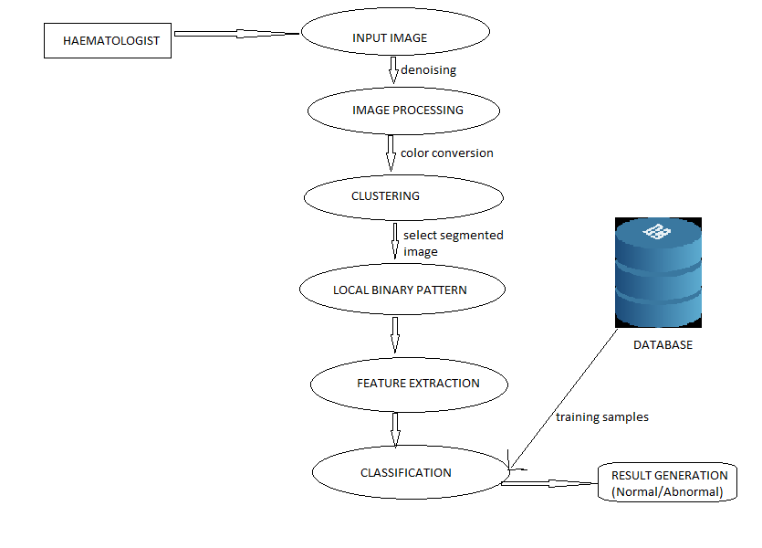
Fig 3.2 Data Flow Diagram
3.3. UML DIAGRAMS:
3.3.1 USE CASE DIAGRAM:
A use case diagram is a graphic depiction of the interactions among the elements of a system. A use case is a methodology used in system analysis to identify, clarify, and organize system requirements.
A use case diagram contains three components.
- The boundary, which defines the system of interest in relation to the world around it.
- The actors, usually individuals involved with the system defined according to their roles.
- The relationships between and among the actors and the use cases.
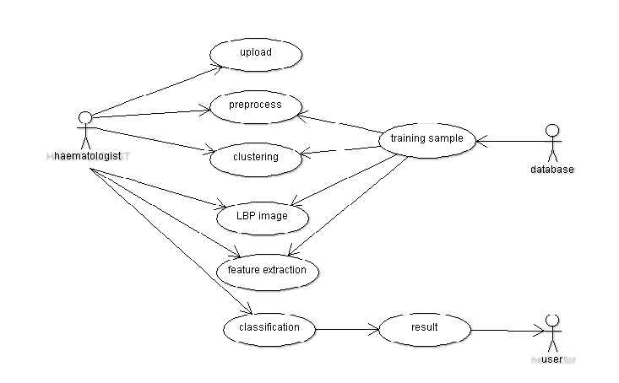
Fig 3.3.1 Use Case Diagram

3.3.2 SEQUENCE DIAGRAM:
Sequence diagram model the flow of logic within your system in a visual manner, enabling you both to document and validate your logic, and commonly used for both analysis and design purpose. Sequence diagram are the most popular UML artifact for dynamic modeling, which focuses on identifying the behaviour within your system.
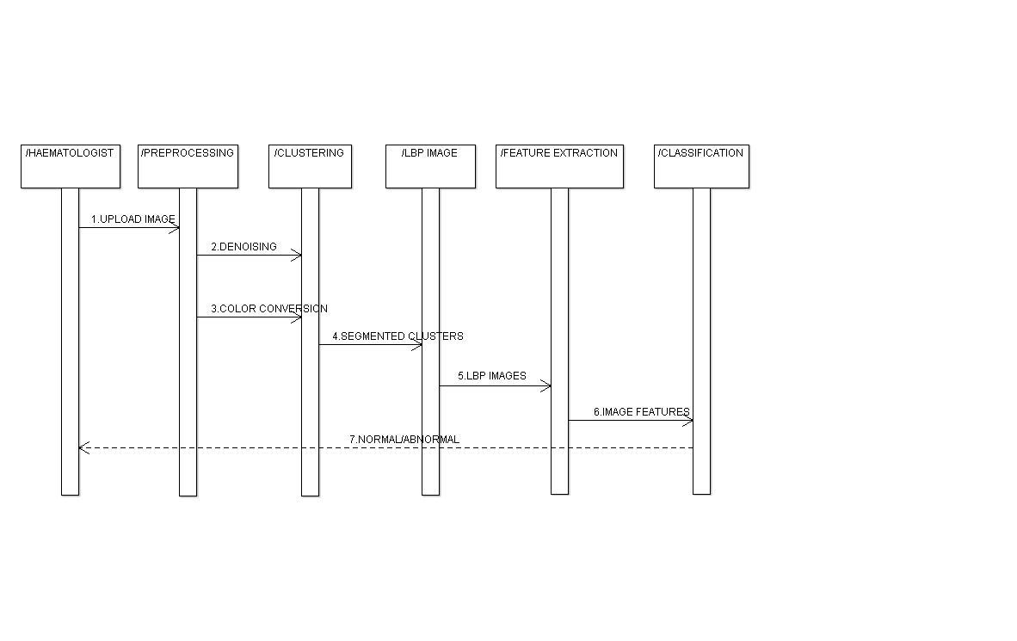
Fig 3.3.2 Sequence Diagram

3.3.3 CLASS DIAGRAM:
In software engineering, a class diagram in the Unified Modeling Language (UML) is a type of static structure diagram that describes the structure of a system by showing the system's classes, their attributes, operations (or methods), and the relationships among the classes. It explains which class contains information.
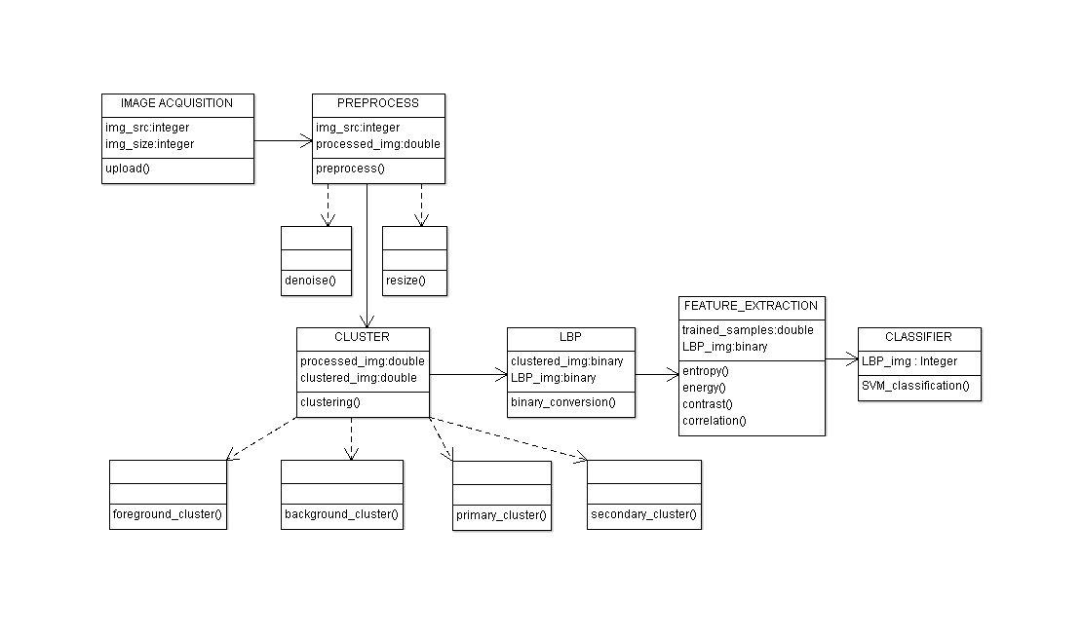
Fig 3.3.3 Class Diagram

3.3.4 ACTIVITY DIAGRAM:
The activity diagram is the graphical representations of workflows of stepwise activities and actions with support for choice, iteration and concurrency. The activity diagrams can be used to describe the business and operational step-by-step workflows of components in a system. Activity diagram consist of Initial node, final node and activities in between. Activity diagram is basically a flowchart to represent the flow from one activity to another activity. The activity can be described as an operation of the system. The control flow is drawn from one operation to another.
An activity in Unified Modeling Language (UML) is a major task that must take place in order to fulfill an operation contract. Activities can be represented inactivity diagrams. An activity can represent: The invocation of an operation. A step in a business process.
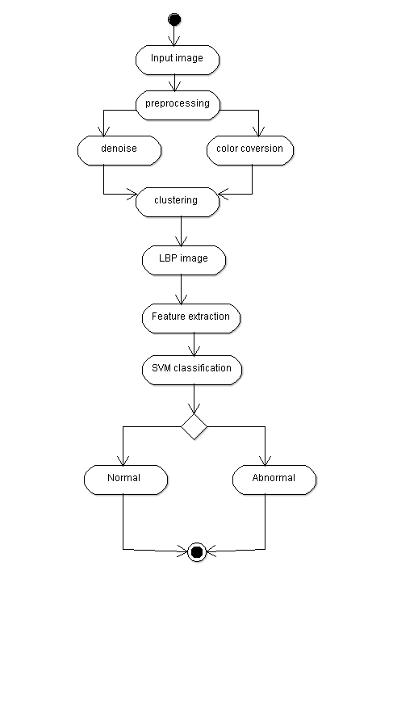
Fig 3.3.4 Activity Diagram

CHAPTER - 4
MODULE DESCRIPTIONS

CHAPTER 4
MODULE DESCRIPTIONS

4.1 MODULES:
A modular design reduces complexity, facilities change (a critical aspect of software maintainability), and results in easier implementation by encouraging parallel development of different part of system. Software with effective modularity is easier to develop because function may be compartmentalized and interfaces are simplified. Software architecture embodies modularity that is software is divided into separately named and addressable components called modules that are integrated to satisfy problem requirements.
Modularity is the single attribute of software that allows a program to be intellectually manageable. The five important criteria that enable us to evaluate a design method with respect to its ability to define an effective modular design are: Modular decomposability, Modular Compatability, Modular Understandability, Modular continuity, Modular Protection.
The following are the modules of the project, which are planned in aid to complete the project with respect to the proposed system, while overcoming existing system and also providing the support for the future enhancement.
In the proposed system, there are five modules and they are described as follows:
- Preprocessing
- Fuzzy C-Means clustering
- Local Binary Pattern
- Feature Extraction
- SVM Classification

4.2 MODULE DESCRIPTION:
4.2.1 PREPROCESSING:
The pre processing includes the image resizing, Gray color space conversion and de-noising. Before the segmentation process, we are going to resize the input image into fixed Row and Column size [256 256] using imresize command. Then the input image is converted into gray scale conversion for accurate segmentation. The conversion is done by RGB2GRAY Matlab commands. To reduce the effect of noise we apply the median filter for de-noising.

4.2.2 FUZZY C-MEANS CLUSTERING:
Clustering of numerical data forms the basis of many classification and system modeling algorithms. The purpose of clustering is to identify natural groupings of data from a large data set to produce a concise representation of a system's behavior. Fuzzy C-means clustering is a data clustering technique in which a dataset is grouped into n clusters with every data point in the dataset belonging to every cluster to a certain degree. It is rather easy to implement and apply even on large data sets, particularly when using heuristics such as Lloyd’s algorithm. A fuzzy based two stage color segmentation strategy is employed for segregating leukocytes or white blood cells (WBC) from other blood components. In the present paper two novel shape features i.e., Hausdorff Dimension and contour signature is implemented for classifying a lymphocytic cell nucleus. Fuzzy c-means (FCM) is a method of clustering which allows one piece of data to belong to two or more clusters. This method is frequently used in pattern recognition. Gives best result for overlapped data set and comparatively better then k-means algorithm. Unlike k-means where data point must exclusively belong to one cluster center here data point is assigned membership to each cluster center.

4.2.3 LOCAL BINARY PATTERN:
The descriptor local binary pattern is used to compare the center pixel with the neighboring pixels in the kernel to improve the robustness against the illumination variation. An LBP code for a neighborhood was produced by multiplying the threshold values with weights given to the corresponding pixels, and summing up the result.LBP codes are weighed using gradient vector to generate the histogram of robust LBP and discriminative features are determined from the robust local binary pattern codes. DRLBP is represented in terms of set of normalized histogram bins as local texture features. DRLBP is a gray-scale texture pattern which characterizes the spatial structure of a local image texture. A DRLBP operator computes the edge response values in all eight directions at each pixel position and generates a code from the relative strength magnitude. The concept of local binary pattern (LBP) was introduced for texture classification. Defining the local neighborhood as a set of sampling points evenly spaced on a circle centered at the pixel to be labeled allows any radius and number of sampling points. When a sampling point does not fall in the center of a pixel, bilinear interpolation was employed. In the LBP method where each pixel is replaced by a binary pattern that is derived from the pixel’s neighborhood. Each grayscale pixel P is compared with these sample points one by one. If the center point P is larger than the current neighborhood sample point I, the result is a binary zero; otherwise, the result is a binary one.

4.2.4 FEATURE EXTRACTION:
Feature extraction in image processing is a technique of redefining a large set of redundant data into a set of features of reduced dimension. Transforming the input data into the set of features is called feature extraction. Feature selection greatly influences the classifier performance; therefore, a correct choice of features is a very crucial step. In order to construct an effective feature set, several published articles were studied, and their feature selection methodology was observed. It was noted that certain features were widely used as they gave a good classification. We implemented these features on whole images in our system. Those features were considered to boost the classifier performance.
Some of these features are the following.
- Energy : It is a measure the homogeneousness of the image and can be calculated from the normalized COM. It is a suitable measure for detection of disorder in texture image.
- Entropy : This parameter measures the disorder of an image. When the image is not texturally uniform, entropy is very large. Entropy gives a measure of complexity of the image. Complex textures tend to have higher entropy.
- Contrast : The contrast feature is a difference moment of the regional Co-occurrence matrix and is a measure of the contrast or the amount of local variations present in an image.
- Correlation : The correlation feature is a measure of regional-pattern linear dependence in the image.
sum(sum((x- μx)(y-μy)p(x , y)/σ_{xσy)})
- Homogeneity : Measures the closeness of the distribution of elements.If the image is homogeneous is uniform in composition or character (i.e. color, shape, size, weight, height, distribution, texture, language, income, disease, temperature, radioactivity, architectural design, etc.)
sum(sum(p(x , y)/(1 + [x-y])))

4.2.5 SVM CLASSIFICATION:
Support Vector Machine(SVM) classification is used for constructing a selection surface in the function space that bisects the 2 classes, i.e., cancerous and noncancerous, and maximizes the margin of separation among training of factors. SVMs is a promising nonlinear nonparametric classification approach, which already confirmed properly outcomes within the scientific diagnostics. The SVM is a powerful state of-the-art work algorithm with strong theoretical foundations based at the Vapnik–Chervonenkis theory and with strong regularization homes. Regularization refers to the generalization of the model to new statistics. An SVM is mostly a two-magnificence classifier. it may be both linear or nonlinear. on this paper, we select a linear SVM two-magnificence classifier; as it is not computationally pricey, it does not appoint the kernel trick explicitly, and it achieves, in widespread, a very good performance. Two especially critical issues are: 1) the determination of the most appropriate feature subspace where to carry out the classification task and 2) model selection. In this paper, these two issues are addressed through a classification system that optimizes the SVM classifier accuracy for this kind of imagery. This system is based on a genetic optimization framework formulated in such a way as to detect the best discriminative features without requiring the a priori setting of their number by the user and to estimate the best SVM parameters (i.e., regularization and kernel parameters) in a completely automatic way. For these purposes, it exploits fitness criteria intrinsically related to the generalization capabilities of SVM classifiers.

CHAPTER - 5
REQUIREMENT SPECIFICATION

CHAPTER 5
REQUIREMENT SPECIFICATION

5.1 HARDWARE REQUIREMENTS:
The hardware requirements may serve as the basis for a contract for the implementation of the system and should therefore be a complete and consistent specification of the whole system. They are used by software engineers as the starting point for the system design. It shows what the systems do and not how it should be implemented.
- HARD DISK : 500 GB and Above
- RAM : 4 GB and Above
- PROCESSOR : I3 and Above
- PROCESSOR SPEED : Minimum 500 MHZ

5.2 SOFTWARE REQUIREMENTS:
The software requirements are the specification of the system. It should include both a definition and a specification of requirements. It is a set of what the system should do rather than how it should do it. The software requirements provide a basis for creating the software requirements specification. It is useful in estimating cost, planning team activities, performing tasks and tracking the team’s and tracking the team’s progress throughout the development activity.
- MATLAB 7.10 or above versions of MATLAB.

MATLAB: MATLAB is a high-performance language for technical computing. Typical uses include:
- Math and computation
- Algorithm development
- Modeling, simulation, and prototyping
- Data analysis, exploration, and visualization
- Scientific and engineering graphics
- Application development, including graphical user interface building
MATLAB is an interactive system whose basic data element is an array that does not require dimensioning. This allows you to solve many technical computing problems, with matrix and vector formulations, in a fraction of the time it would take to write a program in a scalar non-interactive language such as C or FORTRAN.
The MATLAB System:
The MATLAB system consists of five main parts:
Development Environment: This is the set of tools and facilities that help you use MATLAB functions and files. Many of these tools are graphical user interfaces. It includes the MATLAB desktop and Command Window, a command history, and browsers for viewing help, the workspace, files, and the search path.
The MATLAB Mathematical Function Library: This is a vast collection of computational algorithms ranging from elementary functions like sum, sine, cosine, and complex arithmetic, to more sophisticated functions like matrix inverse, matrix eigenvalues, Bessel functions, and fast Fourier transforms.
The MATLAB Language: This is a high-level matrix/array language with control flow statements, functions, data structures, input/output, and object-oriented programming features. It allows both "programming in the small" to rapidly create quick and dirty throw-away programs, and "programming in the large" to create complete large and complex application programs.
Handle Graphics®: The MATLAB graphics system includes high-level commands for 2-dimensional and 3-dimensional data visualization, image processing, animation, and presentation graphics. It also includes low-level commands that allow you to fully customize the appearance of graphics as well as to build complete graphical user interfaces on your MATLAB applications.
The MATLAB Application Program Interface (API): This is a library that allows you to write C and FORTRAN programs that interact with MATLAB. It include facilities for calling routines from MATLAB (dynamic linking), calling MATLAB as a computational engine, and for reading and writing MAT-files.
DEVELOPMENT ENVIRONMENT:
MATLAB Desktop:
When you start MATLAB, the MATLAB desktop appears, containing tools (GUI) for managing files, variables, and applications associated with MATLAB.The tools are:
Command Window:
Use the Command Window to enter variables and run functions and M-files.
Command History:
Lines you enter in the Command Window are logged in the Command History window. In the Command History, you can view previously used functions, and copy and execute selected lines.
Running External Programs:
You can run external programs from the MATLAB Command Window. The exclamation point character ! is a shell escape and indicates that the rest of the input line is a command to the operating system..
Launch Pad:
MATLAB's Launch Pad provides easy access to tools, demos, and documentation.
Help Navigator:
Product filter - Set the filter to show documentation only for the products you specify.
Contents tab- View the titles and tables of contents of documentation for your products.
Index tab- Find specific index entries (selected keywords) in the MathWorks documentation for your products.
Search tab- Look for a specific phrase in the documentation. To get help for a specific function, set the Search type to Function Name.
Favorites tab- View a list of documents you previously designated as favorites.
Display Pane- After finding documentation using the Help Navigator, view it in the display pane.
Current Directory Browser:
MATLAB file operations use the current directory and the search path as reference points. Any file you want to run must either be in the current directory or on the search path.
Search Path:
Any file you want to run in MATLAB must reside in the current directory or in a directory that is on the search path.
Workspace Browser:
The MATLAB workspace consists of the set of variables (named arrays) built up during a MATLAB session and stored in memory. You add variables to the workspace by using functions, running M-files, and loading saved workspaces.
Array Editor:
Double-click on a variable in the Workspace browser to see it in the Array Editor. Use the Array Editor to view and edit a visual representation of one or two-dimensional numeric arrays, strings, and cell arrays of strings that are in the workspace.
Editor/Debugger:
Use the Editor/Debugger to create and debug M-files, which are programs you write to run MATLAB functions. The Editor/Debugger provides
a graphical user interface for basic text editing, as well as for M-file debugging.
MANIPULATING MATRICES:
Entering Matrices:
Start MATLAB and follow along with each example.
You can enter matrices into MATLAB in several different ways:
- Enter an explicit list of elements.
- Load matrices from external data files.
- Generate matrices using built-in functions.
- Create matrices with your own functions in M-files.
Start by entering Durer's matrix as a list of its elements. You have only to follow a few basic conventions:
- Separate the elements of a row with blanks or commas.
- Use a semicolon ; , to indicate the end of each row.
- Surround the entire list of elements with square brackets, [ ].
To enter Durer's matrix, simply type in the Command Window
A = [16 3 2 13; 5 10 11 8; 9 6 7 12; 4 15 14 1]
MATLAB displays the matrix you just entered.
A = 16 3 2 13
5 10 11 8
9 6 7 12
4 15 14 1
This exactly matches the numbers in the engraving. Once you have entered the matrix, it is automatically remembered in the MATLAB workspace. You can refer to it simply as A.
Expressions:
Like most other programming languages, MATLAB provides mathematical expressions, but unlike most programming languages, these expressions involve entire matrices. The building blocks of expressions are:
Variables:
MATLAB does not require any type declarations or dimension statements. When MATLAB encounters a new variable name, it automatically creates the variable and allocates the appropriate amount of storage. If the variable already exists, MATLAB changes its contents and, if necessary, allocates new storage. For example, num_students = 25
Creates a 1-by-1 matrix named num_students and stores the value 25 in its single element.
Numbers:
MATLAB uses conventional decimal notation, with an optional decimal point and leading plus or minus sign, for numbers. Scientific notation uses the letter e to specify a power-of-ten scale factor. Imaginary numbers use either i or j as a suffix. Some examples of legal numbers are
3 -99 0.0001
9.6397238 1.60210e-20 6.02252e23
1i -3.14159j 3e5i
Operators:
+ | Addition
- | Subtraction
* | Multiplication
/ | Division
\ | Left division (described in "Matrices and Linear Algebra" in Using MATLAB)
^ | Power
' | Complex conjugate transpose
( ) | Specify evaluation order

Table 5.1 Expressions use familiar arithmetic operators and precedence rules.
Functions:
MATLAB provides a large number of standard elementary mathematical functions, including abs, sqrt, exp, and sin. Taking the square root or logarithm of a negative number is not an error; the appropriate complex result is produced automatically. MATLAB also provides many more advanced mathematical functions, including Bessel and gamma functions. Most of these functions accept complex arguments. For a list of the elementary mathematical functions, type helpelfun. For a list of more advanced mathematical and matrix functions, type helpspecfun. Some of the functions, like sqrt and sin, are built-in.
GUI:
A graphical user interface (GUI) is a user interface built with graphical objects, such as buttons, text fields, sliders, and menus. In general, these objects already have meanings to most computer usersThe action that results from a particular user action can be made clear by the design of the interface. The sections that follow describe how to create GUIs with MATLAB. This includes laying out the components, programming them to do specific things in response to user actions, and saving and launching the GUI.
Creating GUIs with GUIDE:
MATLAB implements GUIs as figure windows containing various styles of UI control objects. You must program each object to perform the intended action when activated by the user of the GUI. In addition, you must be able to save and launch your GUI. All of these tasks are simplified by GUIDE, MATLAB's graphical user interface development environment.
GUI Development Environment:
The process of implementing a GUI involves two basic tasks:
- Laying out the GUI components
- Programming the GUI components
GUIDE primarily is a set of layout tools. However, GUIDE also generates an M-file that contains code to handle the initialization and launching of the GUI. This M-file provides a framework for the implementation of the callbacks - the functions that execute when users activate components in the GUI.
User Interface Controls:
The Layout Editor component palette contains the user interface controls that you can use in your GUI. These components are MATLAB uicontrol objects and are programmable via their Callback properties. This section provides information on these components.

CHAPTER - 6
IMPLEMENTATION

CHAPTER 6
IMPLEMENTATION
6.1 SAMPLE CODE:
function varargout = gui_proposed_method(varargin)

gui_Singleton = 1;

gui_State = struct('gui_Name', mfilename, ...

'gui_Singleton', gui_Singleton, ...

'gui_OpeningFcn', @gui_proposed_method_OpeningFcn, ...

'gui_OutputFcn', @gui_proposed_method_OutputFcn, ...

'gui_LayoutFcn', [] , ...

'gui_Callback', []);

if nargin && ischar(varargin{1})

gui_State.gui_Callback = str2func(varargin{1});

end

if nargout

[varargout{1:nargout}] = gui_mainfcn(gui_State, varargin{:});

Else

gui_mainfcn(gui_State, varargin{:});

end

function gui_proposed_method_OpeningFcn(hObject, eventdata, handles, varargin)

handles.output = hObject;

guidata(hObject, handles);

function varargout = gui_proposed_method_OutputFcn(hObject, eventdata, handles)

varargout{1} = handles.output;

function inp_img_Callback(hObject, eventdata, handles)

cd test_image

[file path] = uigetfile('*.*','pick any image');

if file == 0

warndlg('select any image');

else

Input=imread(file);

End

cd ..

axes(handles.axes1);

imshow(Input);title('Input image');impixelinfo;

handles.Input=Input;

guidata(hObject, handles);

function pre_process_Callback(hObject, eventdata, handles)

Input=handles.Input;

Input=imresize(Input,[512 512]);

test = Input;

[r c p] = size(Input);

if p == 3

Input = rgb2gray(Input);

End

axes(handles.axes2);

imshow(Input);title('Input image');impixelinfo;

Input1 = filt(Input);

axes(handles.axes3);

imshow(Input1);title('Input image');impixelinfo;

handles.Input1=Input1;

handles.test=test;

guidata(hObject, handles);

function fuzzy_c_means_cluster_Callback(hObject, eventdata, handles)

Input=handles.Input1;

inp=Input;

segI= double(Input);

[r1 c1] = size(segI);

Length = r1*c1;

data = reshape(segI,[Length,1]);

Cluster = 4;

dims = [r1 c1];

[data_n in_n]= size(data);

expo = 2;

max_iter = 100;

min_impro = 1e-5;

display = 0;

nwin =5;

spw =1;

mfw =1;

obj_fcn = zeros(max_iter, 1);

U = rand(Cluster, data_n);

col_sum = sum(U);

U = U./col_sum(ones(Cluster, 1), :);

lba = waitbar(0,'Please Wait...Processing');

for i = 1:max_iter,

mf = U.^expo;

center = mf*data./((ones(size(data, 2), 1)*sum(mf'))'); % new center

dist = zeros(size(center, 1), size(data, 1));

if size(center, 2) > 1,

for k = 1:size(center, 1),

dist(k, :) = sqrt(sum(((data-ones(size(data, 1), 1)*center(k, :)).^2)'));

end

else

for k = 1:size(center, 1),

dist(k, :) = abs(center(k)-data)';
end

end

obj_fcn(i) = sum(sum((dist.^2).*mf)); % objective function

tmp = dist.^(-2/(expo-1));

U_new = tmp./(ones(Cluster, 1)*sum(tmp));

tempwin=ones(nwin);

mfwin=zeros(size(U_new));

for j=1:size(U_new,1)

tempmf=reshape(U_new(j,:), dims);

tempmf=imfilter(tempmf,tempwin,'conv');

mfwin(j,:)=reshape(tempmf,1,size(U_new,2));

end

mfwin=mfwin.^spw;

U_new=U_new.^mfw;

tmp=mfwin.*U_new;

U_new=tmp./(ones(Cluster, 1)*sum(tmp));

U = U_new;

if display,

fprintf('Iteration count = %d, obj. fcn = %f\n', i, obj_fcn(i));

end

if i > 1,

if abs(obj_fcn(i) - obj_fcn(i-1)) < min_impro, break; end,
end

waitbar(i/max_iter,lba);

end

close(lba);

iter_n = i;

obj_fcn(iter_n+1:max_iter) = [];

figure('Name','Segmented Results');

for i=1:Cluster

rimg=reshape(U(i,:,:),size(inp,1),size(inp,2));

subplot(2,2,i); imshow(rimg,[])

title(['Cluster: ' int2str(i)])

nfile = strcat(int2str(i),'.bmp');

cd Clusim

imwrite(rimg,nfile);

cd ..

end

cd Clusim

[file path] = uigetfile('*.bmp','Pick a Segmented Image File');

I = imread(file);

cd ..

seg=im2bw(I);

AA2 = bwfill(seg,'holes');
test=handles.test;

[r c p]=size(test);

cimg(:,:,1) = zeros(r,c);

cimg(:,:,2) = zeros(r,c);

cimg(:,:,3) = zeros(r,c);

for i = 1:r

for j = 1:c

if AA2(i,j) > 0

cimg(i,j,1) = test(i,j,1);

cimg(i,j,2) = test(i,j,2);

cimg(i,j,3) = test(i,j,3);

end

end

end

axes(handles.axes4);

imshow(uint8(cimg));impixelinfo;

cimg=uint8(cimg);

handles.cimg=cimg;

guidata(hObject, handles);

function lbp_pattern_Callback(hObject, eventdata, handles)

cimg=handles.cimg;

Ximg=double(rgb2gray(uint8(cimg)));
[rows,columns,numberOfColorBands] = size(Ximg);

LBP_img = zeros(size(Ximg));

for row = 2 : rows - 1

for col = 2 : columns - 1

centerPixel = Ximg(row, col);

pixel7=Ximg(row-1, col-1) > centerPixel; %%-1-1 225deg

pixel6=Ximg(row-1, col) > centerPixel; %%-10 180deg

pixel5=Ximg(row-1, col+1) > centerPixel; %%-11 135deg

pixel4=Ximg(row, col+1) > centerPixel; %%01 90deg

pixel3=Ximg(row+1, col+1) > centerPixel; %%11 45deg

pixel2=Ximg(row+1, col) > centerPixel; %%10 0deg

pixel1=Ximg(row+1, col-1) > centerPixel; %%1-1 315deg

pixel0=Ximg(row, col-1) > centerPixel; %% 0-1 270deg

LBP_img(row, col) = uint8( pixel7 * 2^7 + pixel6 * 2^6 + pixel5 * 2^5 + pixel4

* 2^4 +pixel3 * 2^3 + pixel2 * 2^2 + pixel1 * 2 + pixel0);

end

end

axes(handles.axes5);

imshow(LBP_img,[]);

title('LBP Image');

handles.LBP_img=LBP_img;

guidata(hObject, handles);
function features_Callback(hObject, eventdata, handles)

LBP_img=handles.LBP_img;

cimg=handles.cimg;

Input=handles.Input1;

AA2 = uint8(LBP_img);

[sd, me, en, hom, con, ene, cor, sarea, sperimeter, seccentricity, smajorAxisLength,

sminorAxisLength, ssolidity] = cts_features(cimg,Input,AA2);

qfeaturevec = [sd me en hom con ene cor sarea sperimeter seccentricity

smajorAxisLength sminorAxisLength ssolidity]';

disp('Feature Set for Input Sample');

disp(qfeaturevec);

handles.qfeaturevec=qfeaturevec;

guidata(hObject, handles);

function svm_classifier_Callback(hObject, eventdata, handles)

qfeaturevec=handles.qfeaturevec;

qfeature = qfeaturevec;

load dfeatures;

disp('Feature Set for Reference Samples : ');

disp(dfeatures);

load svmstruct;

qfeat = qfeature';

dout = svmclassify(svmstruct,qfeat);

if isequal(dout,2)

msgbox('Abnormal','The Status: ');

disp('Abnormal Case');

db=4;

dinp=1;

Acc=100-(dinp*mean(qfeat*0.5)/(dinp+db));

disp(Acc);

elseif isequal(dout,1)

msgbox('Normal','The Status: ');

disp('Normal Case');

db=4;

dinp=1;

Acc=100-(dinp*mean(qfeat*0.15)/(dinp+db));

disp(Acc);

end

6.2 SAMPLE SCREENSHOTS:
6.2.1 GUI SCREEN:
GUI of the proposed system is displayed in matlab editor.
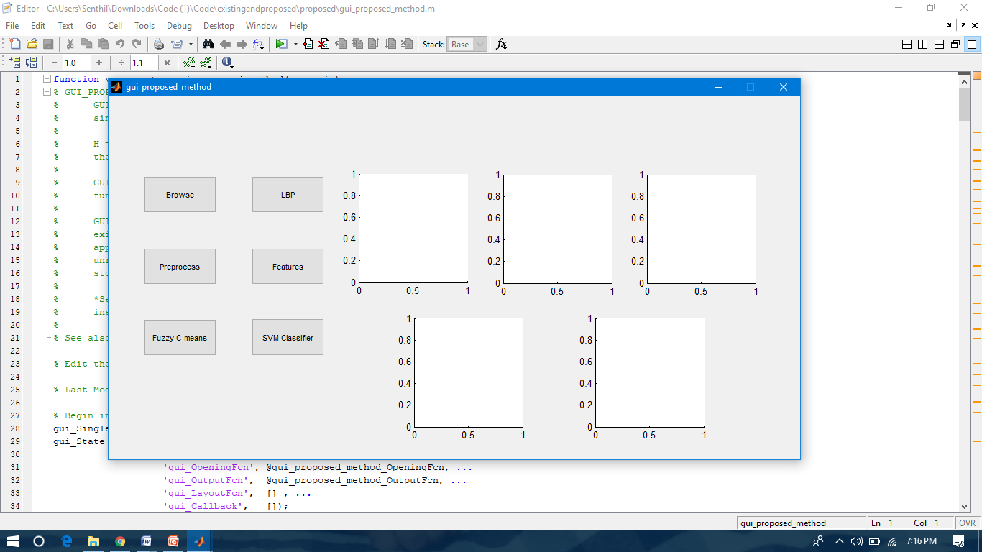

Fig 6.1 Screenshot for GUI screen

6.2.2 INPUT IMAGE SELECTION:

Input image is selected by clicking the browsing button as shown in fig 6.2

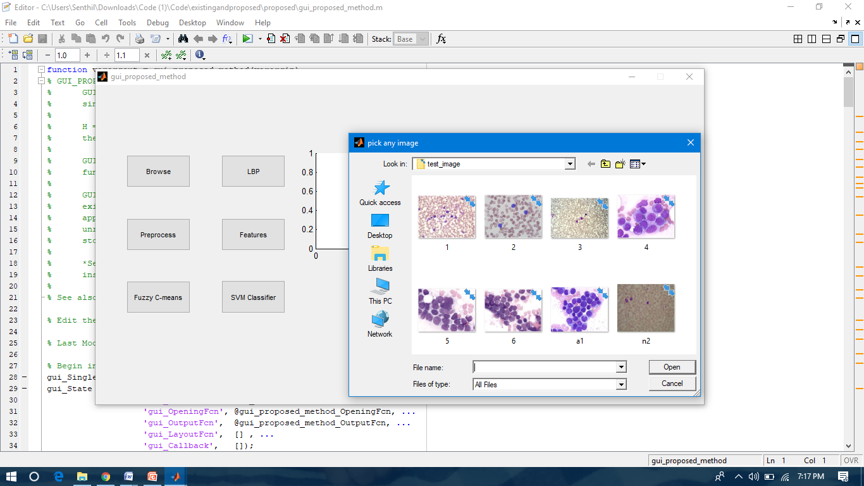
Fig 6.2 Screenshot for Input image selection

6.2.3 PREPROCESSING:

The input image is preprocessed in the form of color space image and denoised image as shown in fig 6.3

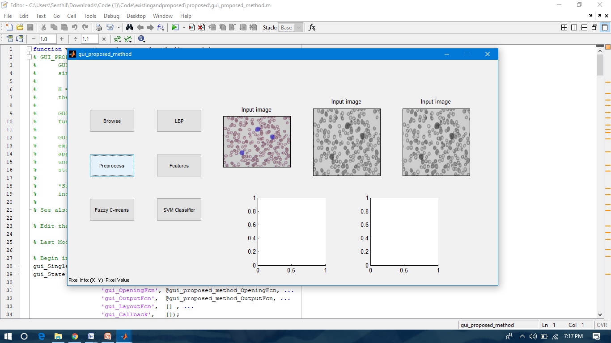

Fig 6.3 Screenshot for preprocessed image
6.2.4 CLUSTERING PROCESS:
The clustering process is performed is shown in fig 6.4
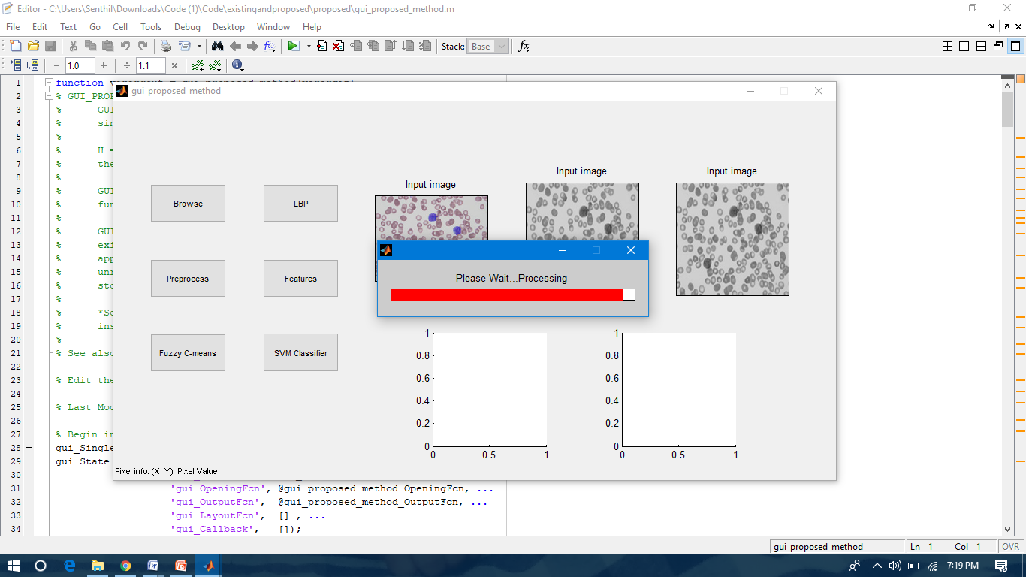
Fig 6.4 Screenshot for clustering process

6.2.5 SELECTION OF SEGMENTED IMAGE:
The segmented image is selected for clustering as shown in fig 6.5

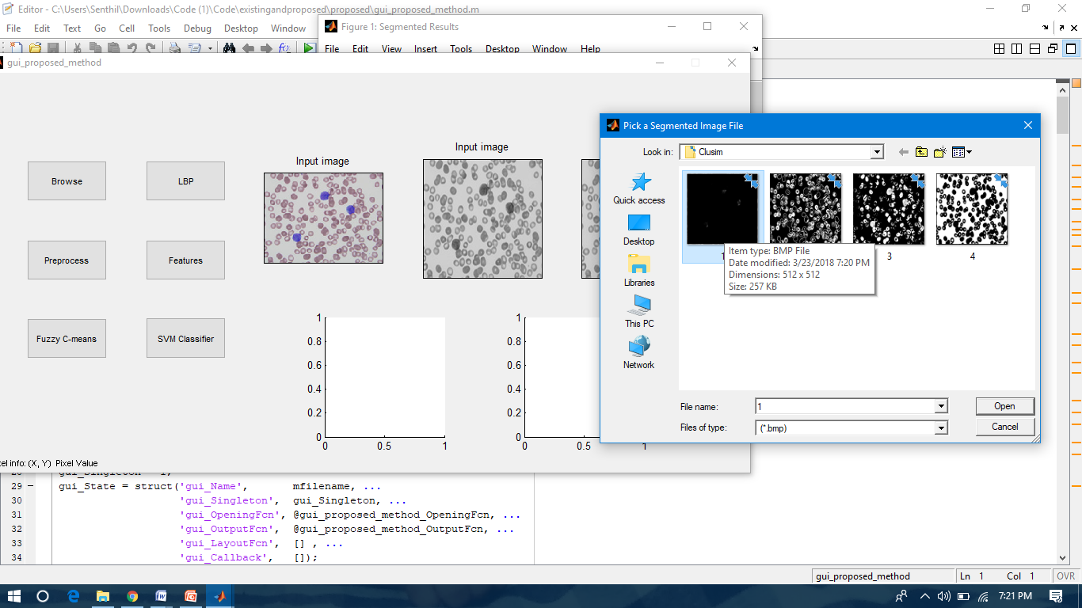

Fig 6.5 Screenshot for selection of segmented image

6.2.6 FUZZY C-MEANS CLUSTERING:

The clustered image is shown in fig 6.6

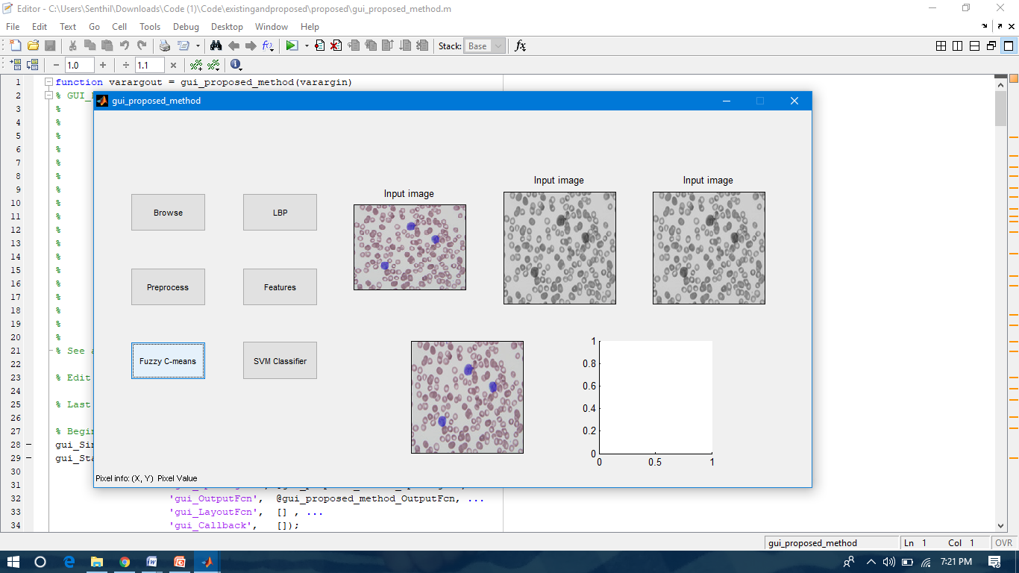

Fig 6.6 Screenshot for clustered image

6.2.7 LOCAL BINARY PATTERN(LBP) IMAGE:

The Local Binary pattern (LBP) image is shown in fig 6.7

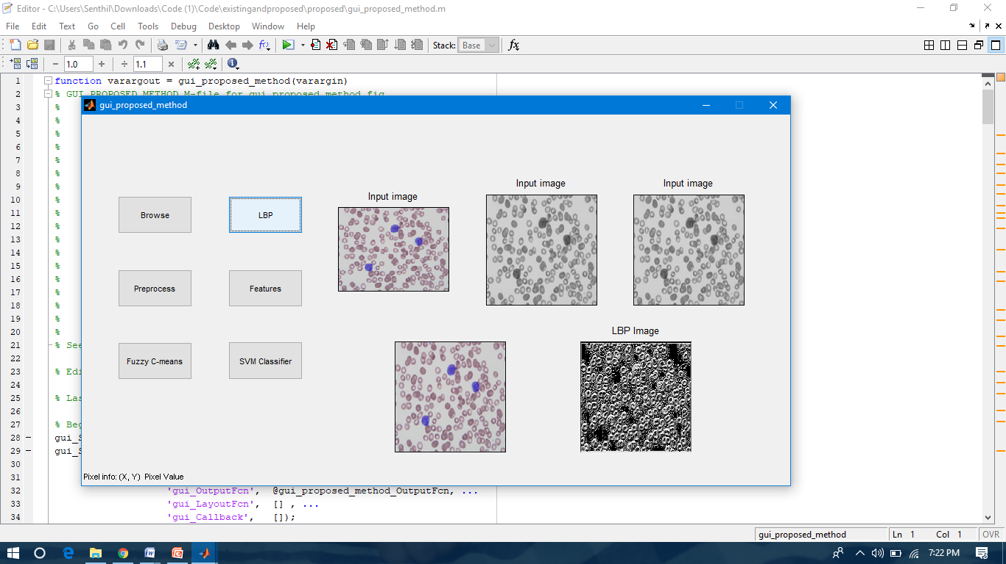

Fig 6.7 Screenshot for LBP image

6.2.8 FEATURE EXTRACTION:

The testing image feature is shown in fig 6.8

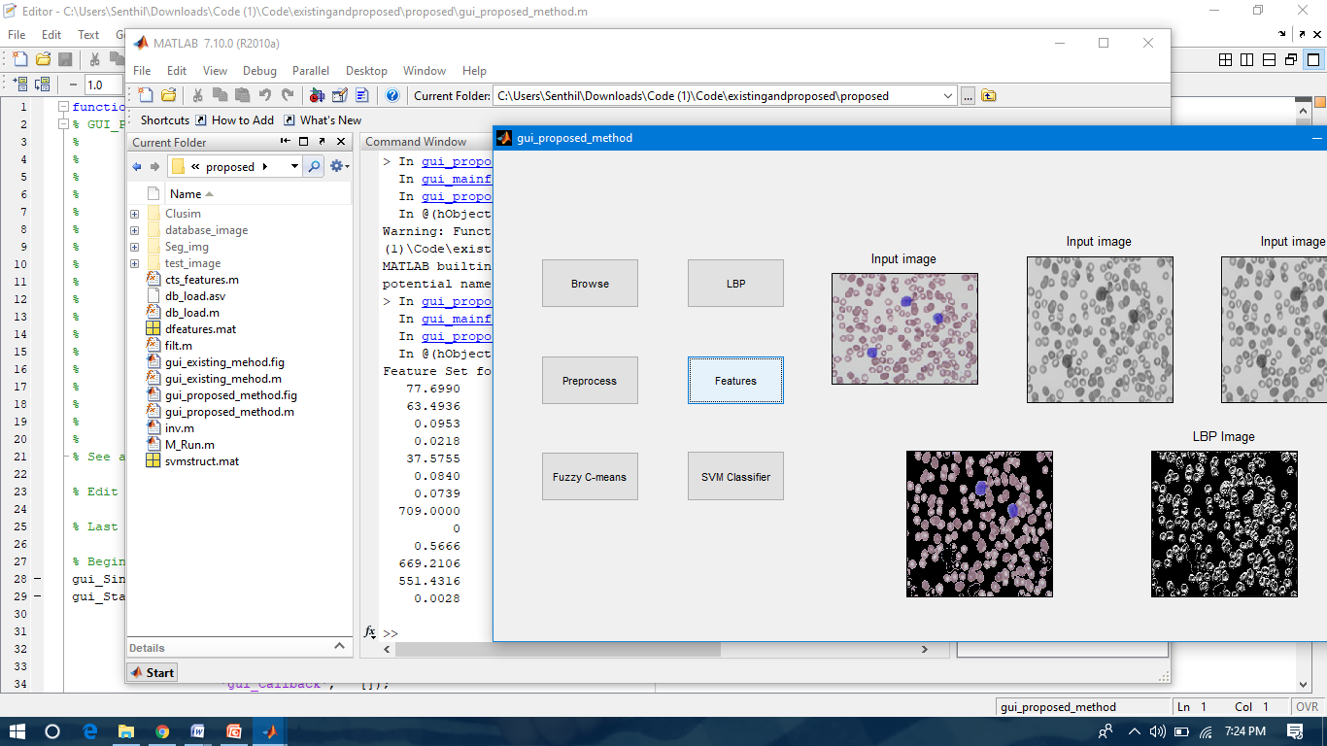
Fig 6.8 Screenshot for feature extraction

6.2.9 TESTED FEATURE VALUES:

The tested image feature values are shown in fig 6.9

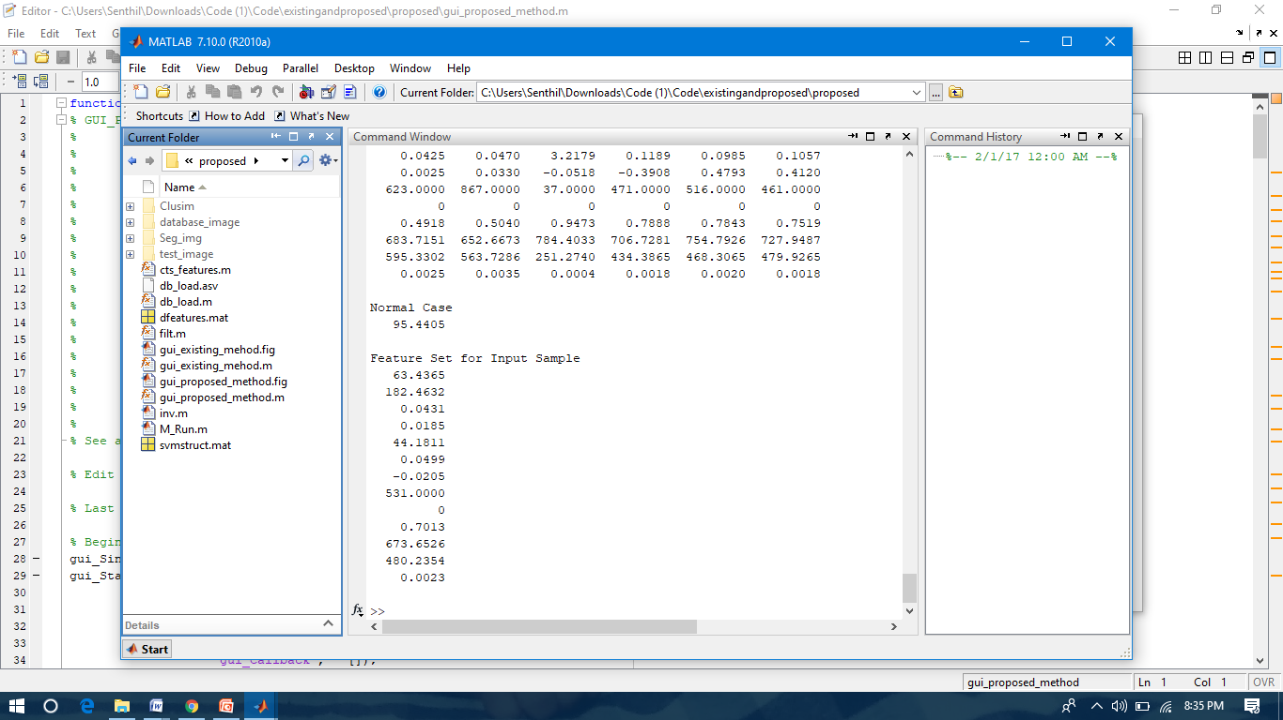

Fig 6.9 Screenshot for feature values

6.2.10 DETECTED NORMAL IMAGE:

The testing image is detected as normal which is shown in fig 6.10
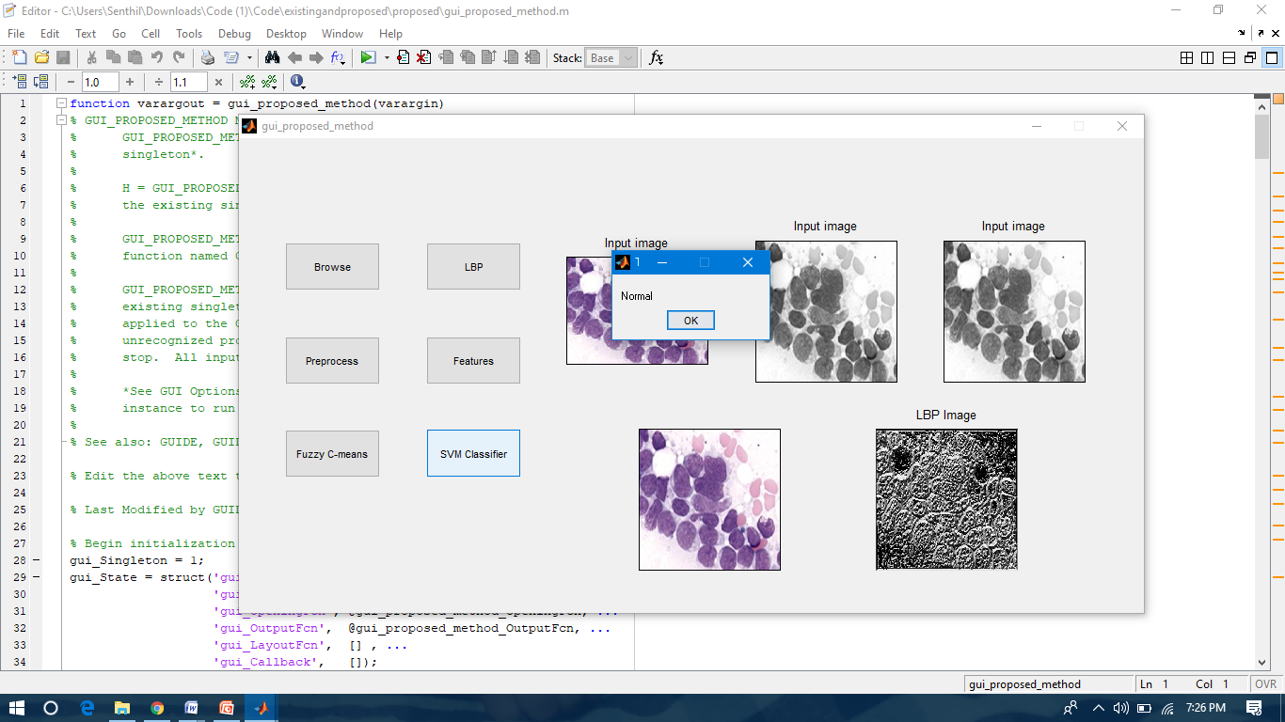

Fig 6.10 Screenshot for normal testing image

6.2.11 DETECTED ABNORMAL IMAGE:

The test image is detected as abnormal image which is shown in fig 6.11

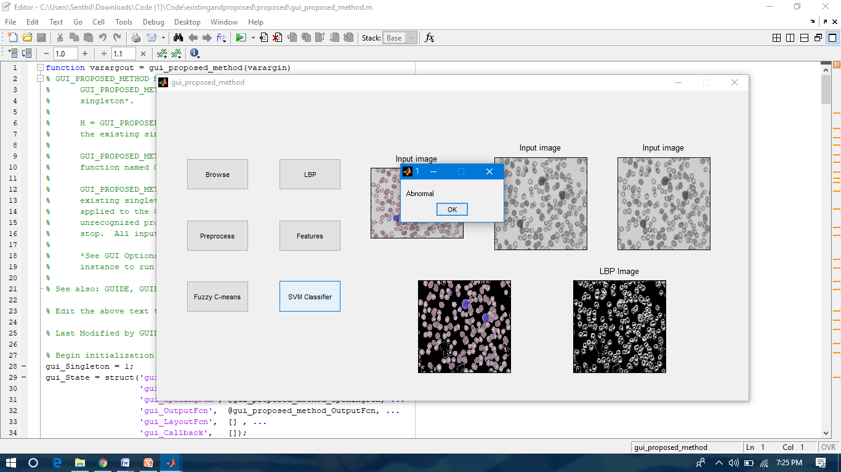

Fig 6.11 Screenshot for abnormal testing image

CHAPTER - 7
TESTING AND MAINTENANCE

CHAPTER 7
TESTING AND MAINTENANCE

7.1 TESTING:
Implementation forms an important phase in the system development life cycle. It is a stage of the project work that transforms the design into a model. Testing was done to see if all the features provided in the modules are performing satisfactory and to ensure that the process of testing is as realistic as possible.
Each program is tested individually at the time of development using the data and has verified that this program linked together in the way specified in the program specification, the computer system and its environment is tested to the satisfaction of the user. The system that has been developed is accepted and proved to be satisfactory for the user. And so the system is going to be implemented very soon.
Initially as a first step the executable form of the application is to be created and loaded in the common server machine which is accessible to all the users and the server is to be connected to a network. The final stage is to document the entire system which provides components and the operating procedures of the system.
The importance of software testing and its implementations with respect to software quality cannot be over emphasized. Software testing is a critical element of software quality assurance and represents the ultimate review of specification, design and coding.
Any product can be tested using either a black box testing or white box testing. Further testing can be implemented along the lines of code, integration and system testing.

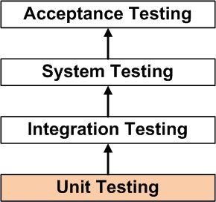

Fig 7.1 Levels of Testing
7.1.1 UNIT TESTING:
Unit testing focused on the smallest unit of software design. Using the procedural description as a guide, important control paths were tested to uncover errors within the boundary of the module. The module interface was tested to ensure proper informational flow in and out of the program unit under test. The local data structures were examined to ensure that the integrity of the temporarily stored data was maintained during all the steps of execution.
Unit Testing is a level of the software testing process where individual units/components of a software/system are tested. The purpose is to validate that each unit of the software performs as designed. A unit is the smallest testable part of software. It usually has one or a few inputs and usually a single output. In procedural programming a unit may be an individual program, function, procedure, etc.
In object-oriented programming, the smallest unit is a method, which may belong to a base/super class, abstract class or derived/child class. This is to be discouraged as there will probably be many individual units within that module. Unit testing frameworks, drivers, stubs and mock or fake objects are used to assist in unit testing. Unit Testing is normally performed by software developers themselves or their peers. In rare cases it may also be performed by independent software testers.
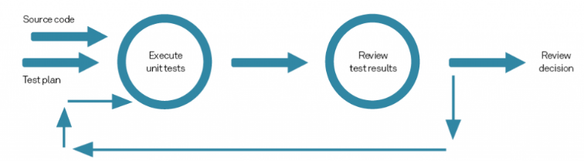
Fig 7.1.1 Unit testing
Tasks:
- Unit Test Plan
- Prepare
- Review
- Rework
- Baseline
- Unit Test Cases/Scripts
- Prepare
- Review
- Rework
- Baseline
- Unit Test
- Perform
Benefits:
- Unit testing increases confidence in changing/maintaining code. If good unit tests are written and if they are run every time any code is changed, the likelihood of any defects due to the change being promptly caught is very high.
- Codes are more reusable. In order to make unit testing possible, codes need to be modular. This means that codes are easier to reuse.
- Development is faster.
- The cost of fixing a defect detected during unit testing is lesser in comparison to that of defects detected at higher levels. Compare the cost (time, effort, destruction and humiliation) of a defect detected during acceptance testing or say when the software is live.
- Debugging is easy. When a test fails, only the latest changes need to be debugged. With testing at higher levels, changes made over the span of several days, weeks or months need to be debugged.
Definition by ISTQB
Unit testing: The testing of individual software components.

7.1.2 INTEGRATION TESTING:
This is a systematic technique for constructing a program structure while conducting tests to uncover errors associated with interfacing. The objective was to consolidate all the unit tested modules and build a program structure that was dictated by design. Then tests were performed to ensure that all the modules interacted satisfactorily, while maintaining the integrity and accuracy of data during inter-module communication.
Integration Testing is a level of the software testing process where individual units are combined and tested as a group. The purpose of this level of testing is to expose faults in the interaction between integrated units. Test drivers and test stubs are used to assist in Integration Testing. The definition of a unit is debatable and it could mean any of the following:
- The smallest testable part of a software
- A ‘module’ which could consist of many of ’1′
- A ‘component’ which could consist of many of ’2′

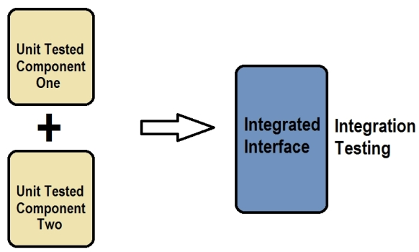
Fig 7.1.2 Integration Testing
Tasks:
- Integration Test Plan
- Prepare
- Review
- Rework
- Baseline
- Integration Test Cases/Scripts
- Prepare
- Review
- Rework
- Baseline
- Integration Test
- Perform

Approaches:
- Big bang is an approach to Integration testing where all or most of the units are combined together and tested at one goes. This approach is taken when the testing team receives the entire software in a bundle. So, the difference between Big Bang Integration Testing and System Testing is that the former tests only the interactions between the units while the latter tests the entire system.
- Top Down is an approach to Integration Testing where top level units are tested first and lower level units are tested step by step after that. This approach is taken when top down development approach is followed. Test Stubs are needed to simulate lower level units which may not be available during the initial phases.
- Bottom Up is an approach to Integration Testing where bottom level units are tested first and upper level units step by step after that. This approach is taken when bottom up development approach is followed. Test Drivers are needed to simulate higher level units which may not be available during the initial phases.
- Sandwich/Hybrid is an approach to Integration Testing which is a combination of Top Down and Bottom Up approaches.
Definition by ISTQB
- Integration testing: Testing performed to expose defects in the interfaces and in the interactions between integrated components or systems. See also component integration testing, system integration testing.
- Component integration testing: Testing performed to expose defects in the interface and interaction between integrated components.
- System integration testing: Testing the integration of systems and packages; testing interfaces to external organizations.

7.2 TEST CASES:
Table 7.2.1 Test Cases
Test Case ID | Test Item | Input Specification |  | Output Specification | Pass/Fail
Test Case ID | Test Item | Action | Case Description | Output Specification | Pass/Fail
TC_01 | Browse GUI | OnClick | When haematologist clicks on the UI element | Input blood sample image is selected for further processing | Pass
TC_02 | Preprocess GUI | OnClick | When haematologist clicks on the UI element | Input sample image is preprocessed i.e., the image is processed as rgb to grey color, resized and denoised for further processing | Pass
TC_03 | Fuzzy clustering GUI | OnClick | When haematologist clicks on the UI element | Preprocessed image is clustered | Pass
TC_04 | Fuzzy clustering GUI | OnSuccess | Clustering of preprocessed image takes place. | On success, the processed image is clustered into four clusters such as foreground, background, primary, secondary. | Pass
TC_05 | Clustered images | OnClick | When haematologist clicks on any clustered image. | The chosen clustered image is displayed on the axes. | Pass
TC_06 | LBP | OnClick | When the haematologist clicks on the UI element | The clustered image is converted to binary image by Local Binary Pattern. | Pass
TC_07 | Features extraction | OnClick | When haematologist clicks on the UI element | The features of the sample images such as energy,entropy, contrast, correlation, homogeneity etc are calculated. | Pass
TC_08 | Features extraction | OnSuccess | Feature extraction of processed image takes place. | The details about the features of the processed image is displayed on the command window. | Pass
TC_09 | SVM Classifier | Onclick | When haematologist clicks on the UI element | The SVM classifier classifies the cells as normal or abnormal cells. | Pass
TC_10 | SVM Classifier | OnSuccess | Classification of cells is done. | The cells are classified as normal or abnormal based on compatibility with the training samples features set. The result is displayed as normal cell or abnormal cell. | Pass
TC_11 | Result Prediction | OnSuccess | SVM Classifier generates the result. | If the result is normal then the patient has no cancer.  If it is abnormal then the patient has cancer. | Pass

BROWSE IMAGE TEST CASE:
package proj;
import static org.junit.Assert.*;
import org.junit.Test;
public class browse_img {
@Test
public void test() {
Imgselect test=new Imgselect ();
int out= test.Imgselect();
assertEquals(1,out);
}
}

TEST CASE OUTPUT:

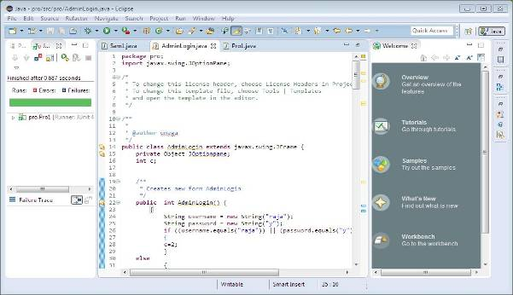
Fig 7.2.1 Output screenshot for success

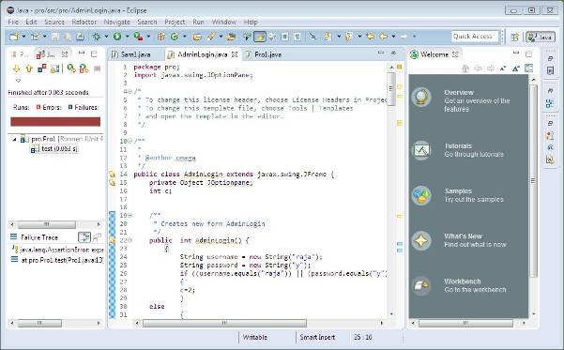

Fig 7.2.2 Output screenshot for failure

CHAPTER -8
CONCLUSION
AND
FUTURE ENHANCEMENTS

CHAPTER 8
CONCLUSION AND FUTURE ENHANCEMENTS
8.1 CONCLUSION:
In this paper, we have proposed a colour-primarily based clustering for segmenting white blood cells from Acute Lymphoblastic Leukemia images. The technique efficiently combines RGB and Lab shade space based unique-threshold methods to exploit their complementary strengths. It consists of three main elements: pre-processing, segmentation, and post-processing. Historical part and red blood cells of the image are extracted through distinct thresholds in segmentation procedure. The experimental outcomes advised that an overall segmentation give high accuracy because the first step of computerized white blood cellular differential system, it indicates a good prospect in further WBC function extraction, ALL category, and diagnosis. As a result of accuracy comparison proposed method have 98% accuracy, that is it have 8% more than existing method.

8.2 FUTURE ENHANCEMENTS:
For future work, we plan to work towards various directions. As the extension/future scope of the project we can do two mode operation in this project, through uploading the data which is obtaining from patient. Here it will work with respect to two mode operation. One is patient mode and other one is doctor mode.

CHAPTER -9
REFERENCES

CHAPTER 9
REFRENCES

[1] Abbas, N., et al., Nuclei segmentation of leukocytes in blood smear digital images. Pak. J. Pharm. Sci, 2015. 28(5): p. 1801-1806.
[2] Duan, J. and L. Yu. A WBC segmentation methord based on HSI color space. in Broadband Network and Multimedia Technology (IC-BNMT), 2011 4th IEEE International Conference on. 2011. IEEE.
[3] Mahmood, N.H., et al., Blood cells extraction using color based segmentation technique. International journal of life sciences biotechnology and pharma research, 2013. 2(2): p. 233-240
[4] Marzuki, N.I.C., N.H. Mahmood, and M.A.A. Razak, Segmentation of White Blood Cell Nucleus Using Active Contour. Jurnal Teknologi, 2015. 74(6).
[5] Mondal, P.K., et al., Segmentation of white blood cells using fuzzy C means segmentation algorithm. IOSR Jornal of Computer Engineering, 2014. 1(16): p. 1-5.
[6] Nazlibilek, S., et al., Automatic segmentation, counting, size determination and classification of white blood cells. Measurement, 2014. 55: p. 58- 65.
[7] V. Piuri and F. Scotti, “Morphological classification of blood leucocytes by microscope images,” in Proc. CIMSA, 2004, pp. 103–108
[8] Prinyakupt, J. and C. Pluempitiwiriyawej, Segmentation of white blood cells and comparison of cell morphology by linear and naïve Bayes classifiers. Biomedical engineering online, 2015. 14(1): p. 1.
[9] H. Ramoser, V. Laurain, H. Bischof, and R. Ecker, “Leukocyte segmentation and classification in blood-smear images,” in Proc. IEEE EMBS, 2006, pp. 3371–3374
[10] C. Reta, L. Altamirano, J. A. Gonzalez, R. Diaz, and J. S. Guichard, “Segmentation of bone marrow cell images for morphological classification of acute leukemia,” in Proc. 23rd FLAIRS, 2010, pp. 86–91.
[11] Rezatofighi, S.H., K. Khaksari, and H. SoltanianZadeh. Automatic recognition of five types.
[12] F. Scotti, “Automatic morphological analysis for acute leukemia identification in peripheral blood microscope images,” in Proc. CIMSA, 2005, pp. 96–101.
[13] M. Subrajeet, D. Patra, and S. Satpathy, “Automated leukemia detection in blood microscopic images using statistical texture analysis,” in Proc. Int. Conf. Commun. Comput. Security, 2011, pp. 184–187.

CHAPTER 10
APPENDIX

CHAPTER 10
APPENDIX
(PUBLICATION DETAILS)

Paper Title | ACUTE LYMPHOBLASTIC LEUKEMIA DIAGNOSIS IN BLOOD MICROSCOPIC IMAGES USING LOCAL BINARY PATTERN AND SUPERVISED CLASSIFIER
Authors | Preethi.R, Manimozhi.R,Nandhini.R,Priyanka.G
Journal Name | International Journal for Research & Development in Technology (IJRDT)
Edition | IJRDT Volume-9, Issue-3, March 2018
Month and Year | March 2018

