ADVANCED PATIENT HEALTH MONITORING SYSTEM USING PLCC TECHNOLOGY
Ms.A.Nithya¹,F.Darthi², K.Dhanusha³,N.Gandhimathi Harini⁴
¹Assistant Professor, Department of Information Technology, Panimalar Engineering College,
Chennai,India.
^{2,3,4} Students, Final Year, Department of Information Technology, Panimalar Engineering College,
Chennai, India.
---------------------------------------------------------------------***---------------------------------------------------------------------

Abstract - PLC is a technology which uses power lines as physical media for data transmission.. PLC offers a no new wires solution because the infrastructure has already been established. PLC modems are used for transmit-ting data at a rapid speed through a power line in a house, an office, a building, and a factory, etc.Hence in our work, temperature and heart beat monitoring equipment based on power line communication is developed. This uses existing power cables as communication medium. Power Line Modem (PLM) is used for transmitting and receiving the signals over power line cable.When compared with other communication technologies like local area network (LAN), ZigBee, Bluetooth, the establishment cost for healthcare monitor using Power Line Communication (PLC) was less. In this project, we propose biomedical sensors inputs which are been transmitted using power line communication and stored in real cloud storage.

Key Words: : Power Line Communication(PLC),through a powerline,existing power cables,Power Line Modem(PLM),DSSS technology,biomedical sensors,cloud storage

1.INTRODUCTION

Power line communication is an emerging home network technology that allows consumers to use their already existing wiring system to connect home appliances to each other and to the Internet. PLC is also used in internal electrical installation within buildings and homes called in home PLC for various communication application. PLC modems are used to make communication in power supply networks. Data signal from conventional communication devices, (computer, telephone) is converted by PLC modem in a form that is suitable for transmission over power lines.
  - MODULES
- Interfacing Sensors
- Programming microcontroller
- Power line communication
- Data Collection using Java
- Encryption
- Internet of Things (IoT)
2. POWERLINE COMMUNICATION:
PLC modems are used to make communication in power supply networks. Data signal from conventional communication devices, (computer, telephone) is converted by PLC modem in a form that is suitable for transmission over power lines. Although, power supply network is not designed for data communication.
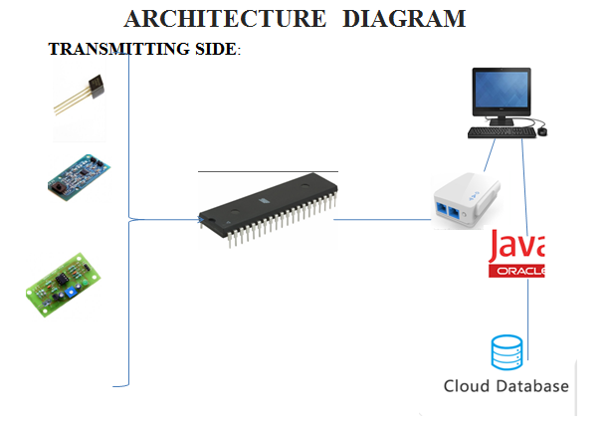
Fig -1: Name of the figure

We present a feasible patient monitoring System in which ubiquitous power lines are mode of transmitting data over 220V/50v) to control the electrical devices. A power line communication modem is used in which FSK [Frequency shift keying] is used for modulating the signal. Sensors connected to microcontroller via PLCC sends the data and in turn controls the devices. There are Multiple receivers which contain the power line modem can be connected through the power line to the devices.. PIC controller and Real Time Operating system whereas embedded web server technology is the combination of embedded device and PLCC. Using PLCC it is possible to monitor patients remotely. This paper presents a PC based temperature monitoring and control system using virtual instrumentation. Temperature sensor measures the temperature and produce corresponding analog signal which is further processed by the microcontroller.. The data will be displayed on the LCD in microcontroller and PC monitor. Monitoring and control can be done with the help of control circuitry.
3. CONCLUSIONS

PLC is a technique that allows exchange of data by means of electric power supply network that are presented in every dwelling, office and in every building. Since the development and research on the subject of Power line communications is relatively new, the primary reason for this project is to serve as a reference for PLC technologies, products and standards. The power line technology is getting stabilized and attracting many industry leading vendors. Thus as a prototype level, we developed a healthcare based power line communication system integrating Internet of Things (IoT).

REFERENCES

[1] Xavier Carcelle,Power line communication in practice.
[2]ETSI, www.etsi.org/WebSite/Technologies/Powerline.aspx
[3] Galli, S., the Inter Inter-Co-PHY Protocol (IPP): A Simple Co Existence Protocol. IEEE International Symposium on Power Line Communications, Dresden, Germany, 31 March 2009.
[4] Galli, S. & Oleg, L., Recent developments in the standardization of power line communications in the IEEE. IEEE Communications Magazine, pp. 64–71, July 2008.
[5]MainsNetwork, http://en.wikipedia.org/wiki/Mains_network.

