DISABLED PATIENT MANAGEMENT SYSTEM
 |  | 

A PROJECT REPORT

Submitted by

reshma b (211414205084)
sirisha a (211414205101)
sunantha k (211414205110)

in partial fulfillment for the award of the degree
of
BACHELOR OF TECHNOLOGY
in
INFORMATION TECHNOLOGY

PANIMALAR ENGINEERING COLLEGE, POONAMALLEE

ANNA UNIVERSITY : CHENNAI 600 025
APRIL 2018

ANNA UNIVERSITY: CHENNAI 600 025
BONAFIDE CERTIFICATE
Certified that this project report “DISABLED PATIENT MANAGEMENT SYSTEM” is the bonafide work of “RESHMA.B (211414205084), SIRISHA.A (211414205101) and SUNANTHA.K (211414205110) ” who carried out the project under my supervision.

SIGNATURE SIGNATURE
Dr. M. HELDA MERCY M.E., Ph.D., Dr. M. HELDA MERCY M.E., Ph.D.,
HEAD OF THE DEPARTMENT SUPERVISOR
Department of Information Technology Department of Information Technology
Panimalar Engineering College Panimalar Engineering College
Poonamallee, Chennai - 600 123 Poonamallee, Chennai - 600 123

Submitted for the project and viva-voce examination held on ______________

SIGNATURE SIGNATURE
INTERNAL EXAMINER EXTERNAL EXAMINER

DECLARATION
We hereby declare that the project report entitled “DISABLED PATIENT MANAGEMENT SYSTEM ” which is being submitted in partial fulfilment of the requirement of the course leading to the award of the ‘Bachelor Of Technology in Information Technology ’ in Panimalar Engineering College, Affiliated to Anna University- Chennai is the result of the project carried out by me under the guidance and supervision of Dr. M. HELDA MERCY M.E., Ph.D., Head of the Department , Department of Information Technology. We further declared that we or any other person has not previously submitted this project report to any other institution/university for any other degree/ diploma or any other person.

Date:
Place: Chennai
(RESHMA B)
(SIRISHA A)
(SUNANTHA K)

It is certified that this project has been prepared and submitted under my guidance.

Date: (Dr. M. HELDA MERCY M.E., Ph.D.,) Place: Chennai (Head of the Department / IT )
ACKNOWLEDGEMENT
A project of this magnitude and nature requires kind co-operation and support from many, for successful completion . We wish to express our sincere thanks to all those who were involved in the completion of this project.
We would like to express our deep gratitude to Our Honorable Secretary and Correspondent, Dr. P. CHINNADURAI, M.A., Ph.D., for his kind words and enthusiastic motivation which inspired us a lot in completing this project.
We also express our sincere thanks to Our Respected Directors Mrs. C. VIJAYA RAJESHWARI , Mr. C. SAKTHI KUMAR, M.E., and Mrs. SARANYA SREE SAKTHI KUMAR , B.E., for providing us with the necessary facilities for completion of this project.
We also express our appreciation and gratefulness to Our Principal Dr. K. MANI, M.E., Ph.D., who helped us in the completion of the project. We wish to convey our thanks and gratitude to our head of the department and project guide, Dr. M. HELDA MERCY, M.E.,Ph.D., Department of Information Technology, for her support and by providing us ample time to complete our project.
Last, We thank our parents and friends for providing their extensive moral support and encouragement during the course of the project.

ABSTRACT
This application is mainly designed for hospitals, which treats both the hearing and speech problem patient. Hospitals currently use a manual system for the management and maintenance of critical information. The current system requires numerous paper forms, with data stores spread throughout the hospital management standards. Forms are often lost in transit between departments requiring a comprehensive auditing process to ensure that no vital information is lost. Multiple copies of the same information exist in the hospital and may lead to inconsistencies in data in various data stores. A significant part of the operation of any hospital involves the acquisition, management and timely retrieval of great volumes of information. This information typically involves patients personal information and their case history, examination results, and recommending. All of this information must be managed in an efficient and cost wise fashion so that an institution’s resources may be effectively utilized. This system will automate the management of the hospital making it more efficient and error free. It aims at standardizing data, consolidating data, ensuring data integrity and reducing inconsistencies.

LIST OF CONTENTS
CHAPTER NO. | TITLE | PAGE NO
 | ABSTRACT | V
 | LIST OF FIGURES | Ix
1 | INTRODUCTION | 1
 | 1.1 OVERVIEW OF THE PROJECT | 2
 | 1.2 SCOPE OF THE PROJECT | 3
 | 1.3 OBJECTIVE OF THE PROJECT | 3
 | 1.4 EXISTING SYSTEM | 3
 | 1.6 PROPOSED SYSTEM | 4
2 | LITERATURE SURVEY | 5
 | 2.1 USABILITY OF AN ELECTRONIC HEALTH  RECORD | 6
 | 2.2 INTELLIGENT HOSPITAL MANAGEMENT SYSTEM  (IHMS) | 7
 | 2.3 METHODOLOGY FOR THE DEVELOPMENT OF AN  ELECTRONIC MEDICAL RECORD | 7
 | 2.4 FEASIBILITY STUDY | 8
 | 2.4.1 Economic feasibility | 8
 | 2.4.2 Technical feasibility | 8
 | 2.4.3 Resource feasibility | 9
 | 2.4.4 Social feasibility | 9
 | 2.4.5 Operational feasibility | 9
3 | SYSTEM DESIGN | 10
 | 3.1 DESIGN OF THE PROPOSED SYSTEM | 11
 | 3.2 DFD FOR PROPOSED SYSTEM | 13
 | 3.3 UML DIAGRAMS | 15
 | 3.3.1. USE CASE DIAGRAM | 16
 | 3.3.2 SEQUENCE DIAGRAM | 17
 | 3.3.3 COLLABRATION DIAGRAM | 18
 | 3.3.4. CLASS DIAGRAM | 19
 | 3.3.5 ACTIVITY DIAGRAM | 20
4 | MODULE DESCRIPTIONS | 21
 | 4.1 MODULES | 22
 | 4.2 MODULE DESCRIPTION | 23
 | 4.2.1 DATA COLLECTION | 23
 | 4.2.2 EXAMINATION | 23
 | 4.2.3 RECOMMENDATION | 23
5 | REQUIREMENT SPECIFICATION | 24
 | 5.1 HARDWARE REQUIREMENTS | 25
 | 5.2 SOFTWARE REQUIREMENTS | 25
6 | IMPLEMENTATION | 26
 | 6.1 SAMPLE CODE | 27
7 | SCREEN SHOTS | 46
8 | TESTINGAND MAINTENANCE | 53
 | 8.1 TESTING | 54
 | 8.1.1 UNIT TESTING | 55
 | 8.1.2 INTEGRATION TESTING | 55
 | 8.2 TEST CASES | 57
 | 8.2.1 VALIDATION TESTING | 57
 | 8.2.2 UNIT TESTING | 58
 | 8.3MAINTENANCE | 58
9 | CONCLUSION AND FUTURE ENHANCEMENTS | 60
 | 9.1 CONCLUSION | 61
 | 9.2 FUTURE ENHANCEMENT | 61
10 | REFERENCES | 62

LIST OF FIGURES

FIGURE NO | NAME OF THE FIGURE | PAGE NO
3.1 | Proposed system architecture | 11
3.2 | Data flow diagram | 13
3.3 | Use case Diagram | 16
3.4 | Sequence Diagram | 17
3.5 | Collabration Diagram | 18
3.6 | Class Diagram | 19
3.7 | Activity Diagram | 20
7.1 | Home page | 47
7.2 | Patient problem | 47
7.3 | Patient entry | 48
7.4 | Patient complaint | 48
7.5 | Patient case history | 49
7.6 | Otologic history | 49
7.7 | Patient list | 50
7.8 | Examination | 50
7.9 | Test results | 51
7.10 | Recommendation | 51
7.11 | Patient profile | 52
8.1 | Testing | 55
8.2 | Testing login unit | 67
8.3 | Testing patient entry | 70

INTRODUCTION

CHAPTER 1
INTRODUCTION
1.1 OVERVIEW OF THE PROJECT
Even in today's modern world where the technology is involved in all
services and industries, there are many business that follow a
traditional practices without involving technology. This might be due
to lack of knowledge to embed the technology into their business or due
to lack of know-how of its use. One such traditional practices is the
registration of the patient's details and their movements in the
hospitals where in most of the hospitals still fill in the patient's
particulars in a manual register book and the patients too are given a
handbook where the doctor's pen down the prescriptions and further
follow ups. In this case there is a lot of manual work involved and
the patients find it too hard to maintain the handbook and also find
it’s difficult to get a prior appointment with the doctors sometimes as
they do not have a visibility of the doctor's availability and may
have to wait in long queue to meet the doctor. Moreover the patient's
Confidential information is vulnerable to be misused in the event of
losing their test results and handbooks etc. This is very tedious
process and all the more difficult for the disabled, especially to the
Deaf and dumb people. In order to evade this problem in practical scenarios, we have developed a software that is mainly designed for hospitals that treat
with ENT for patients with hearing loss and speechless. This software
application can be accessed by the hospitals staffs for registration
of patient's information and maintaining their records for future use.
Simultaneously, this can also be used by the patients to check their
records and fix appointment that saves both their time in a secured
manner.
1.2 SCOPE OF THE PROJECT
The disabled patient management system , treats disabled people for deaf and dumb and even for maintaining patient’s tests results and treatment details by customizing some of the features.
1.3 OBJECTIVE OF PROJECT
Hospitals currently use a manual system for the management and maintenance of critical information. The current system requires numerous paper forms, with data stores spread throughout the hospital management infrastructure. Often information on forms is incomplete, or does not follow management standards. Forms are often lost in transit between departments requiring a comprehensive auditing process to ensure that no vital information is lost. Multiple copies of same information exists in the hospital and many lead to inconsistencies in data in various data stores..

1.4 EXISTING SYSTEM
The existing system provides the basic functionalities needed to be handled in a hospital management environment. There is no intelligence of the software in such cases. In the existing system all the patients details, case history and regarding the tests done to the patients prescribed by the doctor is maintained manually by the receptionist. And there is no proper search technique to check the patient information. It is a very difficult task to maintain all the records in the hospital by using this existing system. There are also many loopholes when we look at the security of the system.
1.4.1 DRAWBACKS OF THE EXISTING SYSTEM:
- Loss of information.
- Database is not maintained efficiently.
- Redundancy of data.
- Usage cost is high.
- Possibility of human error

1.5 PROPOSED SYSTEM
In the proposed system, we are going to provide solutions to all the problems faced in the existing system by automating the whole management system in the hospital by using the integrated software that handles the whole system. This application would accept details from the patients case history like ENT surgery, Ear discharge, medical history and proforma details like voice evaluation, fluency disorder assessment for deaf and dumb patients. The proposed system provides one integrated view to patient demographic details, case history and examination results. Effective search facility to search any type of information related to patient history.
1.5.1 BENEFITS of the PROPOSED system
- No redundancy of data.
- Database is maintained efficiently.
- Error free software.
- Cost efficient

LITERATURE SURVEY

CHAPTER 2
LITERATURE SURVEY

The purpose of the literature survey is to give the brief overview and also to establish complete information about the reference papers. The goal of literature survey is to completely specify the technical details related to the project in a concise and unambiguous manner.

2.1 USABILITY OF AN ELECTRONIC HEALTH RECORD

AUTHORS:Rui Pereira,Julio Duarte,Maria Salazar

DESCRIPTION:
The Electronic Health Records (EHR) is a longitudinal electronic record of patient heath information generated by one or more encounters in any care delivery setting. The information included in the type of records can be progress notes, problems, medication, vital signs, medical history, laboratory data, radiology reports and much more. The usability of an EHR is crucial to achieve success, as well as guaranteeing a high level of safe and effective level of patient care system. Therefore, it is important for care providers to take steps to ensure that their EHR will be usable. Aiming to assess the usability of the EHR, a usability evaluation was performed. This paper describes how two usability evaluation methods (heuristic walkthrough and surveys) were used to evaluate its usability. With those evaluations, it was able to recognize the level of usability present in the EHR, along with the usability issues that can be disposed.

2.2 INTELLIGENT HOSPITAL MANAGEMENT SYSTEM (IHMS)

AUTHOR: Baki Koyuncu, Hakan Koyuncu

DESCRIPTION:
An intelligent hospital information management system was developed to assist the patient at the front desk of a hospital. The patient will be able to learn about the doctors, appointment times, relevant departments, laboratory tests and the specific medicine about his/her medical situation. System will provide an intelligent front desk information service for the patients at the hospital entrance. It will also provide software assistance for the doctors to diagnose easily and rapidly by using the program's decision mechanism.

2.3 METHODOLOGY FOR THE DEVELOPMENT OF AN ELECTRONIC MEDICAL RECORD

AUTHOR: J. Dahle, D.W. Callahan.

DESCRIPTION:
Electronic medical records (EMRs) and computer based patient records (CPRs) hold the opportunity to improve patient care, reduce costs, and facilitate research in medicine. Far too often, however, healthcare organizations and practitioners find that these systems are too costly, lack essential features, or work improperly for their setting. As the result, many decide to develop their own EMR or CPR systems. Often, these undertakings rely on developers and software engineers who are unfamiliar with the concepts, terminology, and the myriad regulations that accompany such development projects. This paper suggests a framework for analyzing, modeling, and developing such a system.

2.4 FEASIBILITY STUDY
The feasibility of the project is analyzed is put forth with a very general plan for the project and some cost estimates. During system analysis, the feasibility study of the proposed system is to be carried out. This is to ensure that the proposed system is not a burden to the user. For feasibility analysis, some understanding of the major requirements for the system is essential.
Three key consideration involved in the feasibility analysis are
- Economic feasibility
- Technical feasibility
- Resource feasibility
- Social feasibility

Economic feasibility
The amount of fund that the company can pour into the research and development of the system is limited, also the expenditures are justified. Thus the developed system is within the budget as this was achieved because most of the technologies used are freely available. Only the customized products had to be purchased.
Technical feasibility
Technical environment is made easy so that the future enhancement becomes handy and enhances reusability. Also the developed system has modest requirements which only requires minimal or null changes for implementing this system.

Resource feasibility
The system is said to be beneficial as the resources are utilized in the concerned project efficiently. The software or hardware requirements needed to perform the operations in the project, evolves the migration of existing system to incorporate with the new systems using impact analysis.
Social feasibility
Social feasibility addresses the influences that the proposed project may have on the society. The level of acceptance by the users solely depends on the methods that are employed to educate the user about the system and to make him familiar with it. Their level of confidence must be raised so that they are able to make some constructive criticism, which is welcomed, as they are the end user of the system.

SYSTEM
DESIGN

CHAPTER 3
SYSTEM DESIGN
3.1 Design of the Proposed System
We propose to allocate resources through RAM with unused memory for new application. We investigate new techniques to reduce inter-thread access interference and access RAM. We propose to partition the internal memory banks between cores to isolate their access streams and eliminate locality interference. We implement this by extending the physical frame allocation algorithm of the OS such that physical frames mapped to the same SDRAM bank can be exclusively allocated to a single thread. The main purpose of this project is allocating resources from previous running application that has memory that is not used by that application currently, for maintaining resource management. For the new application, the memory will be allocated by reusing the memory that the previously running application hold without using, if sufficient memory is available as unused in the previous application, otherwise the memory will be allocated from the unused RAM. We compensate for the reduced bank-level parallelism of each thread by employing memory sub-ranking to effectively increase the number of independent banks. All these reused and allocated memory details will be made available and can be viewed. This combined approach, unlike memory bank partitioning or sub-ranking alone, simultaneously increases overall performance and significantly reduces memory power consumption.

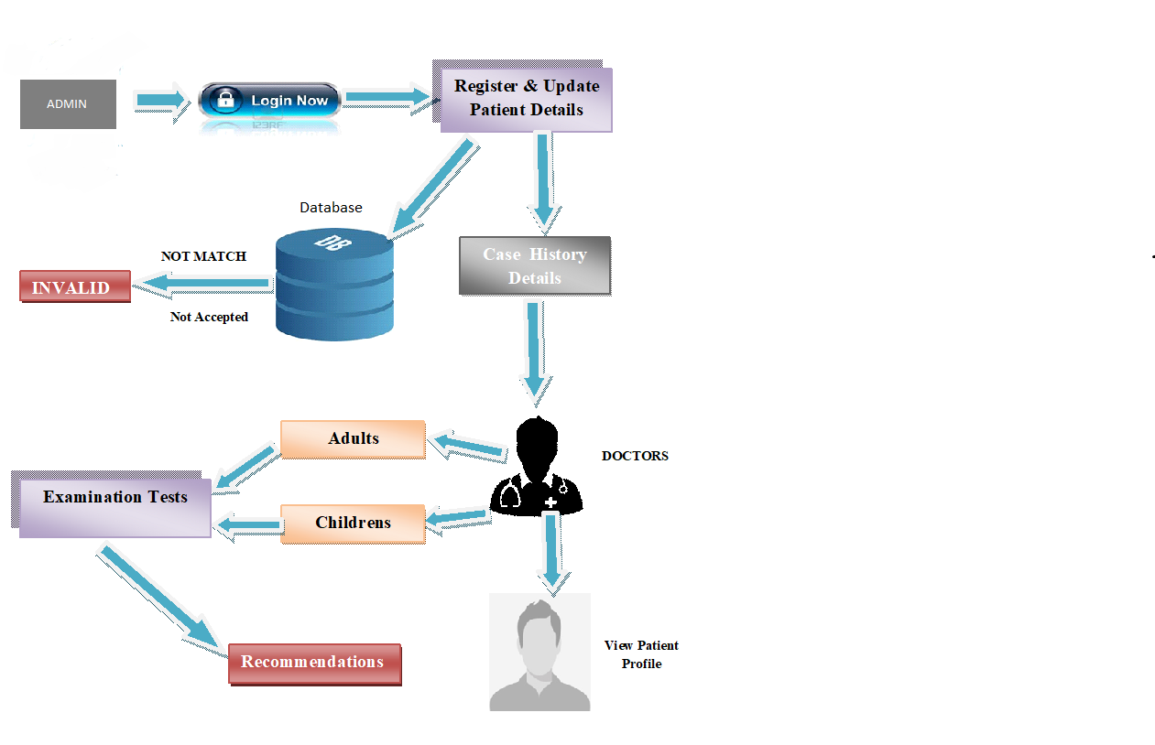

Fig 3.1 Proposed system architecture
3.2 Data Flow Diagram for Proposed System
A data flow diagram (DFD) is a graphical representation of the “flow” of data through an information system, modelling its process aspects. A DFD is often used as a preliminary step to create an overview of the system without going into great detail, which can later be elaborated. DFDs can also be used for the visualization of data processing (structured design).
A DFD shows what kind of the information will be input to and output from the system, how the data will advance through the system, and where the data will be stored. It does not show information about the timing of process or information about whether processes will operate in a sequence or in parallel unlike a flowchart which also shows this information.
Data flow diagrams are also known as bubble charts. DFD is a designing tool used in the top-down approach to Systems Design. It also identifies internal data stores that must be present in order for the system to do its job, and shows the flow of data between the various parts of the system.
Data flow diagrams are one of the three essential perspectives of the structured-systems analysis and design method SSADM. The sponsor of a project and the end users will need to be briefed and consulted throughout all stages of a system's evolution. With a data flow diagram, users are able to visualize how the system will operate, what the system will accomplish, and how the system will be implemented.

Start

login
Error message

INVALID
VALID
Choose problem of patient

Hearing/speech
HEARING SPEECH
Patient entry details
Patient entry details

Examination results
Proforma details

Submit

Patient profile created

3.2 DATA FLOW DIAGRAM

3.3 UML Diagram
UML stands for Unified Modeling Language. UML is a standardized general-purpose modeling language in the field of object-oriented software engineering. The standard is managed, and was created by, the Object Management Group.
The goal is for UML to become a common language for creating models of object oriented computer software. In its current form UML is comprised of two major components: a meta-model and a notation. In the future, some form of method or process may also be added to; or associated with, UML.
The Unified Modeling Language is a standard language for specifying, Visualization, Constructing and documenting the artifacts of software system, as well as for business modeling and other non-software systems. The UML represents a collection of best engineering practices that have proven successful in the modeling of large and complex systems. The UML is a very important part of developing objects oriented software and the software development process. The UML uses mostly graphical notations to express the design of software projects.
UML can be applied to diverse application domains (e.g., banking, finance, internet, aerospace, healthcare, etc.) It can be used with all major object and component software development methods and for various implementation platforms (e.g., J2EE, .NET).
UML is a standard modelling language, not a software development process. UML 1.4.2 Specification explained that process:
- Provides guidance as to the order of a team’s activities.
- Specifies what artifacts should be developed.
- Directs the tasks of individual developers and the team as a whole.
- Offers criteria for monitoring and measuring a project’s products and activities.
3.3.1 USECASE DIAGRAM
Use case diagrams overview the usage requirement for system. They are useful for presentations to management and/or project stakeholders, but for actual development you will find that use cases provide significantly more value because they describe “the meant” of the actual requirements. A use case describes a sequence of action that provides something of measurable value to an action and is drawn as a horizontal ellipse.
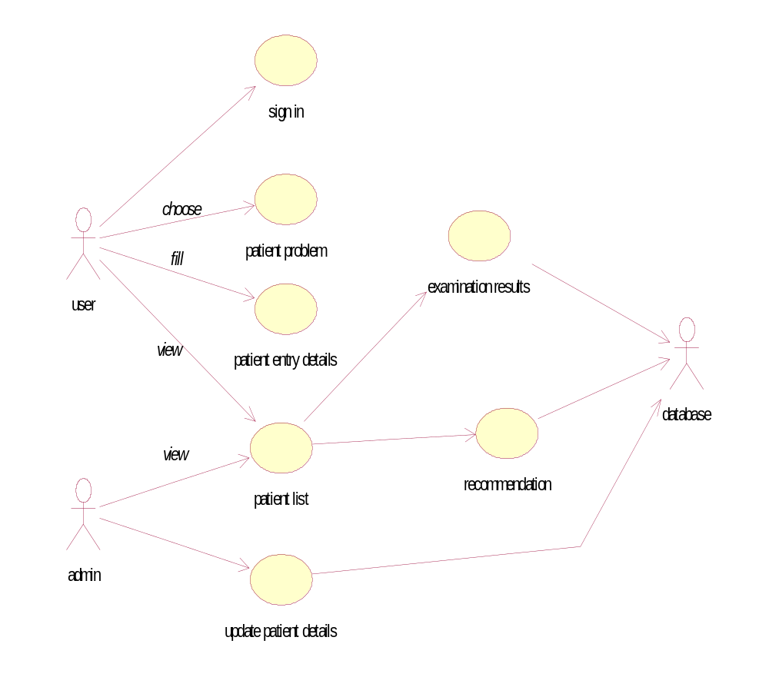
Fig 3.3 Use case Diagram

3.3.2 SEQUENCE DIAGRAM
Sequence diagram model the flow of logic within your system in a visual manner, enabling you both to document and validate your logic, and commonly used for both analysis and design purpose. Sequence diagram are the most popular UML artifact for dynamic modelling, which focuses on identifying the behaviour within your system.

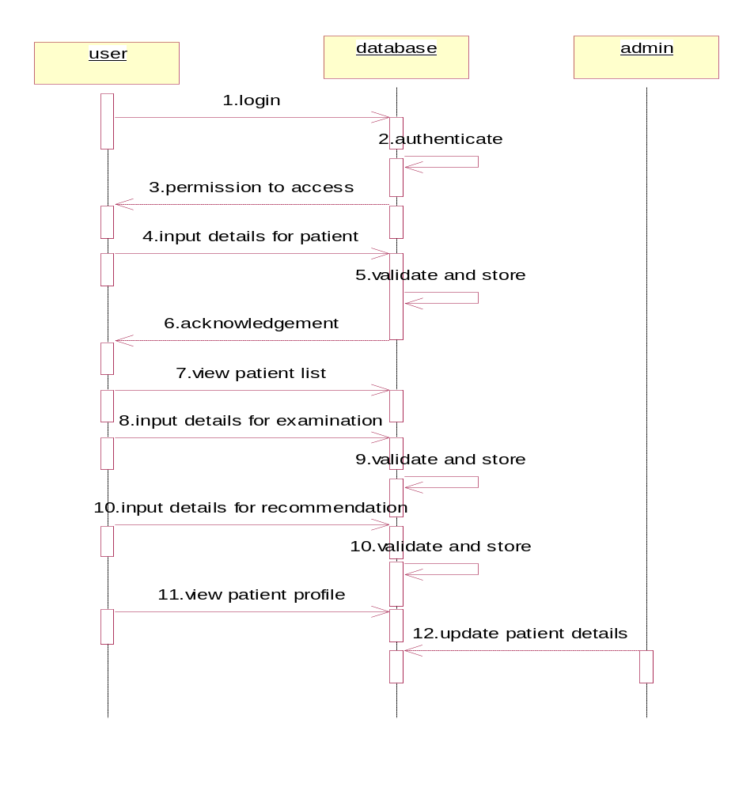
Fig 3.4 Sequence Diagram

3.3.3 COLLABORATION DIAGRAM
Collaboration diagram resembles a flow chart that portrays the roles, functionality and behaviour of individual objects as well as the overall operation of the system in real time.
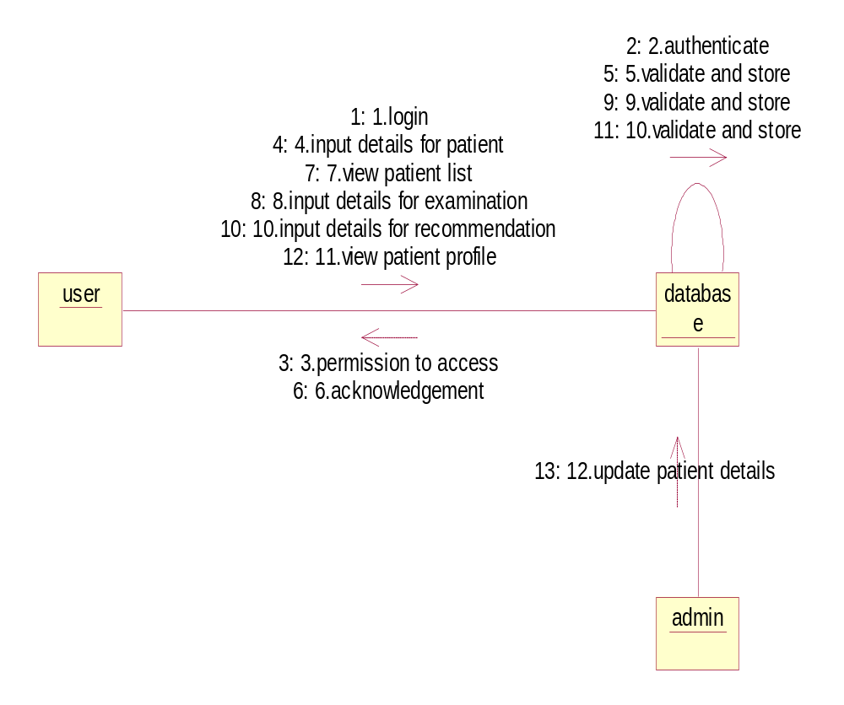

Fig 3.5 Collaboration Diagram

3.3.4 CLASS DIAGRAM
In software engineering, a class diagram in the Unified Modeling Language (UML) is a type of static structure diagram that describes the structure of a system by showing the system's classes, their attributes, operations (or methods), and the relationships among the classes. It explains which class contains information.

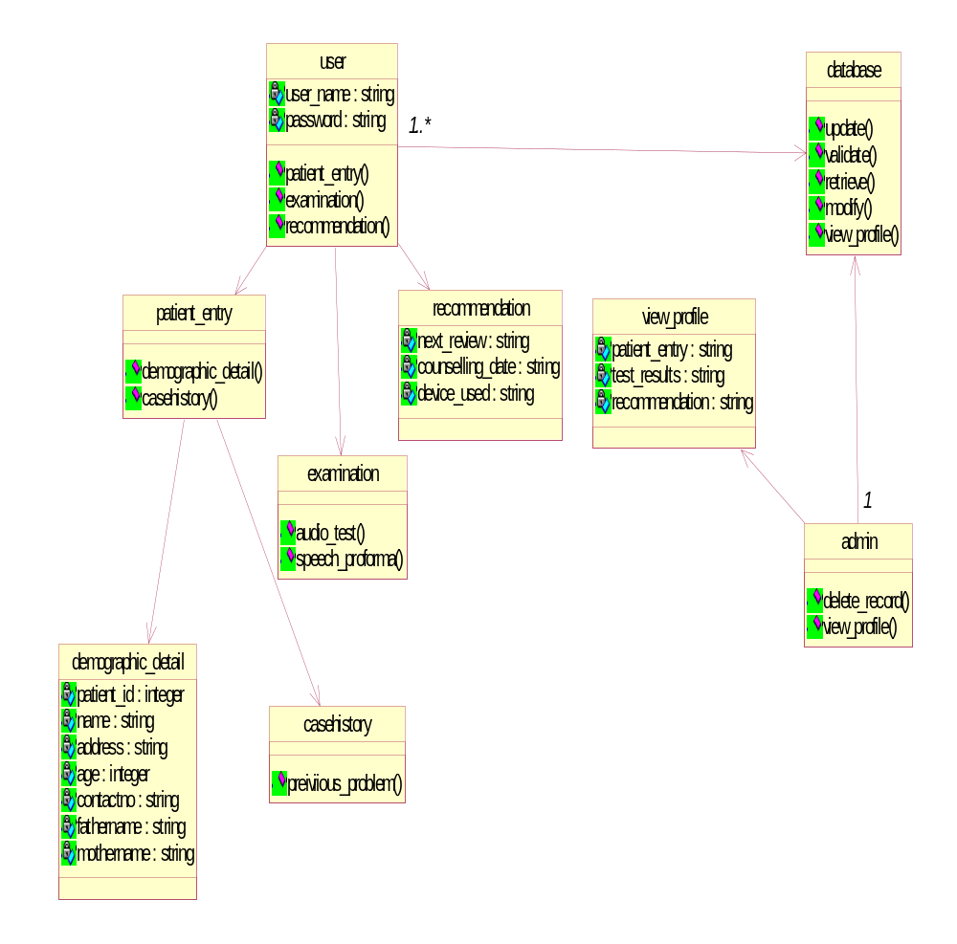

Fig 3.6 Class Diagram
3.3.5 ACTIVITY DIAGRAM
The activity diagram is the graphical representations of workflows of stepwise activities and actions with support for choice, iteration and concurrency. The activity diagrams can be used to describe the business and operational step-by-step workflows of components in a system. Activity diagram consist of Initial node, activity final node and activities in between.
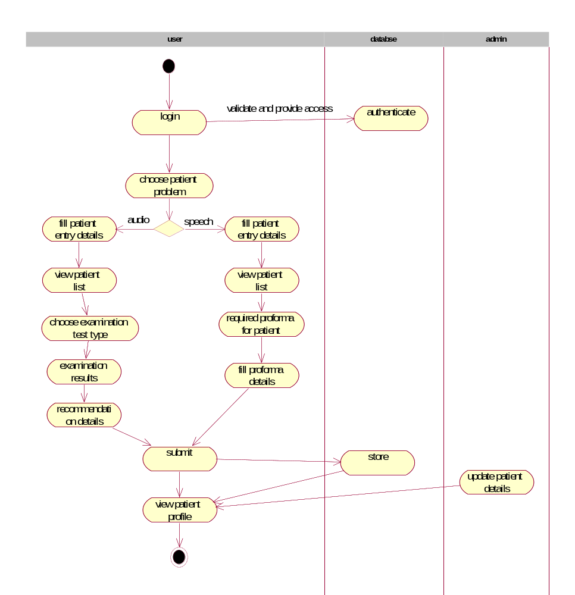
Fig 3.7 Activity Diagram

MODULE
DESCRIPTIONS

CHAPTER 4
MODULE DESCRIPTIONS
4.1 MODULES
A modular design reduces complexity, facilities change (a critical aspect of software maintainability), and results in easier implementation by encouraging parallel development of different part of system. Software with effective modularity is easier to develop because function may be compartmentalized and interfaces are simplified. Software architecture embodies modularity that is software is divided into separately named and addressable components called modules that are integrated to satisfy problem requirements.
Modularity is the single attribute of software that allows a program to be intellectually manageable. The five important criteria that enable us to evaluate a design method with respect to its ability to define an effective modular design are: Modular decomposability, Modular Comps ability, Modular Understandability, Modular continuity, Modular Protection.
The following are the modules of the project, which are planned in aid to complete the project with respect to the proposed system, while overcoming existing system and also providing the support for the future enhancement.
In the proposed system, there are three modules and they are described as follows:
- Data collection
- Examination
- Recommendation

4.2 MODULE DESCRIPTION
4.2.1 DATA COLLECTION:
In the data collection module, patient registers details based on general and demographic information. Patients are allocated a Unique Identification Number (UID) which helps in implementing patient relationship with management and also maintain the medical history such as hypertension, diabetes , renal disorder, carcinoma and otologic history of the patient.
4.2.2 EXAMINATION:
The examination module enables the generation of the test results for various available services such as pure tone audiometry, immitance Audiometry, tuning fork and electrophysiologic tests. The request is made after the analysis by the doctor based on the patients case history..
4.2.3 RECOMMENDATION
In this module, after the patient diagnosis the consultation date and any other observations made by the doctor is noted down for any further references which helps to maintain the data on preoperative and postoperative conditions of the patient.

REQUIREMENT SPECIFICATION

CHAPTER 5
REQUIREMENT SPECIFICATION
5.1 HARDWARE REQUIREMENTS
The hardware requirements may serve as the basis for a contract for the implementation of the system and should therefore be a complete and consistent specification of the whole system. They are used by software engineers as the starting point for the system design. It shows what the systems do and not how it should be implemented.
- RAM : Min 512 MB.
- Processor : Pentium IV 2.4 GHz.
- Hard Disk : min 40 GB.
- Motherboard : Genuine Intel.
5.2 SOFTWARE REQUIREMENTS
The software requirements are the specification of the system. It should include both a definition and a specification of requirements. It is a set of what the system should do rather than how it should do it. The software requirements provide a basis for creating the software requirements specification. It is useful in estimating cost, planning team activities, performing tasks and tracking the team’s and tracking the team’s progress throughout the development activity.

- Operating system : Windows XP, 7 and more.
- Coding Language : PHP
- Tools used : Xampp , Notepad++
- Database : My Sql.
- Front End Tool : HTML , CSS , Bootstrap.
- Back End Tool : Php , My Sql.

IMPLEMENTATION

CHAPTER 6
IMPLEMENTATION
6.1 SAMPLE CODE
Login Page
<?php
ini_set('display_errors',0);
include("connectmerf.php");
session_start();
if($_SERVER["REQUEST_METHOD"] == "POST") {
$username = $_POST['name'];
$password = $_POST['password'];
$passwordw =md5($password);
$sql = mysqli_query ($conn,"SELECT id FROM adminlogin WHERE username = '$username' and password = '$passwordw'");
$row = mysqli_fetch_array($sql);
$count = mysqli_num_rows($sql);
if($count == 1)
{
echo "login successfully";
echo "<script type='text/javascript'>window.location = 'index.php'</script>";
$_SESSION['name'] = $username;
}
else {
echo "<script type='text/javascript'>alert('Your Username or Password is invalid ');</script>";
}
}
?>
<!DOCTYPE html>
<html lang="en">
<!-- Mirrored from www.urbanui.com/zoom/pages/samples/login-2.html by HTTrack Website Copier/3.x [XR&CO'2014], Sat, 27 Jan 2018 13:06:27 GMT -->
<head>
<!-- Required meta tags -->
<meta charset="utf-8">
<meta name="viewport" content="width=device-width, initial-scale=1, shrink-to-fit=no">
<title>MERF Login</title>
<!-- plugins:css -->
<link rel="stylesheet" href="node_modules/mdi/css/materialdesignicons.css">
<link rel="stylesheet" href="node_modules/perfect-scrollbar/dist/css/perfect-scrollbar.min.css">
<!-- endinject -->
<!-- inject:css -->
<link rel="stylesheet" href="css/style.css">
<!-- endinject -->
<link rel="shortcut icon" href="images/favicon.png" />
<!-- for SWEET ALERT -->
<style>
.p_input:focus{
background :#eee;}
.p_input{
border: 1px solid #808080 !important;}
#title{
text-align:center !important;
font-weight:bold;
}
#logo{
width:33%;
margin-left:35%;
margin-bottom:5%;
}
#back{
background:pink;
height:100%;
}
#sub{
font-size: 18px;
font-weight: bold;
cursor:pointer;
}
#contents{
padding:0;
background: url("img/login.jpg");
background-repeat: no-repeat;
background-attachment: fixed;
}
@media (min-width:294px) and (max-width:990px){
#back{
background:#fff;
}
}
</style>
</head>

<body>
<div class="container-scroller">
<div class="container-fluid page-body-wrapper">
<div class="row">
<div class="content-wrapper full-page-wrapper auth-pages login-2" id="contents">
<div class="card col-lg-4" id="back">
<div class="card-body px-5 py-5" >
<img src="img/merf.png" id="logo">
<h3 class="card-title text-left mb-3" id="title">MERF Admin Login</h3>
<form method="POST">
<div class="form-group">
<label>Username *</label>
<input type="text" name="name" class="form-control p_input" placeholder="Username">
</div>
<div class="form-group">
<label>Password *</label>
<input type="password" name="password" class="form-control p_input" placeholder="Password">
</div>
<div class="form-group d-flex align-items-center justify-content-between">

<a href="#" class="forgot-pass">Forgot password ?</a>
</div>
<div class="text-center">
<button type="submit" class="btn btn-primary btn-block enter-btn" id="sub" >LET ME IN</button>
</div>
<p class="sign-up">Don't have an Account?<a href="#">Sign Up</a></p>
</form>
</div>
</div>
</div>
<!-- content-wrapper ends -->
</div>
<!-- row ends -->
</div>
<!-- page-body-wrapper ends -->
</div>
<!-- container-scroller -->
<!-- plugins:js -->
<script src="node_modules/jquery/dist/jquery.min.js"></script>
<script src="node_modules/popper.js/dist/umd/popper.min.js"></script>
<script src="node_modules/bootstrap/dist/js/bootstrap.min.js"></script>
<script src="node_modules/perfect-scrollbar/dist/js/perfect-scrollbar.jquery.min.js"></script>
<!-- endinject -->
<!-- inject:js -->
<script src="js/off-canvas.js"></script>
<script src="js/hoverable-collapse.js"></script>
<script src="js/misc.js"></script>
<!-- endinject -->
</body></html>

Data collection/entry[speech/audio]
<li class="nav-item">
<a class="nav-link" data-toggle="collapse" href="#patientSubmenu" aria-expanded="false" aria-controls="collapseExample">
<i class="mdi mdi-atom" id="sidnavicon"></i>
<span class="menu-title">Patient Entry</span>
<i class="mdi mdi-chevron-down"></i>
</a>
<div class="collapse" id="patientSubmenu">
<ul class="nav flex-column sub-menu">
<li class="nav-item">
<a class="nav-link side" href="patiententrys.php">
<i class="mdi mdi-send sides" id="sidnavicon" ></i>Adult Audiometry</a>
</li>
<li class="nav-item">
<a class="nav-link side" href="patient_entrys_child.php" >
<i class="mdi mdi-send" id="sidnavicon"></i>Children Audiometry</a>
</li>
</ul>
</div>
</li>

Entry details for adult audiometry:
<body class="sidebar-icon-only">
<?php include 'header.php';?>
<div class="container-fluid page-body-wrapper">
<div class="row row-offcanvas row-offcanvas-right">
<!-- partial:../../partials/_sidebar.html -->
<?php include 'sidenav.php'; ?>
<div class="wrapper">
<!-- Content Wrapper. Contains page content -->
<div class="content-wrapper">
<!-- Content Header (Page header) -->
<section class="content-header">
<h1 id="title">
Patient Registration
</h1>
</section>
<br>
<div id="adult_audio">
<h2 id="formtil">Department of AUDIOLOGY (ADULT)</h2><br>
<!-- progressbar -->
<ul id="progressbar">
<li class="li active" id="1">Demographic Details</li>
<li class="li" id="2">Patient Complaints</li>
<li class="li" id="3">Patient Case History (1)</li>
<li class="li" id="4">Patient Case History (2)</li>
<li class="li" id="5">Otologic History (1)</li>
<li class="li" id="6">Otologic History (2)</li>
</ul>
<div id="msform">
<fieldset>

<!-- Main content -->
<section class="content">
<div class="row">
<!-- left column -->
<div class="col-md-12">
<!-- general form elements -->
<div class="box box-primary" style="border-top-color: #008080;">
<div class="box-header with-border" style="background:#008080;">
<h3 class="box-title" style="color:#fff; font-weight:bold;">Demographic Details</h3>
</div>
<!-- /.box-header -->
<!-- form start -->
<form method="POST" role="form" name="myform" onsubmit="return validateform()" >
<div class="box-body">
<div class="container ">
<div class="row">
<div class="col-md-6">
<div class="form-group">
<label for="id" class="lab">Patient ID &nbsp;&nbsp;<span id='mes' style="color:red; font-weight:bold;"></span></label>
<input type="text" class="form-control" id="patid" name="patid" placeholder="Enter Patient ID" >
</div>
<div class="form-group" >
<label for="Patient Name" class="lab">Patient Name</label>
<input type="text" class="form-control" id="name" name="name" placeholder="Enter Patient N</div>
<div class="form-group" >
<label for="age" class="lab">Age</label>
<select class="form-control" id="age" name="age" placeholder="">
<option>Select Patient Age</option>
<?php for($oi=1;$oi<=110;$oi++){ ?>
<option value="<?php echo $oi; ?>"><?php echo $oi; ?></option>
<?php } ?>
</select>
</div>
<div class="form-group" >
<label for="Gender" class="lab">Gender</label><br>
<input type="radio" id="gender" name="gender" value="male" style="margin-left:1%;" >&nbsp;&nbsp;&nbsp;Male
<input type="radio" id="gender" name="gender" value="female" style="margin-left:3%;" >&nbsp;&nbsp;&nbsp;Female
<input type="radio" id="gender" name="gender" value="others" style="margin-left:3%;" >&nbsp;&nbsp;&nbsp;Others
</div>
</div>
<div class="col-md-6">
<div class="form-group">
<label for="Occupation" class="lab">Occupation</label>
<input type="text" class="form-control" id="occupation" name="occupation" placeholder="Enter Patient Occupation">
</div>
<div class="form-group">
<label for="Supervisor" class="lab">Supervisor</label>
<input type="text" class="form-control" id="supervisor" name="supervisor" placeholder="Enter Supervisor Name">
</div>
<div class="form-group" >
<label for="Language" class="lab">Language</label>
<select class="form-control" id="language" name="language">
<option>Select Patient Language</option>
<option value="tamil">Tamil</option>
<option value="english">English</option>
<option value="hindi">Hindi</option>
<option value="telugu">Telugu</option>
<option value="Kannada">Kannada</option>
<option value="malayalam">Malayalam</option>
</select>
</div>
<div class="form-group" >
<label for="Contact Number" class="lab">Contact Number</label>
<input type="text" class="form-control" id="contact" name="contact" placeholder="Enter contact number" maxlength="10" onkeypress='validate(event)'>
</div>
</div>
</div>
</div>
<div class="container">
<label for="address" class="lab">Address</label>
<textarea class="form-control" id="textarea" name="address" placeholder="Enter Patient Address"></textarea>
</div>
<!-- /.box-body -->
<div class="box-footer">
<br>
</div>
</div>

Evaluation/examination phase of adult:
View patient list:
<li class="nav-item">
<a class="nav-link" data-toggle="collapse" href="#patientlistSubmenu" aria-expanded="false" aria-controls="collapseExample">
<i class="mdi mdi-format-list-bulleted" id="sidnavicon"></i>
<span class="menu-title">MERF Patient List</span>
<i class="mdi mdi-chevron-down"></i>
</a>
<div class="collapse" id="patientlistSubmenu">
<ul class="nav flex-column sub-menu">
<li class="nav-item">
<a class="nav-link side" href="patient_list.php"> <i class="mdi mdi-send sides" id="sidnavicon" ></i>Adult Audiometry List</a>
</li>
<li class="nav-item">
<a class="nav-link side" href="patient_list_child.php" ><i class="mdi mdi-send" id="sidnavicon"></i>Child Audiometry List</a>
</li>
</ul>
</div>
</li>
Examination details:
<?php include 'header.php';?>
<div class="container-fluid page-body-wrapper">
<div class="row row-offcanvas row-offcanvas-right">
<!-- partial:../../partials/_sidebar.html -->
<?php include 'sidenav.php'; ?>
<div class="wrapper">
<!-- Content Wrapper. Contains page content -->
<div class="content-wrapper">
<!-- Content Header (Page header) -->
<section class="content-header">
<h1 id="title">Examination Test</h1>
</section>
<br>
<div class="row">
<div class="col-12 col-lg-7 grid-margin">
<div class="card">
<div class="card-body">
<h2 class="card-title">Examination</h2>
<form class="forms-sample">
<div class="form-group">
<div class="container">
<div class="row">
<div class="col-md-6">
<div class="">
<label class="contain"> BEHAVIORAL TESTS
<input type="radio" name="examination" id="behavioral" value="behavioral" style="margin-left:6.5%;" >
<span class="radiomark"></span>
</label>
</div>
<div class="">
<label class="contain"> IMMITANCE AUDIOMETRY
<input type="radio" name="examination" value="immitance_audiometry" style="margin-left:6.5%;" >
<span class="radiomark"></span>
</label>
</div>
<div class="">
<label class="contain"> ELECTROPHYSIOLOGIC TESTS
<input type="radio" name="examination" value="electrophysiologic" style="margin-left:6.5%;" >
<span class="radiomark"></span>
</label>
</div>
</div>
<div class="col-md-6">
<div class="">
<label class="contain"> PROVISIONAL DIAGNOSIS
<input type="radio" name="examination" value="provisional_diagnosis" style="margin-left:6.5%;" >
<span class="radiomark"></span>
</label>
</div>
<div class="">
<label class="contain"> HEARING AID TRIAL
<input type="radio" name="examination" value="hearing_aid_trail" style="margin-left:6.5%;" >
<span class="radiomark"></span>
</label>
</div>
</div>
</div>
</div>
</div>
</form>
</div>
</div>
</div>
Recommendation phase
<body class="sidebar-icon-only">
<?php include 'header.php';?>
<div class="container-fluid page-body-wrapper">
<div class="row row-offcanvas row-offcanvas-right">
<!-- partial:../../partials/_sidebar.html -->
<?php include 'sidenav.php'; ?>
<div class="wrapper">
<!-- Content Wrapper. Contains page content -->
<div class="content-wrapper">
<!-- Content Header (Page header) -->
<section class="content-header">
<h1 id="title">Recommendation</h1>
</section>
<br>
<br>
<!-- RECOMMENDATION -->
<fieldset>
<div id="provisional_diagnosis_pat_det" style="">
<h2 id="formtil">Department of AUDIOLOGY (ADULT)</h2><br>
<!-- progressbar -->
<?php
$get_profileq = mysqli_query($conn,"select * from audio_adult_recommendation where pat_id='$patyid'");
while($profile_detailq = mysqli_fetch_array($get_profileq)) {
$vjk1 = $profile_detailq['pat_name'];
$vjk2 = $profile_detailq['counselling'];
$vjk3 = $profile_detailq['device'];
$vjk4 = $profile_detailq['ent_review'];
$vjk5 = $profile_detailq['follow_up'];
$vjk6 = $profile_detailq['examined_on'];
}?>
<div class="row" >
<?php
$get_profile = mysqli_query($conn,"select * from patiententry_audio_adult where pat_id='$patyid'");
while($profile_detail = mysqli_fetch_array($get_profile)) {
$pat_id = $profile_detail['pat_id'];
$vjo2 = $profile_detail['pat_name'];
$vjo3 = $profile_detail['age'];
$vjo4 = $profile_detail['gender'];
$vjo5 = $profile_detail['occupation'];
$vjo6 = $profile_detail['supervisor'];
}?>
<div class="col-12 col-lg-12 grid-margin">
<div class="card">
<div class="card-body">
<h2 id="formtil">Patient Details</h2><br>
<!-- <form class="forms-sample"> -->
<div class="form-group">
<div class="container">
<div class="row">
<div class="col-md-6">
<table>
<tr>
<td class="noborder">
<label style="float:left;font-weight:bold;">PATIENT NAME </label>
</td>
<td class="pleft noborder para">
<?php echo $vjo2; ?>
<input type="hidden" name="pat_nameq" value="<?php echo $vjo2; ?>" form="myformq">
</td>
</tr>
<tr>
<td class="noborder">
<label style="float:left;font-weight:bold;">AGE/SEX </label>
</td>
<td class="pleft noborder para">
<?php echo $vjo3; ?> / <?php echo $vjo4; ?>
</td>
</tr>
</table>
</div>
<div class="col-md-6">
<table class="noborder">
<tr>
<td class="noborder">
<label style="float:left;font-weight:bold;">OCCUPATION </label>
</td>
<td class="pleft noborder para">
<?php echo $vjo5; ?>
</td>
</tr>
<tr>
<td class="noborder">
<label style="float:left;font-weight:bold;">DATE</label>
</td>
<td class="pleft noborder">
<input type="date" name="dateq" class="form-control tableinput" form="myformq" value="<?php echo $vjk6; ?>">
</td>
</tr>
</div>
</div>

SCREENSHOTS

CHAPTER 7
SCREENSHOTS
7.1 HOME PAGE:
This is the home page of the patient management system.
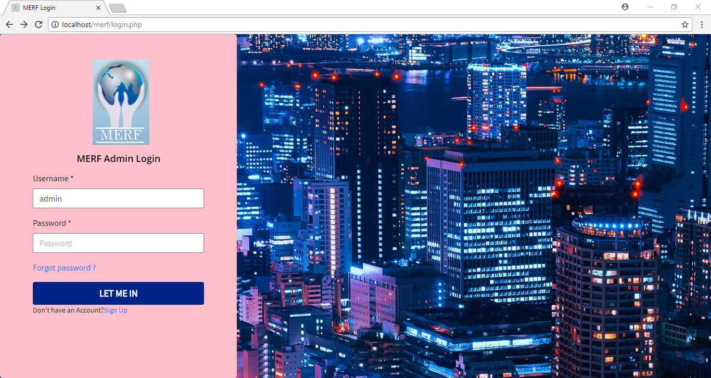
Fig 7.1.Home page
7.2 PATIENT PROBLEM:
The user chooses the problem of patient into the application.
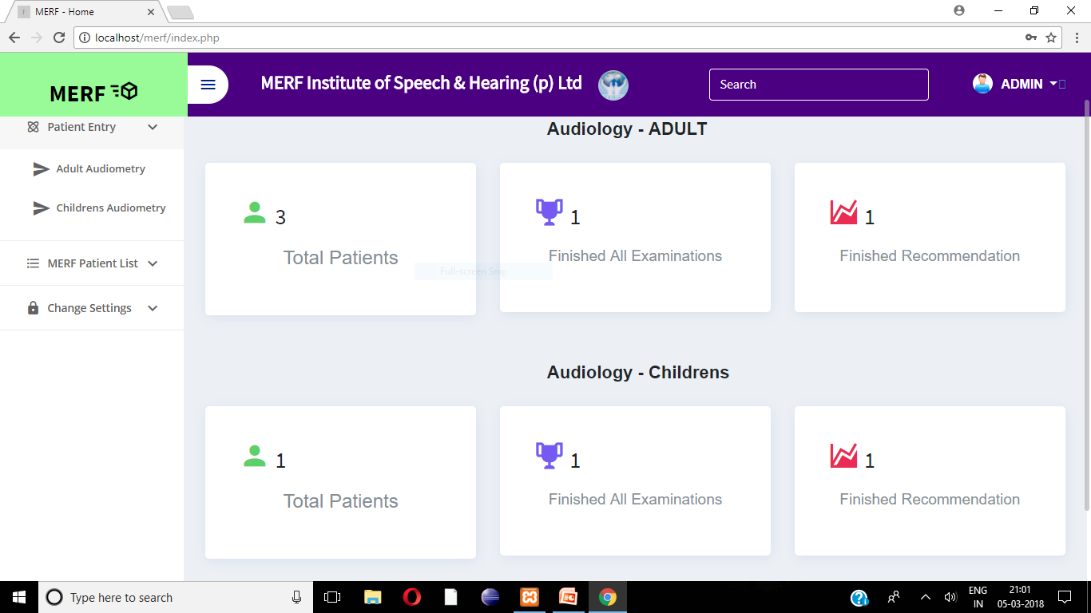
Fig 7.2 Patient problem
7.3 PATIENT ENTRY [DEMOGRAPHIC DETAILS]:
The user fills personal details of patient.
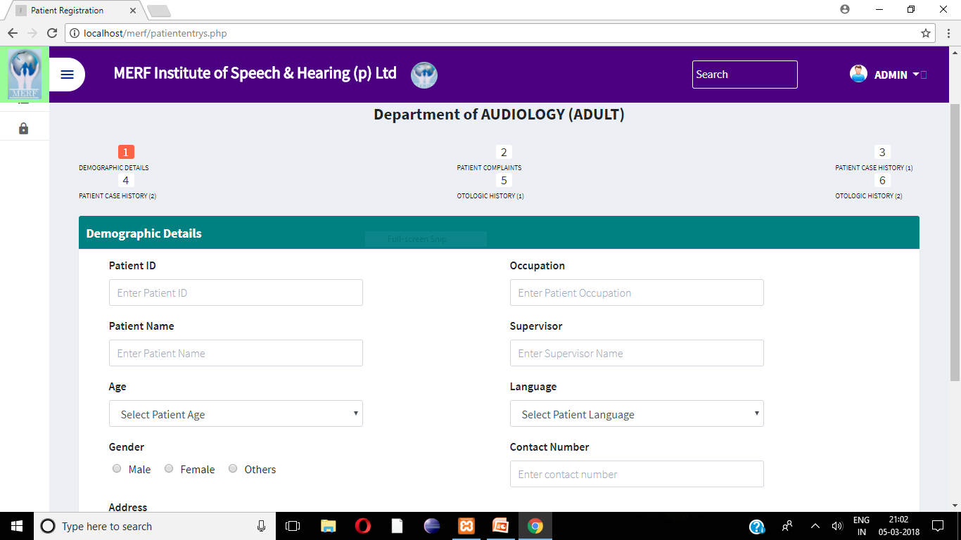
Fig 7.3 Patient entry
7.4 PATIENT COMPLAINTS:
The user fills the complaint about the problem from patient.
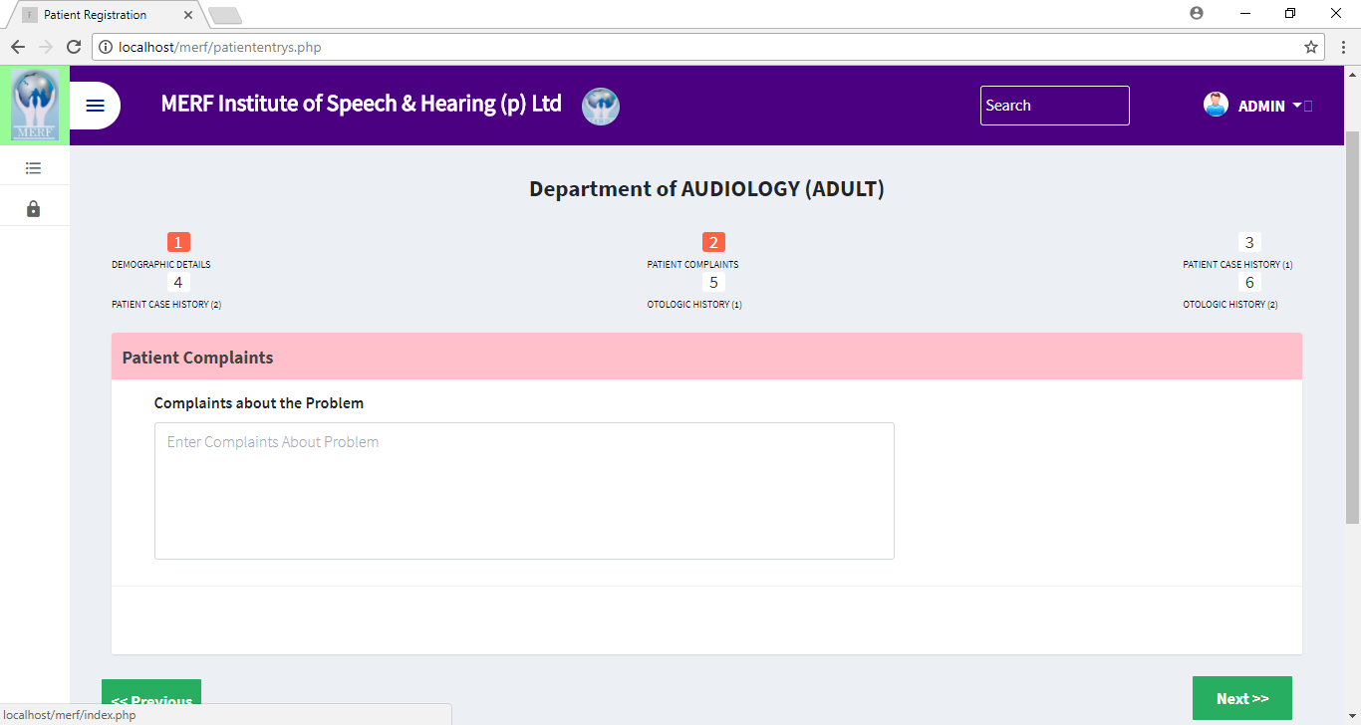
Fig 7.4 Patient complaint
7.5 PATIENT CASE HISTORY:
The user fills the case history of the patient into the application.
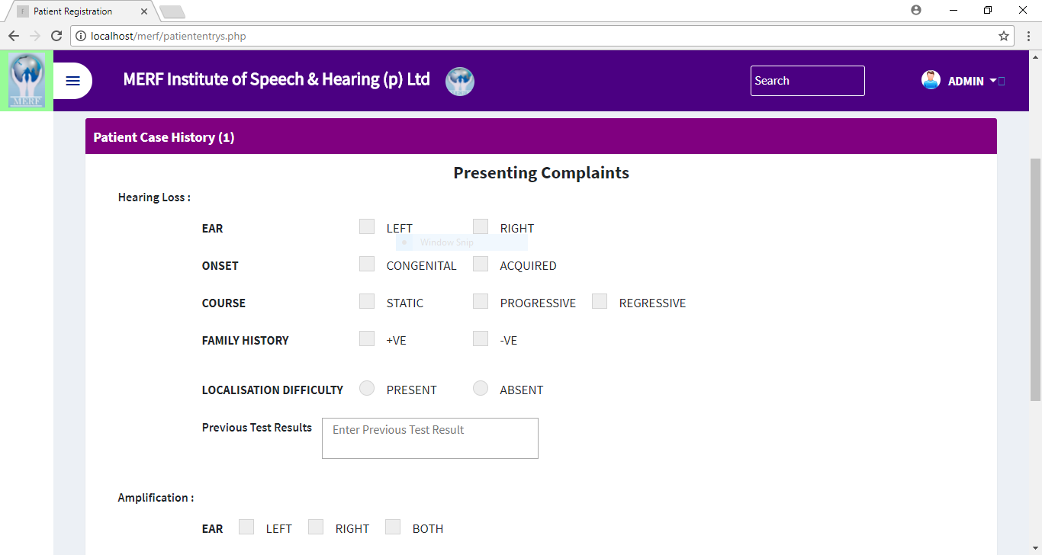
Fig 7.5 Patient case history

7.6 OTOLOGIC HISTORY:
The user fills the otologic history details of patient. 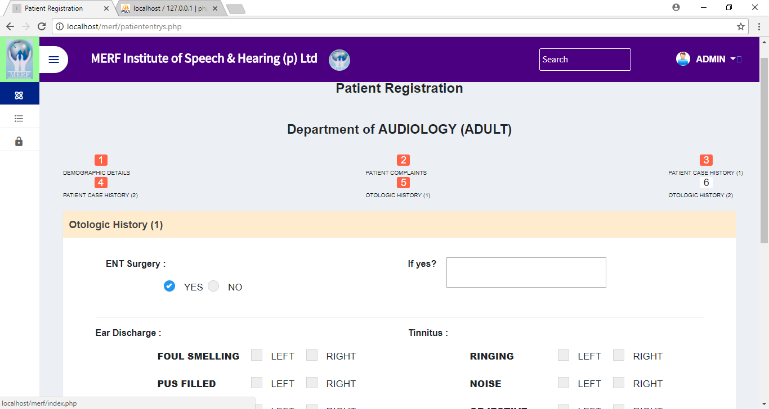
Fig 7.6 Otologic history
7.7 PATIENT LIST:
The doctors can view the details of the patient.
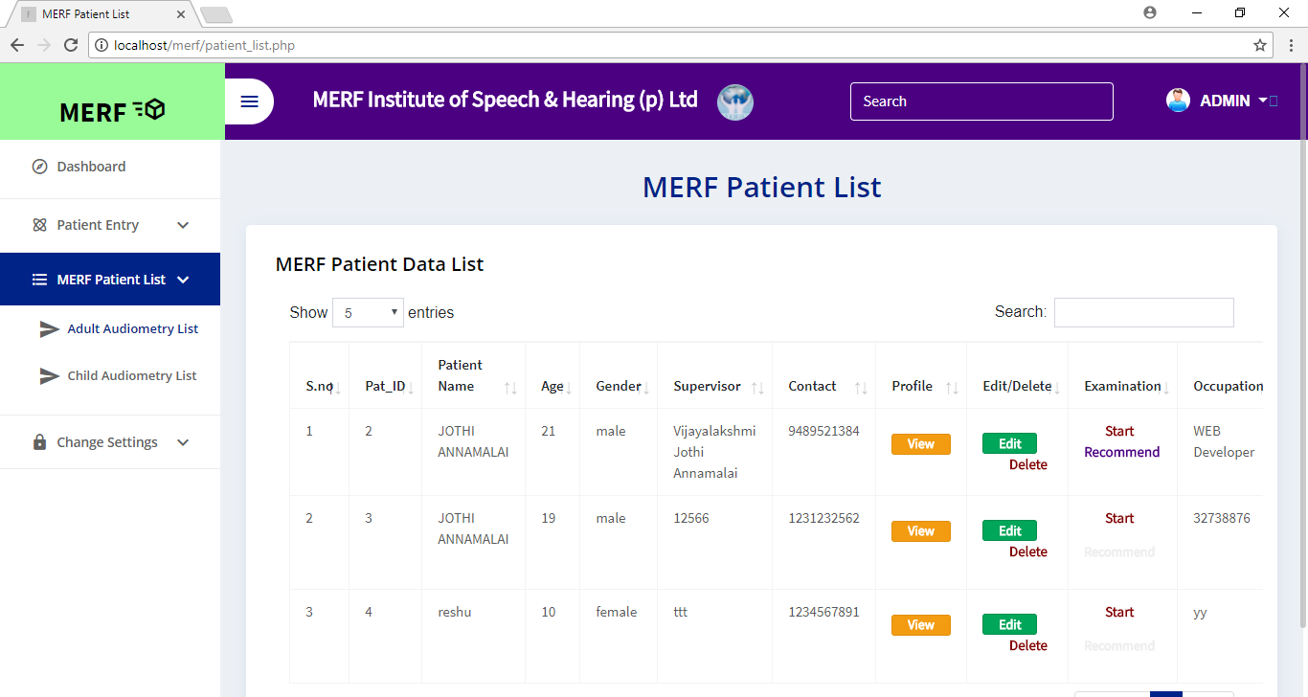
Fig 7.7 Patient list
7.8 EXAMINATION:
After the patient get examined, their examination results will entered by the doctor into the application. 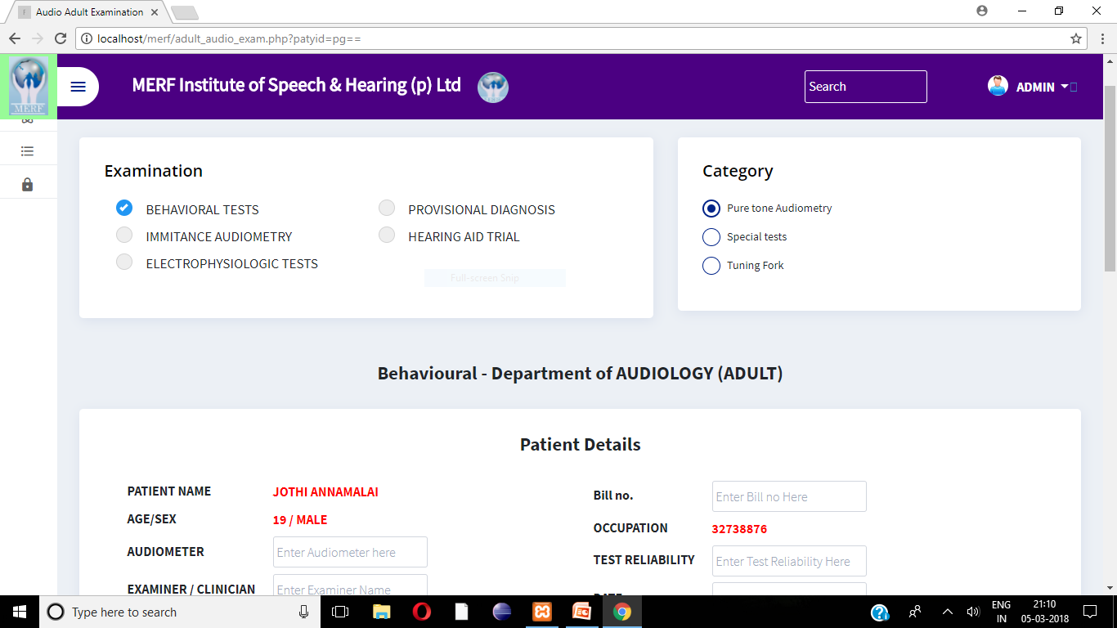
Fig7.8 Examination
7.9 TEST RESULT:
The examination results will be stored in the required test page.
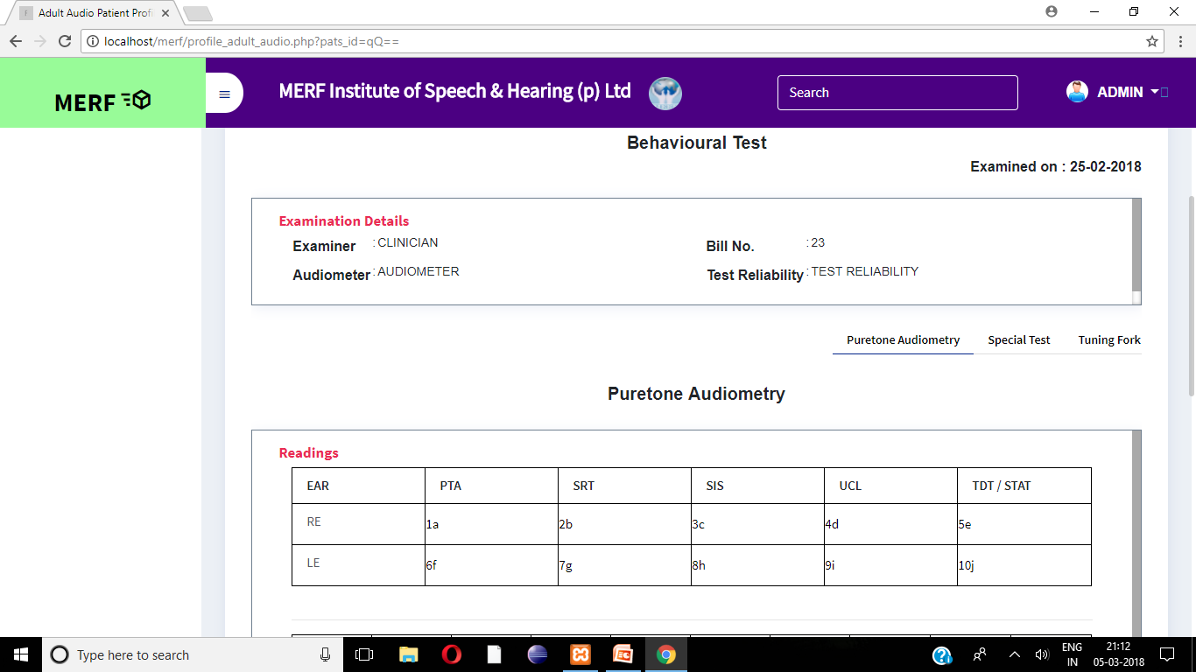
Fig 7.9 Test result
7.10 RECOMMENDATION:
After the examination, counselling and device details is get filled by the doctor into the application. 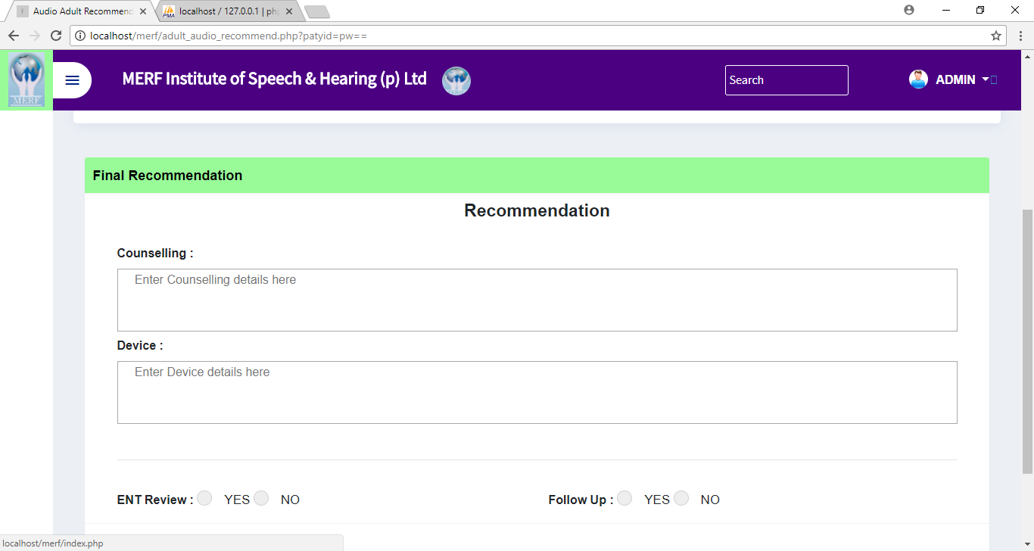 Fig7.10 Recommendation
7.11 PATIENT PROFILE:
The full details of the patient can be viewed at any time once it get stored.
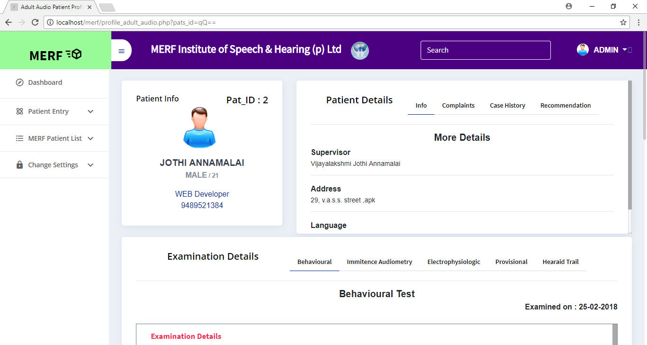
Fig 7.11 Patient profile

TESTING
AND MAINTENANCE

CHAPTER 8
TESTING AND MAINTENANCE

8.1 TESTING
Implementation forms an important phase in the system development life cycle. It is a stage of the project work that transforms the design into a model. Testing was done to see if all the features provided in the modules are performing satisfactory and to ensure that the process of testing is as realistic as possible.
Each program is tested individually at the time of development using the data and has verified that this program linked together in the way specified in the program specification, the computer system and its environment is tested to the satisfaction of the user. The system that has been developed is accepted and proved to be satisfactory for the user. And so the system is going to be implemented very soon.
Initially as a first step the executable form of the application is to be created and loaded in the common server machine which is accessible to all the users and the server is to be connected to a network. The final stage is to document the entire system which provides components and the operating procedures of the system.
The importance of software testing and its implementations with respect to software quality cannot be over emphasized. Software testing is a critical element of software quality assurance and represents the ultimate review of specification, design and coding.
Any product can be tested using either a black box testing or white box testing. Further testing can be implemented along the lines of code, integration and system testing.

Acceptance Testing

System Testing

Unit Testing
Integration Testing

Fig 8.1 Levels of Testing.
8.1.1 UNIT TESTING
Unit Testing is a level of the software testing process where individual units/components of a software/system are tested. The purpose is to validate that each unit of the software performs as designed. A unit is the smallest testable part of software. It usually has one or a few inputs and usually a single output. In procedural programming a unit may be an individual program, function, procedure, etc.
8.1.2 INTEGRATION TESTING
Integration Testing is a level of the software testing process where individual units are combined and tested as a group. The purpose of this level of testing is to expose faults in the interaction between integrated units. Test drivers and test stubs are used to assist in Integration Testing. The definition of a unit is debatable and it could mean any of the following:
- The smallest testable part of a software
- A ‘module’ which could consist of many of ’1′
- A ‘component’ which could consist of many of ’2′

Approaches
- Big bang is an approach to Integration testing where all or most of the units are combined together and tested at one goes. This approach is taken when the testing team receives the entire software in a bundle. So, the difference between Big Bang Integration Testing and System Testing is that the former tests only the interactions between the units while the latter tests the entire system.
- Top Down is an approach to Integration Testing where top level units are tested first and lower level units are tested step by step after that. This approach is taken when top down development approach is followed. Test Stubs are needed to simulate lower level units which may not be available during the initial phases.
- Bottom Up is an approach to Integration Testing where bottom level units are tested first and upper level units step by step after that. This approach is taken when bottom up development approach is followed. Test Drivers are needed to simulate higher level units which may not be available during the initial phases.
- Sandwich/Hybrid is an approach to Integration Testing which is a combination of Top Down and Bottom Up approaches.
Definition by ISTQB
- Integration testing: Testing performed to expose defects in the interfaces and in the interactions between integrated components or systems. See also component integration testing, system integration testing.
- Component integration testing: Testing performed to expose defects in the interface and interaction between integrated components.
- System integration testing: Testing the integration of systems and packages; testing interfaces to external organizations (e.g. Electronic Data Interchange, Internet).

8.2 TEST CASES AND RESULTS
8.2.1 VALIDATION TESTING
The login unit is validated using various correct and incorrect test cases. The incorrect test case produced the following result.
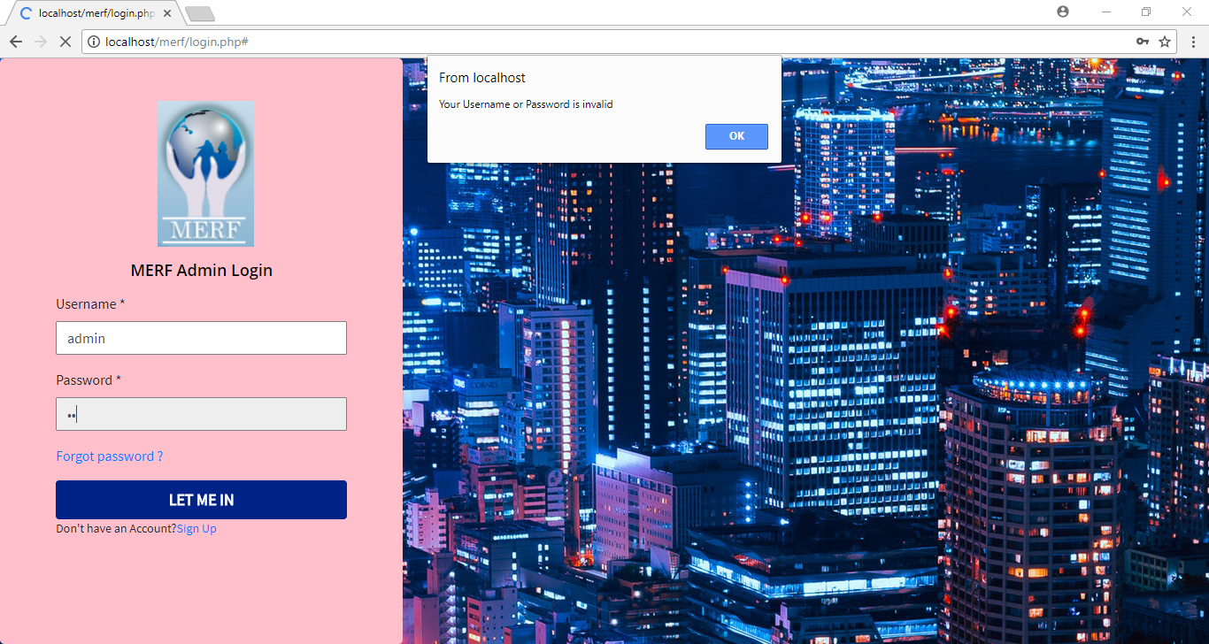
Fig 8.2 Testing the Login unit

8.2.2 UNIT TESTING
All the units are test by giving suitable test cases and the results are produced below:
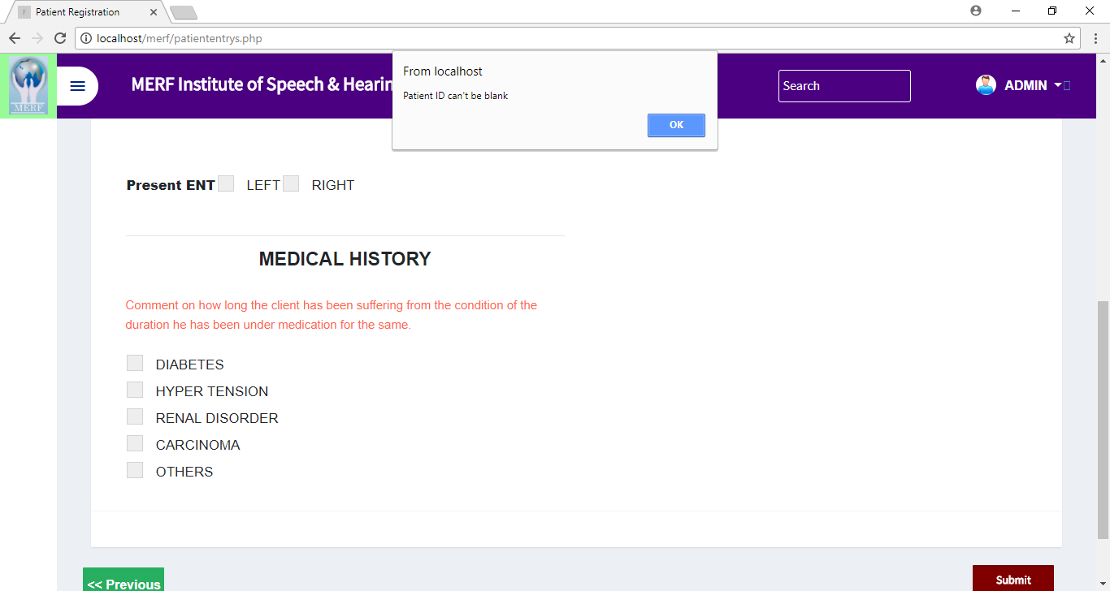
Fig 8.3 Testing Patient entry
8.3 MAINTENANCE
After a software system has been verified, tested and implemented, it must continue to be maintained. Maintenance routines will vary depending on the type and complexity of the technology. Many software systems will come with a maintenance schedule or program recommended by the developer. Maintenance could be provided by the developer as part of the purchase agreement for the technology.
Systems will need to be maintained to ensure that they continue to perform to the level demonstrated during the system testing stage. If systems deteriorate, there is a risk that the systems will not perform to the required standard.
Ongoing monitoring or testing systems may be installed to ensure that maintenance needs are identified and met where necessary. Where systems are in long-term use, a system can be designed to monitor feedback from users and conduct any modifications or maintenance as needed. Where modifications to software are made as a result of system maintenance or upgrades, it may be necessary to instigate further rounds of system verification and testing to ensure that standards are still met by the modified system.

CONCLUSION AND
FUTURE ENHANCEMENTS

CHAPTER 9
CONCLUSION AND FUTURE ENHANCEMENTS
9.1 CONCLUSION
The project patient management system is for computerizing the working in a hospital. It is a great improvement over the manual system. The computerization of the system has sped up the process . In the current system the management in the hospital is very slow , this system is thoroughly checked and tested and thus is found reliable . This software takes care of all the requirements of an average hospital and is capable to provide easy and effective storage of information related to patients that come up to the hospital. It generates test reports and also provides the facility for searching the details of the patient.
9.2 FUTURE ENHANCEMENTS
The proposed system can be enhanced by providing billing facility on the basis of patient’s status and also the maintaining the stock details of medicines in the pharmacy. Providing such features makes the system user-friendly.

REFERENCES

CHAPTER 10
REFERENCES

- F. Fritz, S. Balhorn, M. Riek, B. Breil, and M. Dugas, "Qualitative and quantitative evaluation of ehr-integrated mobile patient questionnaires regarding usability and cost-efficiency," International Journal of Medical Informatics, vol. 81, no. 5, pp. 303-313, 2012.

- M. F. Walji, E. Kalenderian, D. Tran, K. K. Kookal, V. Nguyen, O. Tokede, J. M. White, R. Vaderhobli, R. Ramoni, P. C. Stark, N. S. Kimmes, M. E. Schoonheim-Klein, and V. L. Patel, "Detection and characterization of usability problems in structured data entry interfaces in dentistry," International Journal of Medical Informatics, no. 0, pp.-, 2012.

- Md. Zan Saari. (2007, 5 December). Kos Rawatan Mahal: Pilihan di Tangan Pengguna. Retrieved April, 21, 2011, at http://www.yadim.com.my/Kesihatan/ KesihatanFull.asp?Id=175.

- Bernama (2009, 24 July). Kerajaan Bayar Pampasan RM7 Juta Untuk Kes Kecuaian Perubatan. Retrieved March, 12, 2011, at http://www.bernama.com/ bernama/v3/bm/news

- Aniza et al. (2010). The Implementation of Hospital of Hospital System (HIS) in Tertiary Hospitals in Malaysia: A Qualitative Study. Retrieved February,3,2011at http://www.pppkam.org.my/mjphm/journals/Volume10.2/3

