***Smart meter for effective power consumption and voltage detection using IoT***

1 K Lalitha, 2Annie Nithya.N.V, 3Sowmya.A, 4Subhashini.P, 5Sunantha.S

Assistant Professor 1, UG Students 2-5, Department of Information Technology 1-5

Panimalar Engineering College 1-5, Chennai-600123

***Abstract-*The usage of Smart Meter(SM) calculates a consumer’s electricity usage and details. The Smart Meter(SM) can control the loads and hence secure the system stability, faster than the ordinary generators. The main system of the Smart Meter(SM) is the sensing devices that are used to calculate both the current and voltage magnitudes of the systems. Due to its functionality, smart meters have a vast relevancy in monitoring the energy consumed daily and also monthly. Monthly electricity bills will be automatically sent to the consumer’s mobile phone. When there is a low voltage the message will directly sent to the customer, so the customers can switch off the device immediately to prevent from damages. In this paper, we reveal the Smart Meter platform, as a low-cost solution for data storage, processing and data analytics.**

***Keywords-*smart meter, data analytics, electricity, messages**

I.INTRODUCTION

With the increasing necessity for modern life and a grand lifestyle of the people, the demand for electricity has increased. Different kind of results reveals that the increase in electricity demand depends on the population. It is common to know that the power consumption is high during summer season. Many challenges on generation and transmission have damaged the energy industry and service providers. The enlarging energy requirements and changes in weather climate are noteworthy matters of concern.

A Smart Meter(SM) is an electronic device to calculate and manage the power consumption. A SM provides countless benefits for energy generation, transmission, distribution and consumption, the use of information and communication technologies that enables SM to monitor and control the power network effectively. A SM is also record and report the electricity consumption of the household. SM’s are frequently linked with power line communications (PLC) link and send the data installed in the transformer.

The adoption of smart electricity meters can contribute to decrease carbon dioxide emission in two ways. First one is they will allow visually showing to customers about their electricity consumption. Second is the automated bill will be automatically generated to the customer’s mobile phone. The SM’s has been spreading widely throughout the world, and also the new technology is quickly spreading in countries throughout the world. The main goal of the system is to reduce checking electricity consumption manually. In this system we can monitor the power consumed daily and monthly. Then the voltage goes low automatically message will receive by consumer, so that the damage for the household products can be avoided.

They can switch off the devices using the mobile application. Also the online payment can be done through internet banking. Above all, there is an urgent requirement to design a smart metering load data compression method that can provide high compression efficiency, high reconstruction precision and a simple data compression format for system.

The smart meter proposes replaced the regular electricity meter. Regular updates from the server will be sent to the user through SMS or email along with an advisory message regarding the excess power consumption. The electricity bill is generated for every month and intimated the users along with the due-date. The technologies, devices and systems that make up a smart network will vary across electricity distribution systems, just as existing electricity networks vary according to the geographic, climatic, ownership and business parameters.

II.RELATED WORK

Today power distribution systems are featured by structural weakness, geopolitical and environmental shortcomings. The main limitation of the existing electricity delivery processes is that consumers are passive participants, with limited access to information to demonstrate energy usage and costs. Furthermore, the current design of the network is a one way flow of both energy and information, and it will not meet the anticipated expectations of consumers and the key stakeholders in the future, that require two way energy and information exchange to support best practice asset management, customer enablement and the range of emerging energy storage and renewable generation technologies. While this future is dependent on the uptake of new technology, the greater dependence on the need for consumers to fundamentally to change the way that energy is used.

In a power distribution network, it is evident that smart meter is needed to operate power utilities in a globalised environment and cope with the changing requirements and technologies. Smart meters in distribution network are one of the challenging tasks to address in order to visualize the distribution network in the digital world under modern communication standard.

Electricity usually is consumed the moment, it is generated. The main problem is to meet the peak demand. The challenge for distribution networks are ensuring a two-way flow of electricity and information between distribution systems and appliances and the distribution network must be designed to meet peak rather than the average demand. There are several ways to mitigate the challenge of rapidly growing peak demand such as managing supply, managing demand and solutions to shift demand away from peaks. A smart network will support all these solutions.

A smart network facilitates energy security by reducing total demand as customers respond to price signals and implement energy savings strategies and responses in their homes and businesses, developing economical storage system such as integrating distributed renewable generation adding to the total generation capability, addressing power-quality problems that may be exacerbate the situation and enhancing asset utilization and enhancing reliability by way of real-time monitoring and control of network performance, rapid fault diagnosis and response, automated switching under fault conditions, local generation providing alternatives to central generation in the event of major disruptions, and greater interconnection of networks. The new world of electric utility operations will require the monitoring and control of every power line and piece of equipment on the distribution system. It will also involve an increased level of monitoring and control of every one of the utility’s retail consumers. Involving retail consumer will most likely involve multiple monitoring and control devices on the consumer’s premises. Immense amounts of data will have to be organized, analyzed and acted upon. Extremely large number of control points will have to be managed. The necessity of smart meter system interoperability for the customer is already well recognized within the industry. Along with the challenge of developing the three different sets of standards. Standards can also help to reduce installation complexity, facilitate interoperability and address security. Interoperability can provide appliance manufacturers with the confidence and motivation to install smart meter technology into their products.

Smart meter network need an intelligent communications infrastructure enabling the timely, secure and adaptable information flow needed to provide power to the evolving digital economy. Interoperability has become a reality and today’s devices are self-describing and programmable. The technology requirement for smart meter network has been discussed. Advanced metering infrastructure, distributed automation, digital communication and standard communication with required bandwidth are all needed to allow self healing, plus provide high reliability of power. With the imposing of smart meter network, new ways are being sought to improve standard communication with the required bandwidth without diminishing network reliability. Hence, a reliable and more efficient two-way communications infrastructure with less propagation delay should be developed for operation of smart meter network.

III.EQUIPMENTS USED

***A. Sensors***

***a. AC current sensor***

A current sensor (CT1270) is a device that detects [electric current](https://en.wikipedia.org/wiki/Electric_current) (AC or DC) in a wire, and generates a signal proportional to it. The generated signal could be analog voltage or current or even digital output. When a current flows through a wire or in a circuit, voltage drop occurs. Also, a magnetic field is generated surrounding the current carrying conductor. Both of these phenomena are made use of in the design of current sensors. Thus, there are two types of current sensing: direct and indirect. Direct sensing is based on Ohm’s law, while indirect sensing is based on Faraday’s and Ampere’s law. Direct Sensing involves measuring the voltage drop associated with the current passing through passive electrical components.

Indirect Sensing involves measurement of the magnetic field surrounding a conductor through which current passes. Generated magnetic field is then used to induce proportional voltage or current which is then transformed to a form suitable for measurement and/or control system.

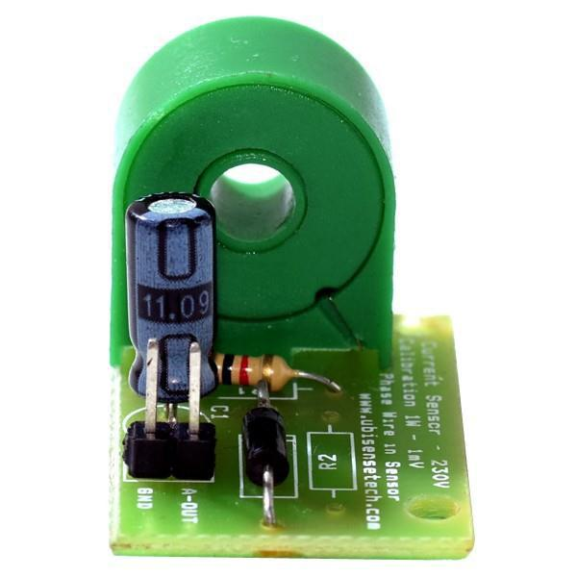

***b. AC voltage sensor***

The Voltage Sensor block represents an ideal voltage sensor, that is, a device that converts voltage measured between two points of an electrical circuit into a physical signal proportional to the voltage. Connections + and – are electrical conserving ports through which the sensor is connected to the circuit. Connection V is a physical signal port that outputs the measurement result.

AC voltage sensor works according to Magnetic Modulation and is designed for AC voltage measurement. The output signal of this sensor is proportional to the input AC voltage. It can be used for continuous ac voltage monitoring of the system.

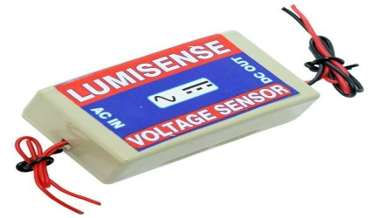

***B. Four relay board***

Relays are simple switches which are operated both electrically and mechanically. Relays consist of a n electromagnet and also a set of contacts. The switching mechanism is carried out with the help of the electromagnet. The main operation of a relay comes in places where only a low-power signal can be used to control a circuit. It is also used in places where only one signal can be used to control a lot of circuits.They were used to switch the signal coming from one source to another destination. The high end applications of relays require high power to be driven by electric motors and so on. Such relays are called contactors.

A relay is an electromechanical switch which is activated by an electric current. A four relay board arrangement contains driver circuit, power supply circuit and isolation circuit. A relay is assembled with that circuit. The driver circuit contains transistors for switching operations. The transistor is use for switching the relay.An isolation circuit prevents reverse voltage from the relay which protects the controller and transistor from damage. The input pulse for switching the transistor is given from the microcontroller unit. It is used for switching of a four device.

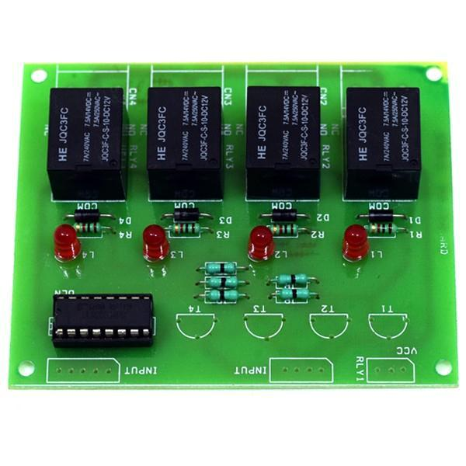

***C. transformer (0-12v/1a)***

It is a general purpose chassis mounting mains transformer. Transformer has 240V primary windings and centre tapped secondary winding. The transformer has flying colored insulated connecting leads (Approx 100 mm long). The Transformer acts as step down transformer reducing AC - 240V to AC - 12V. Power supplies for all kinds of project & circuit boards. Step down 230 V AC to 12V with a maximum of 1Amp current. In AC circuits, AC voltage, current and waveform can be transformed with the help of Transformers. Transformer plays an important role in electronic equipment. AC and DC voltage in Power supply equipment are almost achieved by transformer’s transformation and commutation

A transformer is an electrical device that transfers electrical energy between two or more circuits through electromagnetic induction. Electromagnetic induction produces an electromotive force within a conductor which is exposed to time varying magnetic fields. Transformers are used to increase or decrease the alternating voltages in electric power applications. It is a step down transformer in which the secondary winding is more than primary winding. Due to this windings it can able to step down the voltage. A Transformer changes electricity from high to low voltage or low to high voltage using two properties of electricity.

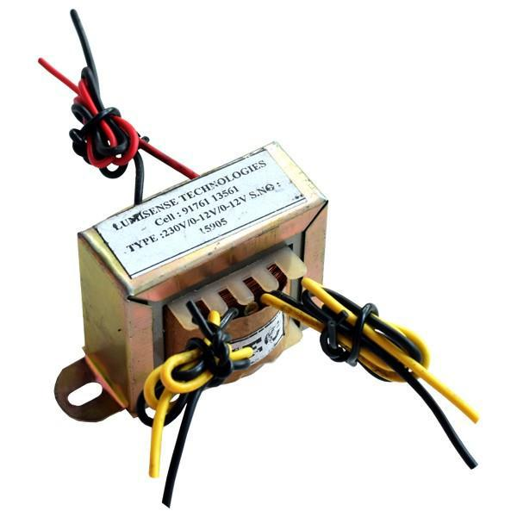

IV.PROPOSED WORK

The system is concerned about measuring power using Smart Meter(SM) and intimate users regarding their power consumption. The data is transmitted in a wireless network and stored in a centralized server. Intimation to the user also includes due date to pay the bill. The Smart Meter(SM) may collect several data from network sensors and smart home devices by measuring outages, voltage, phase, frequency data and detailed status and diagnostic data. Hence this smart meter is need to perform bidirectional communication between the control unit and the smart meter.

***A. Functionalities of smart meter network***

***Strength:***development in power quality and best customer service, and decreasing the time and count of power outages.

***Safety:***To enlarge the resilience against attack and real occurrences.

***Low-Cost*:** Offering chances and possibilities for customers to save the energy bills.

***Cost-effective:***Saving energy by consumers, reduction in system loses and providing less maintenance and capital expenditures.

***Surroundings Responsibility:*** Enabling renewable energies.

***B. Parts of Smart Meter Network***

* Smart meter network enables real time communication and two-way communication to pass the information.
* Smart measurement devices will record and communicate more detailed information about energy usage.
* Sensors, monitoring systems keep on checking the flow of energy in the system and the performance of the network assets.
* Automatic control that detect and repair network problems and provide self-hearing solutions.
* Advance switches and cables that improve network performance.

***C. Proposed System Architecture***

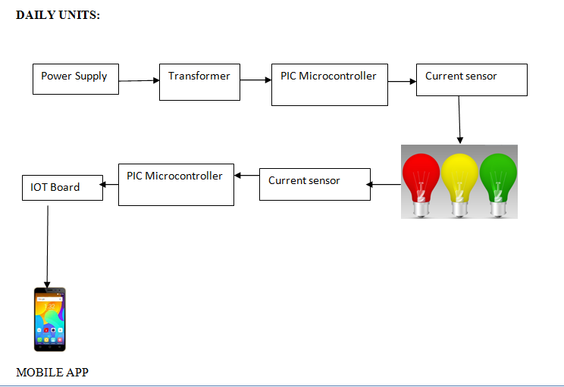

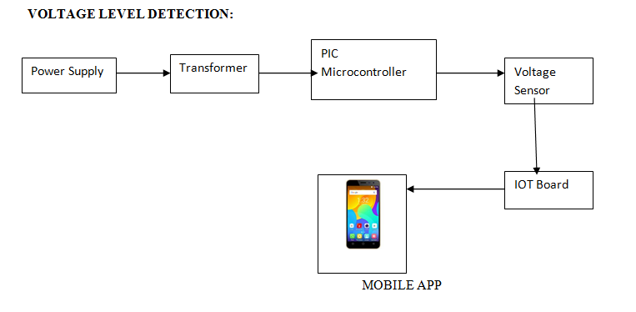

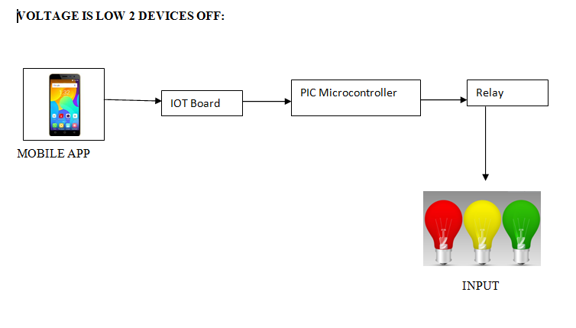

Fig 1.Proposed System Architecture

***Architecture Diagram Description:***

***Registration and login***

This module is that which allows the user to register themselves with an account so that they get optimal use of the mobile application. The registration module includes getting all account related information which is used to store their data and utilize it whenever necessary. First the user is prompted to enter the information such as first name, last name, consumer number and password. The user has to enter the password again in order to confirm the password. The user is then prompted to enter some additional details such as address, mail id and contact number. Once the user is done with the registration process they must click on the REGISTER button. Now in order to login to their account they must enter their consumer number and password which they chose during the registration process. Therefore the login activity is triggered and the authentication is determined which if true moves on to the main activity else the user is prompted to enter the login details correctly.

***Daily meter readings***

After logging into the system the user is navigated to the next page where the user can monitor the units consumed each day, the units consumed in a week as well as the units consumed each month which helps the user to use electricity in a more efficient manner.

***Voltage fluctuation***

Nowadays voltage fluctuation occurs frequently which is not intimated to the user. When the voltage goes low all the home appliances in order to work efficiently start to consume more power which results in a higher electricity bill but the user is not aware of this situation.

Hence the major module of the project is detecting the voltage level and when the voltage goes low the user is intimated so that they can switch off the devices which they do not require thus reducing the current consumed.

Whenever the voltage level goes below 190V intimation is sent to the user through the mobile application as well as a SMS is sent to the registered mobile number.

Whenever the user receives a low voltage message the user is requested to select 2 devices in the application, this data is then transmitted to the iot board through the serial port which in turn is received by the PIC Microcontroller, it sends signals to the relay as to which device has to be switched off, thus the relay automatically switches off the selected device.

***Online payment***

Waiting in queues for payment is a tough task in this fast paced environment. Therefore we have implemented a secure payment portal by which once when the user receives a bill for his two month payment he can make the payment. The user is prompted to enter the banking detail which is then validated over the network and if the authentication is right then it proceeds to the payment. The user can click on the PROCEED TO PAYMENT button to make the payment.

V.RESULTS

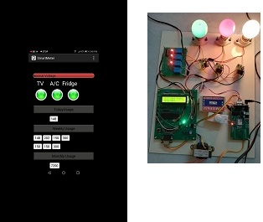

Fig 2 Kit and app when all the input is switched on

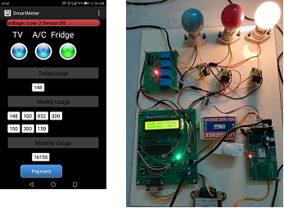

Fig 3 Kit and app when all two devices is switched off

V. CONCLUSION

This paper deals with the designing of the sensing circuits for Smart Meter(SM) system. The main objective of the project is to measure the electricity consumed daily and monthly and use them in an efficient manner without wasting the energy. Also the due date of the electricity bill will automatically generate the message to the owner. By using this Smart Meter(SM) system the wastage of power consumption is reduced and consumer can also monitor the electricity power consumption.

REFERENCES

[1] Ashraf Khalil, Zakariya Rajab,”**Load Frequency Control system with Smart Meter and Controllable Loads**”, The 8th International Renewable Energy Congress (IREC 2017)

[2] Babak Karimi, Vinod Namboodiri, and Murtuza Jadliwala, “**Scalable Meter Data Collection in Smart Grids Through Message Concatenation**”, IEEE TRANSACTIONS ON SMART GRID, VOL. 6, NO. 4, JULY 2015

[3] Damminda Alahakoon, Member, IEEE, and Xinghuo Yu,Fellow ,”**Smart Electricity Meter Data Intelligence for Future Energy Systems: A Survey**”, IEEE Transaction on Industrial Informatics, Vol.12,NO. 1,February 2016.

[4]Giulio Giaconi, Student Member, IEEE, Deniz Gund ̈ uz, ̈ Senior Member, IEEE, and H. Vincent Poor, Fellow, IEEE, **“Smart Meter Privacy with Renewable Energy and an Energy Storage Device”** , Citation information: DOI 10.1109/TIFS.2017.2744601, IEEE 2017

[5]Jayant.P.Pawar, Amirthaganesh.S, ArunKumar.S, Satiesh Kumar.B,

”**REAL TIME ENERGY MEASUREMENT USING SMART METER**”, Online Conference on Green Engineering and Technologies (IC-GET),2016

[6]Negrea Liviu Andrei,Vladimir Tanasiev, Mihai Sanduleac,”**Smart metering platform as a solution for data analysis**”,PNII carried out by MEN-UEFISCDI ,2014

[7] Savita Pawar, Dr. B. F. Momin, “**Smart Electricity Meter Data Analytics: A Brief Review**”, IEEE 2016

[8] Wen-Shyong Yu, Member, IEEE, and Yi-Jie Fang,” **Data Analysis of the Smart Meters and Its Applications in Tatung University**”, 2017

[9] Xing Tong, Chongqing Kang, and Qing Xia ,”**Smart Metering Load Data Compression Based on Load Feature Identification**”, IEEE TRANSACTIONS ON SMART GRID, VOL. 6, NO. 4, JULY 2015

[10] Yasin KABALCI1,Ersan KABALCI2,”**A Low Cost Smart Metering System Design for Smart Grid Applications**”, ECAI 2016 - International Conference – 8th Edition Electronics, Computers and Artificial Intelligence

30 June -02 July, 2016, Ploiesti, ROMÂNIA