# Export schema

Click on the View menu and DBA option.

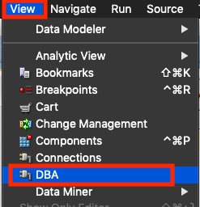

On DBA window Click on + icon

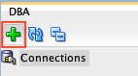

Select the appropriate Connection name and click on OK to connect the database for administrative purposes.

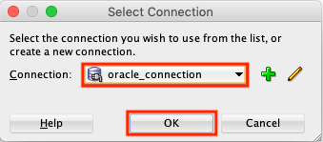

Click on + icon left of the Database icon to expand the menu list under database connection.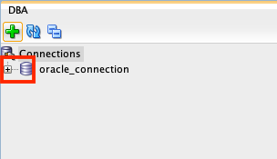

Expand Data Pump and right click on Export Jobs option.

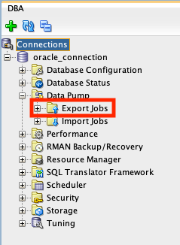

Once you right click on Export Jobs click on Data Pump Export Wizard.

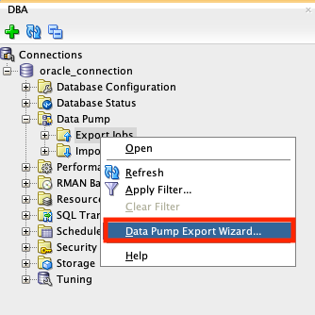

Select Schemas option and click on Next.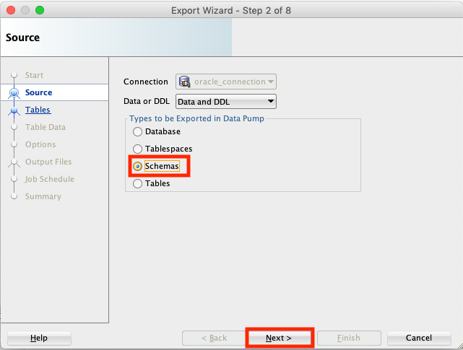

On Schemas list Click on appropriate schema and click on > sign.

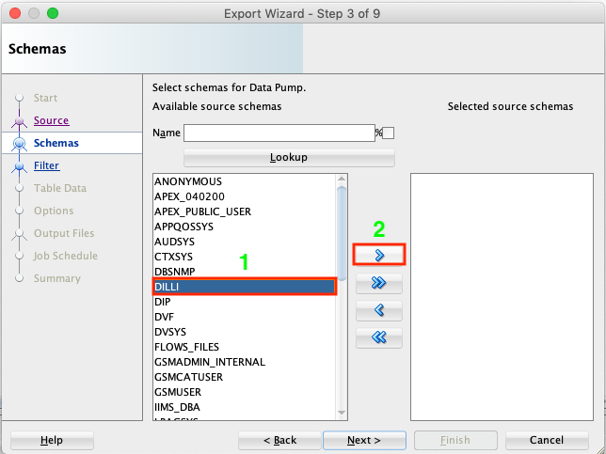

Click on Next to continue.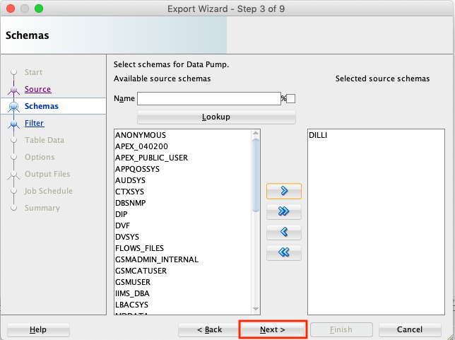

Click on Next.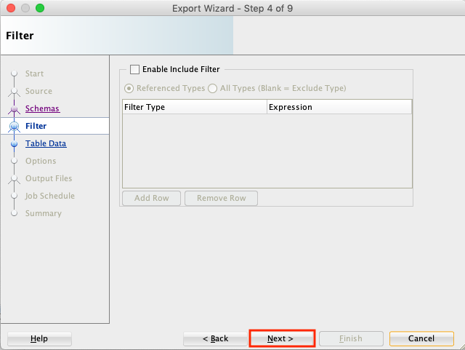

Click on Next once again.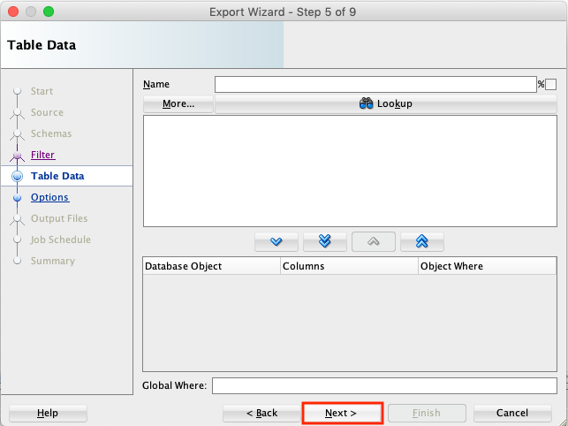

Click on DATA_PUMP_DIR and select DIR_IIMS.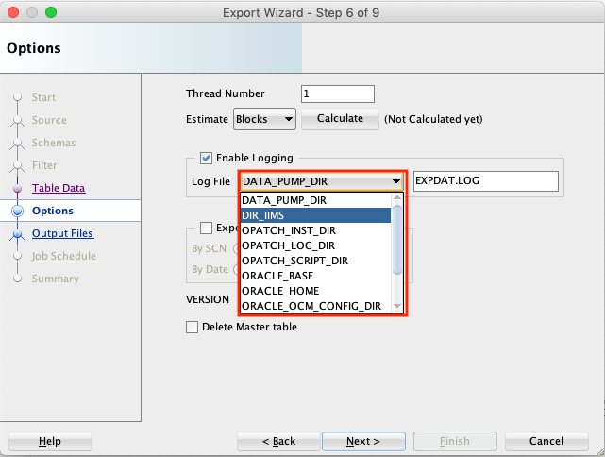

Click on EXPDATA.LOG and change name to appropriate log file name.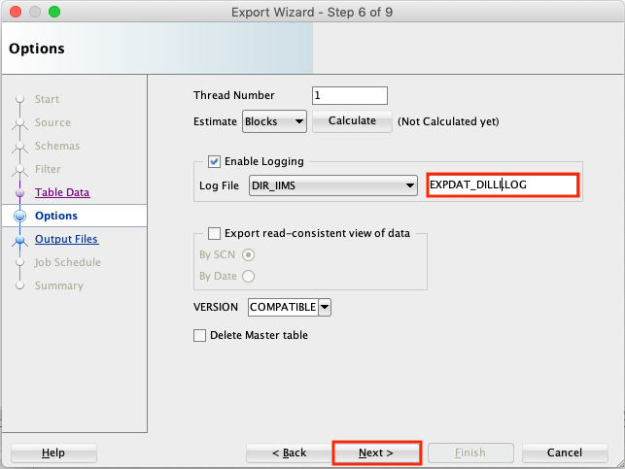

Click on No if you are prompt for Advanced Compression License requirement.

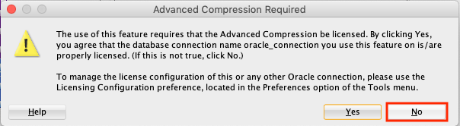

Click on DATA_PUMP_DIR and select appropriate directory. In our case DIR_IIMS is our destined Oracle directory to stop dumps

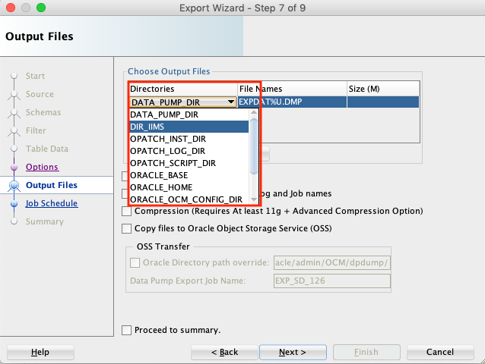

Modify the file name, Unselect all the options and click on Next to continue.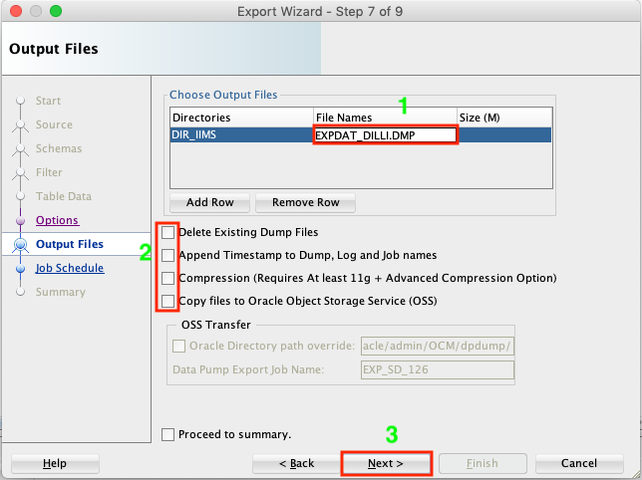

Click on Next to continue.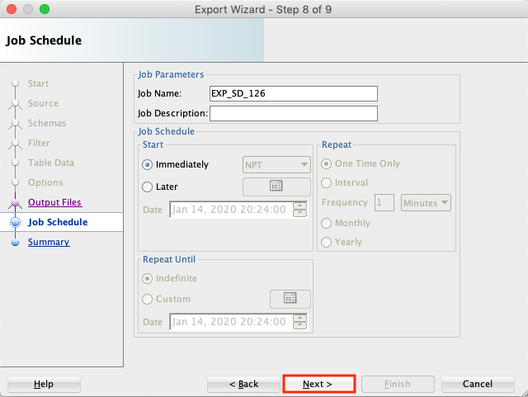

Finally click on Finish to export schema.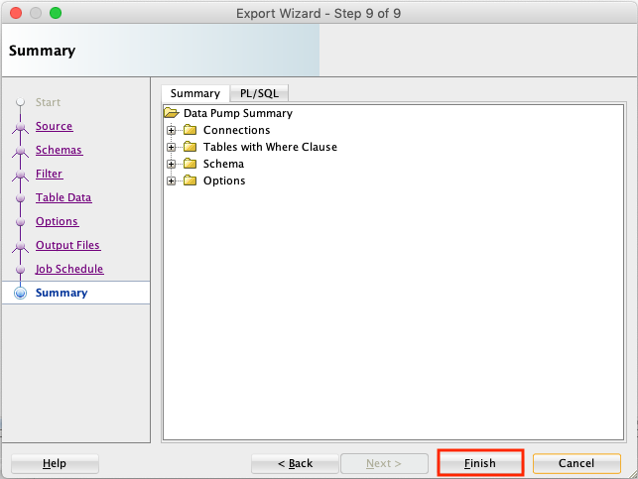

Once export is completed you will notice the following message on the output window.

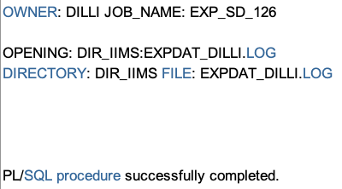

# Import schema

Right Click on Import Jobs and click on Data Pump Import Wizard.

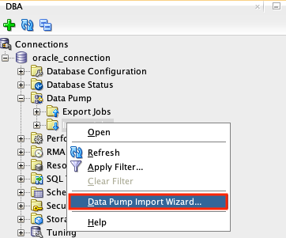

Select Schema option and click on Directory and select appropriate directory object.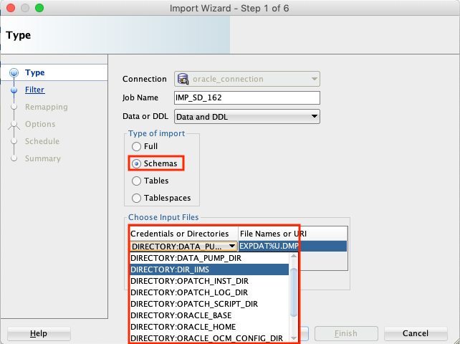

Once directory object is selected type appropriate dump file name and click on Next.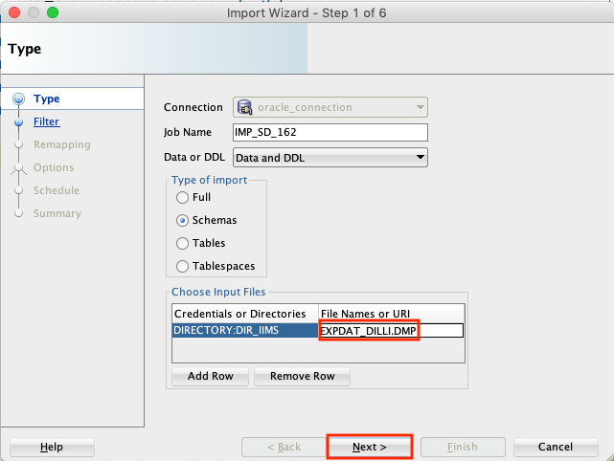

Select your schema name and click on > sign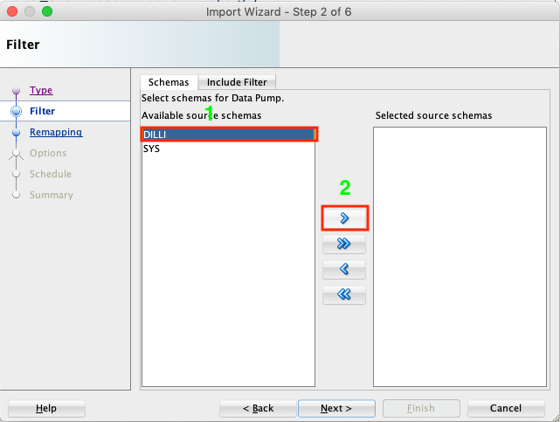

Once you get the name of schema in the right pan click on Next to continue.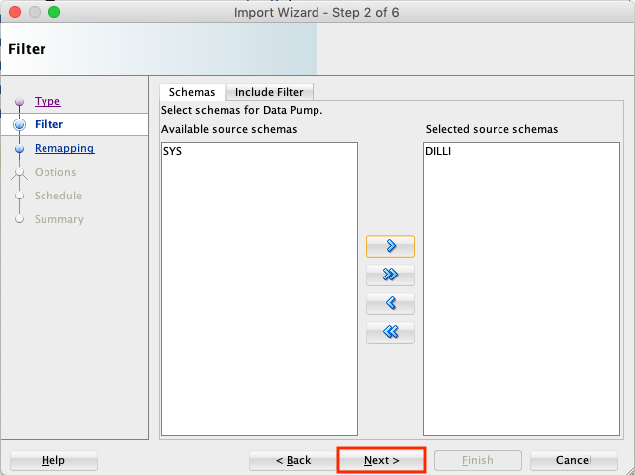

Click on Next to continue.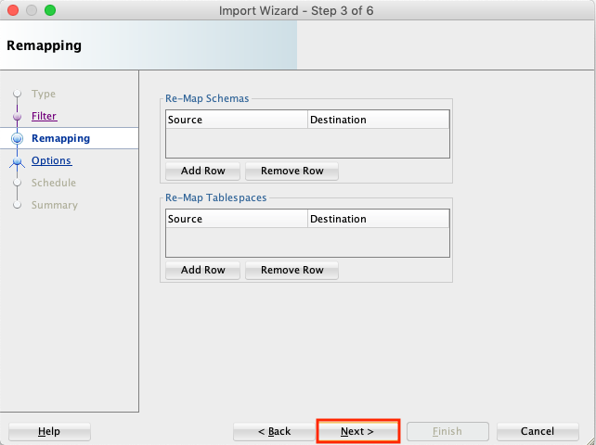

Select appropriate directory name for log file. In my case I have DIR_IIMS as appropriate directory.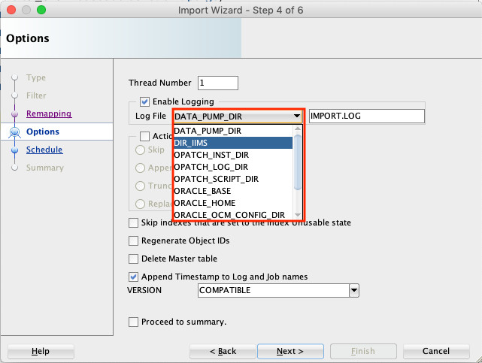

Select appropriate logfile name in my case IMPORT_DILLI.LOG is appropriate logfile name.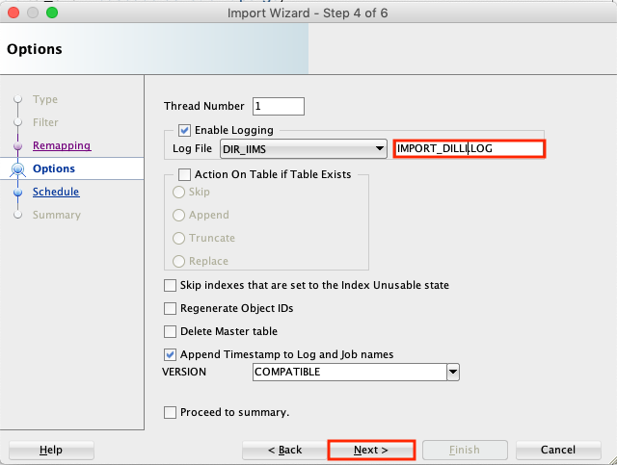

Click on Next to continue.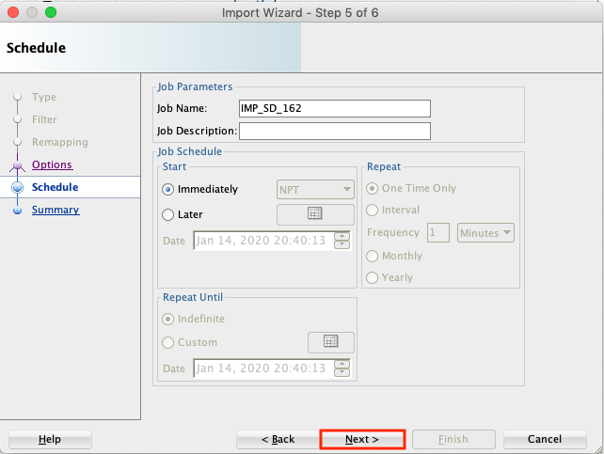

Click on Finish to complete import job.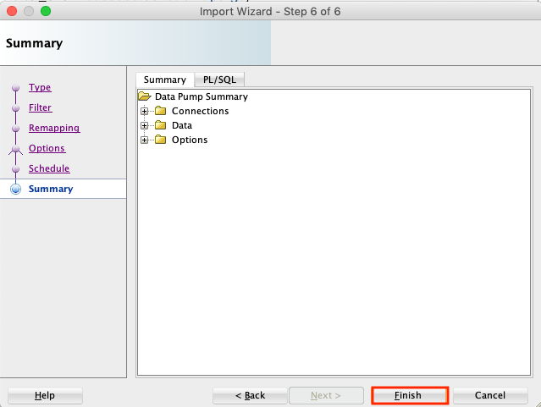

Once import job is completed you will notice Output as below.

