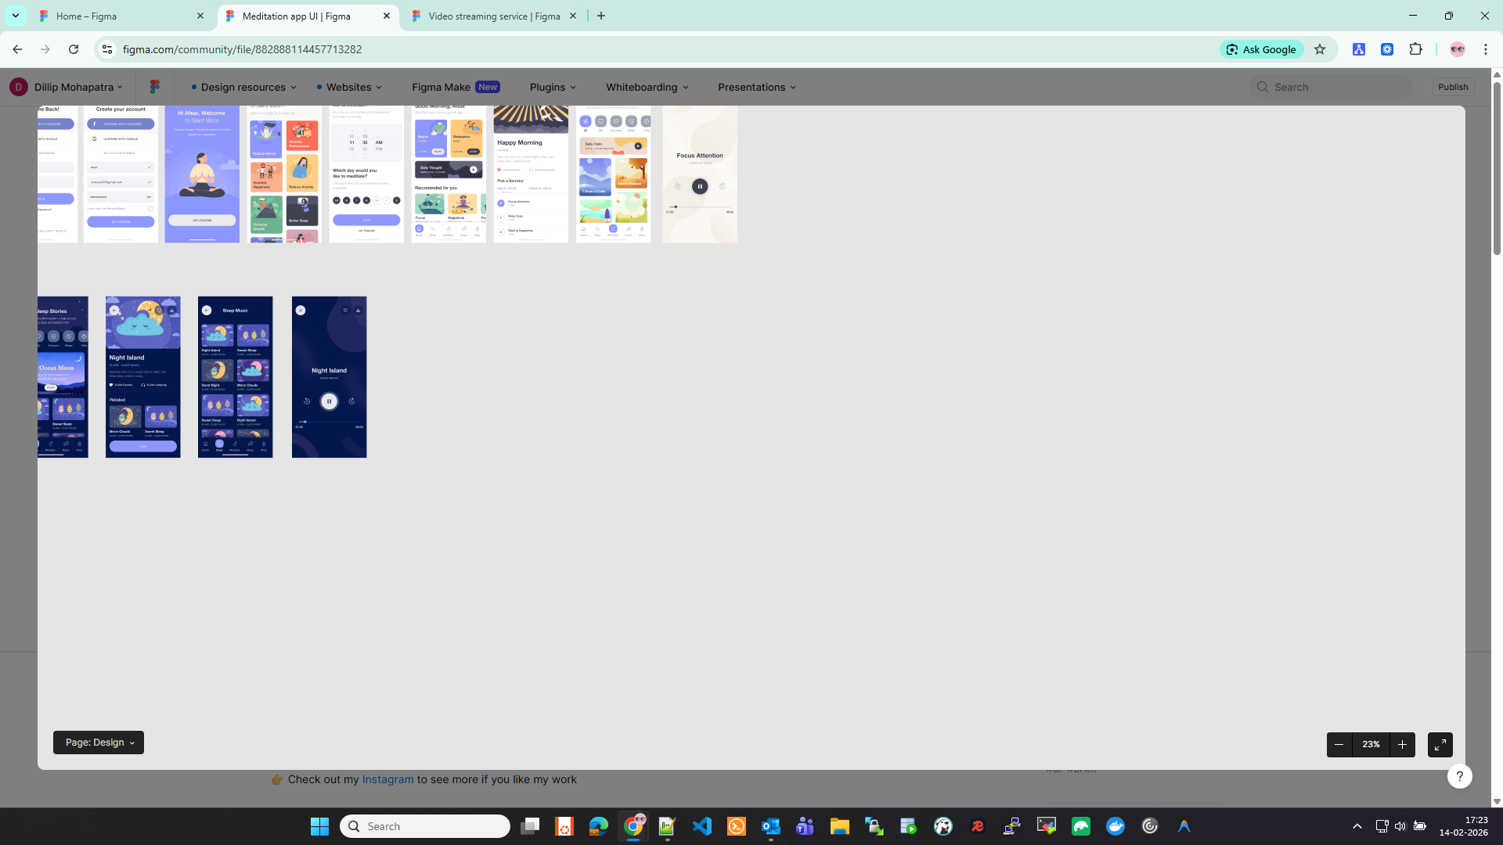

<iframe style="border: 1px solid rgba(0, 0, 0, 0.1);" width="800" height="450" src="https://embed.figma.com/design/jjhsRAjOGfCl4v0TLmdSWc/Religious-Landing--Community-?node-id=32-2&embed-host=share" allowfullscreen></iframe>

