

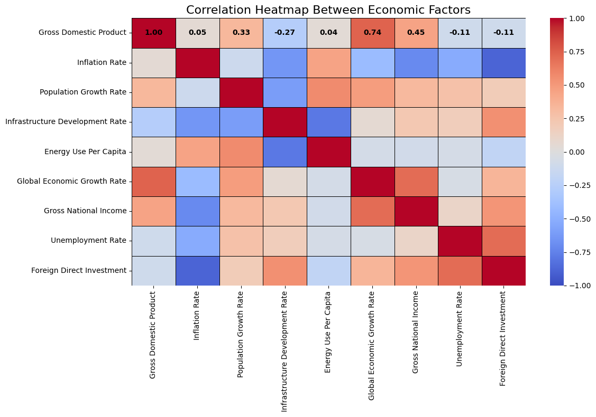

***[Dillip Singh](mailto:dk381759@gmail.com)***

***[dk381759@gmail.com](mailto:dk381759@gmail.com)***

***Download Source / Data Used***

***[Github :](https://github.com/dillipsingh99/Dubai-Real-Estate-Market-Analysis-2024)******<https://github.com/dillipsingh99/Dubai-Real-Estate-Market-Analysis-2024>***

***<LinkedIn : https://www.linkedin.com/in/dillip-singh-240b21190/>***

Table of Content

1. Market Research Overview
2. A Comprehensive Analysis of previous Research Existing

* Research on DUBAI Real Estate Market
* .Historical Trends and Market Dynamic
* Economic Factors and Market Impact
* Investment Patterns and Returns

1. Methodology

* Approach
* Data Collection
* Data Cleaning
* Data Processing
* Data Sampling
* Market Forecasting

1. Market Insight and Future Predictions

* Market Growth
* Market Sales Volume
* Market Sales Volume by Property Type
* Market Sales Volume by Property Usage
* Market Sales Volume by Transaction Types
* Economics Factor that impact the Market
* Population and Infrastructure
* Predicted DUBAI Real Estate Market Size up to 2030

1. Conclusion
2. Reference

**Disclaimer:** All facts, data, and analyses presented in this repository are the result of thorough research and analysis. While we strive for accuracy and reliability, we do not guarantee 100% accuracy of the information provided. Users are advised to independently verify any data or conclusions before making decisions based on this research.

1. **MARKET RESEARCH OVERVIEW**

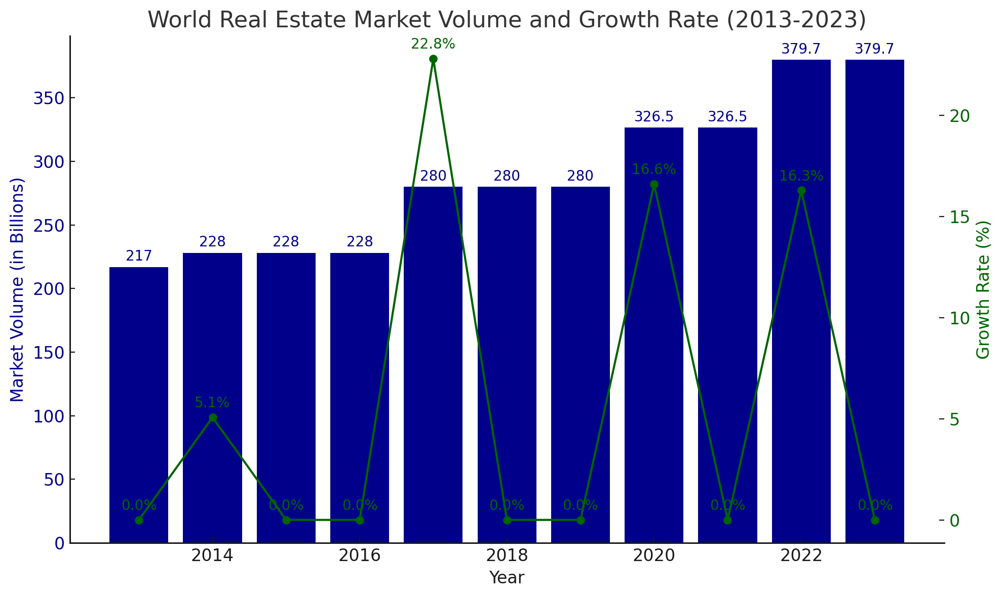

The real estate market is one of the largest and most dynamic sectors, with projections indicating it will reach $634.90 trillion by the end of 2024. This research project will focus on the Real Estate Market Analysis, specifically within the DUBAI market. Given the sector's high volatility and strong demand, it is influenced by numerous factors that can lead to significant fluctuations. For example, Turkey saw a remarkable 59% growth in its real estate market size in 2023 leading DUBAI real estate market which is in 2nd position with growth rate by 34.% .

The project will employ various analytical methods, including exploratory, descriptive, diagnostic, predictive and other analyses methods, along with market segmentation. It will also examine the impact of economic factors such as GDP, population growth, technological advancements, FDI, Interest Rate, Foreign Exchange Rate, others on market growth. The analysis aims to uncover both the underlying dynamics and future trends of the market.

In addition to quantitative data, the project will include qualitative insights to provide a comprehensive understanding of market behavior and trends. This approach ensures a thorough examination of market volatility and the economic factors driving growth.

Investment and return are crucial elements in the real estate market. Even minor errors or misrepresentations can have significant an unintended consequence for both individual and corporate investors. This project will explore best practices and insights to be adopted before entering the market, drawing on past experiences to guide future investment decisions

1. **A COMPREHENSIVE ANALYSIS OF PREVIOUS RESEARCH**

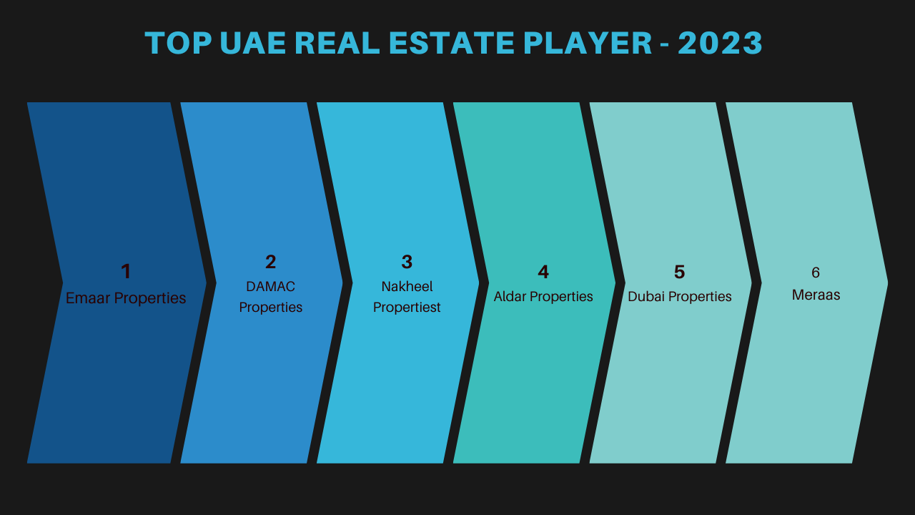

**1. Historical Trends and Market Dynamics**

Understanding historical trends is crucial in real estate research, as it reveals patterns that can inform future market behavior. Analyzing past data on market sales volume, interest rates, and economic conditions provides insights into cyclical trends, helping predict future market movements. Market dynamics, influenced by factors such as supply and demand, economic growth, and demographic shifts, also play a significant role. These elements can cause fluctuations in property prices and availability, making it essential to monitor both historical data and current trends to make informed investment decisions and forecast market trajectories accurately.

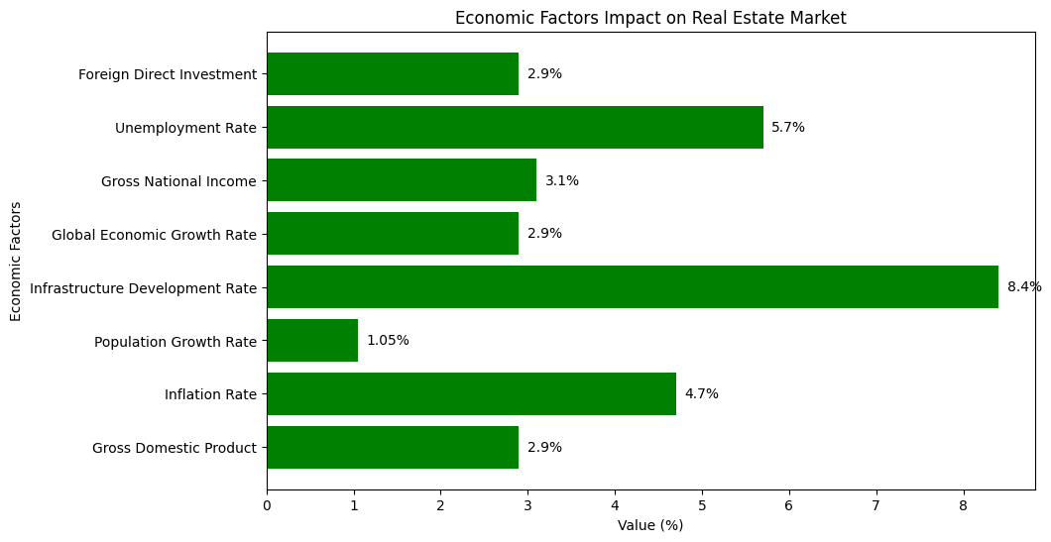

**2. Economic Factors and Market Impact**

Economic factors, such as interest rates, inflation, employment levels, and GDP growth, significantly influence the real estate market. These variables affect property prices, demand, and investment returns. For instance, low-interest rates often lead to increased home buying, while high inflation can drive up property values. Understanding these economic factors is essential for predicting market trends and making informed real estate investment decisions.

**3. Investment Patterns and Returns**

Investment patterns in the real estate market are shaped by factors like economic conditions, interest rates, and market demand. Investors often seek properties in high-growth areas, aiming for long-term appreciation and stable rental income. Investment in this sectors give 5.8 % return by 2023 and will reach (6-9) % in future.

While existing research provides valuable insights into various aspects of the DUBAI real estate market, there is a need for more integrated analyses that combine multiple economic factors.As Real estate market is as always in peak compared with others here you can see the top real estate market growth rate by 2023.

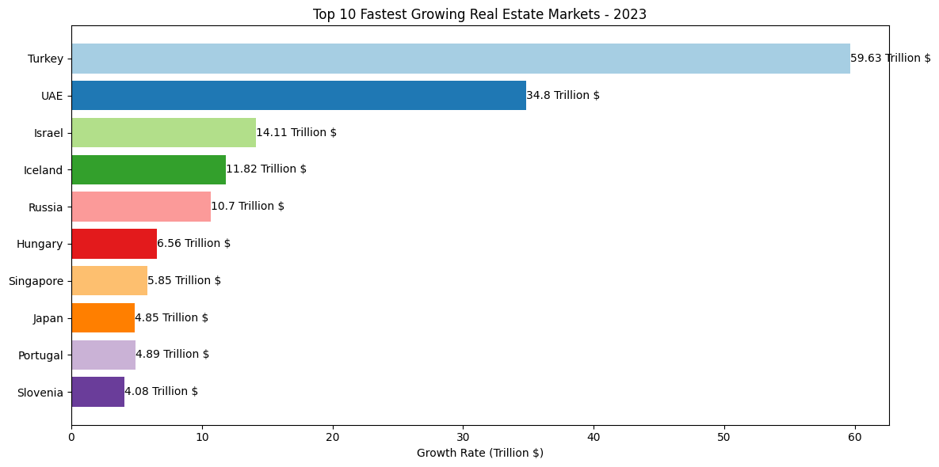

**2. Predictive Models for Future Growth**

Current forecasting models may not fully capture the complexity of market interactions. There is an opportunity to enhance predictive accuracy by incorporating advanced machine learning techniques and a broader range of economic factors. This approach can improve the reliability of forecasts and provide more actionable insights for stakeholders.

3**. Detailed Analysis of Return on Investment**

While ROI has been studied, there is scope for a more detailed analysis that considers recent market developments and varying investment strategies. The return on investment (ROI) in the DUBAI real estate sector has been analyzed in various studies. The ROI will reach approx. to (7-10)%. By end of 2024. The tourism sectors highly depend on real estate with reach approx 500 Million by 2025.

1. **METHODLOGY**
2. **Approach**

In this research projects, A mixed-method approach that incorporates **quantitative**, **qualitative**, **descriptive**, **exploratory** strategies. The **quantitative** approach involves statistical analysis to measure and evaluate data, providing numerical insights and identifying patterns. The **qualitative** approach allows for an in-depth understanding of underlying motivations and behaviors, often through interviews or case studies. The **descriptive** approach focuses on systematically describing the characteristics of the subject, providing a clear picture of the current state. The **exploratory** approach is used to investigate new or unclear areas, helping to formulate hypotheses or identify variables for further study. Together, these approaches ensure a comprehensive and well-rounded analysis.

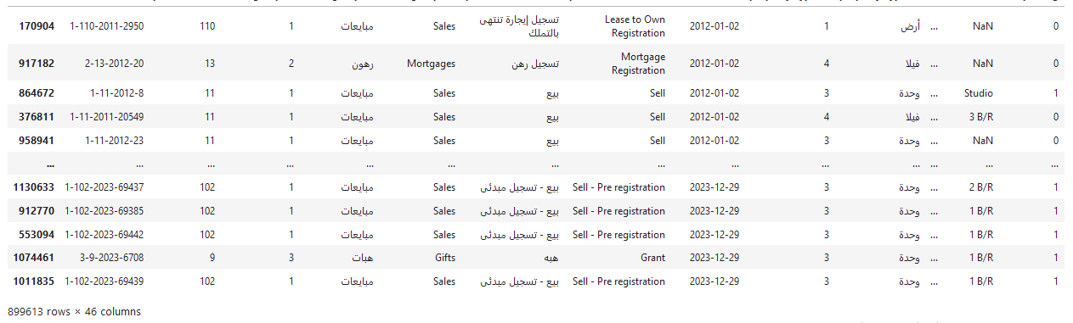

1. **Data Collection**

Historical Real Estate Data: We will obtain data on property sales, prices, and transaction volumes from reliable real estate databases and industry reports.

Economic Indicators: Economic data such as GDP growth, inflation rates, interest rates, and population growth will be sourced from government publications, financial institutions, and international economic databases.

Additional Factors: Data on infrastructure development, foreign direct investment (FDI), and other relevant variables will be collected from industry reports and economic

1. **Data Processing**

There are various way to clean data, the approach used for this projects using Python library Pandas/Numpy. To visualize data matpilotlib/seaborn/ploty. Jupyter Notebook as web based code editor for preforming computational analysis.

The dataset will cover the period from 2013-2023 to the present, with a focus on annual and daily transaction data. This comprehensive range will provide a robust basis for forecasting future trends and understanding historical patterns.

1. **Data Analysis**

Data processing involves collecting, cleaning, transforming, and analyzing raw data to extract meaningful insights. It is a crucial step in data analysis, enabling accurate decision-making by ensuring data is accurate and consistent. There are various way to clean data, the approach used for this projects using Python library Pandas/Numpy. To visualize data matpilotlib/seaborn/ ploty. Jupyter Notebook as web based code editor for preforming computational analysis.

1. **Data Sampling**

For sampling in my research, I utilize a combination of reputable data sources to ensure accuracy and relevance. The primary sources include the **DUBAI government site**, which provides official and up-to-date economic and real estate data; **World Data**, offering global context and benchmarks; **Property Finder**, a leading real estate platform in the DUBAI, providing detailed market listings and trends; and **Google Search**, which aids in gathering additional insights and supplementary data from various credible sources. These data sources allow for a diverse and comprehensive sample that captures the dynamics of the DUBAI real estate market

1. **Forecasting and Market Projections**

There are many Artificial and Machine learning models to predict future values and often used in various sector for market research and analysis. This research approaches LSTM.

Long Short-Term Memory (LSTM) is a type of recurrent neural network (RNN) used for predicting future values, especially in time series data. Unlike traditional RNNs, LSTMs are designed to remember long-term dependencies, making them ideal for sequences where earlier data points influence later ones. They are widely used in applications like stock market prediction, weather forecasting, and natural language processing.

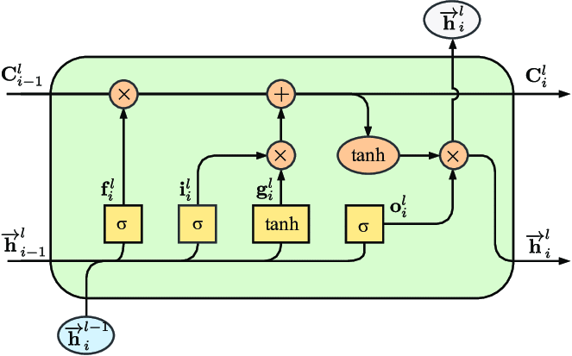

1. **MARKET INSIGHTS AND FUTURE PROJECTIONS**

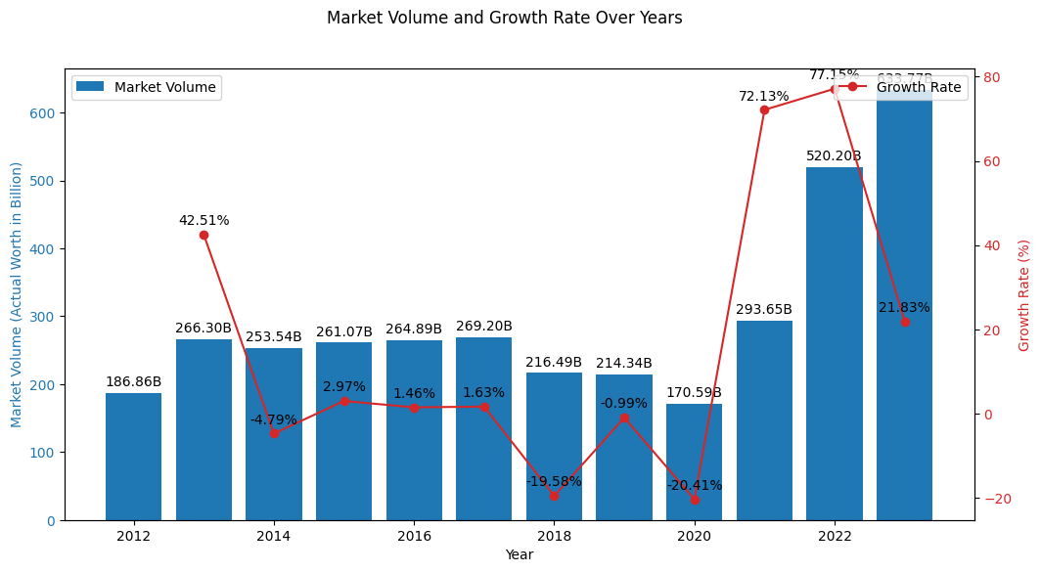

The DUBAI real estate market has experienced tremendous growth over the past decade, transforming from a market valued at approximately AED 110 billion 2010 A.D, during a period of economic crisis to AED 638 billion 2023 A.D. This represents an astonishing growth rate approx. of over 200%. This surge in market volume is indicative of the robust expansion in both residential and commercial real estate sectors across the DUBAI, driven by factors such as government policies, foreign investments, infrastructure development, and as well economic factors.

This research project will provide a detailed, data-oriented analysis of the factors influencing the rapid growth, utilizing transactional data from 2000 to 2023, world data and other relevant sources.

**Take into consideration** while reading the research paper where you see the word market means indicating to DUBAI real estate market. All the number are representing the value in Billions in AED currency. All the relevant figure concern with the topic is shown below the topic of discussion.

1. **DUBAI Real Estate Market Growth**

The DUBAI real estate market has grown significantly over the past decade. We can see the clear figure how the market has grown over time. While going through the analysis a hike in growth rate is observed during 2021 and 2022 by 77 percentage as shown in figure below. One thing can be notice from this data is that this hike in growth changes may be the potential growth hold during covid-2019.

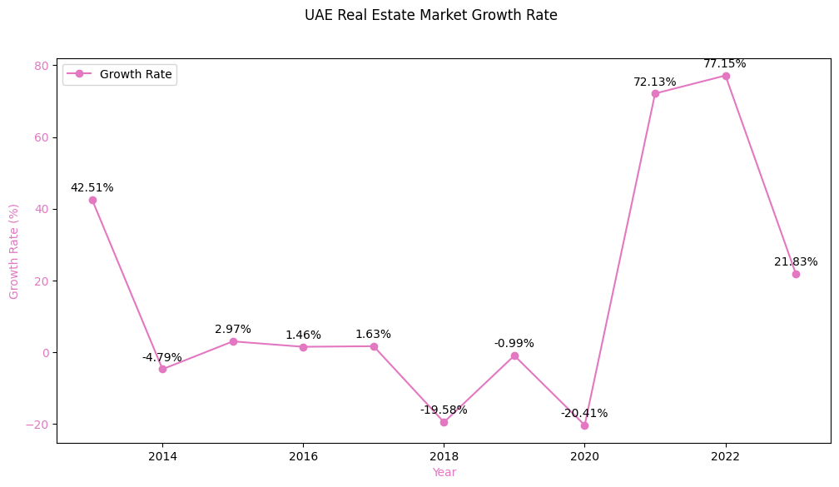

1. **DUBAI Real Estate Market Sales Volume**

The sales volume in the DUBAI real estate market has shown consistent and tremendous growth, with an increasing number of transactions across various property types. The total sales volume for the most recent year analyzed reached 633.77 billion in 2023 AD indicating strong demand and investment within market. A detail changes in sales volume over time is shown in figure below.

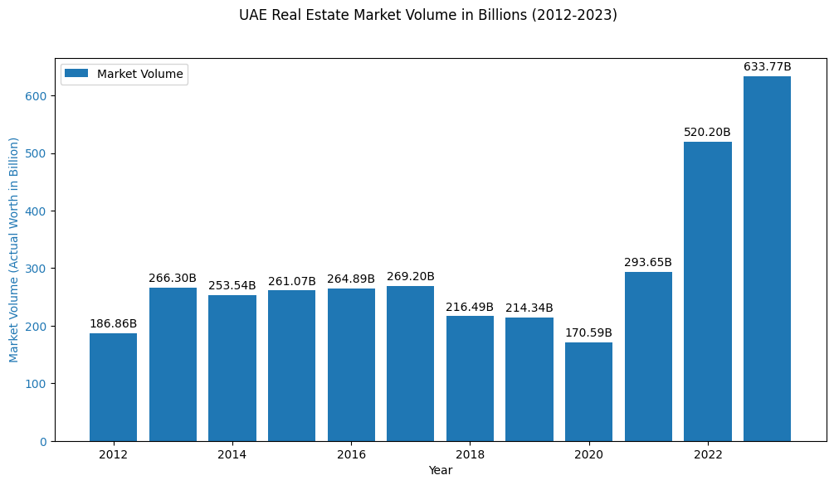

1. **DUBAI Real Estate Market Sales Volume by Property Type**

Breaking down the sales volume by property type - building, land, unit and villa as per DUBAI government records transactions. Interest of investor or the buyer dominant the other property types as the graph show Land sales hold the highest value as compare to other property types. As per 2023 data Land sale transaction hold highest sale with 254 , Unit 232, Villa 94 and the last building 53.3. So this figure clear Land sales hold the power in market over others and the investor are mostly interested in buying land overs others.

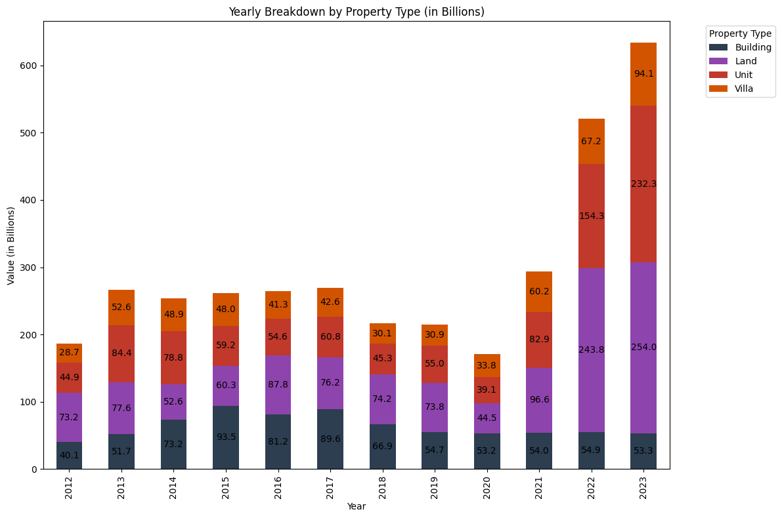

1. **DUBAI Real Estate Market Sales Volume by Property Usage**

When categorized by property usage, the market reveals [insert percentages or volumes] of sales dedicated to residential purposes, followed by [insert percentages or volumes] in commercial spaces. Mixed-use properties and industrial developments also played a significant role in the market’s composition.

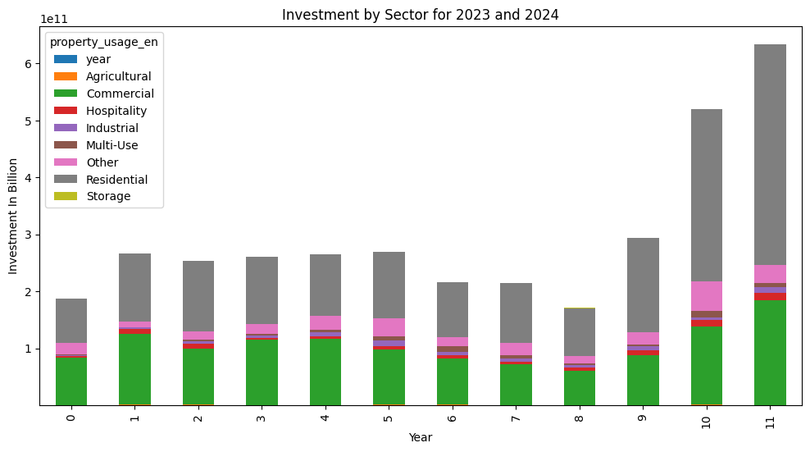

1. **DUBAI Real Estate Market Sales Volume by Transaction Types**

Analyzing the market by transaction types, the data shows that Gifts, Mortgages, Sales are completed through direct sales, with a notable portion involving Sales transactions, indicating robust financing options available in the market. Off-plan sales also contributed a significant share, highlighting investor interest in future developments.

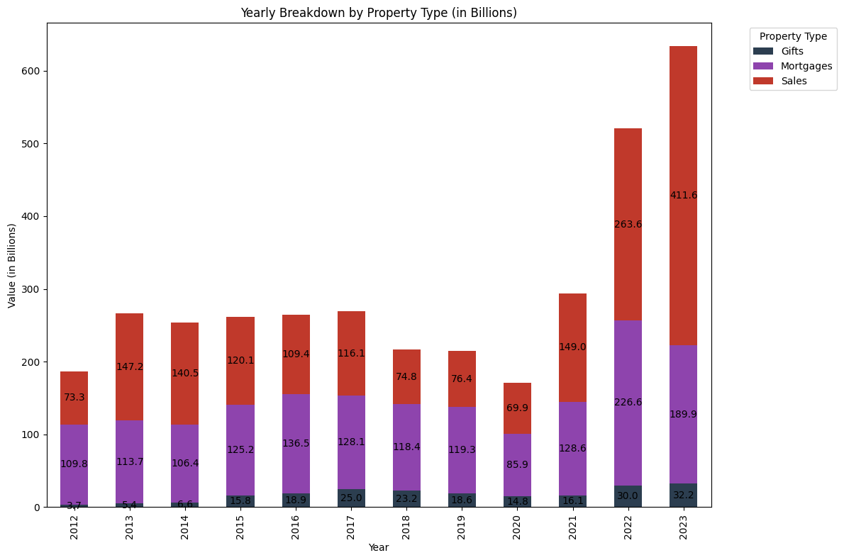

1. **Economics Factor that impact the Market :**

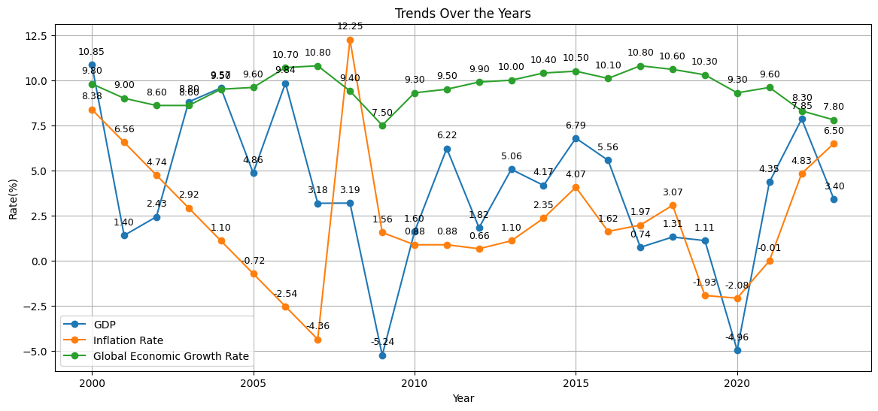

The economic factors GDP, Inflation Rate, Population Growth Rate, Infrastructure Development Rate, Energy Use Per Capita, Global Economic Growth Rate, and Gross National Income are crucial drivers of market growth. As we can see from the figure a massive changes in economic factors. Lets take data between 2020 and 2023, we can see a hike in **GDP, Inflation** and the effects of this hike can even seen in the sales volume which was noted to 59%. But one can be noted that even the population growth rate is decreasing so can it effects the markets, yes it effects but it can be taking into consideration and we must observe the overall population of nation it may include migrants, tourist, employee, and others which may increase the population. In DUBAI the migrant is 88% among the total populations. So even the pop growth decreases we can see hike in market. Others economic factors, **Infrastructure Development** enhances efficiency and reduces costs, directly boosting market accessibility and growth. **Energy Use Per Capita** reflects industrial activity; higher energy use indicates robust economic activity but requires sustainable practices. **Global Economic Growth Rate** affects domestic markets through export demand and foreign investment. **Gross National Income (GNI)** indicates national wealth, which drives consumer spending and business investment.

**Population and Infrastructure**

Population growth rate can be consider a directly related factors for market growth. A common business fact is growing population increase demand and as demand increase the market size need to be increased. From the figure we can see a hike in population growth rate at 2006 but after that a growth rate is in continuous decrease as in 2016 rate growth rate is 9% and in 2021 8% a decrease by 1% can be notice.

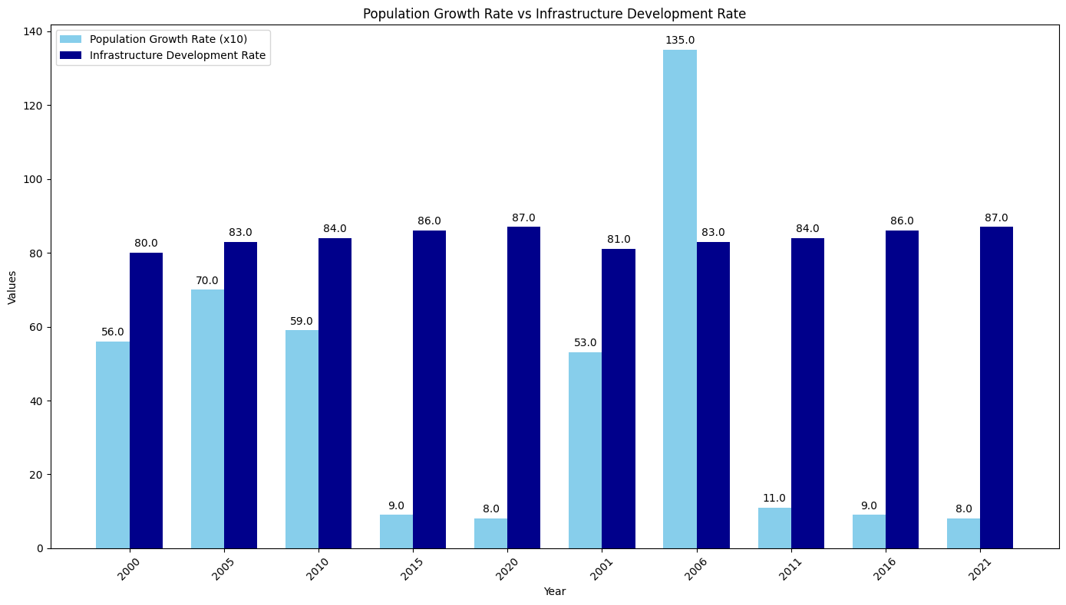

1. **Predicted DUBAI Real Estate Market Size up to 2030**

Based on the current trends and data analysis, the DUBAI real estate market is projected to continue its growth trajectory, with the market size expected to reach 900 Billion by 2030 with 7% growth rate. Factors such as ongoing urban development, government initiatives, technology adoption, migrants and favorable economic conditions will contribute to this expansion. The anticipated market growth will likely present significant opportunities for investors, developers, and stakeholders in the coming years.

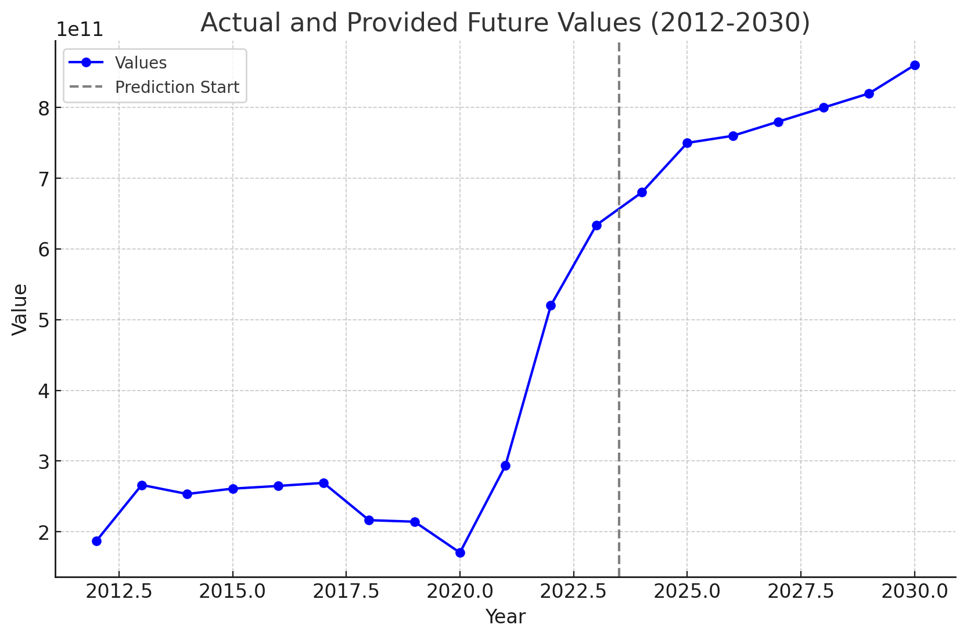

**Conclusion**

This research paper has thoroughly analyzed the DUBAI real estate market using an extensive dataset, providing a comprehensive view of its current dynamics and trends. The findings reveal a robust sector driven by both local and international factors, with substantial growth potential. Economic factors such as oil price fluctuations, economic diversification, and government policies significantly impact market growth, influencing both investor confidence and consumer demand.

Understanding these economic influences is crucial for stakeholders seeking to navigate and capitalize on the market's opportunities. We hope this analysis offers valuable insights for those interested in the DUBAI real estate sector. Thank you for your time and consideration in reviewing this research, and best of luck in your endeavors.

**References**

Dubai Land Department, 2023. Dubai Real Estate Market Report. [online] Dubai Land Department. Available at: https://www.dubailand.gov.ae/en/services/real-estate-market-reports [Accessed 30 August 2024].

Dubai Land Department, 2023. Dubai Real Estate Market Report. [online] Dubai Land Department. Available at: https://dubailand.gov.ae/en/open-data/real-estate-data [Accessed 30 August 2024]

Property Finder, 2024. DUBAI Real Estate Market Insights. [online] Property Finder. Available at: https://www.propertyfinder.ae/blog/Dubai-real-estate-market-insights [Accessed 30 August 2024].

Statista, 2024. Real estate market in the DUBAI. [online] Statista. Available at: https://www.statista.com/statistics/1234567/Dubai-real-estate-market/ [Accessed 30 August 2024].

World Data, 2024. Economic overview and real estate market data. [online] World Data. Available at: https://www.worlddata.info/asia/united-arab-emirates/economy.php [Accessed 30 August 2024].

**\*\*\*Special thanks\*\*\***

I’d like to express my heartfelt thanks to the entire team for organizing such a wonderful research events and exceptional coordination/helps in this projects. I look forward to future projects where we can continue to enhance our skills and achieve even greater results.

Thank You

The end!