Data With Dillon

Quarterly review
What twelve months of orders say about repeat customers

1. Summary
Repeat customers drove most of the growth this year. New customer numbers held steady, while orders from returning buyers rose in every quarter.

Key numbers
The table below compares the first and last quarter of the year.
Measure | Q1 | Q4
Orders | 1,240 | 1,610
Repeat share | 38% | 47%
Average order | $84 | $91
Table 1. Orders by quarter

What changed
- Email reminders went out after 30 days.
- Shipping became free over $75.
- The returns window grew to 60 days.
- Keep the reminder emails.
- Test a lower free shipping line.
- Review the returns cost in Q2.
Repeat share rose nine points in a year. That is the single biggest change in the data.
"I came back because the second order was as easy as the first." - Customer survey, October

2. Orders by week
Weekly orders for the year. The header row repeats when the table crosses a page.
Week | Orders | Repeat share | Change
Week 1 | 269 | 36% | -3 pts
Week 2 | 308 | 36% | -1 pts
Week 3 | 257 | 36% | +1 pts
Week 4 | 296 | 36% | +3 pts
Week 5 | 245 | 37% | +5 pts
Week 6 | 284 | 37% | -4 pts
Week 7 | 323 | 37% | -2 pts
Week 8 | 272 | 37% | +0 pts
Week 9 | 311 | 37% | +2 pts
Week 10 | 260 | 38% | +4 pts
Week 11 | 299 | 38% | -5 pts
Week 12 | 338 | 38% | -3 pts
Week 13 | 287 | 38% | -1 pts
Week 14 | 326 | 38% | +1 pts
Week 15 | 275 | 39% | +3 pts
Week 16 | 314 | 39% | +5 pts
Week 17 | 353 | 39% | -4 pts
Week 18 | 302 | 39% | -2 pts
Week 19 | 341 | 39% | +0 pts
Week 20 | 290 | 40% | +2 pts
Week 21 | 329 | 40% | +4 pts
Week 22 | 278 | 40% | -5 pts
Week 23 | 317 | 40% | -3 pts
Week 24 | 356 | 40% | -1 pts
Week 25 | 305 | 41% | +1 pts
Week 26 | 344 | 41% | +3 pts
Week 27 | 293 | 41% | +5 pts
Week 28 | 332 | 41% | -4 pts
Week 29 | 371 | 41% | -2 pts
Week 30 | 320 | 42% | +0 pts
Week 31 | 359 | 42% | +2 pts
Week 32 | 308 | 42% | +4 pts
Week 33 | 347 | 42% | -5 pts
Week 34 | 386 | 42% | -3 pts
Week 35 | 335 | 43% | -1 pts
Week 36 | 374 | 43% | +1 pts
Week 37 | 323 | 43% | +3 pts
Week 38 | 362 | 43% | +5 pts
Week 39 | 311 | 43% | -4 pts
Week 40 | 350 | 44% | -2 pts
Week 41 | 389 | 44% | +0 pts
Week 42 | 338 | 44% | +2 pts
Week 43 | 377 | 44% | +4 pts
Week 44 | 326 | 44% | -5 pts
Week 45 | 365 | 45% | -3 pts
Week 46 | 404 | 45% | -1 pts
Week 47 | 353 | 45% | +1 pts
Week 48 | 392 | 45% | +3 pts
Week 49 | 341 | 45% | +5 pts
Week 50 | 380 | 46% | -4 pts
Week 51 | 419 | 46% | -2 pts
Week 52 | 368 | 46% | +0 pts
Table 2. Orders by week

3. Trend
Repeat orders overtook new orders in the second quarter and stayed ahead.
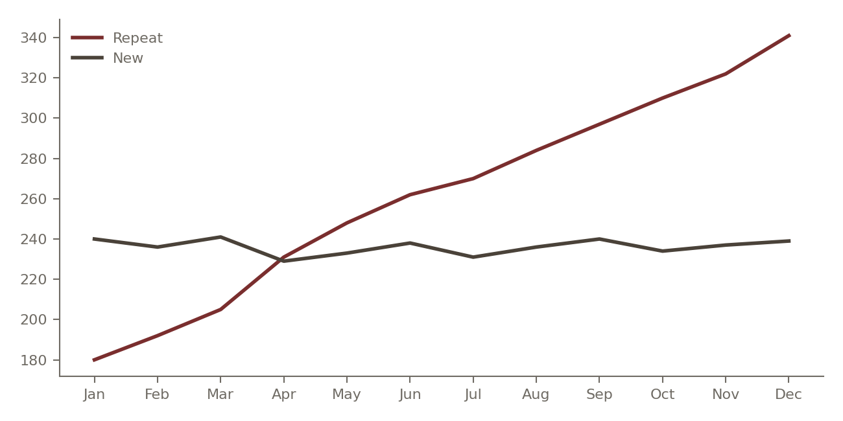
Figure 1. Orders by month

4. Next steps
The numbered list below restarts at 1.
- Share the review with the team.
- Agree the Q1 targets.
- Book the next review for March.

