Instrumentation of Distributed Control Loops
Andrew Boie, Dr. Douglas Niehaus
Information and Telecommunications Technology Center

1 Introduction

1.1 What is the Problem
Software involving control loops are an important class of applications which are sensitive to timing of their behavior. In many emerging control applications components of various control loops will be widely distributed. Delay constraints imposed by supporting computational and networking components are a crucial factor in correctness of distributed control.
Many components of the system software within these distributed systems can affect and constrain the overall performance of the control loop applications. Thus, determining which aspects of the the system software create such constraints, and why they are created is fundamental to effective and efficient design and implementation of such distributed control loop applications.

1.2 Our approach
We use Linux systems as a testbed because we have source access to all components of the system, can instrument it for performance evaluation, and modify it to determine the effects of specific changes to default system behavior parameters.
While Linux is a likely implementation platform for deployed control applications, nonetheless results of these experiments are strongly applicable to such applications implemented on proprietary platforms, as long as the behavioral semantics of the system components can be made to satisfy necessary constraints.
Specifically we use system software developed over many years at KU for these experiments, which include:
- KU System Programming (KUSP) modifications to the Linux Kernel including (1) Data Stream Kernel Interface (DSKI) and (2) the CLKSYNC modifications supporting high resolution clock synchronization across sets of machines
- The user-level performance evaluation support of the Data Streams User Interface (DSUI), which together with DSKI provides integrated and detailed performance evaluation data across both the user-OS and system-system boundaries.
- The NETSPEC tool which permits automated control of configuration, execution and instrumentation for arbitrary distributed applications such as the distributed control experiments which are the subject of this report.
- The KU Image Processing (KUIM) software that was used to implement the distributed video control loop experiment.
- NISTNet: software executing on an independent Linux router that introduces delays, packet drops or repetitions according to behavioral parameters specified as part of the experimental design. NISTNet thus simulates a range of realistic effects on network communications supporting the control loop experiments and thus affecting the behavior of the control loop applications.
The rest of the report discusses the Tools we used to implement the experiments in Section 2, the design of the experiments in Section 3, the results of the experiments and their implications in Section 4, while Conclusions and possible topics for future work is discussed in Section 5.

2 Experiment Component Software
The various software components are used to create executing application software that either implements a plausible control loop application directly, or strongly emulates the relevant computation and communication behaviors of such applications for performance evaluation purposes.
We first describe the Datastream components that support the collection and analysis of performance data. We then describe the CLKSYNC improvements to clock synchronization necessary for effective evaluation of the distributed control loop applications. We then briefly describe (1) NETSPEC application helping automate the configuration, execution and instrumentation of the distributed application experiments, (2) the KUIM Image processing library used in the distributed video control loop experiment, and (3) the NISTNet router used to simulate a variety of realistic network conditions.

2.1 Datastreams
Datastreams is a Linux kernel patch, user-level library, and related tools for collecting and analyzing performance data. Developers place instrumentation point macros within the kernel or user-level applications, and during execution a binary file containing the instrumentation data is written to the disk. The data within this binary file can be further analyzed, filtered, and transformed using the Datastreams Post-Processing software (DSPP).

2.2 CLKSYNC
In order to create global timelines of distributed experiments, we need a higher degree of clock synchronization than is provided by vanilla NTP with off-the-shelf networking hardware.
The accuracy of clock synchronization depends on the variance of the round-trip time of time-keeping messages; the underlying assumption is that the transmission interval between the two machines is symmetric with respect to sending and receiving messages. In normal NTP, the send/receive timestamps are collected at the user level, which means that OS-level processing time for the NTP packets introduces more variance. We have devised a system for writing timestamps to the NTP packet at the kernel level, significantly improving the accuracy of clock synchronization.
The KURT-Linux kernel has been modified to obtain and record timestamps of NTP packet transmission and arrival as close to the hardware as possible. The modified NTP daemon and ntpdate programs use modified NTP data structures. The kernel records the TSC (CPU timestamp counter) value whenever it sends or receives an NTP packet over the CLKSYNC Ethernet interface. These TSC values are converted into timestamps, which are much more accurate than the NTP timestamps with respect to when NTP packets arrive and leave.

2.3 NETSPEC Control Software
There are a lot of administrative and housekeeping tasks associated with running a distributed experiment. These include:
- Invoking processes on remote machines
- Supplying each process with configuration information
- Troubleshooting any processes that fail to execute properly
- Gathering any output files written by each process so that they can be analyzed
Doing this by hand involves spawning a large number of terminal windows, activating the components of the experiment in a specific order, and manually copying all the data files back.
NETSPEC was written to automate the execution of distributed experiments. All the parameters for the components of a distributed experiment are written to a single configuration file. By doing this, it is trivial to reproduce existing experiments, and it also makes adjusting parameters and re-running an experiment very easy, improving the efficiency of running experiments significantly.

2.4 KUIM Image Processing Software
KUIM is a video processing library that we found reasonable for the construction of the video control loop experiment. It is a modular, multithreaded framework for arranging various video computation threads in a graph structure, with threads exchanging video frames via shared queues.
We extended KUIM to allow for distributed video processing experiments by adding network send/receive threads, which read frames from a shared queue, transmit it over the LAN, and write frames to a shared queue on another machine. We instrumented these threads with DSUI so that we can measure machine-to-machine frame transmission intervals.

2.5 NIST Net
NIST Net is a network emulation package for Linux. With a kernel module and set of control programs, a Linux machine can be configured as a router to simulate a variety of network conditions. NIST Net works at the IP (Internet Protocol) level, emulating end-to-end performance characteristics of wide-area networks.
For our experiments, we configured a Linux machine as a router between two separate subnets, and installed the NIST Net software. We implemented a simple NETSPEC-aware application to set the NIST Net parameters for each experiment, simulating delays and dropped packets between machines. CLKSYNC runs on a separate LAN so that NIST Net does not affect the accuracy of clock synchronization.

2.6 Linux RT-Patch
- Less overall latency than vanilla Linux, due to greater preemptibility of kernel code
  - RT-Mutex concurrency control within the kernel code
- Vanilla Linux hard/soft IRQ OS computation component execution is controlled under hard-wired scheduling semantics that are separate from the application level thread scheduling
  - RT-Patch all IRQ components are mapped onto threads which are controlled by thread scheduling but are assigned to the RT scheduling class which takes precedence over normal threads
- RT-Patch makes control loop applications work somewhat better than under vanilla Linux, but we have not tried to evaluate the difference for two reasons:
  - RT Patch features are slowly being incorporated into Vanilla Linux, we estimate that the features we are using will become part of the Vanilla kernel very soon
  - Even if these features are not folded into Vanilla, anyone doing control loops would want to use the RT Patch anyway
  - Our performance evaluation framework depends on the RT patch, and we decided that porting the software to run on Vanilla Linux would not be worth the trouble

3 Design and Implementation of Control Loop Experiments
We implement several experiments. The first experiments were designed to calibrate and exercise the various components of our instrumentation software. Later we moved from simple to more complex scenarios.
The ETTCP and Stimulus-Response experiments are essentially sanity checks and demonstrations for our experimental and evaluation methods.
The Distributed Pipeline experiment is an abstract emulation of a set of communicating processes implementing a control loop application. The components of the control loop can be arbitrarily distributed across system boundaries.
The Distributed Video Control loop is a real video tracking application which involves capturing a stream of video frames from a camera, transmitting the video stream across a network to and arbitrary set of processing nodes which analyze the contents and track objects. The tracking components can also generate camera pan-tilt-zoom messages as required to keep the object being tracked within the video frame, thus closing the control loop.

3.1 ETTCP
ettcp is an enhanced version of the venerable UNIX ttcp tool. We added instrumentation points to ettcp as a way to test our kernel network instrumentation. ettcp has a feature to send random data over the network to another machine, with options for data rate and block size. We found this an excellent way to test our instrumentation of network performance with large amounts of data, as well as to introduce competing network load while running other experiments.

3.2 Stimulus-Response Experiment
This was the first experiment written and was used during the development of CLKSYNC and Datastreams as a sanity check. It consists of a client and server program running on two different machines. The server listens for incoming network connections. When it receives one from the client, it obtains the local current time, logs an event, and sends it to the client machine. It then awaits an acknowledgement from the client. This process is repeated a user-configurable number of times.
Upon receiving the time from the server, the client machine obtains its own time. It then computes the difference between the two timestamps and logs it to an event and an aggregate histogram. The difference is also displayed to the screen, and an error message is printed if the difference is negative.
After the test completes, a global timeline is constructed which can be displayed using DSPP. These data can be inspected to ensure that the TSC-to-nanosecond conversion mechanism is working properly.

3.3 Distributed Pipeline
The next step in the evolution of our experiments is to extend the stimulus-response experiment to span an arbitrary number of machines. The data_pipe application runs in one of three different modes: source, sink, and processing node, with one data_pipe instance running on each node in the experiment. The source instance sends a small message to the first processing node in the pipeline, which forwards it on to the next machine, repeating the process until it is received by the sink machine, which discards it. A user-configurable number of stimuli are sent over the network; the end-to-end response time, as well as the individual transmission intervals between each machine are measured.
This experiment is a generalization of a multi-machine pipeline and control loop; we run the source and sink programs on the same machine, measuring the interval between generating a message and receiving it back.

3.4 Video Control Loop
The video control loop experiment demonstrates performance evaluation using a real-world scenario. One machine is connected to a video camera, and captures video frames using the KUIM API. These frames are then sent over the network to a computation node, which reads the frames and attempts to track a moving object. If the tracker determines that the object is moving too close to the edges of the frame, pan/tilt/zoom commands are sent back to the video camera machine to reposition the object towards the center of the video frame. The frames are also sent from the processing node to a third machine, which displays the frames on an X11 display.
The video camera machine and the processing nodes are on separate subnets, with a NIST Net router between them.

3.4.1 Video Capture Machine Threads
Several threads are at work on the video capture machine, to support video capture and camera movement:
- A KUIM Capture thread, which reads video frames from the camera and writes them to a shared queue
- A KUIM Network Server thread, which reads frames from the queue and either discards them (if no client connected) or writes them to a network socket
- The camserv program, which listens for pan/tilt/zoom commands from remote clients and moves the camera accordingly

3.4.2 Processing Node threads
The first processing node contains threads to analyze the incoming video, send movement commands, and forward the video data to the next machine in the pipeline:
- A KUIM Network Client thread, which reads video frames sent from the capture machine and writes them to a shared queue
- The tracking thread, which performs analysis on video frames and determines where and when the camera should move
- The pan-tilt-zoom library, which spawns worker threads upon receiving movement commands so they can be executed asynchronously
- A KUIM Network Server thread, which forwards the received video frames to the next computation node

3.4.3 Video Display Machine threads
The display machine reads video frames from the network and displays them in an X11 window. Its threads are:
- A KUIM Network Client thread, which reads video frames sent from the capture machine and writes them to a shared queue
- A KUIM Display thread which reads video frames from the queue and displays them on the screen

3.4.4 Performance Metrics and Experimental Parameters
We wanted to see the correspondence between the delay introduced by the NIST Net router and performance of the video pipeline. We also subjected the machines in the video processing pipeline to competing CPU and network load, to show how this affected the variance of both video frame transmission and the individual IP datagrams associated with each frame.
<Expand this section....>

4 Experimental Results and Their Implications

Common issues/observations
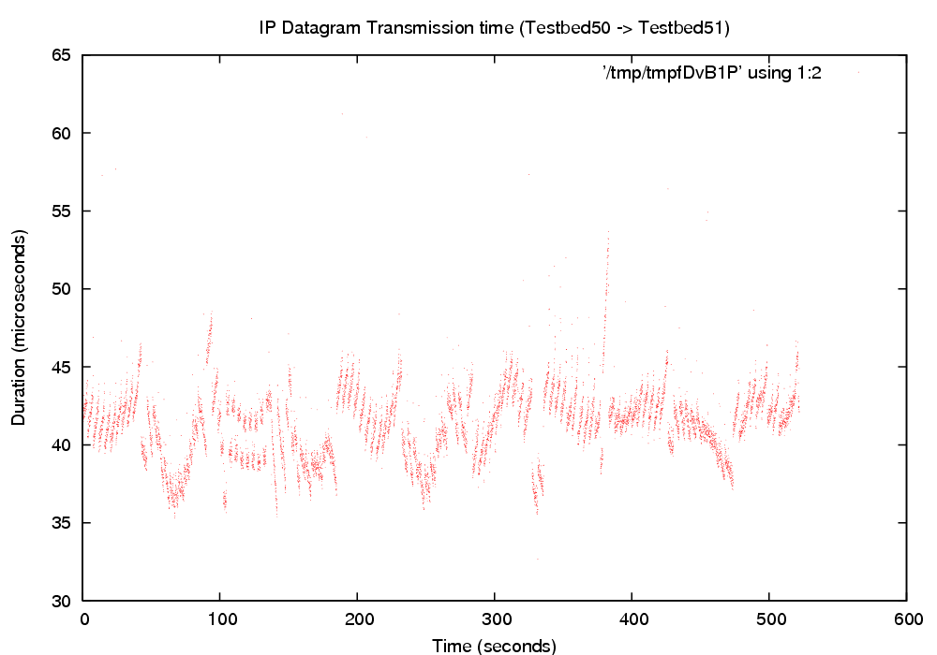
Figure 4.0.1: Small IP Datagram Transmission Time
- Figure 4.0.1 shows IP Datagram transmission time for the distributed pipeline experiment.
- Good illustration of what we think the measurement limits are
  - Because these are small packets in a simple experiment with no other load, measured as close to the hardware as we can get
  - Individual offsets applied can be seen, with slight spikes due to an offset being applied on one machine before the other is corrected.
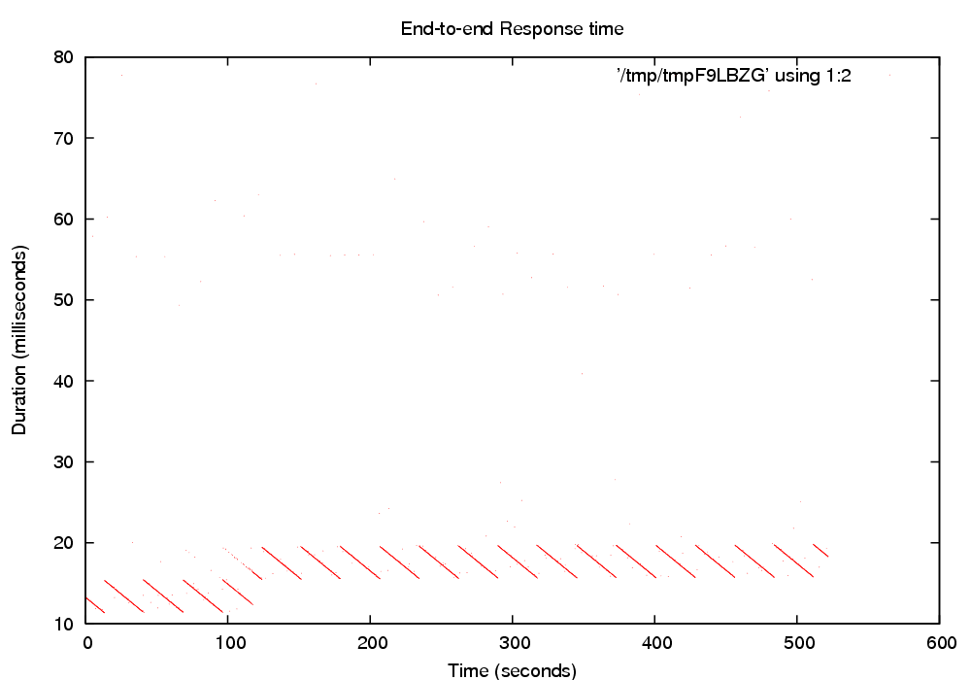
  - Resolution of clock synchronization has a variance of about 10 microseconds around the median value
  - Figure 4.0.2 shows unusual organization of the end-to-end response time of the distributed pipeline experiment, which we think is a result of three unidentified external influences:
    - Organization of the majority of the sample points into “lines” within the scatter plot indicates that there is at any given moment, a most likely packet transmission time with comparatively few outliers
    - The scatter plot data is segregated into well-defined subsets approximately every 30 seconds, within each subset the most likely packet transmission time is maximum at the beginning of the period, and decreases to minimum over the period. This is what makes the scatter plot appear to be a set of parallel lines.
      - This shows the existence of three independent outside influences
        - Approximately every 30 seconds the first influence causes the most likely packet transmission time increases to its maximum value
        - Continuously during each period, the second influence causes the most likely packet transmission time to linearly decrease
    - The third outside influence causes the operating region of the system to change from ~10-15ms (0-100 seconds) to ~15-20ms (100-500 seconds)
      - The previous maximum becomes the new minimum
      - During the transition, two overlapping lines show on the scatter plot
        - There were two most likely packet transmission time during the transition from the old operating region to the new operating region. (100-120 seconds into the experiment)
  - While we considered the possibility that clock synchronization might be one of the causes of these phenomena, this is extremely unlikely for two reasons
    - Start and end timestamps taken on the same machine, eliminating CLKSYNC errors as a possibility
    - The magnitude of these changes is at the millisecond level, while CLKSYNC modifications take place at the microsecond level
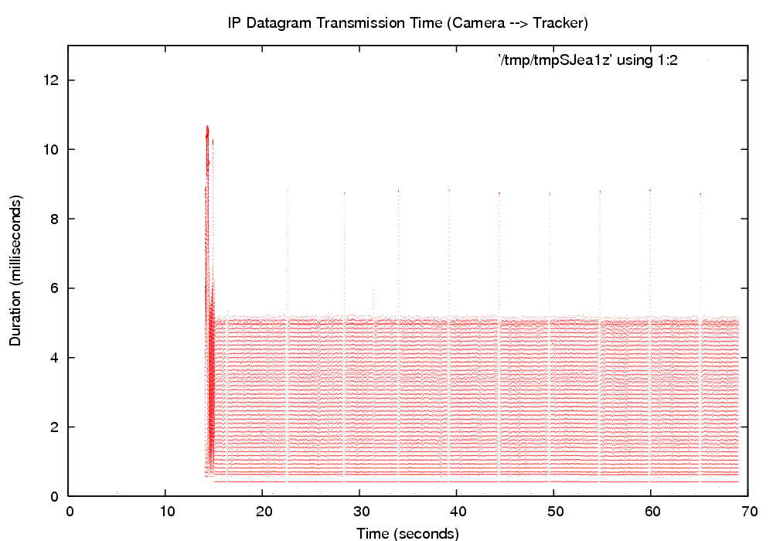
      - Figure 4.0.3 shows periodic gaps in video data transmission from one machine to another
    - Some periodic conditions on the boxes that increase the packet transmission time and/or interrupts the transmission of data from one machine to another for a short period of time, resulting in 'empty' regions in the output interval graph.
  - We do not know what causes this behavior
    - We believe that these observations are caused by periodic activity on the Linux boxes
      - ~30 seconds for distributed pipeline experiment
      - ~8 seconds for video data transmission
      - The mismatch of the periods leads us to believe at this time that these are two different outside influences

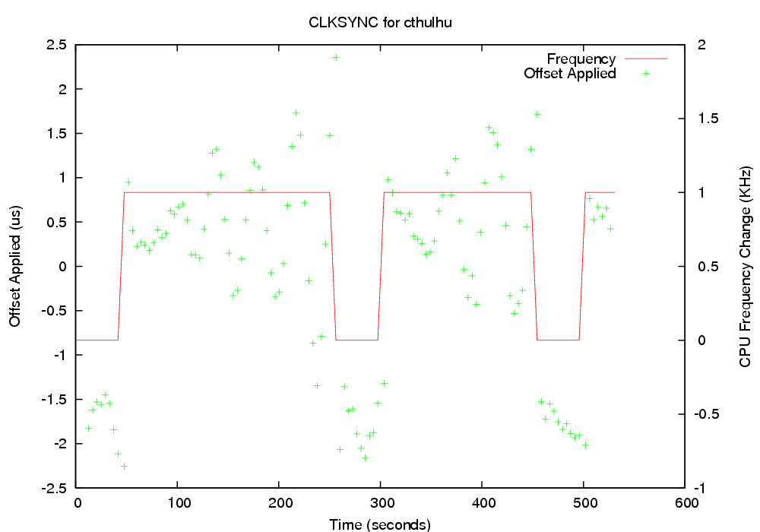
4.1 Stimulus-Response

CLKSYNC Offset/Frequency Adjustments
- Figure 4.1.1
- One graph generated per computer involved in the experiment.
- Individual points visualize each offset applied to the computer's clock, plotted on left vertical axis
- Lines show the estimated CPU frequency used to convert TSC-based timestamps to nanoseconds, plotted on right vertical axis. Graph shows regions of difference from the original estimated frequency.
- Frequency changes are a response to observations of offset values. At microsecond resolution the TSC is not necessarily stable.
- Frequency was generally stable over the course of the experiment, since the adjustments made were +/- 1 from the original base frequency.

Packet Transmission Times
- <clksync/derived_ack.ps> <clksync/derived_ack_hist.ps>
- Graph for each leg of round-trip performance
- Average client -> server transmission time was generally symmetrical with server -> client time.
  - An indication whether the clocks are in fact synchronized is to observe that the send/recieve delay times are symmetric
  - A very simple experiment to quickly verify the functioning of the CLKSYNC software
  - Experiment is conducted using small packets under pristine conditions, with no competing network or CPU load, so that we can compare/contrast later experiments under loaded scenarios.
- TODO: Generate histograms from intervals, not runtime
- TODO: Y-axes of interval plots need to be on same scale
- TODO2: Investigate outliers, turn on ctxt switch intervals, interrupt processing

4.2 Distributed Pipeline
Figure 4.2.1: Small IP Datagram Transmission Time

IP Datagram Transmission Time
- Figure 4.2.1 is a repeat of Figure 4.0.1 shown in Section 4.0
  - Shown earlier because it is an excellent example of both
    - clock synchronization
    - minimum-cost message transmission overhead
- Messages are small
  - Message size (4 bytes)
  - Message content (6 bytes)
- Measurements taken as close to hardware as possible
- Average 40us, with approximately +/-10us perturbation around the average, caused by clock synchronization precision.

End-to-End Response Time

Repeating Parallel Lines
Figure 4.2.1: End-to-end Response Time
- Measured at the user level, showing the time taken for the packet to travel through the entire 4-machine pipeline and return to the source machine
  - Round-trip times are subject to various factors influencing packet processing on each box in the pipeline
- Appears to be a base value with two interfering factors added in
  - Something that causes the most likely packet transmission time to increase periodically, causing a 'jump' to a new slope line
  - Another factor which reduces at a steady rate the packet transmission line, forming a sloped line
  - Overlapping lines in the middle of the experiment
  - Changing the number of machines in the experiment did not noticeably change these results, although the point where operating regions are switched appears to be totally random
- Start and end timestamps taken on the same machine, eliminating CLKSYNC errors as a possibility
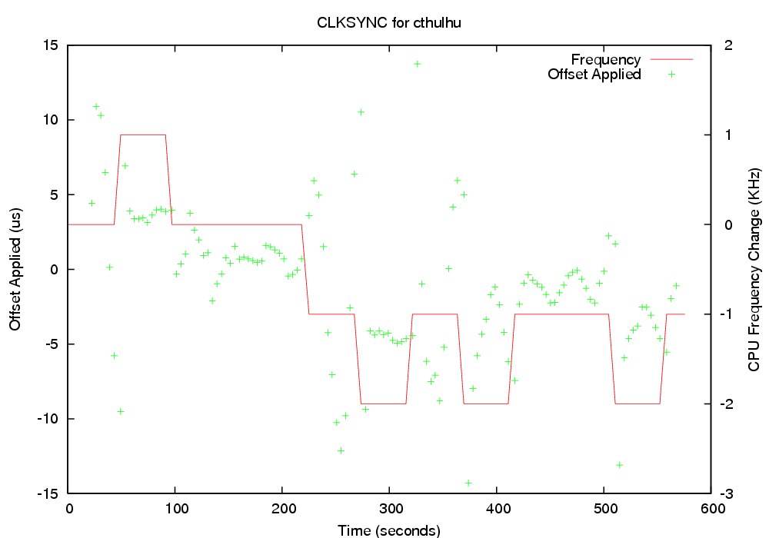
- TODO: run with DSKI off

Competing CPU Load
- Interferes with the clock synchronization somewhat
  - Increased error from 10us to 15 us
  - More frequent adjustments to CPU frequency within range of +1/-2 of base
  - In future work, place some or all of the clock synchronization software under explicit scheduler control to isolate it from the influence of the competing load, which may help by improving the clock synchronization.
- <histogram/Interval plot of complete loop>
  - Scatter plot of complete control loop
- <histogram/Interval plot of cthulhu_t50_packet.ps>
  - One connection from the heavily loaded machine
  - Average packet transmission time seems to go up from about 40ms to 70ms

Competing Network Load
- Do it!

4.3 Distributed Video Tracking

4.3.1 IP Datagram Transmission Time
Introduction paragraph
Figure 4.3.1: No NIST-Net Delay
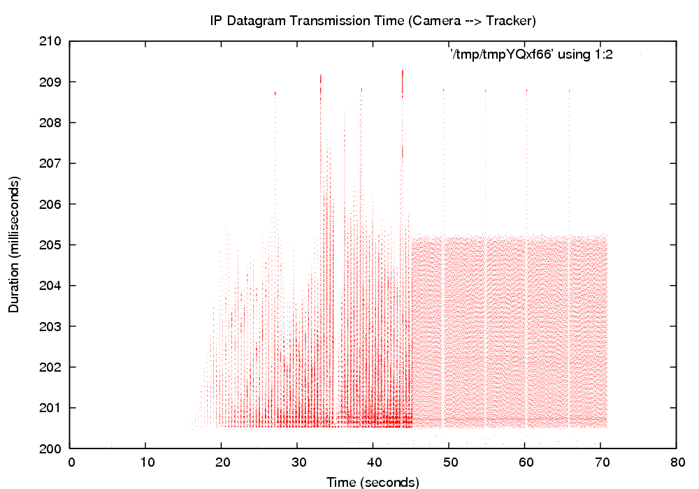
Figure 4.3.2: 200ms NIST-Net Delay

Initial Warm-Up Period of More Chaotic Behavior
- Figures 4.3.1 and 4.3.2 show two 60-second experiments.
  - Figure 4.3.1 has 0 NIST-Net delay
  - Figure 4.3.2 has 200ms NIST-Net delay
- Initial burst of chaotic activity increases non-linearly with increased NIST-Net delay
    - Clumped with greater delay between groups of packets
    - Greater variance in packet transmission interval duration during this period
    - Spikes of greater delay were qualitatively more prevalent with data sent from capture machine to the tracker, than the tracker to display machine.
    - Delay seems to mostly increase at the kernel level (Figure 4.3.2)
    - In the user-level graph, two behaviors were observed:
      - From the camera to the tracker (Figure 4.3.3), video transmission was chaotic with many frames taking much longer to reach the tracker machine
      - From the tracker to the display machine (Figure 4.3.4), the video transmission interval was mostly lower than the median transmission time in the steady state
  - Speculation
    - The NIST-Net box could be creating this behavior
    - TCP Slow Start or other protocol starting delays
    - Packet buffering at various points in the data flow
    - Any scheduling delays related to softirqs, although the magnitude of these delays makes this seem less likely. Could be eliminated with measurement.

Regular Bands of Inactivity
- Once data flow reaches a 'steady state', we observed periodic gaps in the graphs which correspond to
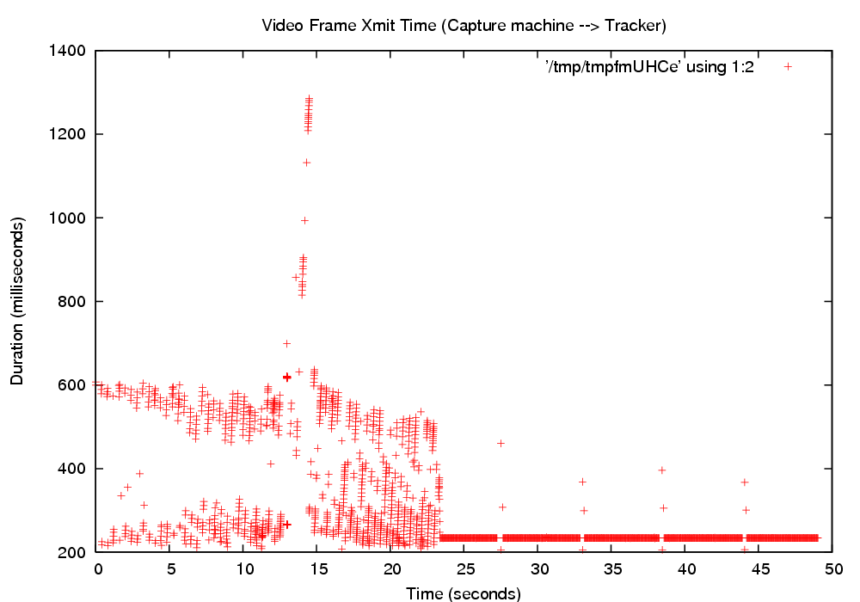
Figure 4.3.3: Video Frame Transmission Interval 1
  - Delivery of few and perhaps no packets
  - Increased delay as evidenced by outliers contemporaneous with the gaps
  - The gaps are periodic with the period being on the order of seconds, but where the specific period varies with experimental conditions
  - This behavior can be observed on Figures 4.3.1, 4.3.2, 4.3.3, and 4.3.4 after the system reached steady state behavior.
- For our experiments, we were interested in the steady-state behavior
  - This is most relevant to control loops, because control loops run for long periods of time
  - Also, writing control software to send messages to 'warm up' the network connections is trivial
    - Observed warm-up period is short enough that having the control software adapt to its existence wouldn't be hard.
  - The periodic delays in the steady state
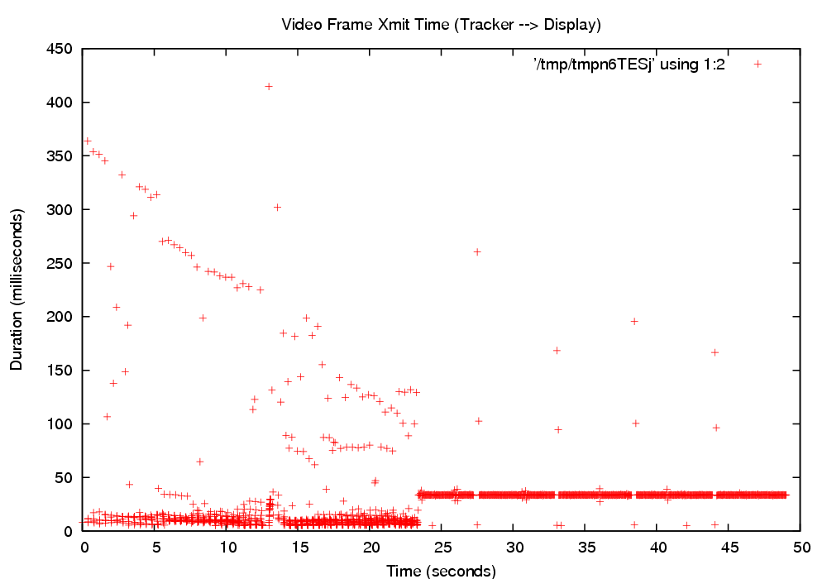
Figure 4.3.4: Video Frame Transmission Interval 2

4.3.2 Aggregate Performance Data
- Multiple runs of experiment with different NIST-NET parameters, each experiment ran for 20 minutes.

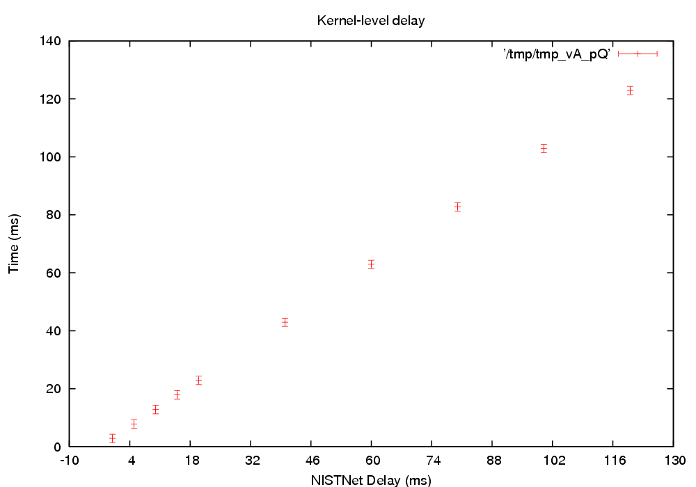
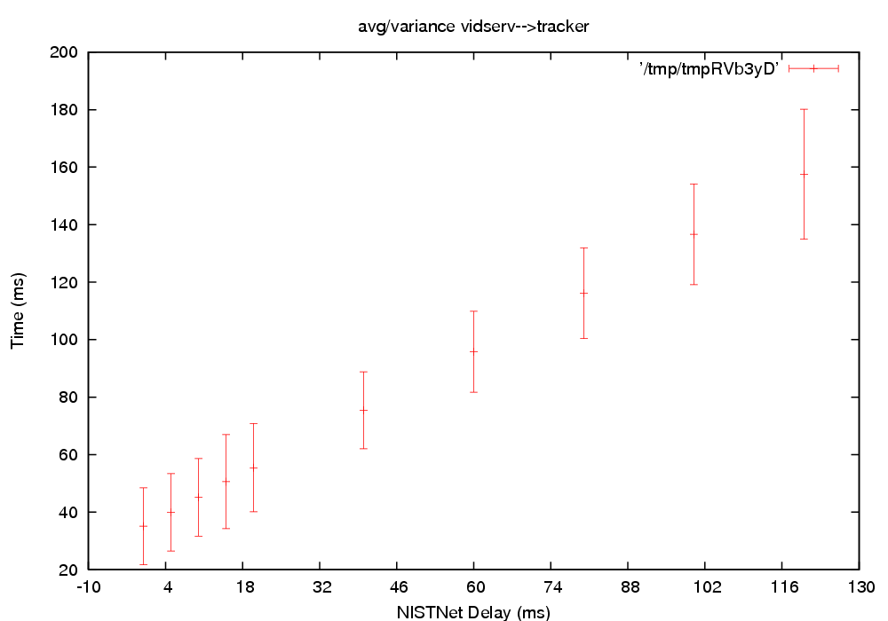
Aggregate IP-Level Delay
- Variance of hardware-to-hardware delay remained the same, was relatively small (~ 5ms) as expected, since the measurement points were not not subject to system-level delays
- Average delay was a linear function of the NIST Net delay setting
- This is kernel level, and only the network

Aggregate User-Level Video Frame delay
- Average delay a linear function of NIST Net delay setting, with a higher magnitude than the IP level graph, due to influence of added overhead of the network stack and application thread scheduling
- Variance was relatively uniform but significantly larger than the kernel data. Two sources of increased variance are evident
  - Packet fragmentation and reassembly (the sum of the individual variances of each packet the video frame is decomposed into)
  - Hardware interrupt soft-IRQ and application thread scheduling delays
- Variance was less uniform than kernel data due to smaller amount of sample points.

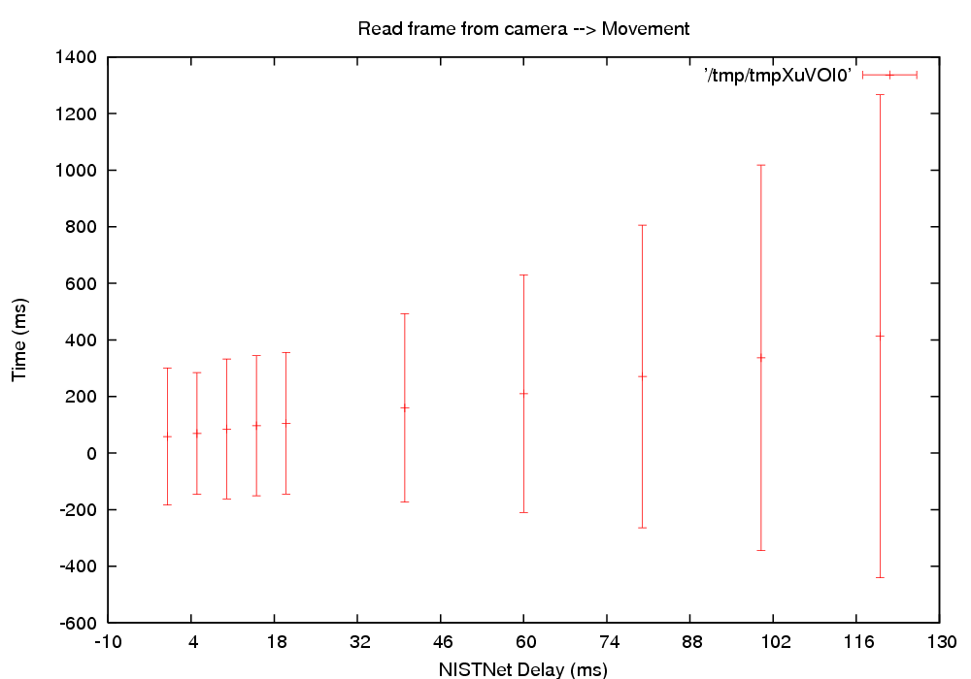
Aggregate Control Loop Delay
- Packet assembly/disassembly occurs in video stream, but not the control messages back to the camera machine
- Both average delay and variance were increasing functions of the NIST Net delay. Two NIST-Net segments are contributing to the total round-trip delay. The delay parameter at the NIST-Net level is constant, not a distribution, and should thus not increase the variance.
- The increase of the variance is clearly super-linear, and the shape of the curve suggests quadratic function of delay rather than linear.

4.3.3 Competing Loads

Competing CPU/Disk Load
We simulated a mix of CPU and I/O load by compiling a Linux Kernel in the background on the video capture machine. We found that this competing load roughly doubled the variance of video frame transmission
- <clksync/loaded/clksync_0_cthulhu.ps>
  - CLKSYNC quality was slightly worse, with estimated accuracy within 20 microseconds rather than 10 on the unloaded system.
- Disk I/O interrupts are lower priority than network interrupts (NOAH)
  - If true, plausible that network processing is not particularly impacted by the disk load of computational
- Since Kernel compile is a mix of CPU and Disk operations, video capture program apparently can fit into gaps left without noticeably degrading video performance
- Vanilla Linux scheduler does attempt to classify processes on its own according to their pattern of computational activity into interactive and batch classes. Interactive processes are given preference, it is possible (though not verified) that the video processing pattern is classified as interactive and thus given precedence over the kernel compilation.

Competing Network Load
- CLKSYNC Performance degraded
  - <camera/netloaded/clksync_0_cthulhu.ps>
- User-level measurements of video frame transmission time from the video machine to the tracking machine show that
  - in the presence of competing network load, the average transmission (CHECKME) time roughly doubles to 115ms,
  - with small number of extreme outliers up to ten seconds, and
  - a nontrivial number that were up to 3 seconds, as shown by the scatter plot. [Fig xxx] The smaller magnitude outliers seemed to occur periodically, as shown by their clustering in 'columns' in the scatter plot.
- Tracker machine to display machine
  - Showed similar effects of some extreme outliers with other outliers about 3 sec
  - Behavior was less regular than the (vid -> tracker transmission time) graph.
- IP Datagram Transmission
- Performance envelope of 0-5ms remained unchanged from unloaded experiments, with a slight increase in outliers
- Degraded performance of video frame transmission at the user level due to contention over network device, video frame reassembly, scheduling, and other end-system effects rather than the network.
- Difference between packet and frame measurement is disassembly/reassembly of video frames into IP datagrams and vice versa.
  - We estimate the video frames are split up into roughly 50 IP packets.
  - The ratio of the IP xmit average and video frame xmit average may be useful to determine the relative magnitude of two effects
    - reassembly of packets into a video frame
    - scheduling effects of network receive and other application thread-level activites.

4.4 Implications for Control Loops
- Warm-up period, if not solely an artifact of using the NIST-Net delay box, is clearly a factor that the control software would have to account for, although this should be easy to do.
- The distributed pipeline experiment is more representative of common control loops due to the size of the data
  - The outside influences causing the repeated pattern in the scatter plot (see Figure 4.2.1 in Section 4.2) are of concern in general, and especially because we do not know the causes
  - Since the magnitude of the changes in behavior (about 5ms) is fairly small, there will be many distributed control loops for which this variation is below thresholds of concern. However, identifying and eliminating these sources of behavioral changes would clearly permit distributed control loops with more stringent behavioral constraints to be created.
- More problematic are the periodic delays observed in the video pipeline experiment, because
  - This represents a constraining factor on the time constraints of the control loop
    - The worst-case response time of the control loop would have to permit these higher-magnitude delays, whereas if they did not exist, the worst-case delay of the control loop would be smaller.
- In distributed control loops, clock synchronization across machine boundaries may be a factor
  - If stages of a distributed control loop need to know the message delay between stages, or need to verify that delay is no greater than some specific value, then the performance of the clock synchronization avaliable can become a limiting factor.
    - While NTP is not the only technique for clock synchronization, and other clock distribution methods exist, it is the most popular Linux-based solution, and does not require specialized hardware support.
  - Our experience with clock synchronization for measurement purposes shows that vanilla NTP synchronization (on the order of 1ms) is not sufficient to quantify messaging delay among machines on local networks. For measurement purposes, we had to take measures to improve this in order to adequately quantify the message delays between machines.
    - We were able to reduce the synchronization error to approximately 1ms to 10us, depending on conditions
    - This enabled us to quantify message transmission times on a scale of tens or hundreds of microseconds with moderate accuracy.
- ??? N-system computation conflict/competition and scheduling effects for different computation components play a role as well as delay within the network.

5 Conclusions and Future Work

Although the Datastreams package has evolved to a very stable form during the course of our research, other tools are still in a proof-of-concept state and could use further refinement.
- Modify the CLKSYNC tools to use their own communication protocol, rather than as a modification of NTP.
- Add Datastreams instrumentation to the NIST Net package, in order to distinguish real network delays from OS-level scheduling on the router machine.
- Further refine the NETSPEC communication protocol, and improve both the error handling and the user interface of the ns_control application.
- Devise a method for associating individual IP datagrams with their respective video frames in the video pipeline experiment
- Introduce a distributed version of the Group Scheduling framework, and investigate whether fine-grained scheduling control across the cluster will improve performance.
- Expand the video pipeline experiment to include additional cameras, more sophisticated tracking, and additional computation nodes.
- Improve the speed and efficiency of the DSPP software, and implement support for distributed post-processing over a cluster

Appendices

A Datastreams
Datastreams is a Linux kernel patch, user-level library, and set of related tools for collecting and analyzing performance data. Developers place instrumentation point macros within the kernel or user-level applications, and during execution a binary file containing the instrumentation data is written to the disk. The data within this binary file can be further analyzed, filtered, and transformed using the post-processing software.

A.1 Entity Types
When an instrumentation point is encountered, the performance data written to the output file is called an entity. There are four different types of entities, outlined below. In addition, the macro definitions of some of the more commonly used instrumentation are shown.

A.1.1 Events
Events are the simplest entity type, which indicates that some named event occurred at a specific time. All events may have a long integer tag value saved with it, and optionally a sized chunk of extra data.
DSTRM_EVENT(<group name>, <entity name>, <tag_value>)
DSTRM_EVENT_DATA(<group name>, <entity name>, <tag value>, <size>, <data pointer>, <decoder function name>)

A.1.2 Intervals
Intervals represent an elapsed time, with macros for start and end points. The start point notes the time it was called, and the end point logs the elapsed time to the data stream. As with events, intervals can be tagged with an integer value.
DSTRM_INTERVAL_START(<group name>, <entity name>)
DSTRM_INTERVAL_END(<group name>, <entity name>, <tag value)

A.1.3 Counters
Maintains a value that is incremented each time the counter's instrumentation point is executed. The counter total can be logged at any time, and it can be reset to zero. Counters have significantly less logging overhead than events.
DSTRM_COUNTER_ADD(<group name>, <entity name>, <amount>)
DSTRM_COUNTER_LOG(<group name>, <entity name>)
DSTRM_COUNTER_RESET(<group name>, <entity name>)

A.1.4 Histograms
Histograms keep a data structure that can be used to generate a graphical display of tabulated frequencies. The histogram is parameterized with a range and a number of 'buckets' representing intervals of input data. Histogram instrumentation points increment the appropriate bucket based on the given value, and can be logged to the data stream or reset at any time. Histograms can also be constructed in post-processing from other entity types, and can be sent to GNUPlot to be rendered graphically.
DSTRM_HISTOGRAM_ADD(<group name>, <entity name>, <amount>)
DSTRM_HISTOGRAM_LOG(<group name>, <entity name>)
DSTRM_HISTOGRAM_RESET(<group name>, <entity name>)

A.2 Entity Namespace
All the entities within an application have metadata associated with them. There is a two-level hierarchy of names--group name and entity name. This allows for performing operations on groups of entities, which is convenient for enabling/disabling them at runtime, and also during post-processing. Entities also may have a description as well as entity-specific metadata. For example, events that log extra data will give a string that names a Python function that can unpack the binary extra data during post-processing.
For performance reasons, it is inefficient to log these strings every time an instrumentation point is encountered. Instead, at the beginning of any output file will be a set of namespace data, which declares the names of all the instrumentation points within the application, their metadata, and a unique id. Subsequent entities are logged only by this id, making the entity data structure very small.
Both DSKI and DSUI use special binary text sections, GCC attributes, and linker operations to automatically extract the namespace information from the compiled application itself. Other languages may not support this; in this case special namespace files must be created.

A.3 Data Stream Management
By default, no entities are logged in the kernel or application when it is running. To log data, a data stream must be created. A data stream is associated with a set of buffers, an output file to write data to, and some other parameters. Any data stream has a set of entities associated with it. Initially this set is empty; the user can ‘turn on’ entities for that data stream through configuration options. Any time an instrumentation point is encountered during execution, the corresponding entity is logged to all data streams that have that entity enabled.
Two fundamental data stream types are implemented: normal and ring buffer. Normal data streams send entities to the output file as they receive them. Ring buffer data streams accumulate entities in a circular ring buffer until a triggering condition is met. Once the trigger condition is satisfied, all the buffered entities are written out. This is useful for logging instrumentation data that generates a large volume of entities, but is only interesting under certain conditions. The ring buffer data stream will show a history of all the entities leading up to that condition.
All non-event entities have state information, such as a counter’s current count or the contents of a histogram’s buckets. This state information is kept at the data stream level. Functions exist which allow the user to write out the current state of a counter or histogram at any time. State information is not logged when a counter or histogram has data added to it, for performance reasons.

A.4 Datastreams Kernel Interface
Datastreams Kernel Interface is a tool for gathering performance data from a running Linux kernel. It uses the RelayFS subsystem to efficiently buffer and write events to the disk.

A.4.1 DSKI Daemon
The DSKI Daemon is the user-level interface to DSKI. It communicates with the DSKI kernel module, and allows the user to create data streams, enable entities, and capture instrumentation data. It is implemented in Python.

A.4.2 DSKI Linux TCP/IP Instrumentation
<Write some high-level description on the tcp.ip stack instrumentation points>

A.5 Datastreams User Interface
The goal of Datastreams User Interface (DSUI) is to make instrumentation of user-level programs easy to do, with minimal impact on performance. Any program or library that uses DSUI will need to generate a header and code file.

A.5.1 Header File Generation
All DSUI instrumentation points are macros that define data structures in a special text section, and also call the appropriate functions within DSUI. Any given application may be linked to one or more libraries that also use DSUI; in order for these text sections not to overwrite each other, these text sections must have unique names, on a per-application or per-library basis.
The generated header file has all the macro definitions for DSUI instrumentation points. The associated data structures for these instrumentation points is placed in the text section, the name of which is provided on the command line when the header is generated.
For some languages or architectures, the automatic declaration of namespace information via text sections is not possible. In this case, a separate namespace file must be maintained declaring the names and other metadata for all active instrumentation points. From this namespace file a header can be generated which explicitly declares all the instrumentation point data structures, and a constructor function to register them with DSUI. The difference is that this header must be regenerated every time the namespace changes.

A.5.2 Instrumentation Effect
<What is the instrumentation effect of DSUI? Measure this and write this section...>

A.6 Datastreams Post-Processing (DSPP)
The Python-based post-processing software (DSPP) is used to transform, merge, filter, and create graphical representations of data gathered from DSUI/DSKI, showing the performance of computations within a given experiment.
DSPP also handles the details of merging data from multiple applications into a single timeline. Using the timekeeping information logged by the synchronize program, it will convert the CPU TSC-based timestamps into a global timeline based on nanoseconds. Events that log extra data will have this data unpacked from binary form into more general-purpose Python data structures.

A.6.1 Configuration Files
DSPP is designed as a directed graph arrangement of individual filters, which are fed a stream of entities and operate on one entity at a time. Linear chains of filters are grouped into pipelines for efficiency reasons. Pipelines are themselves connected to an arbitrary number of other pipelines via shared queues. The configuration file syntax allows for specification of an arbitrary graph of filters, the only constraint being that the graph must be acyclic.

A.6.2 Filters
DSPP is designed to be easily extensible to meet the needs of any kind of performance evaluation. A base Filter class is defined, which defines methods for initialization, processing of a single entity, and cleanup/teardown tasks. DSPP comes with a rich set of general-purpose filters grouped into modules, and the DSPP configuration file syntax allows for custom, experiment-specific filter modules to be imported.

A.6.3 Output Formats
Currently, DSPP supports saving the results of post-processing in a pickle (the Python data structure serialization) format, which stores a complete record of all data logged. An XML-based file format is also planned but implementation is not complete. When finished, this XML format will allow an easy way for third-party applications to read and write DSPP data.
Various filters exist to output data in other, more human readable formats. These include graphing filters, which output visual representations of data using GNUPLOT, and a narration filter that shows a human-readable log of an experiment, useful for troubleshooting both experiment design and filter specifcations.

B CLKSYNC Kernel Patch
Anytime do_irq() is called for the IRQ of the CLKSYNC network device, a timestamp is recorded. The packet is then examined in the network softirq. If the packet is a CLKSYNC NTP packet, the arrival timestamp is written to the packet in one of the extra fields.
For outgoing packets, a check is performed right before the packet is written to the hardware buffers. If the packet is a CLKSYNC NTP packet, a timestamp for packet departure is written to the packet in an extra field.
The synchronize program is the end user’s interface to CLKSYNC. It is a command line tool that takes the remote timeserver as its argument. It periodically exchanges timekeeping messages with the remote server, and adjusts the clock and estimated CPU frequency as necessary. Every time an adjustment is made to the computer’s clock, a DSUI timekeeping event is logged with the current time and TSC-to-nanosecond correspondence. The binary DSUI output file created by Synchronize must be merged with any other DSUI/DSKI data created on that machine. DSPP will convert the TSC-based timestamps to nanoseconds on the global timeline.

C NETSPEC Control Software
There are a lot of administrative and housekeeping tasks associated with running a distributed experiment. These include:
- Invoking processes on remote machines
- Supplying each process with configuration information
- Troubleshooting any processes that fail to execute properly
- Gathering any output files written by each process so that they can be analyzed
Doing this by hand involves spawning a large number of terminal windows, activating the components of the experiment in a specific order, and manually copying all the data files back.
NETSPEC was written to automate the execution of distributed experiments. All the parameters for the components of a distributed experiment are written to a single configuration file. By doing this, it is trivial to reproduce existing experiments, and it also makes adjusting parameters and re-running an experiment very easy, improving the efficiency of running experiments significantly.

C.1 Phased Execution Model
NETSPEC specifies experiments as a list of phases, with each phase corresponding to a stage in the overall experiment. This provides a form of barrier synchronization; NETSPEC will not move on to the next phase until all the tasks in the current phase have completed successfully. Any NETSPEC-aware application provides function pointers for each stage that it supports.
For example, consider a simple client-server experiment running on two machines. The phases for this experiment might look like:
- Launch all applications across the cluster and perform initialization tasks
- Launch the synchronize program (part of CLKSYNC) on each machine, and adjust the estimated CPU frequency in the kernel until the NTP offsets gathered are below a certain threshold
- Send a command to the DSKI daemons running on each machine to begin logging data
- Have the server process open up a socket and begin listening for network connections
- Have the client process connect to the server and begin transmitting data
- Wait for the client and server processes to report that they have finished the distributed computation. Collect all data gathered and send it to the host machine running the NETSPEC controller for later analysis.

C.2 LibNETSPEC
LibNETSPEC is a library that is used by all NETSPEC-aware applications. Upon startup the application registers function pointers corresponding to each of the phases it has. It then transfers control to a function within the library that handles the communication details between the application and the NETSPEC controller.
The LibNETSPEC API is simple and designed to make migrating existing software to use the NETSPEC model as painless as possible.

C.3 NETSPEC Controller
The NETSPEC controller program, ns_control, is the user interface to a distributed experiment. It reads the provided experiment configuration files, and communicates with netspecd processes running on each machine in the cluster. For each phase of the experiment it sends the necessary configuration data to each node, and collects log files of each program’s execution, as well as any data files generated.
ns_control is designed to make troubleshooting easy. If any of the components of a distributed experiment fail, ns_control will detect it and display that program’s output up to when it failed. It manages the currently running processes for an experiment and can reset each machine to an initial state.
Currently, ns_control is a command line interface and the code is somewhat proof-of-concept. Further revisions will introduce a graphical user interface and more advanced error handling.

