Employee Performance Review
Employee Name: Rogan Glensore Reviewer Name: Bianca Dillon Date: 06/02/2026 Review Period: 02/02/2026 – 06/02/2026

Rating Scale
- 5 - Exceptional: Consistently exceeds expectations.
- 4 - Exceeds Expectations: Frequently goes above and beyond.
- 3 - Meets Expectations: Consistently does what is required.
- 2 - Needs Improvement: Inconsistent performance; gaps exist.
- 1 - Unsatisfactory: Does not meet minimum standards.

Section 1: Communication & Responsiveness
Focuses on clarity, speed, and information flow.
Rating (1-5)
Criteria
3
Are
Communication Style:
concise?
updates clear, professional, and
3
does the employee respond to
How quickly
Response Time:
Does
Feedback to Management:
emails, messages, or requests?
4
management informed of status,
the employee proactively keeps
risks, or needs?

Performance Review: Team Lead Comments
Rogan’s communication has been excellent. He consistently keeps me informed of his schedule and proactively communicates any changes throughout the day via phone or WhatsApp. When faced with complex situations, he ensures he contacts me to seek approval from Louis on the best way forward, keeping both leadership and the team fully informed of his location and job status.
He has shown great initiative by assisting staff with Wi-Fi issues to the best of his ability, even when managing a tight schedule with clients. Rogan also follows the established protocol of sending photos of completed jobs for review, allowing Louis and me to provide immediate feedback on the quality of work.
Rogan demonstrates a high level of accountability and a desire for growth; he recently initiated a private conversation to ask for feedback on his performance and to ensure he was meeting expectations. One area for development is the quote request process. Rogan needs to ensure he gathers all necessary information required by Lee before submitting a request. This will streamline the process and avoid the need for Lee to follow up with him or the client for missing details.

Section 2: Execution & Reliability
Focuses on the quality of work and adherence to directions.
Criteria
Rating (1-5)
Job Completion:
Are assigned tasks
completed fully and to a standard?
3
Listening to Instructions:
Does the
employee listen carefully and follow
guidelines accurately?
3
Follow-Up:
Does the employee circle
back to ensure tasks are closed out or
Clients or manager are satisfied.
4

Performance Review: Team Lead Comments
I have observed that Rogan consistently gives his best effort to assist every client using the full extent of his knowledge and skills. While I’ve noticed that time isn't always on his side, he remains diligent about communicating with both the client and Louis before leaving a site.
I have specifically noted his attention to detail regarding operational tasks; he regularly checks the stock in his vehicle and ensures that every job site is left neat and the work is fully completed. This is reflected in the fact that I have not received any negative feedback from clients regarding his performance.
I have also noticed that after a long, demanding day, Rogan’s fatigue becomes visible in his body language and in the way he speaks or responds to requests. However, I am impressed by his work ethic; even when he is clearly exhausted, he remains disciplined and continues to head out and complete every job requested by management.

Section 3: Problem Solving & Attitude
Focuses on how challenges and blockers are handled.
Criteria | Rating (1-5)
Handling Blockers: When stuck, does the employee communicate early or find a workaround rather than waiting? | 4
Problem Solving: Does the employee identify root causes and suggest solutions rather than just reporting problems? | 3
Helpfulness: Is the employee approachable and willing to assist others when asked? | 3

Performance Review: Team Lead Comments
Rogan has been utilizing WhatsApp to communicate "blockers" to me. We recently discussed a specific instance regarding the Paul ACS battery where Rogan did not initially identify the situation as a blocker. I explained that if a quote cannot be completed because a serial number is missing—requiring a return trip to the client—it constitutes a blocker that puts the process on hold. Rogan explained that the client needed the laptop for a meeting and intended to clean it before providing the serial number; however, we discussed the importance of communicating these delays to leadership before leaving the site, rather than at the end of the day.
Rogan has shown improvement in this area. On Thursday, 05/02/2026, he communicated his blockers to us before leaving the client and discussed the situation with Louis to ensure he could proceed correctly. This demonstrates a much-better communication flow.
Regarding problem-solving, Rogan consistently consults with Louis whenever he encounters a challenge. This collaboration has allowed Louis to assist him in resolving issues efficiently across various jobs. Furthermore, Rogan continues to maintain a good standard for his workmanship by always sending photos of his completed tasks for confirmation. Well, done on the progress made so far.

Summary & Next Steps
Overall Rating: _3_/5
- [4 ] Excellent response time
- [3 ] High quality of work
- [3 ] Strong problem solver
- [4 ] Very helpful/Team player
- [4 ] Communication frequency - If time permits and how long job takes.
- [3 ] Following specific instructions
- [3 ] Proactive follow-up
- [4 ] Handling blockers independently with Louis and with the Team
- [2 ] Body language when you with client, looking tired, dragging your feet
Date Reviewed: 2nd to 6th Feb 2026 First week assessment by
Team Lead Bianca Dillon.

WhatsApp Communication from Rogan to Bianca as follows:
Monday 2/02/2026:
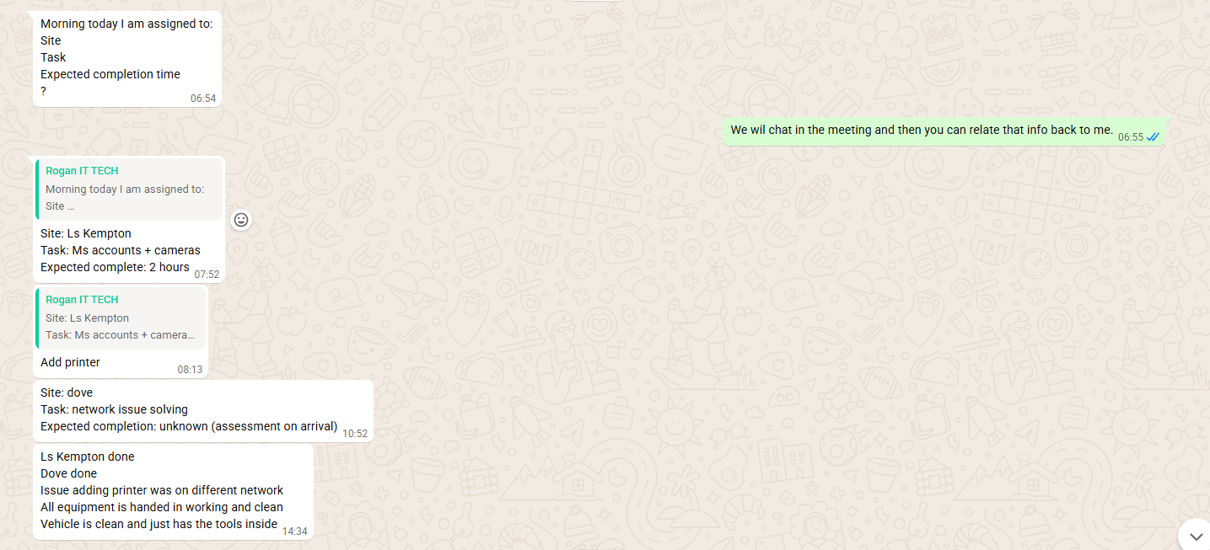
Tuesday 3/02/2026
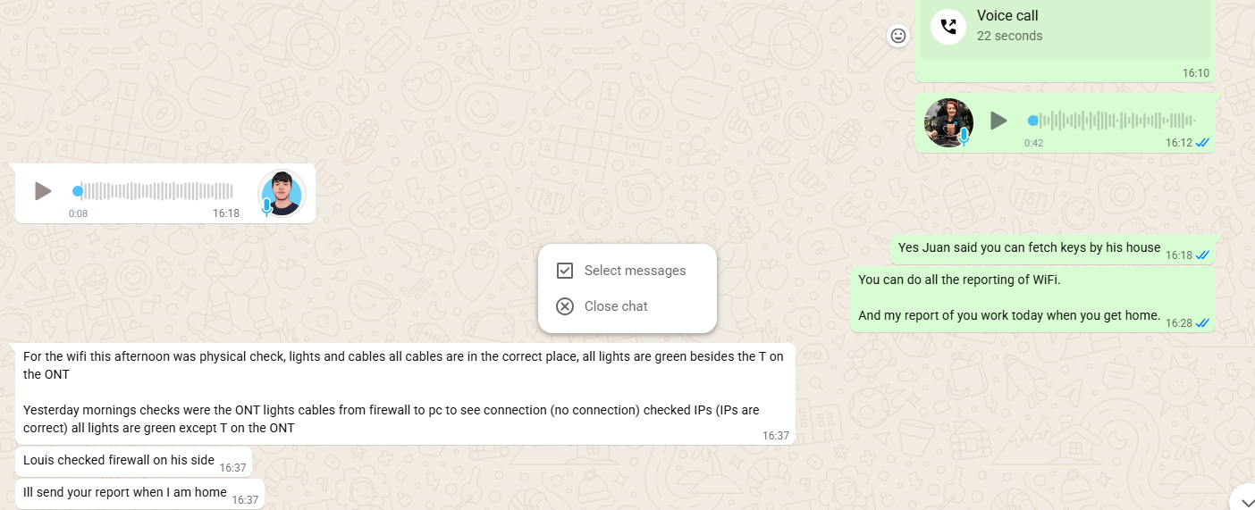
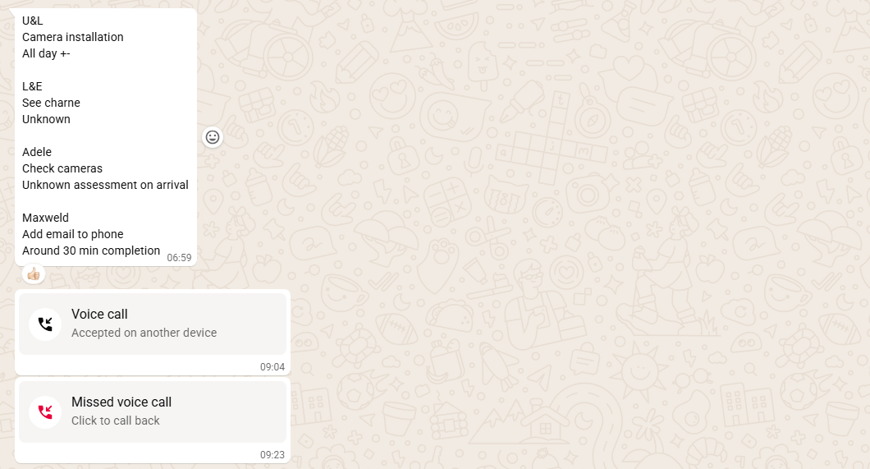

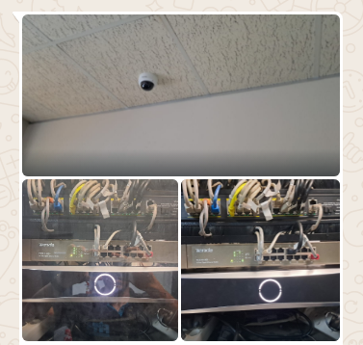
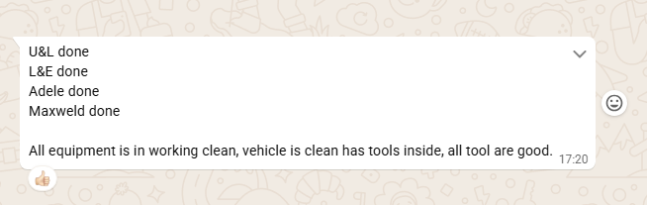

Wednesday 4/02/2026
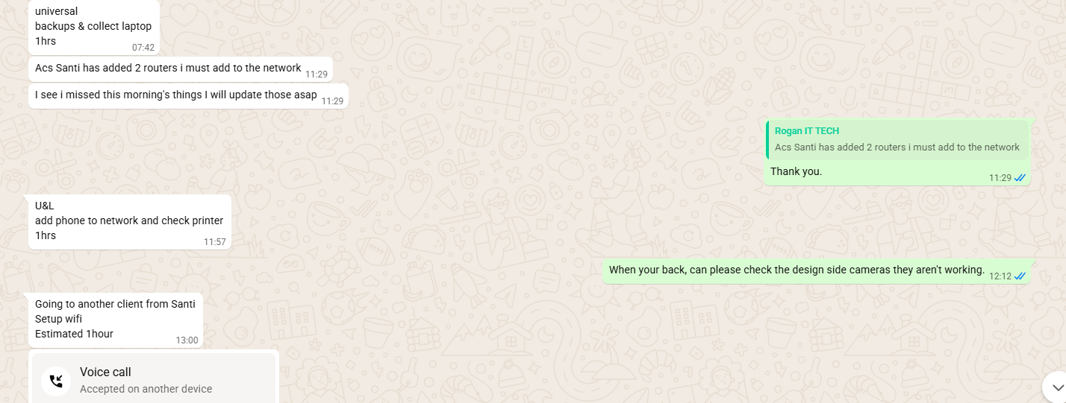

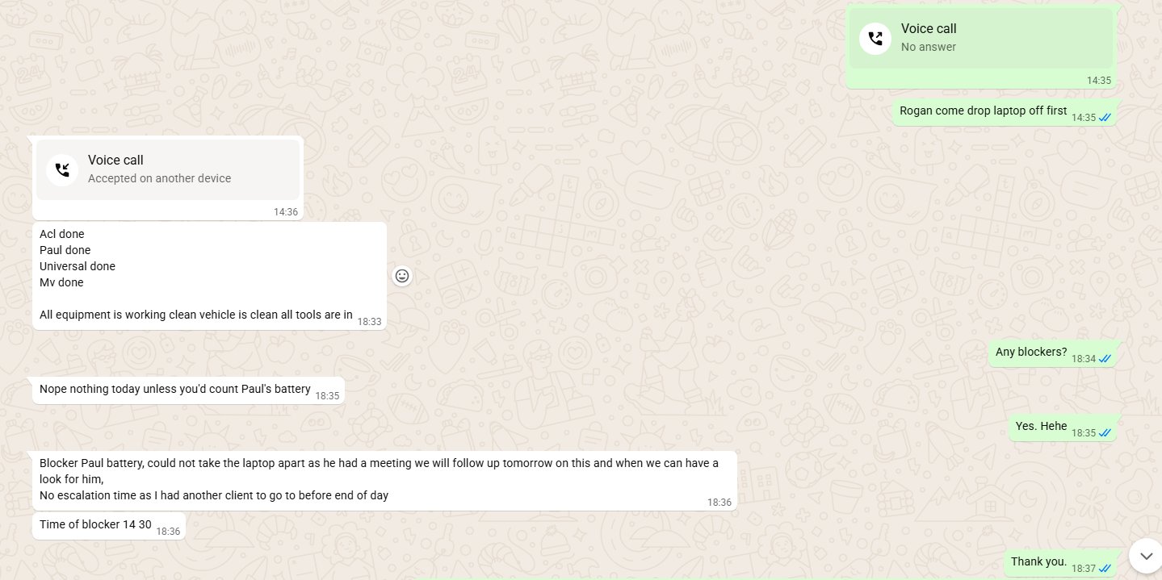

Thursday 05/02/2026

Thursday 05/02/2026
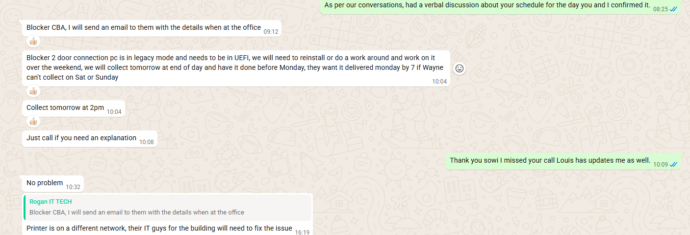
Friday 06/02/2026 – 07/02/2026
