Table of Contents
1. Introduction
- Welcome to Networking Fundamentals
- Course Overview
2. Local Area Network (LAN)
- Core Purpose of a LAN
- Key Components of a Modern LAN
- Simple LAN Diagram
3. Wide Area Network (WAN)
- Core Purpose of a WAN
- Key Components and Technologies
- WAN Diagram
4. IP Address
- How IP Addresses Work
- Types of IP Addresses
- Examples in Action
5. Subnetting
- Why Use Subnetting?
- How Subnetting Works
- Examples in Action
6. Gateway
- How a Gateway Works
- Examples in Action
7. DHCP (Dynamic Host Configuration Protocol)
- The DORA Process
- Information Provided by DHCP
- Troubleshooting DHCP
8. Network Troubleshooting
- Step 1: Check the Physical Layer
- Step 2: Check for a Valid IP Address
- Step 3: Test Connectivity with Ping
- Step 4: Trace the Route
9. Business Network Infrastructure
- Core Infrastructure
- Endpoint Devices
- Servers & Services

Introduction:

Welcome to Networking Fundamentals! 🌐
Hello and welcome to your first step in mastering computer networks. If you've ever had a user tell you "the internet is down" and your only plan was to restart the router, this course is for you. Our goal today is to replace that uncertainty with a confident, logical troubleshooting process.
Over the next two hours, we'll demystify the core concepts you'll encounter every single day as an IT technician. We will cover:
- The Big Picture: Understanding the difference between a local network in your office (LAN) and the massive network that is the internet (WAN).
- The Language of the Internet: Learning what IP addresses, Subnet Masks, and Gateways are and why they are essential for any device to communicate.
- Automatic Configuration: Discovering how DHCP works to automatically assign addresses and prevent network chaos.
- Practical Troubleshooting: Most importantly, we'll get hands-on with command-line tools like ping and ipconfig. You'll learn a step-by-step method to diagnose connectivity problems like a detective, pinpointing exactly where the failure is occurring.
This course isn't about memorizing theory; it's about building the practical, real-world skills that will make you an effective and reliable technician. Let's get started.

LAN (Local Area Network)

A Local Area Network, or LAN, is a collection of connected devices, such as computers, printers, and servers, that are confined to a small geographical area. Think of it as a private, high-speed digital network for a single location. This location could be a single home, an office building, a school campus, or a library. The defining characteristic of a LAN is that the organization or individual who owns it also typically owns the networking equipment.
Core Purpose
The primary purpose of a LAN is resource sharing. Before LANs, transferring a file meant saving it to a USB drive and physically walking it to another computer. A LAN allows for seamless and instantaneous sharing of:
- Files and Data: Users can access and share documents from a central server or directly from each other's computers.
- Hardware (Peripherals): A single powerful printer or scanner can be shared among dozens of users on the network, which is far more cost-effective than giving every user their own.
- Applications: Software can be installed on a central server and accessed by multiple users, simplifying licensing and updates.
- Internet Connection: A single internet connection provided by an Internet Service Provider (ISP) can be securely shared among all devices on the LAN via a router.

Key Components of a Modern LAN
A functional LAN is built from several essential hardware components working together:
- Network Interface Card (NIC): This is the hardware built into or added to a device (like a computer or printer) that allows it to connect to the network. It can be an Ethernet port for a wired connection or a Wi-Fi adapter for a wireless one. Every NIC has a unique physical address called a MAC address.
- Ethernet Cables: For wired LANs, these are the physical cables (like Cat5e or Cat6) that carry data signals between devices. They offer the most stable and fastest connection speeds.
- Switch: The switch is the central traffic controller for the wired part of a LAN. It's a box with many Ethernet ports. When a device sends data to another device on the LAN, the switch intelligently forwards that data only to the port connected to the intended recipient. This is efficient and prevents unnecessary data "chatter" on the network.
- Wireless Access Point (AP): This is the equivalent of a switch for wireless devices. It broadcasts a Wi-Fi signal (a SSID, or network name) that devices can connect to. In most home and small office setups, the AP functionality is built directly into the router.
- Router: The router is the gateway of the network. It has two primary jobs:
  - It connects the entire LAN to a different network, most commonly the internet (a WAN).
  - It manages IP addresses for the devices on the LAN, often acting as the DHCP server.

Simple LAN Diagram
Here is a diagram illustrating how these components work together in a typical small office LAN.
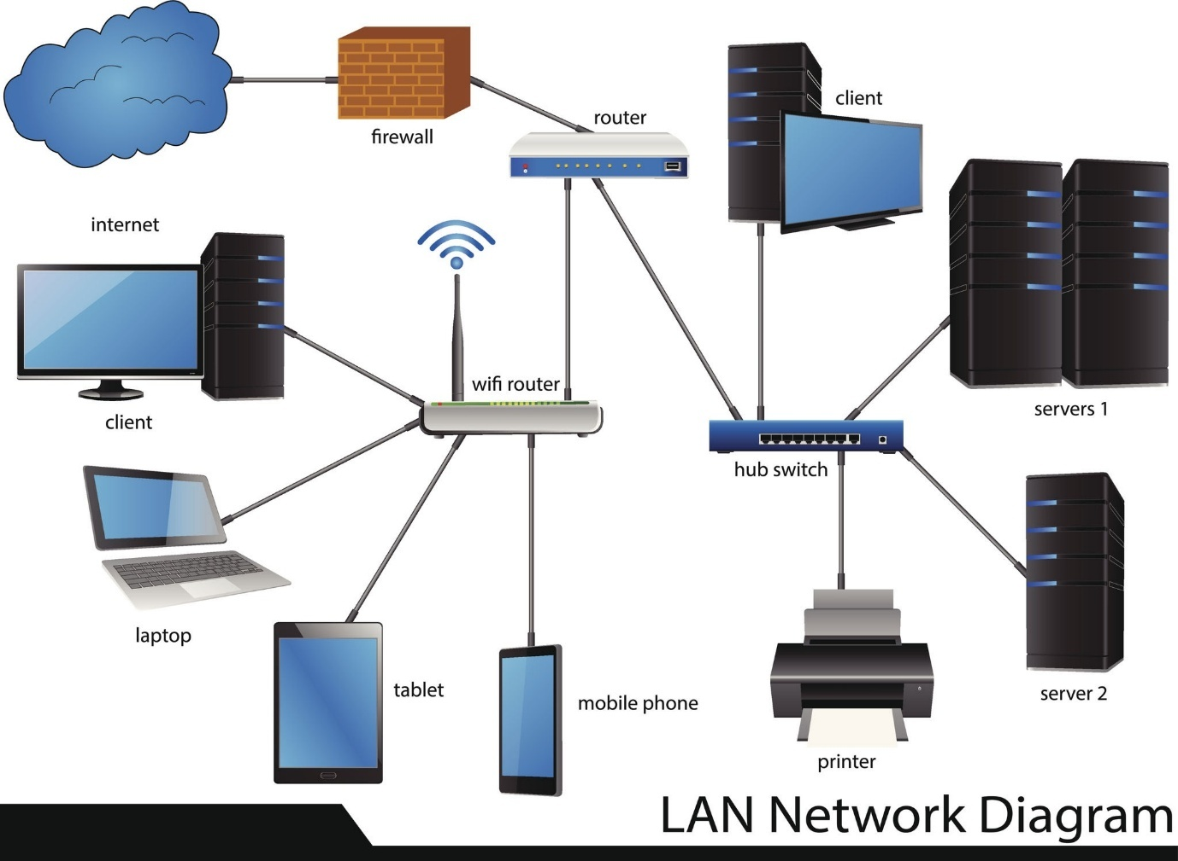

How to read this diagram:
- The Router receives the internet connection from the outside world (the WAN).
- It connects via an Ethernet cable to the central Switch.
- Wired devices like the Desktop Computers and the Network Printer are plugged directly into the switch.
- The router also functions as a Wireless Access Point, allowing wireless devices like the Laptop and Smartphone to connect to the network.
- All of these devices exist on the same local network, allowing them to communicate with each other and share the single internet connection.

WAN (Wide Area Network)

A Wide Area Network, or WAN, is a network that spans a large geographical area, such as a city, country, or even the entire globe. Unlike a LAN, which is confined to a single building, a WAN connects multiple LANs together over these long distances.
The defining characteristic of a WAN is that the infrastructure used to connect the locations (like fiber optic cables, satellite links, or undersea cables) is typically not owned by the organization using it. Instead, organizations lease these communication lines from telecommunication companies or use the public internet as their WAN connection.
Core Purpose
The primary purpose of a WAN is to interconnect geographically dispersed LANs. It acts as the long-haul "highway system" that allows a company's office in one city to communicate with its office in another city. Key functions include:
- Centralized Data Access: Allows employees in a branch office to access a central database or file server located at the company headquarters.
- Global Communication: Enables services like company-wide email, internal websites (intranets), and VoIP (Voice over IP) phone calls between different office locations.
- Connecting to the World: The most well-known WAN is the Internet, which is a massive, public network connecting millions of LANs globally. When your office LAN connects to the internet, it's connecting to a WAN.

Key Components and Technologies
WANs are built using a different set of technologies than LANs, focusing on long-distance and reliable data transmission:
- Routers: While routers are the gateway of a LAN, they are the fundamental traffic directors of a WAN. A router at each LAN location reads the destination IP address of outgoing data packets and determines the best path to send them across the WAN to the correct destination LAN.
- Modems (Modulator/Demodulator): These devices are required to connect a LAN to a service provider's network. A modem converts the digital signals from your network (LAN) into analog signals suitable for transmission over the provider's media (like fiber optic or cable lines) and vice-versa.
- WAN Links/Connections: These are the actual communication lines that carry data over long distances. Organizations have several options:
  - Leased Lines: A private, dedicated communication circuit that an organization leases from a telecom provider. This offers a very secure and reliable connection but can be expensive.
  - MPLS (Multiprotocol Label Switching): A high-performance telecom service that can carry data for many customers over the same infrastructure. It's a popular choice for businesses as it's reliable and can prioritize important traffic (like video calls over email).
  - VPN (Virtual Private Network): This technology uses the public internet to create a secure, encrypted "tunnel" between two LANs. It's a very cost-effective way to build a WAN, as it leverages an existing internet connection.

WAN Diagram
This diagram illustrates how a WAN connects multiple office LANs, allowing them to function as a single, cohesive company network.
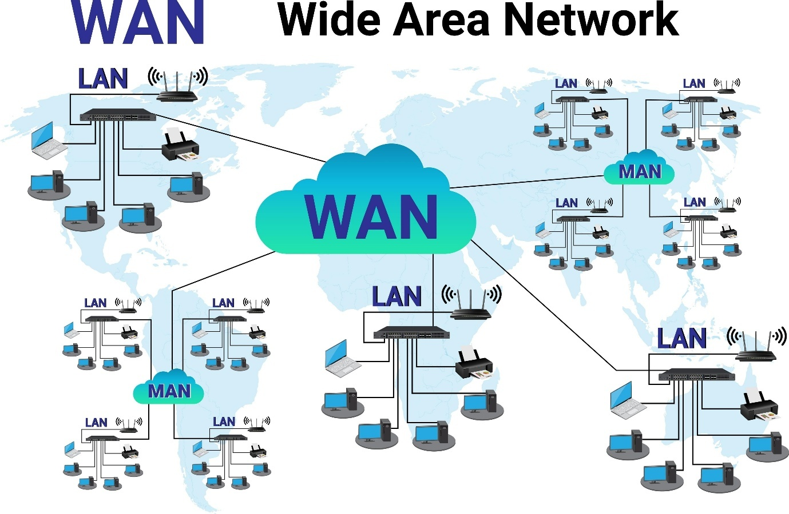
How to read this diagram:
- You can see three separate LANs: one at the Headquarters, one at a Branch Office, and another at a Remote Office. Each LAN has its own switch, computers, and printers.
- Each LAN is connected to the outside world by a Router.
- The WAN is represented by the "cloud" in the middle. This cloud symbolizes the complex infrastructure (leased lines, internet, etc.) that connects the routers from each location.
- Because of the WAN, a user at the Branch Office can access the Server located at the Headquarters as if it were on their own local network. The WAN makes inter-office communication possible.

IP Address
What is an IP Address?
An IP address, which stands for Internet Protocol address, is a unique numerical label assigned to every device connected to a computer network that uses the Internet Protocol for communication. Think of it as a device's mailing address and phone number rolled into one. It serves two primary functions:
- Identification: It uniquely identifies a specific device (like a computer, server, phone, or printer) on a network.
- Location: It specifies the device's location within the network, allowing data to be routed to it correctly.
Just like you need a specific street address to send a letter, network devices need a specific IP address to send and receive data packets.

How IP Addresses Work: The Two Key Parts
Every IP address is made up of two distinct parts: the Network ID and the Host ID. The best way to understand this is with the postal address analogy.
- Network ID: This is like the street name and city part of your address (123 Main Street, Anytown). It identifies the specific network the device is on. All devices on the same local network share the same Network ID.
- Host ID: This is like the house or apartment number (#123). It identifies the unique device (the "host") on that specific network. No two devices on the same network can have the same Host ID.
The Subnet Mask: The Decoder Ring
So how does a computer know which part of an IP address is the Network ID and which is the Host ID? It uses a subnet mask. The subnet mask is a number that looks like an IP address (e.g., 255.255.255.0) and acts like a decoder ring or a stencil. It tells the computer, "The parts of the IP address that align with the 255s belong to the network, and the parts that align with the 0 belong to the host."

Types of IP Addresses
IP addresses are categorized in several ways, which is crucial for understanding how networks are structured.
IPv4 vs. IPv6
There are two versions of IP addresses currently in use:
- IPv4 (Internet Protocol version 4): This is the format you're most familiar with (e.g., 172.16.254.1). It's a 32-bit number, allowing for roughly 4.3 billion unique addresses. We have now run out of available IPv4 addresses due to the explosion of internet-connected devices.
- IPv6 (Internet Protocol version 6): This is the newer, 128-bit version designed to solve the address shortage. It looks much more complex (e.g., 2001:0db8:85a3:0000:0000:8a2e:0370:7334). IPv6 allows for a virtually limitless number of addresses.
Public vs. Private IP Addresses
This is a critical concept for how modern networks function.
- Public IP Address: 🌐 This is a globally unique address assigned to your network by your Internet Service Provider (ISP). It's the address the rest of the world sees and uses to communicate with your network. Only one public IP address is needed per network.
- Private IP Address: 🏠 These are non-unique addresses used inside your private network (your home or office LAN). Ranges like 192.168.x.x, 172.16.x.x, and 10.x.x.x are reserved for private use. Your laptop, phone, and printer each get a unique private IP on your local network.
This system works because of a process called NAT (Network Address Translation), which is performed by your router. The router acts as a receptionist, taking all the data from devices with private IPs and sending it out to the internet using its single public IP address.
Static vs. Dynamic IP Addresses
This refers to how an IP address is assigned to a device.
- Dynamic IP Address: This is the most common type. Addresses are automatically and temporarily assigned to devices by a DHCP (Dynamic Host Configuration Protocol) server, which is usually part of your router. When you connect your laptop to Wi-Fi, it gets a dynamic IP address for that session.
- Static IP Address: This is a fixed address that is manually configured and does not change. Static IPs are used for devices that need to be consistently reachable at the same address, such as servers, printers, and other key network hardware.

Examples in Action
Example 1: A Typical Home Network
- Your router gets a public IP address from your ISP (e.g., 45.20.113.88).
- The router's DHCP server assigns private IP addresses to your devices:
  - Your laptop gets 192.168.1.10.
  - Your phone gets 192.168.1.11.
  - Your smart TV gets 192.168.1.12.
- The router's own private address is the Default Gateway, usually 192.168.1.1.
- All devices use the subnet mask 255.255.255.0, telling them that 192.168.1 is the network and the last number is the host.
Example 2: Accessing a Website
- Your laptop (192.168.1.10) wants to visit google.com.
- Your computer sends the data request to its Default Gateway (the router at 192.168.1.1).
- Your router performs NAT, replacing your laptop's private source IP with its own public IP address (45.20.113.88).
- The request travels across the internet to Google's server, which has its own public IP address (e.g., 142.250.184.206).
- Google's server sends the website data back to your router's public IP address.
- Your router remembers it was your laptop that made the request and forwards the data to 192.168.1.10.

Subnetting
What is Subnetting?
Subnetting is the process of taking a single, large computer network and dividing it into smaller, more manageable sub-networks, or subnets. Imagine you have a massive open-plan office. Subnetting is like putting up walls to create individual departments (Sales, HR, IT). Everyone is still in the same main building, but they are now organized into smaller, more logical groups.
Each subnet operates as its own independent network, with its own specific range of IP addresses. This division is purely logical; it's achieved by manipulating the subnet mask, not by physically changing the network's main IP address range.

Why Do We Use Subnetting?
Dividing a network isn't just for neatness; it provides three critical benefits for any IT technician to understand:
- Improved Performance: On a large, flat network, every time a device sends out a broadcast message (like a DHCP request), every single device on that network has to stop and listen to it. This creates a lot of unnecessary "noise" or traffic. By creating subnets, broadcast messages are contained within their own subnet. A broadcast in the Sales subnet is not heard by devices in the IT subnet, reducing overall network congestion and making the network faster.
- Enhanced Security: Subnetting is a fundamental security practice. Since each subnet is a separate network, you can control the traffic that flows between them using a router or firewall. You can create a rule that says, "Devices on the Guest Wi-Fi subnet are not allowed to communicate with devices on the Server subnet." This isolation prevents unauthorized access and contains security threats.
- Simplified Organization and Management: Subnetting allows you to logically group devices. You can have separate subnets for different departments (Sales, Marketing), different device types (VoIP phones, security cameras), or different physical floors in a building. This makes it much easier to manage, apply policies, and troubleshoot issues.

How Subnetting Works: The Subnet Mask
Subnetting works by altering the deal between the Network ID and the Host ID within an IP address.
As a reminder, an IP address has two parts. The subnet mask is what tells a computer where that dividing line is.
- Standard Setup: In a simple network like 192.168.1.0 with a subnet mask of 255.255.255.0, the mask clearly says the first three numbers (192.168.1) are the network and the entire last number is for hosts (allowing for 254 devices).
- Subnetting in Action: Subnetting "borrows" some of the bits that were originally reserved for the Host ID and reassigns them to the Network ID. This extends the network portion of the address, effectively creating new, smaller network divisions. This change is reflected in the subnet mask.
The Apartment Building Analogy 🏢
- A standard, non-subnetted network is like a single, massive dormitory with 254 rooms, all sharing one giant hallway.
- The IP Address Range (192.168.1.0) is the Building's Street Address.
- When we subnet, we act as the landlord and decide to renovate. We take the giant dormitory and build walls to create separate apartments (the subnets) on different floors.
- We change the Subnet Mask to tell the router, "The first few rooms on this floor belong to Apartment A, the next few to Apartment B," and so on.
- Each apartment (subnet) now has its own smaller, private hallway. To get from one apartment to another, you must go through the main lobby (the router).

Examples in Action
Let's look at a practical example using CIDR notation, where the number after the / represents how many bits are used for the network part.
Example 1: A Standard, Non-Subnetted Network
- Network Address: 192.168.10.0/24
- Subnet Mask: 255.255.255.0
- Meaning: The /24 tells us the first 24 bits (the first three octets) are for the network. The last 8 bits are for hosts.
- Usable IP Range: 192.168.10.1 to 192.168.10.254
- Total Hosts: 254
- Broadcast Address: 192.168.10.255
- Result: One single network with 254 available slots.
Example 2: The Same Network, Subnetted
Now, let's say we need to split this network into two separate subnets for the "Staff" and "Servers." We can do this by borrowing one bit from the host portion, changing our network prefix from /24 to /25.
- Original Network: 192.168.10.0/24
- New Subnet Mask: 255.255.255.128 (This is what a /25 mask looks like)
This single change divides our original network into two smaller, equal subnets:
Subnet A (Staff):
- Network Address: 192.168.10.0/25
- Usable IP Range: 192.168.10.1 to 192.168.10.126
- Total Hosts: 126
- Broadcast Address: 192.168.10.127
Subnet B (Servers):
- Network Address: 192.168.10.128/25
- Usable IP Range: 192.168.10.129 to 192.168.10.254
- Total Hosts: 126
- Broadcast Address: 192.168.10.255
By simply changing the subnet mask, we've created two distinct networks. Now, a device in the Staff subnet (e.g., 192.168.10.50) cannot talk directly to a device in the Server subnet (e.g., 192.168.10.200); all communication must pass through the router, where we can apply security rules.

Gateway
What is a Default Gateway?
A Default Gateway is the network device—usually a router—that serves as the access point or "exit door" for all traffic leaving a local network (LAN or subnet). When a device on one network needs to communicate with a device on a different network, it sends the data packet to its configured default gateway. The gateway then takes responsibility for forwarding that packet toward its final destination.
Think of your local network as your house. 🏠 You can talk to anyone inside your house directly. But if you want to send a letter to someone in another city, you can't just shout out the window. You must take the letter to the post office. The default gateway is the post office for your network; it handles all communication that is destined for the outside world.

How a Gateway Works: The Routing Decision
Every time you try to connect to another device (e.g., load a website, access a file server), your computer's operating system makes a critical, split-second decision. Here's the process:
- Destination Check: Your computer looks at the destination IP address of the data it wants to send.
- Network Comparison: It compares the destination IP address to its own IP address and subnet mask. This comparison determines if the destination is "local" (on the same network/subnet) or "remote" (on a different network).
- The Decision:
  - If the destination is local: Your computer sends the data directly to the target device through the local switch. It does not involve the gateway.
  - If the destination is remote: Your computer knows it cannot reach the device directly. It wraps the data packet and sends it to the IP address of its configured Default Gateway.
The gateway, being a router, has a routing table—a map of different networks. It examines the packet's final destination and forwards it to the next "hop" on its journey, whether that's another internal router or out to the public internet via your Internet Service Provider (ISP).

Examples in Action
Let's assume your computer has the following configuration:
- IP Address: 192.168.1.50
- Subnet Mask: 255.255.255.0
- Default Gateway: 192.168.1.1 (the router's address)
Example 1: Printing a Document on the Local Network
- You want to print to the office printer, which has the IP address 192.168.1.100.
- Your computer compares the printer's network ID (192.168.1) to its own (192.168.1).
- Result: They match. The printer is on the local network. Your computer sends the print job directly to the printer through the switch. The gateway at 192.168.1.1 is not involved in this conversation.
Example 2: Browsing a Website on the Internet
- You want to visit a website whose server has the IP address 104.26.10.150.
- Your computer compares the website's network ID (104.26.10) to its own (192.168.1).
- Result: They do not match. The website is on a remote network. Your computer sends the data packet to its configured Default Gateway at 192.168.1.1.
- The gateway (your router) then forwards this packet out to the internet, and the process continues until it reaches the destination server.
Conclusion: Without a correctly configured default gateway, your device would be an isolated island. It could communicate with other devices on its own local network, but it would have no way to send or receive information from the internet or any other network. It is the essential bridge between your local world and the wider digital universe.

How DHCP Works: The DORA Process
The automatic assignment process happens in a four-step conversation between the client (the device needing an address) and the DHCP server. This is known as the DORA process:
- Discover: When a client device first connects to a network, it knows nothing about it. It sends out a DHCP Discover message, which is a broadcast that essentially shouts, "Is there a DHCP server out there? I need an IP address!"
- Offer: One or more DHCP servers on the network will hear this broadcast. Each server checks its pool of available IP addresses and sends back a DHCP Offer message to the client. This offer contains an available IP address, the lease duration, and other network information.
- Request: The client receives one or more offers. It typically accepts the first one it receives and sends back a DHCP Request message. This message is also a broadcast, informing the chosen server, "I would like to accept the IP address you offered me," and implicitly telling any other servers that their offers were declined.
- Acknowledge (ACK): The chosen DHCP server receives the request and finalizes the lease. It sends a DHCP Acknowledge (or ACK) packet back to the client. This packet confirms the IP address, lease time, and provides other vital information. The server then marks that IP address as "in use."
At this point, the client device is fully configured and can begin communicating on the network.

Information Provided by DHCP
A DHCP server provides more than just an IP address. A complete DHCP Acknowledge packet typically includes:
- IP Address: The unique address for the client.
- Subnet Mask: Defines which part of the IP is the network and which is the host.
- Default Gateway: The router's IP address, used to access other networks (like the internet).
- DNS Server Address(es): The IP address(es) of the server(s) that translate domain names (like www.google.com) into IP addresses.
Troubleshooting DHCP
When the DORA process fails—for instance, if the client's "Discover" message is never answered by a server—a Windows device will often self-assign an APIPA (Automatic Private IP Addressing) address. If you are troubleshooting a device and see an IP address in the 169.254.x.x range, it's a clear sign that DHCP has failed.

Troubleshooting Network

Step 1: Check the Physical Layer ("Is It Plugged In?")
Before touching a keyboard, always check the physical connections. This solves a surprising number of problems.
What to Check:
- Cables: Ensure the Ethernet cable is securely plugged into both the computer's network port and the wall outlet or switch. Listen for a "click."
- Lights: Look at the lights on the computer's network port (NIC) and the switch or router. You should typically see a solid green light (indicating a good link) and a blinking amber or green light (indicating data activity).
Example: A user reports they have no network connection. You look at the back of their PC and see no lights on the Ethernet port. You push the cable in until it clicks, and the lights immediately turn on. The problem is solved.

Step 2: Check for a Valid IP Address ("Does It Have an Address?")
If the physical connection is good, the next step is to see if the computer has a valid network address.
How to Check:
- Open the Command Prompt (cmd in Windows) or Terminal (macOS/Linux).
- Type the command ipconfig (for Windows) or ifconfig / ip addr (for macOS/Linux) and press Enter.
What to Look For:
- A Valid IP: Look for an "IPv4 Address." It should be a logical address for your network (e.g., 192.168.1.105 or 10.10.5.50).
- The APIPA Red Flag: If the IP address starts with 169.254.x.x, it means the computer tried to get an address via DHCP but failed. This is your biggest clue that there's a problem with the DHCP server or the connection to it.
Example: A user can't connect. You run ipconfig and see the IP address is 169.254.88.97. You now know the problem isn't the cable but is related to the device's inability to contact the DHCP server.

Step 3: Test Connectivity with ping ("Can It Talk to Anyone?")
The ping command sends a small packet to a destination to see if it responds. It's your most powerful tool. Follow these steps in order; the first one that fails tells you where the problem is.
The 4-Step Ping Test:
- Ping Yourself (ping 127.0.0.1):
  - Purpose: Tests if your computer's own network adapter is working correctly.
  - If it fails: The problem is on the local computer (e.g., a bad network driver).
- Ping Your Default Gateway (ping 192.168.1.1 - use the address from ipconfig):
  - Purpose: Tests the connection from your computer to your local router.
  - If it fails: The problem is between you and the router (e.g., a bad cable, a faulty switch, or a poor Wi-Fi connection).
- Ping a Public IP (ping 8.8.8.8):
  - Purpose: Tests your network's connection to the internet, bypassing DNS. 8.8.8.8 is a reliable Google server.
  - If it fails (but the gateway ping works): The problem is with the router's connection to the internet. It's time to check the router or call the Internet Service Provider (ISP).
- Ping a Domain Name (ping www.google.com):
  - Purpose: Tests your DNS (Domain Name System).
  - If it fails (but ping 8.8.8.8 works): The problem is DNS. Your internet connection is active, but your computer can't translate website names into IP addresses.

Step 4: Trace the Route ("Where is the Connection Failing?")
If pings are failing to an external site, you can use tracert to see the exact path the data is taking and where it stops.
How to Use:
- In the Command Prompt, type tracert 8.8.8.8 or tracert www.google.com.
What to Look For:
- The command will list every "hop" (router) your connection goes through. If you see it successfully leave your local network but then get a "Request timed out" message repeatedly, it often confirms the problem is outside your control (e.g., with your ISP).
Example: tracert shows 3 successful hops within your ISP's network, but then fails. This is strong evidence to provide to the ISP's support team.
Core Infrastructure in Business
This is the central hardware that runs the network, usually located in a server room or network rack.
- Firewall: A dedicated security appliance that acts as the first line of defense, monitoring and filtering all incoming and outgoing traffic between the internal network and the internet.
- Router: The device that connects the entire business LAN to the internet (WAN) and directs traffic between different subnets within the company.
- Switches:
  - Core/Distribution Switches: Larger, more powerful switches that form the backbone of the network, connecting servers and other switches.
  - Access/Edge Switches: These are the switches that endpoint devices like computers and printers plug into. Many are PoE (Power over Ethernet) switches, which provide electrical power through the Ethernet cable to devices like VoIP phones and security cameras.
- Wireless Access Points (APs): Multiple ceiling- or wall-mounted devices distributed throughout the building to provide consistent Wi-Fi coverage for laptops and mobile devices.
- Structured Cabling: The physical wiring system, including Ethernet cables run through walls and ceilings, patch panels for organization in the network rack, and wall outlets for user access.

Endpoint Devices
These are the devices that employees and systems use to connect to the network.
- Desktop Computers and Laptops: Standard employee workstations.
- VoIP (Voice over IP) Phones: Business telephones that use the network instead of traditional phone lines.
- Network Printers & Scanners: Centralized devices shared by multiple users.
- Security Cameras (IP Cameras): Surveillance cameras that connect to the network for recording and monitoring.
- Mobile Devices: Company or personal smartphones and tablets connected to the business Wi-Fi.

Servers & Services
These are the computers and software that provide centralized functions and resources to the network users.
- Physical Servers: On-premise machines that run various services. They can host virtual machines to run multiple server instances on a single piece of hardware.
- Domain Controller: A server running a service like Microsoft Active Directory, which manages user accounts, passwords, and security policies for the entire network.
- File Server: A central server used for storing, sharing, and backing up company files and data.
- DHCP/DNS Servers: Essential services that automatically assign IP addresses (DHCP) and translate website names to IP addresses (DNS). These roles are often handled by a server or the main router.

