Course Booklet

The Core Protocols of IT Networking

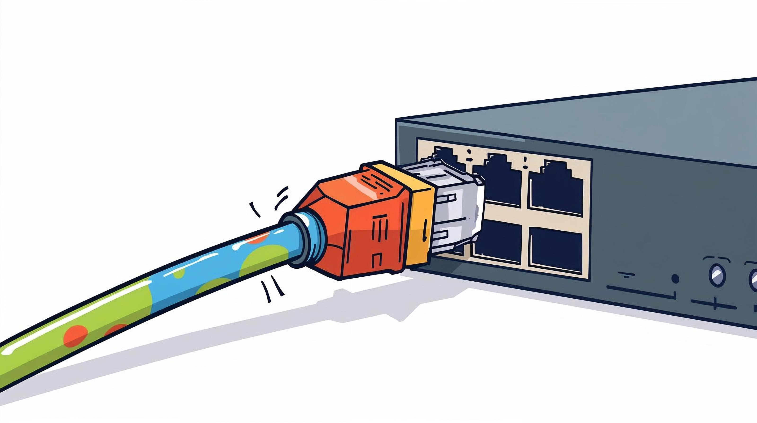

Instructor: Kevin Dillon
Date: September 9, 2025

Tabel of content

Peer-to-Peer vs. Client-Server Models

At its core, a network model is just a way of describing how computers connect and share information with each other. The two most common ways to organize this are the Client-Server model and the Peer-to-Peer model.

The Client-Server Model 🏢
Think of the Client-Server model like a restaurant. You, the customer, are the client. You make a request (order food). The waiter takes your request to the kitchen, which is the server. The server has all the resources (ingredients, chefs, ovens) to fulfill your request and sends the completed order (your meal) back to you.
In this model, the network has two distinct types of computers:
- Clients: These are the devices you use every day, like your PC, smartphone, or laptop. They request services or information.
- Servers: These are powerful, specialized computers that provide services or information. They store the data, run the applications, and wait for client requests.
How it works: A client sends a request over the network to a server. The server processes the request and sends a response back. The client doesn't talk directly to other clients; all communication goes through the central server.
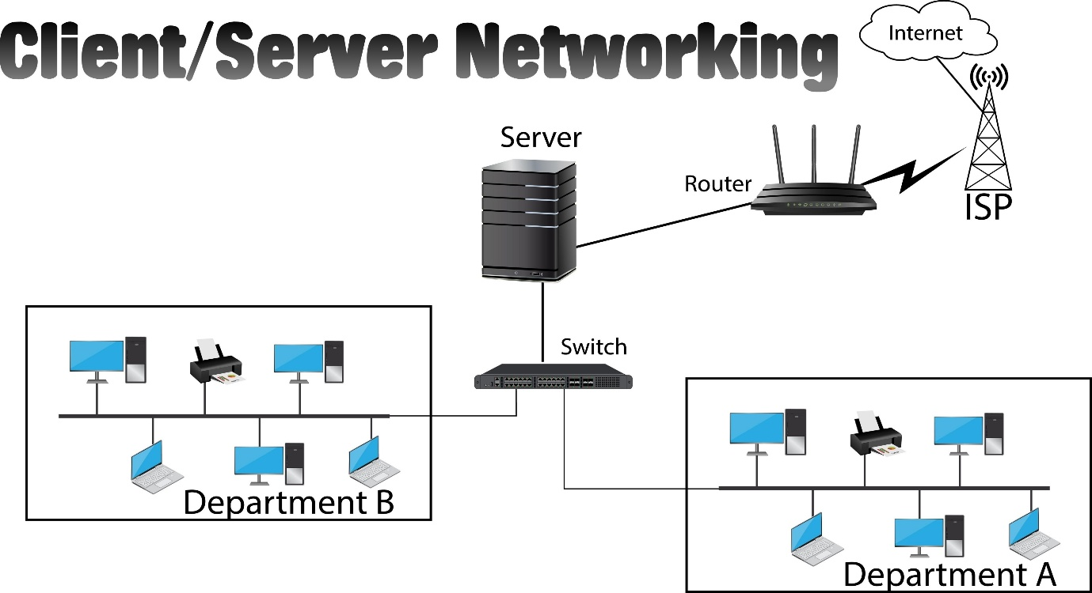
Licensed by Google
Real-world examples:
- Web Browsing: Your browser (client) requests a webpage from a web server.
- Email: Your email app (client) connects to a mail server to send and receive messages.
- Online Gaming: Your game console (client) connects to the game company's server, which manages the game world and connects you with other players.
- Company Networks: In an office, your computer (client) might access files stored on a central file server.
Pros & Cons:
- 👍 Pros: It's centralized, making it easier to manage, secure, and back up data. It's also very reliable since servers are usually powerful and well-maintained.
- 👎 Cons: The server can be a single point of failure. If the server goes down, the entire network service stops working. It can also be expensive to buy and maintain a powerful server.

The Peer-to-Peer (P2P) Model 🤝
Now, think of the Peer-to-Peer (P2P) model like a potluck dinner or a study group. Everyone brings something to share, and everyone can take something from others. There's no central kitchen or single teacher. Each person is both a provider and a consumer.
In a P2P network, every computer is a "peer." A peer is a computer that is equal to all the others. It can act as both a client and a server. It can request information from other peers and also provide information to other peers. There is no central, dedicated server.
How it works: When you want a file in a P2P network, you ask the network, "Who has this file?" Multiple peers might respond, and you can download small pieces of the file from several peers at once, making the download much faster. At the same time, someone else might be downloading a file that you have, and your computer will act as a server for them.
Real-world examples:
- File Sharing (BitTorrent): This is the most famous example. Users share files directly with each other without a central server hosting the files.
- Cryptocurrencies (Bitcoin, Ethereum): The ledger of all transactions is distributed across thousands of peers, ensuring no single entity has control.
- Early versions of Skype: Originally, Skype used P2P technology to route calls directly between users to reduce the load on their servers.
Pros & Cons:
- 👍 Pros: It's highly scalable—the more peers that join, the stronger and faster the network can become. There is no single point of failure; if one peer goes offline, the network continues to function. It's also very low-cost to set up since you don't need a powerful central server.
- 👎 Cons: It's less secure because data is distributed everywhere, and it can be difficult to verify the source of files. It's also harder to back up data since it's not stored in one central place. Performance can be inconsistent because it depends on the peers that are currently connected.
- Key Differences at a Glance
Feature | Client-Server Model | Peer-to-Peer (P2P) Model
Structure | Centralized | Decentralized
Roles | Clear roles: Clients request, Servers provide. | All computers are equal peers.
Data Storage | Data is stored on a central server. | Data is distributed among peers.
Scalability | Harder; requires upgrading the server. | Easier; just add more peers.
Reliability | Depends on the server. If it fails, all fails. | High; no single point of failure.
Cost | More expensive due to server hardware/software. | Less expensive; uses existing peer hardware.
Best For | Services needing high security and control. | Collaborative tasks and large file sharing.

Data Encapsulation & Decapsulation

This process is like the digital postal service for the internet, ensuring your data gets to the right place in the right format.
The Analogy: Sending a Package 📦
Imagine you're mailing a gift.
- You put the gift (your data) inside a box.
- You write a card for the recipient (Transport Layer Header with port numbers).
- You put the box inside a shipping container and write the full street address on it (Network Layer Header with IP addresses).
- The local post office puts a tag on it for the specific mail truck that will deliver it (Data Link Layer Header with MAC addresses).
- The truck (Physical Layer) drives the package to its destination.
When the package arrives, the process happens in reverse. The truck driver removes the local tag, the sorting facility reads the street address, and finally, the recipient opens the box to get the gift. That's encapsulation (packing) and decapsulation (unpacking) in a nutshell.

Data Encapsulation (Going Down 👇)
Encapsulation is the process of adding control information in the form of headers (and sometimes trailers) to data as it moves down through the layers of a network model (like the OSI or TCP/IP model). Each layer adds its own "wrapper" with instructions for its corresponding layer on the receiving end.
Here's the step-by-step journey of your data from an application (like a web browser) to the network cable:
- Application Layer: You start with your raw Data. (e.g., "Hello world").
- Transport Layer: The data is broken into chunks. A TCP or UDP header is added to each chunk, creating a Segment. This header includes source and destination port numbers, which act like apartment numbers to identify the specific application (e.g., port 443 for HTTPS).
- Network Layer: A IP header is added to the Segment, creating a Packet. This header contains the source and destination IP addresses—the global street addresses for the computers.
- Data Link Layer: A MAC header is added to the Packet, creating a Frame. This header contains the source and destination MAC addresses, which are the unique hardware addresses for devices on the local network (like your Wi-Fi router and your computer).
- Physical Layer: The Frame is converted into Bits (electrical signals, radio waves, or pulses of light) and sent across the physical medium (cable, Wi-Fi, etc.).

Data Decapsulation (Going Up 👆)
Decapsulation is the exact reverse process. It happens on the receiving computer as the data moves up the network layers. Each layer strips off the header added by its counterpart on the sending computer.
- Physical Layer: Receives the Bits and reassembles them into a Frame.
- Data Link Layer: Reads the information in the MAC header. It confirms the frame is for this device, then strips the header off, passing the Packet up.
- Network Layer: Reads the information in the IP header. It confirms the packet is for this computer, then strips the header off, passing the Segment up.
- Transport Layer: Reads the TCP or UDP header to identify which application the data is for (e.g., the web browser on port 443). It strips the header off, reassembles the data chunks, and passes the original Data up.
- Application Layer: Receives the clean Data ("Hello world") and displays it to you.
This process ensures that data gets to the right computer (via IP address), the right network card on that computer (via MAC address), and the right application on that computer (via Port Number) in an orderly fashion.
The OSI (Open Systems Interconnection) Model is a conceptual framework used to understand and standardize the functions of a telecommunication or computing system. Think of it as a blueprint that breaks down the complex process of network communication into seven smaller, more manageable parts called layers.
It’s important to know that the OSI model is a theoretical model. The real world often uses a simpler model (the TCP/IP model), but learning the OSI model is the best way to understand all the distinct jobs that need to happen for your data to get from A to B.
We'll go from top (Layer 7) to bottom (Layer 1), just as your data does during encapsulation.

The 7 Layers of the OSI Model
Layer 7: The Application Layer 👨‍💻
- What it does: This is the only layer that directly interacts with the user. It provides the interface for applications to use network services.
- Analogy: It's the app on your phone or the program on your computer (e.g., your web browser, Outlook, or a video game). It's what you actually see and use.
- PDU (Protocol Data Unit): Data

Layer 6: The Presentation Layer 🎨
- What it does: This layer acts as a translator. It makes sure that data is in a usable format for the application. It handles tasks like data compression, encryption, and character encoding (e.g., ASCII to UTF-8).
- Analogy: It's a universal translator ensuring two people who speak different languages can understand each other. It also handles putting the conversation into a secret code (encryption).
- PDU: Data

Layer 5: The Session Layer 📞
- What it does: This layer is the conversation manager. It establishes, manages, and terminates the connection (or "session") between two computers. It ensures that the communication stays in sync.
- Analogy: It’s like a phone call operator who dials the number, keeps the line open for your entire conversation, and hangs up when you're done.
- PDU: Data

Layer 4: The Transport Layer 🚚
- What it does: This layer provides reliable end-to-end data transfer. It breaks data into smaller chunks (segmentation), controls the flow of data, and checks for errors. This is where protocols like TCP (reliable) and UDP (fast) operate.
- Analogy: This is the certified mail service. It chops your long letter into numbered pages, sends them, and makes sure they all arrive in the correct order, asking for any missing pages to be resent.
- PDU: Segment

Layer 3: The Network Layer 🗺️
- What it does: This is the routing layer. It is responsible for moving packets from their source to their destination across different networks. This is the layer of IP addresses and routers.
- Analogy: This is the global postal service headquarters. It looks at the final destination address (IP address) on your package and determines the best path across cities and countries to get it there.
- PDU: Packet

Layer 2: The Data Link Layer 🔗
- What it does: This layer handles communication on the local network. It takes the packets from the Network Layer and puts them into frames. It's responsible for error-free transfer between two devices on the same network using MAC addresses.
- Analogy: This is the local mail carrier for a specific neighborhood. They don't care about the final country, only about finding the correct house number (MAC address) on their specific street.
- PDU: Frame

Layer 1: The Physical Layer 🔌
- What it does: This is the hardware layer. It defines the physical means of sending data, like cables, connectors, and wireless signals. It's all about converting the digital frames into electrical, radio, or light signals (bits).
- Analogy: These are the physical roads, mail trucks, airplanes, and the paper the mail is written on. It’s the actual infrastructure that moves the information.
- PDU: Bits

How to Remember the Layers
A popular mnemonic to remember the layers from top (7) to bottom (1) is: "All People Seem To Need Data Processing."
While the OSI model is perfect for learning and theory, the TCP/IP model is the one that the internet was actually built on and continues to use today. It's a more practical, streamlined framework that combines some of the OSI layers.
The TCP/IP model is typically described as having four layers. The best way to understand it is to see how it maps directly to the seven layers of the OSI model you just learned.

The Four Layers of the TCP/IP Model
Here’s a breakdown of each layer, showing its corresponding OSI layers.
4. Application Layer 🖥️
- What it does: This layer combines the functions of the OSI model's Application, Presentation, and Session layers (Layers 7, 6, and 5). It handles everything from the user interface to data formatting and managing the communication session.
- Protocols: HTTP (for web browsing), FTP (for file transfer), SMTP (for email).
- OSI Layers: Application (7), Presentation (6), Session (5)

3. Transport Layer 📦
- What it does: This layer is identical to the OSI model's Transport Layer. It's responsible for end-to-end communication, reliability, and flow control. It uses protocols like TCP and UDP to segment data and manage the connection between applications.
- Protocols: TCP (Transmission Control Protocol), UDP (User Datagram Protocol).
- OSI Layer: Transport (4)

2. Internet Layer 🌐
- What it does: This layer's job is to move packets from source to destination. It's directly equivalent to the OSI model's Network Layer. It handles logical addressing (IP addresses) and routing to find the best path across the internet.
- Protocols: IP (Internet Protocol).
- OSI Layer: Network (3)

1. Network Access Layer 🔗
- What it does: This layer combines the functions of the OSI model's Data Link and Physical layers (Layers 2 and 1). It deals with everything related to the physical transmission of data on the local network, including MAC addresses, cables, switches, and network interface cards.
- Protocols: Ethernet, Wi-Fi.
- OSI Layers: Data Link (2), Physical (1)

Why TCP/IP Won
The main reason the TCP/IP model is the standard is that it was developed alongside the internet protocols themselves. The OSI model was created by academics as a more formal, prescriptive standard, but by the time it was finished, the internet was already running successfully on the more pragmatic TCP/IP protocol suite.

NAT (Network Address Translation)
It's a crucial technology that makes the modern internet work.
The Analogy: An Office Receptionist 🏢
Imagine a large office building with hundreds of employees.
- The building has one public street address (Public IP Address).
- Each employee has a unique internal office number, like #101, #204, etc. (Private IP Addresses).
If an employee in office #101 sends a letter, they don't put "#101" as the return address. They give it to the receptionist at the front desk. The receptionist sends the letter out using the building's main street address. When a reply comes back to that main address, the receptionist remembers it's for office #101 and forwards it to them.
In this story, your home or office router is the receptionist, and NAT is the process it uses.

Why Do We Need NAT?
The original internet addressing system (IPv4) had a limited number of unique addresses—about 4.3 billion. With the explosion of devices (PCs, phones, smart TVs), we quickly ran out. NAT was invented as a clever solution to this problem. It allows a whole network of devices (a home, an office) to share a single public IP address.
- Public IP Address: This is the unique address your Internet Service Provider (ISP) assigns to your router. It's visible to the entire internet.
- Private IP Address: These are addresses used inside your local network (like 192.168.1.5 or 10.0.0.10). They are not visible to the internet and can be reused in millions of homes and offices worldwide.

How NAT Works
NAT is the process where your router modifies the IP address information in data packets as they cross from your private network to the public internet (and vice-versa).
- Outgoing Traffic:
  - Your computer (private IP 192.168.1.50) wants to visit https://www.google.com/search?q=google.com. It sends a request packet to your router.
  - The router takes the packet and replaces the source address from 192.168.1.50 to your public IP address (e.g., 8.8.4.4).
  - Crucially, the router makes a note in its internal NAT table, saying, "Any response to this request belongs to 192.168.1.50."
  - The packet is sent to the internet.
- Incoming Traffic:
  - Google's server sends a response back to your public IP address 8.8.4.4.
  - The router receives the packet and checks its NAT table. It sees that this response matches the earlier request from 192.168.1.50.
  - The router replaces the destination address from the public IP to the private IP 192.168.1.50 and forwards the packet to your computer.
The Most Common Type: PAT (Port Address Translation)
What if multiple devices on your network are browsing the web at the same time? How does the router know which response goes to the laptop and which goes to the smartphone?
This is solved by PAT (Port Address Translation), also called NAT Overload. This is the type of NAT used in virtually all home routers.
When your router replaces the private IP with its public IP, it also assigns a unique outgoing port number to the request. The NAT table now tracks both the IP address and the port number (e.g., "Response for port 62354 goes to 192.168.1.50," "Response for port 62355 goes to 192.168.1.51"). This allows a single public IP address to handle tens of thousands of connections simultaneously.

Network Topologies

A network topology is simply the way computers and other devices are physically or logically arranged in a network. Think of it as the network's blueprint or map. We'll focus on the most common physical topologies.

Bus Topology 🚌
This is one of the simplest topologies. All devices are connected to a single central cable, called the bus or backbone. Data sent by one device travels along the bus, and all other devices can see it, but only the intended recipient accepts and processes it.
- Analogy: Imagine a single street where all the houses are connected directly to it. When a mail truck drives down the street, it passes every house.
- 👍 Pros: It's cheap and easy to set up.
- 👎 Cons: It's an older technology that is not very efficient. If the main cable fails, the entire network goes down. It can also be difficult to troubleshoot.

Ring Topology 💍
In a ring topology, devices are connected in a circle. Data travels from one device to the next in a single direction around the ring until it reaches its destination.
- Analogy: Think of a round-table discussion where a "talking stick" is passed from person to person in order.
- 👍 Pros: It's orderly and prevents data collisions since data only flows in one direction.
- 👎 Cons: If one device or cable fails, it breaks the entire ring and the network goes down. Adding or removing a device disrupts the network.
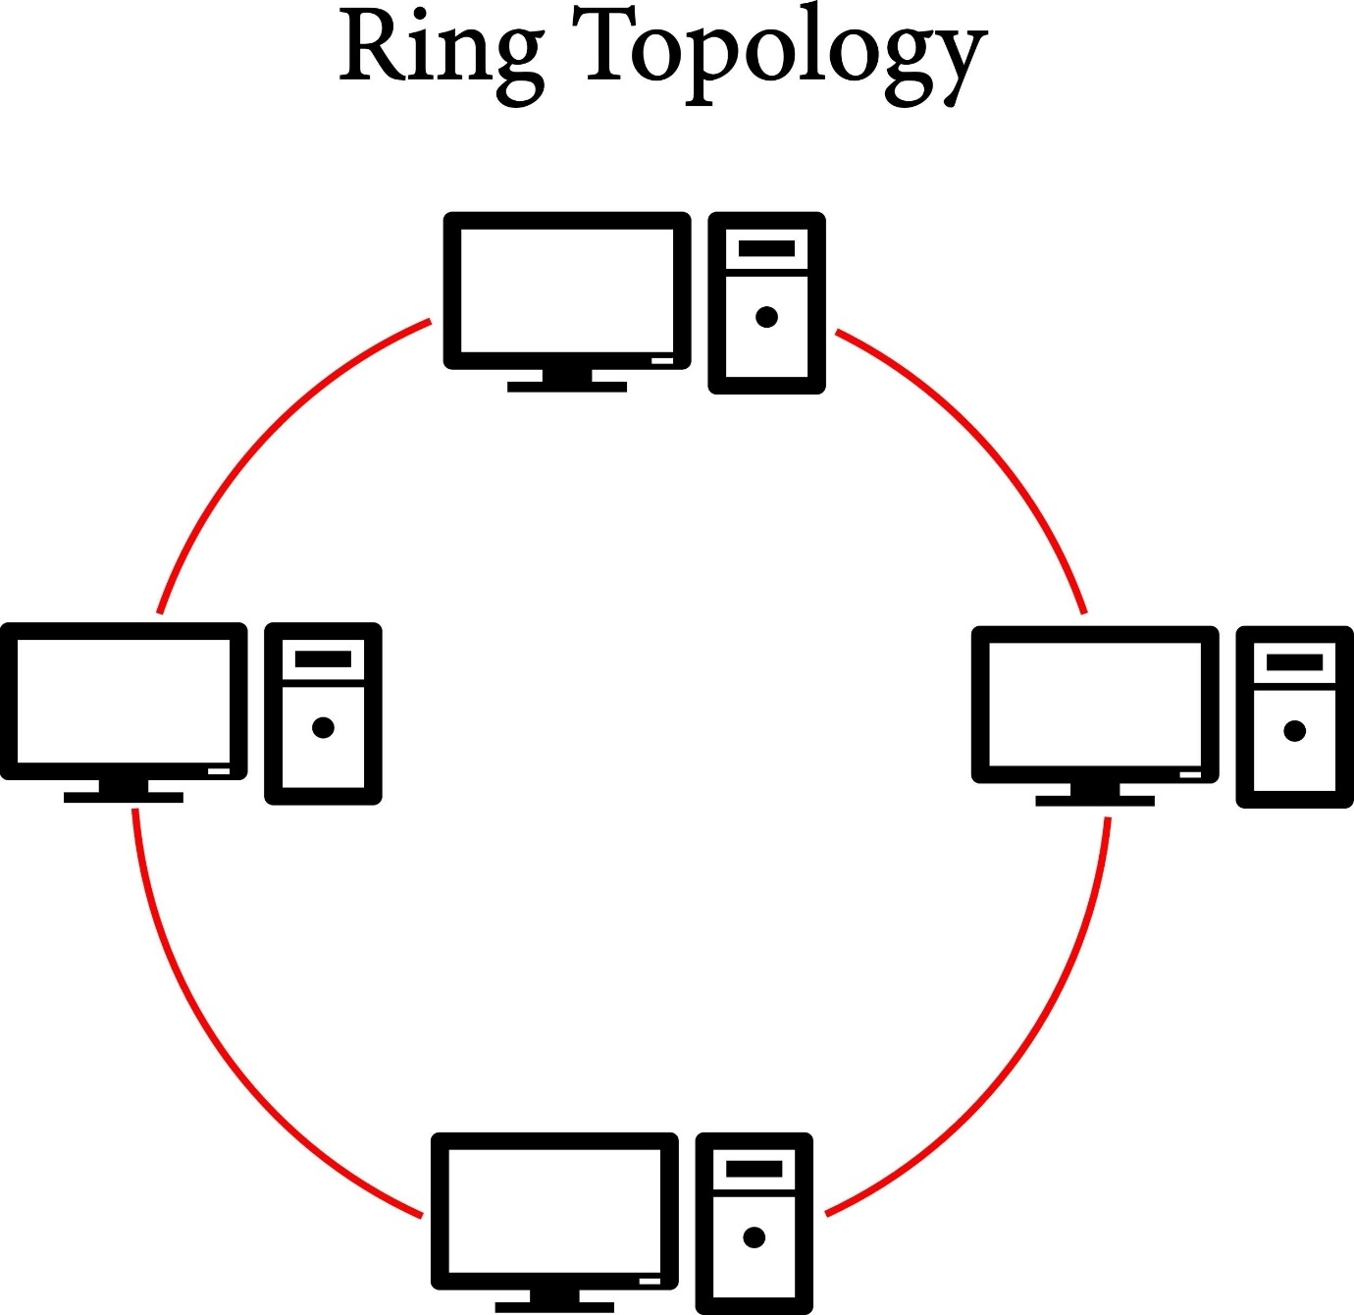

Star Topology ⭐
This is the most common topology used in modern home and office networks. All devices are connected to a central device, like a switch or a hub. All traffic must pass through this central hub.
- Analogy: A bicycle wheel, where all the spokes (devices) connect to the center hub.
- 👍 Pros: It's reliable; if one cable fails, only that one device is affected, not the whole network. It's also easy to add new devices and troubleshoot problems.
- 👎 Cons: The central device is a single point of failure. If the central switch or hub fails, the entire network goes down.
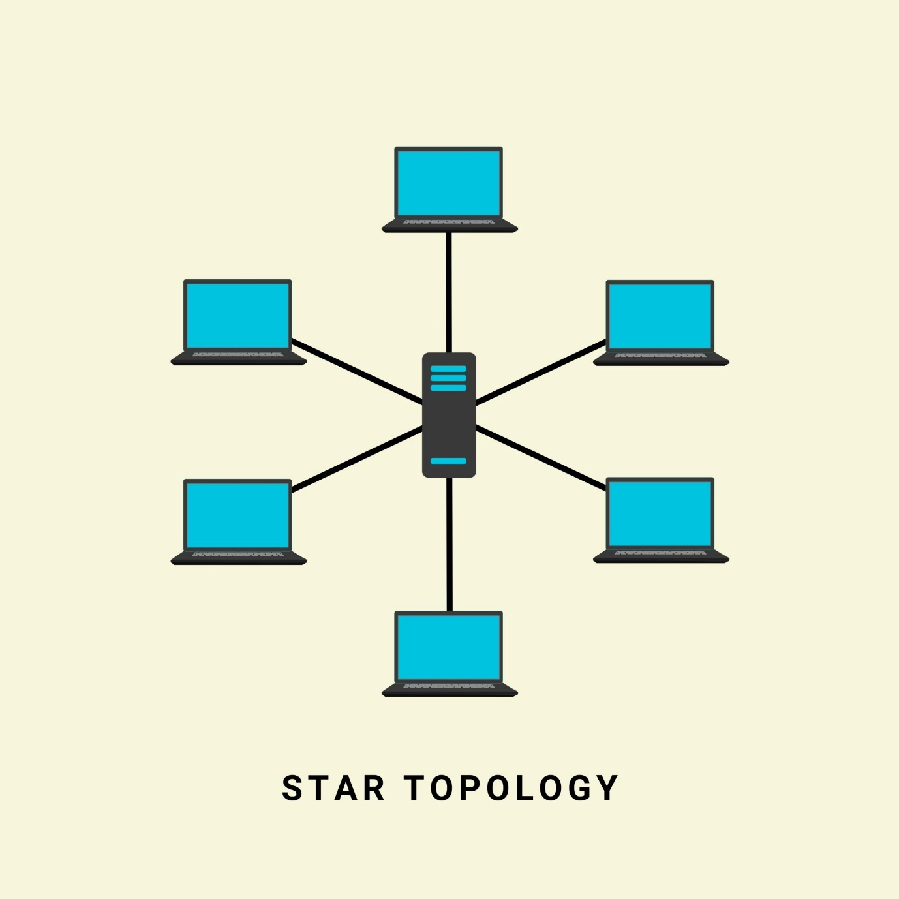

Mesh Topology 🕸️
In a mesh topology, devices are interconnected. In a full mesh, every device is connected directly to every other device. In a partial mesh, some devices are connected to multiple other devices. This topology is highly reliable and is often used for the backbone of the internet.
- Analogy: A spider's web, with many interconnected paths from one point to another.
- 👍 Pros: It's extremely fault-tolerant and reliable. If one path fails, data can be rerouted through another.
- 👎 Cons: It's very expensive and complex to set up due to the large amount of cabling and connections required.
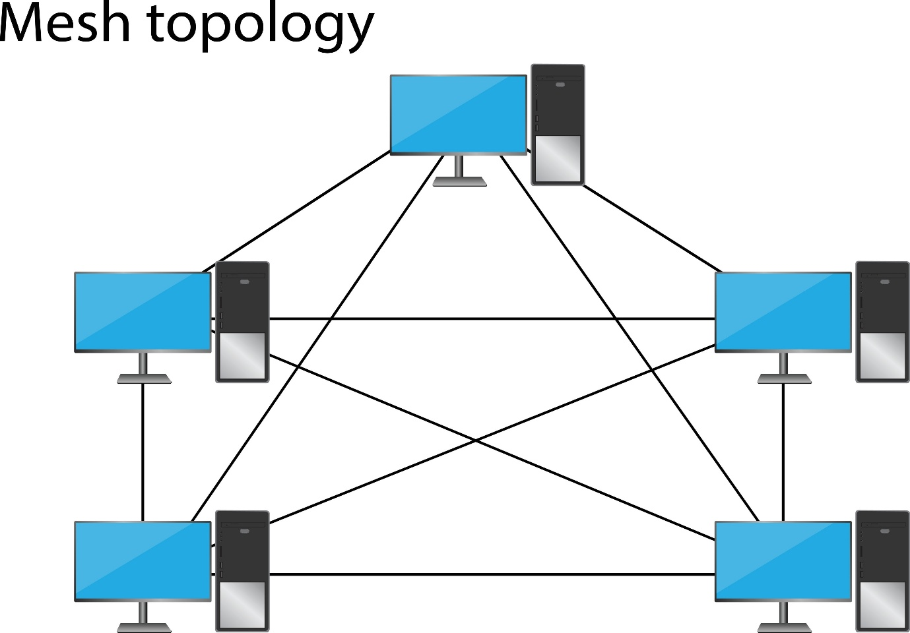

Hybrid Topology 🧩
In practice, many networks use a hybrid topology, which is just a combination of two or more different topologies. For example, a company might connect several star-configured department networks to a central bus backbone that runs between floors.

